Ex:No: 10

Date:

**Simple programming exercise using (REPEAT, WHILE )**

**Program1**

Write a function to build a string repeatedly until the value of the variable becomes s greater than 5. Then, we display the final string using a SELECT statement.

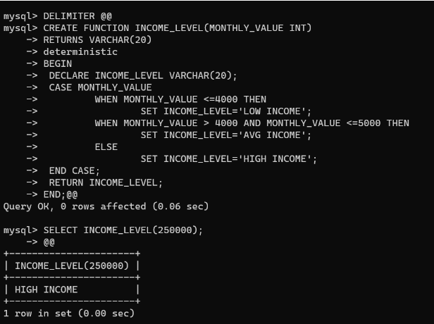

**Program 2:**

Write a function that uses REPEAT statement which would repeat the loopuntil income is greater than or equal to 4000, at which point the REPEAT loop would beterminated

