********************************* Import Dataset ***********************

**#importing the necessary libraries**

import numpy as np # linear algebra

import pandas as pd # data processing, CSV file I/O (e.g. pd.read_csv)

import seaborn as sns

import matplotlib.pyplot as plt #matplotlib is used for plot the graphs,

%matplotlib inline

from sklearn.model_selection import train_test_split

from sklearn.neighbors import KNeighborsClassifier

**#importing the data and print first 5 rows**

data=pd.read_csv("C:\\Users\\hp pc\\Desktop\\python\\Datasets\\cancer.csv")

data.head()

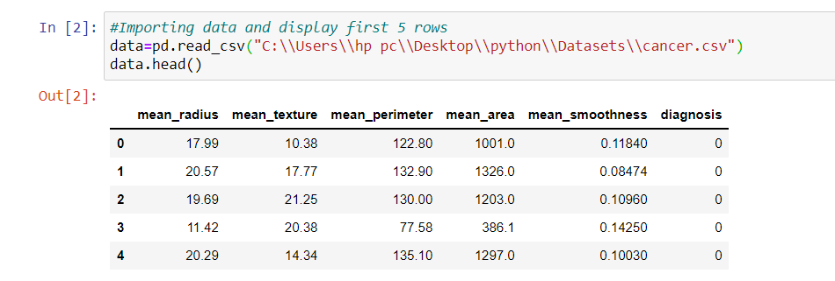

**#no of rows and columns of data**

data.shape

data.info()

****************************** Data visualization ****************************

sns.lmplot(x ='mean_radius', y ='mean_texture',

fit_reg = False, hue = 'diagnosis',

data = data)

plt.show()

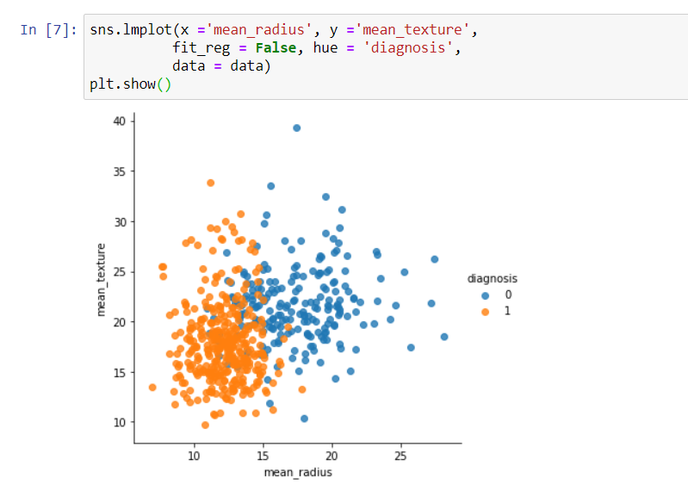

****************************** Data Cleaning ****************************

**#checking if there is any null value present or not**

data.isnull().sum()

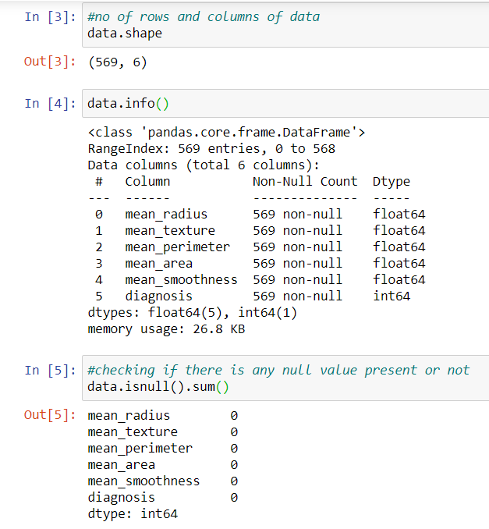

**#finding the pairwise correlation of all columns in the dataframe**

corr=data.corr()

corr.nlargest(30,'diagnosis')['diagnosis']

************************** Data Preprocessing ***************************

**#creating independent and dependent variable**

x=data[['mean_radius','mean_texture','mean_perimeter','mean_area','mean_smoothness']]

y=data[['diagnosis']]

**************************** Data Splitting ******************************

**#Distributing training and testing data**

x_train, x_test, y_train, y_test = train_test_split(x, y, test_size=0.3, random_state=1)

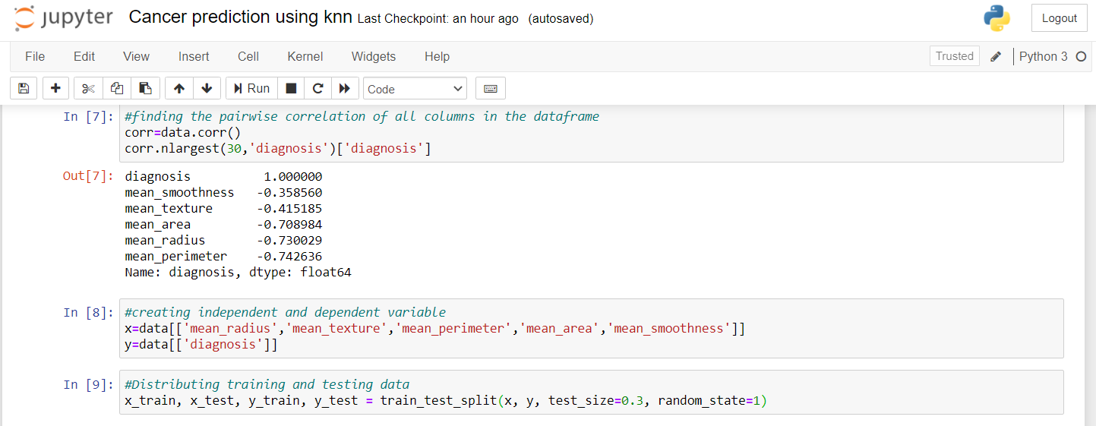

**************************** Create Model ******************************

**#building KNN model and fitting data into it.**

from sklearn.metrics import accuracy_score

model = KNeighborsClassifier(n_neighbors=8)

model.fit(x_train, y_train)

predict = model.predict(x_test)

accuracy_score(predict,y_test)

print(accuracy_score)

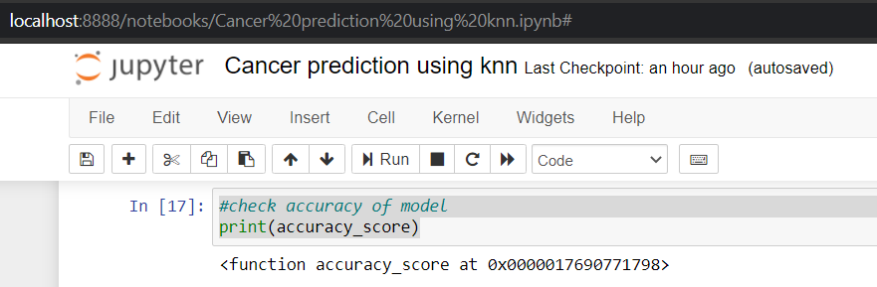

model.score(x_train,y_train)

**#checking score using cross validation method**

from sklearn.model_selection import cross_val_score

score=cross_val_score(model,x,y,cv=2)

score

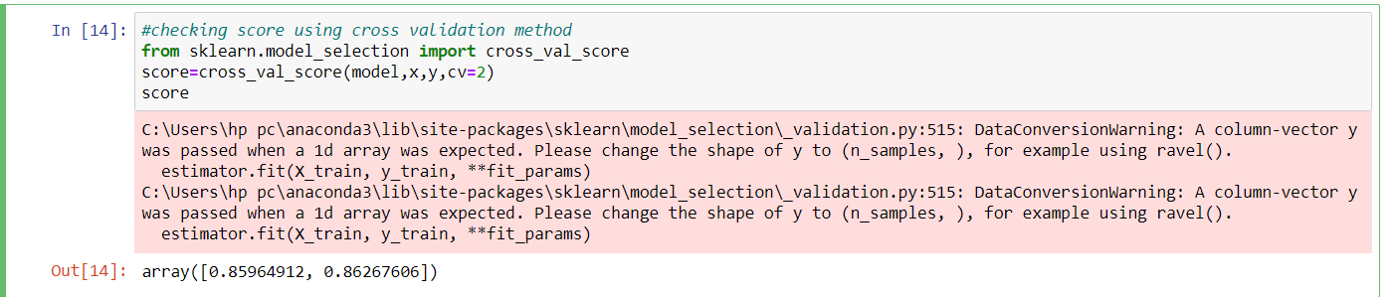

**#Display prediction**

model.fit(x_train,y_train)

predict=model.predict(x_test)

predict

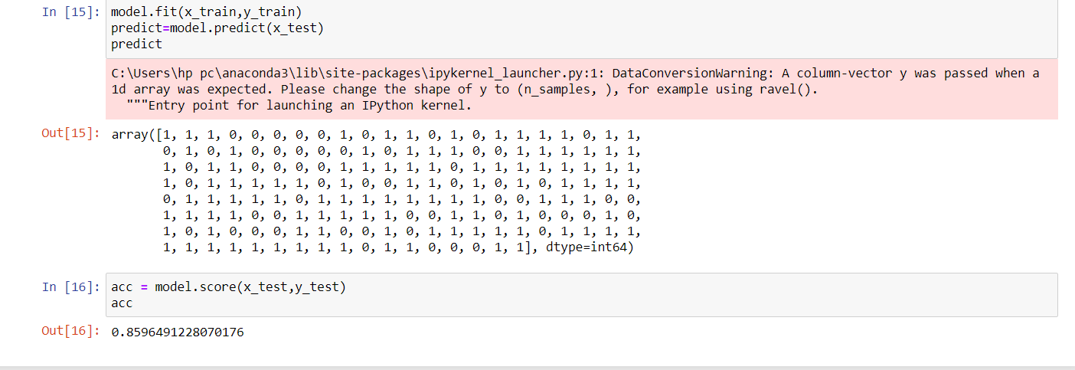

**************************** Accuracy Checking ************************

**#accuracy of model of test data**

acc = model.score(x_test,y_test)

acc