**Objective:**

A software product which provides solution for baby health, baby food, baby tips, baby products, baby names, parenting etc. Here, user can view baby names, baby tips, baby food and baby product.

**Users of the System**

**Users**

1. Can view baby names.
2. Can view baby tips.
3. Can view baby food.
4. Can view baby products.

**Tools to be used**

1. Use an IDE to develop the project which is- Eclipse / Netbeanse.
2. MySql for the database.
3. Server: Apache Tomcat.

**How It Works:**

1. Create account with signing up.
2. Login with valid user id and password.
3. Now home page will appear with tips of baby health, baby food, baby tips, baby products, baby names, parenting etc. Here, user can view baby names, baby tips, baby food and baby product.

**Technology used:**

MVC Architecture with ORM architecture.

**MVC:**

**MODEL**

**(Data Access Model by ORM)**

**View**

**(Java server pages)**

**Controller**

**(jsp)**

**ORM:**

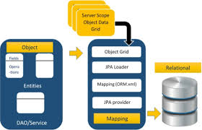

**Class Diagram**