ReadMe for Technical Person:

Cybage Net-book review system

This Project is about book review management, which is implemented in Servlet as well as jsp.HTML and CSS are used as Front End Technologies.

DataBase Schema:

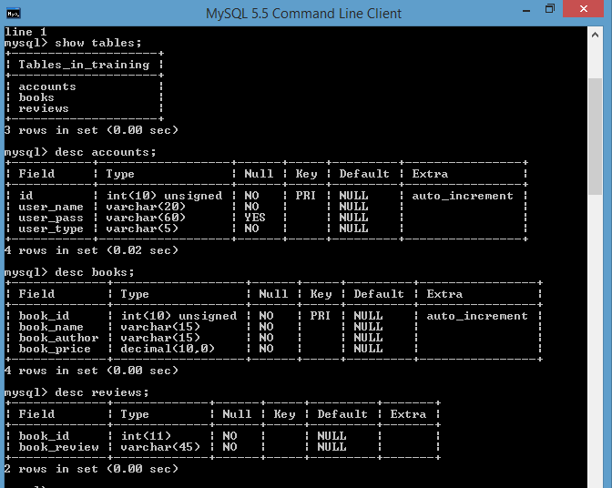

DAOs(Data Access Objects)-

1. LoginDao-

Fields:

private Connection con;

private PreparedStatement pst;

private Utility utill;

Methods:

1) Constructor

2) public String getCheckUserCredintials(String username,String password)

3)getter for Connection

1. AdminDao-

Fields:

private Connection con;

private PreparedStatement pst,pst1,pst2,pst3,pst4,pst5;

Methods:

1. Constructor
2. Getter and Setter for connection
3. public String getPst()
4. public String addBook(int maxId,String bName,String bAuthor,double bPrice)
5. public int maxBookId()
6. public List<BookDto> getBooks()
7. public String deleteBook(String[] ids)
8. public int bookCount(String bName,String bAuthor)
9. UserDao-

Fields:

private Connection con;

private PreparedStatement pst1,pst2,pst3,pst4;

Methods:

1. Constructor
2. Getter and Setter for con
3. public String getPst()
4. public List<BookDto> searchBook(String bookName)
5. public List<String> showReview(int id)
6. public String addReview(int id,String review)
7. public BookDto getBook(int id)

DTOs (Data Transfer Object)-

1. UserDto-

Fields:

private Integer id;

private String name;

private String pass;

private String type;

private LoginDao loginDao;

Methods:

1) getters and setters

2) toString()

3) public String getRole()

1. BookDto

Fields:

private int bookId;

private String bookName;

private String bookAuthor;

private double bookPrice;

private String bookReview;

private UserDao userDao;

private AdminDao adminDao;

Methods:

1. Constructor
2. Getters and Setters
3. toString()
4. public List<BookDto> getSearchBooks()
5. public String getAddBook()
6. public List<String> getShowReviews()
7. public BookDto getBook()
8. public String getAddReview()