Decision tree using X data

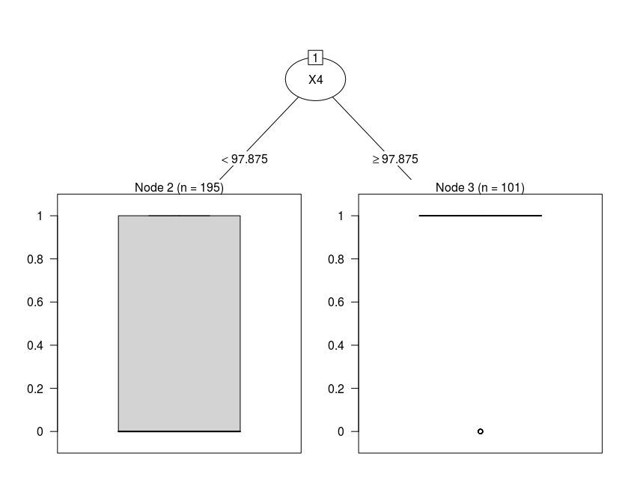

Accuracy for Decision tree using X data: 0.753378378378378

Decision tree using Y data

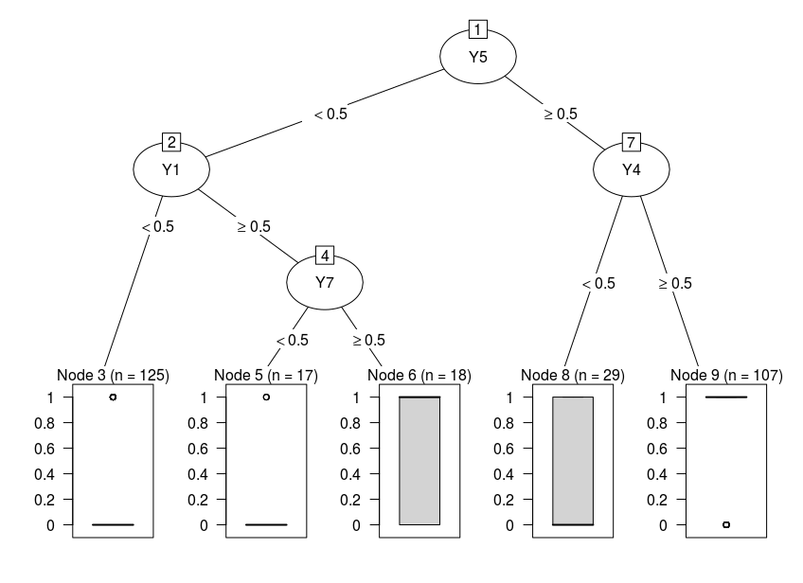

Accuracy for Decision tree using Y data: 0.760135135135135

Decision tree using X & Y data

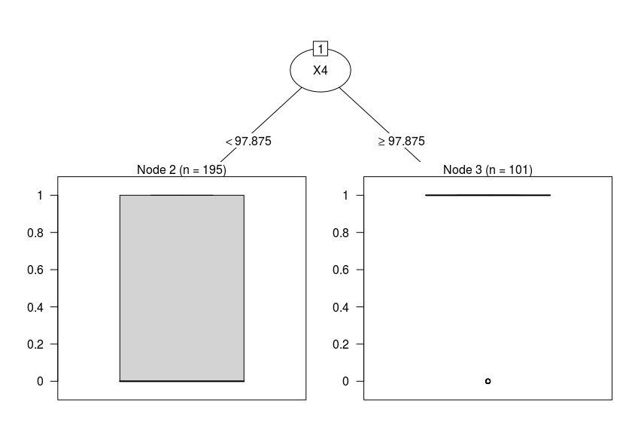

Accuracy for Decision tree using X & Y data: 0.753378378378378

Decision tree using X data for group 0

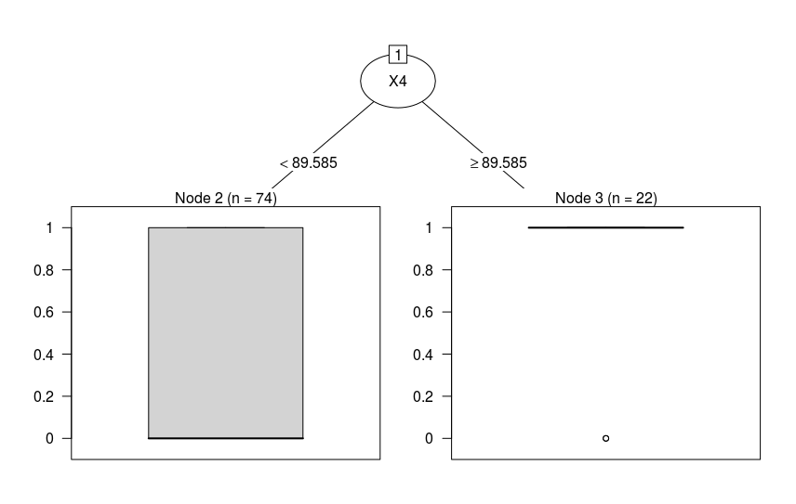

Accuracy for Decision tree using X data for group 0: 0.736486486486487

Decision tree using Y data for group 0

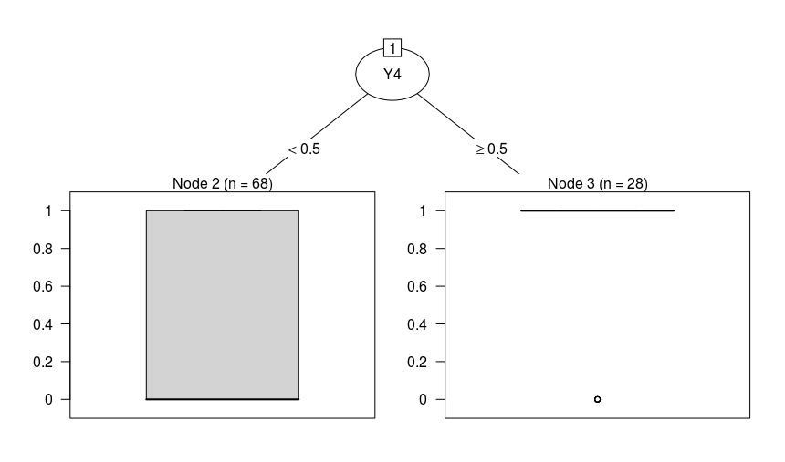

Accuracy for Decision tree using Y data for group 0: 0.668918918918919

Decision tree using X & Y data for group 0

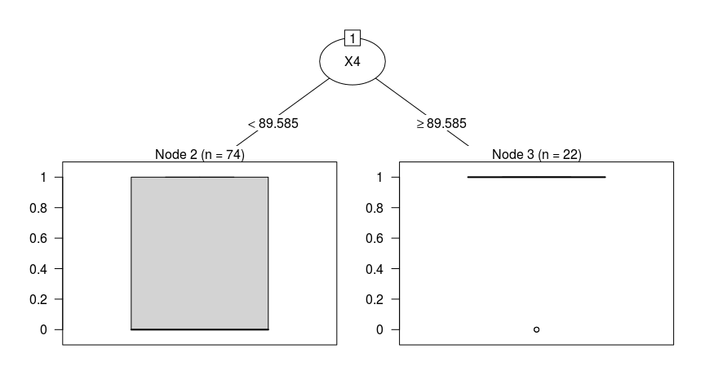

Accuracy for Decision tree using X & Y data for group 0: 0.736486486486487

Decision tree using X data for group 1 \*

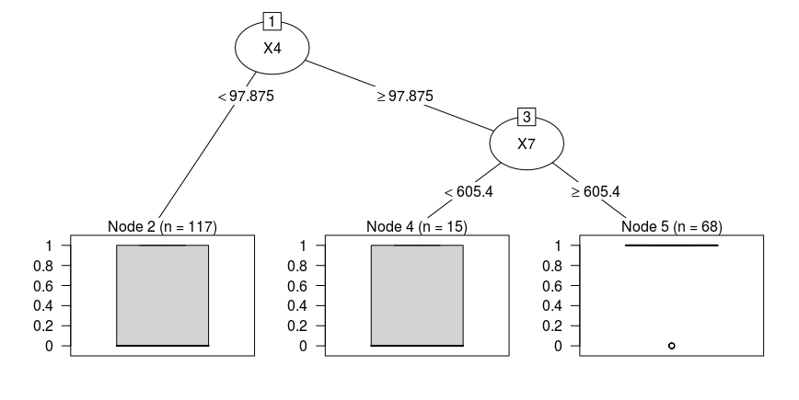

Accuracy for Decision tree using X data for group 1: 0.763513513513513

Decision tree using Y data for group 1

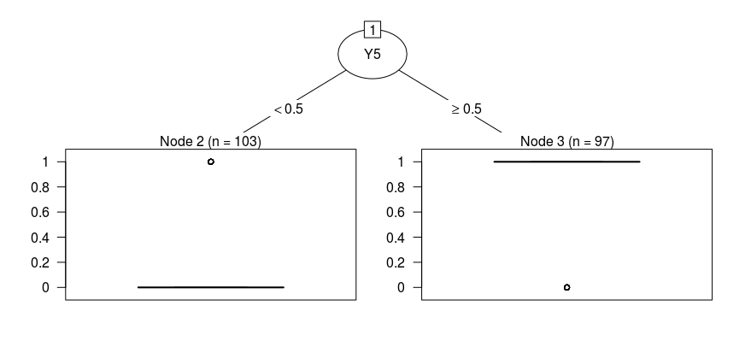

Accuracy for Decision tree using Y data for group 1: 0.716216216216216

Decision tree using X & Y data for group 1

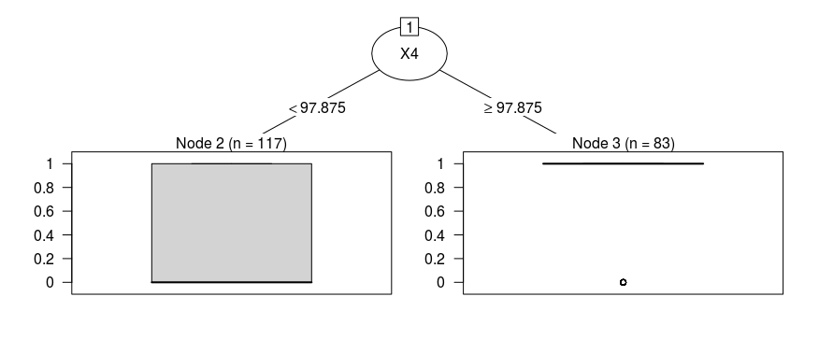

Accuracy for Decision tree using X & Y data for group 1: 0.753378378378378