**Decision tree using X data**

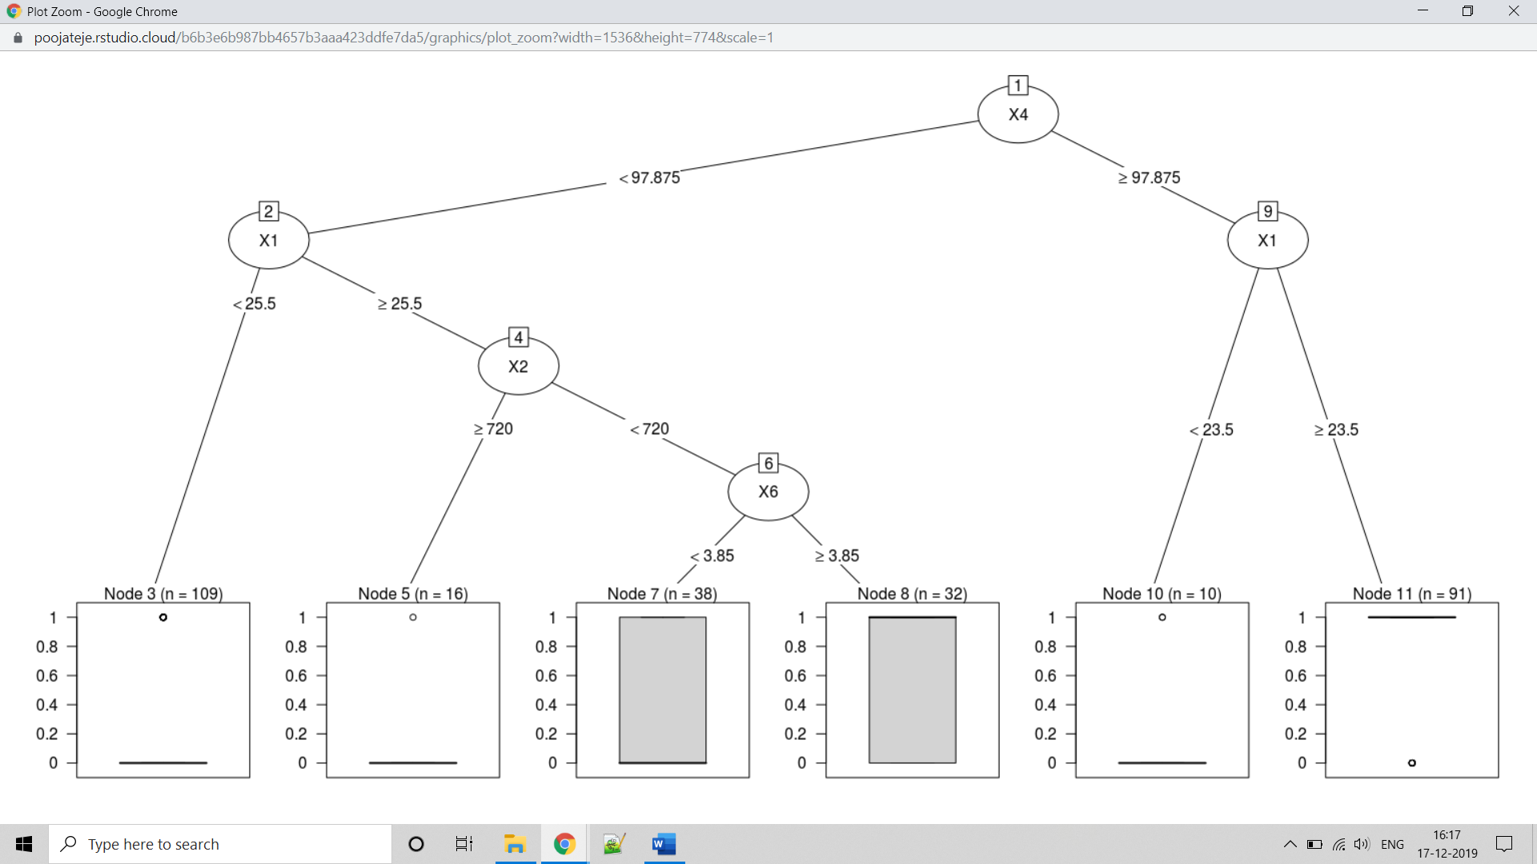

Accuracy for Decision tree using X data: 0.814189189189189

|  |  |
| --- | --- |
| **Without handling null values** | **With handling null values** |
| Accuracy: 0.753378378378378 | Accuracy: 0.814189189189189 |
| n= 296  CP nsplit rel error xerror xstd  1 0.48591549 0 1.0000000 1.0000000 0.06052995  2 0.04225352 1 0.5140845 0.5211268 0.05246361 | n= 296  CP nsplit rel error xerror xstd  1 0.48591549 0 1.0000000 1.0000000 0.06052995  2 0.04225352 1 0.5140845 0.5563380 0.05359314  3 0.02816901 2 0.4718310 0.5774648 0.05422251  4 0.02112676 5 0.3873239 0.5492958 0.05337543 |

**Decision tree using Y data**

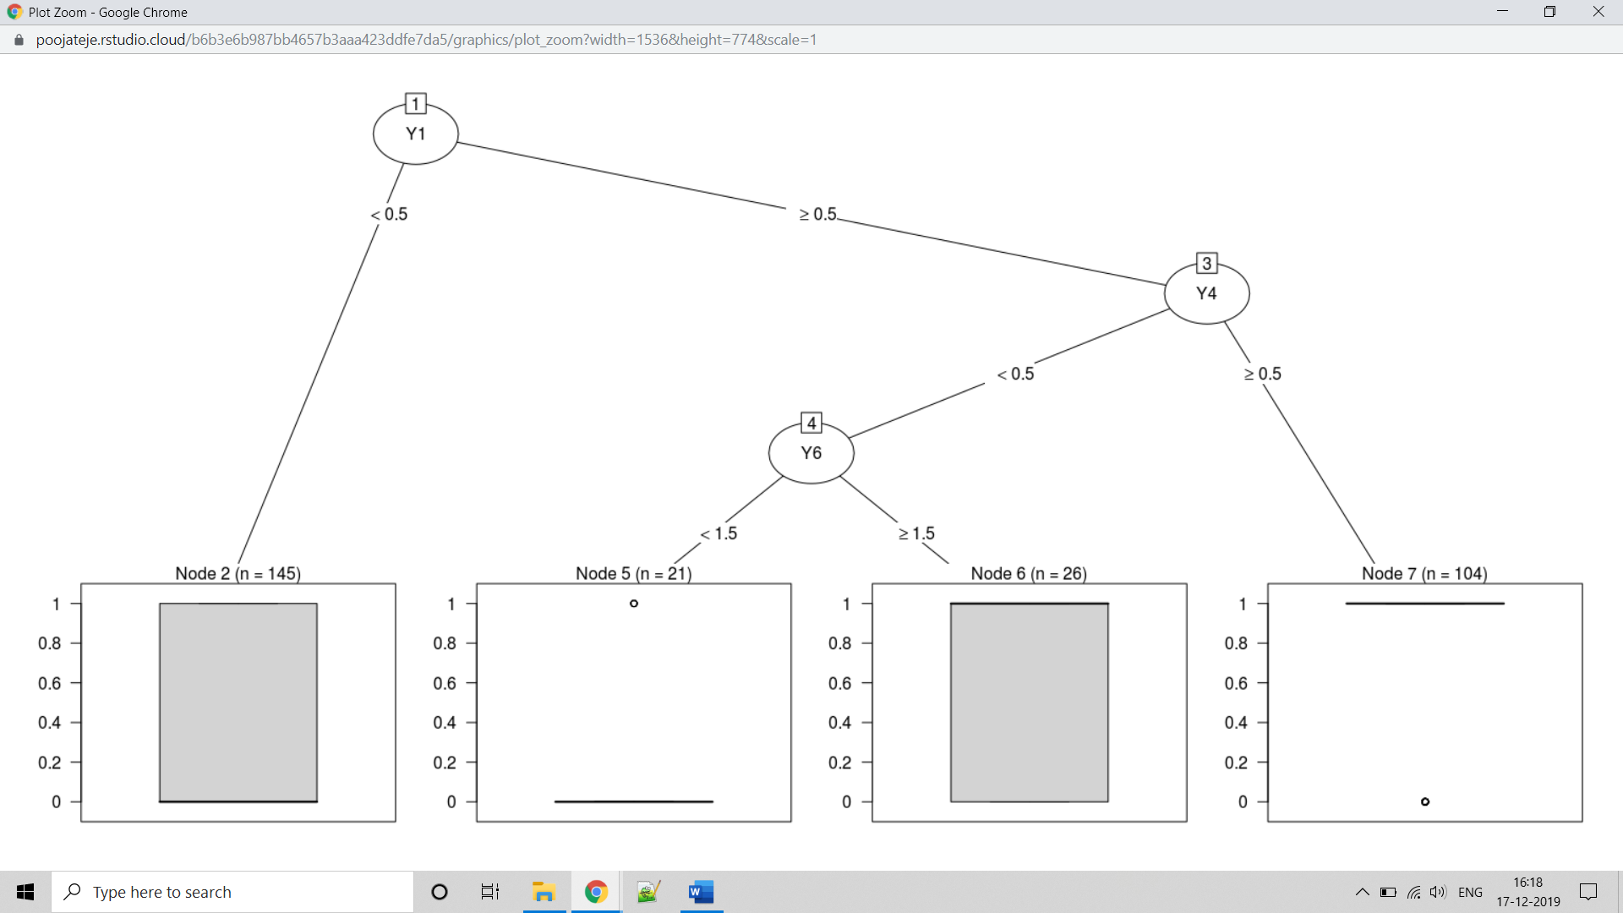

Accuracy for Decision tree using Y data: 0.756756756756757

|  |  |
| --- | --- |
| **Without handling null values** | **With handling null values** |
| Accuracy: 0.773648648648649 | Accuracy: 0.756756756756757 |
| n= 296  CP nsplit rel error xerror xstd  1 0.41549296 0 1.0000000 1.2323944 0.05956313  2 0.04225352 1 0.5845070 0.6197183 0.05537820  3 0.03521127 2 0.5422535 0.6056338 0.05500785  4 0.01000000 4 0.4718310 0.5211268 0.05246361 | n= 296  CP nsplit rel error xerror xstd  1 0.40140845 0 1.0000000 1.0000000 0.06052995  2 0.04929577 1 0.5985915 0.6478873 0.05607571  3 0.04225352 2 0.5492958 0.6408451 0.05590664  4 0.01408451 3 0.5070423 0.5492958 0.05337543 |

**Decision tree using X & Y data**

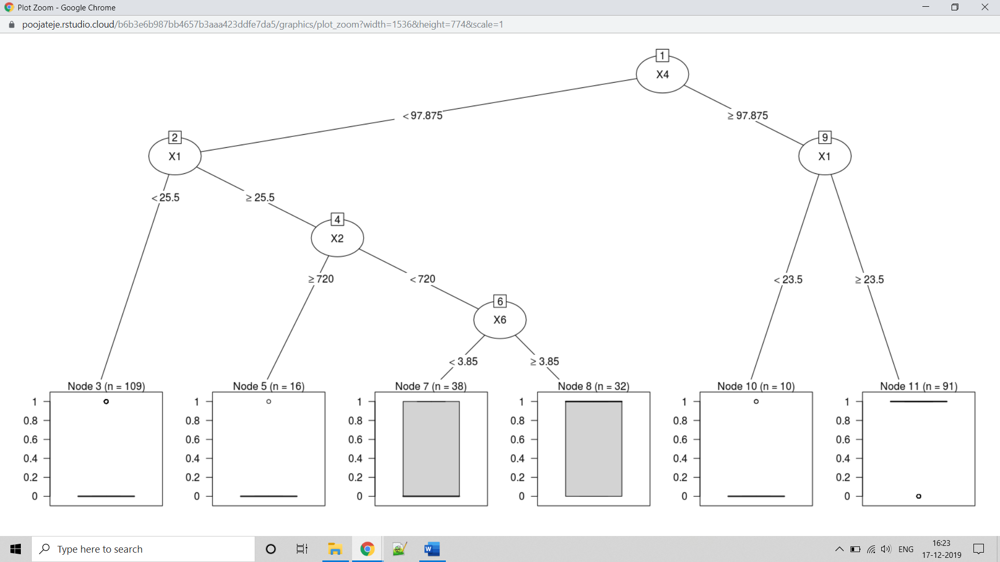

Accuracy for Decision tree using X & Y data: 0.814189189189189

|  |  |
| --- | --- |
| **Without handling null values** | **With handling null values** |
| Accuracy: 0.753378378378378 | Accuracy: 0.814189189189189 |
| n= 296  CP nsplit rel error xerror xstd  1 0.48591549 0 1.0000000 1.000000 0.06052995  2 0.04225352 1 0.5140845 0.528169 0.05269781 | n= 296  CP nsplit rel error xerror xstd  1 0.48591549 0 1.0000000 1.0000000 0.06052995  2 0.04225352 1 0.5140845 0.5492958 0.05337543  3 0.02816901 2 0.4718310 0.5281690 0.05269781  4 0.02112676 5 0.3873239 0.5000000 0.05173521 |

**Decision tree using X data for group 0**

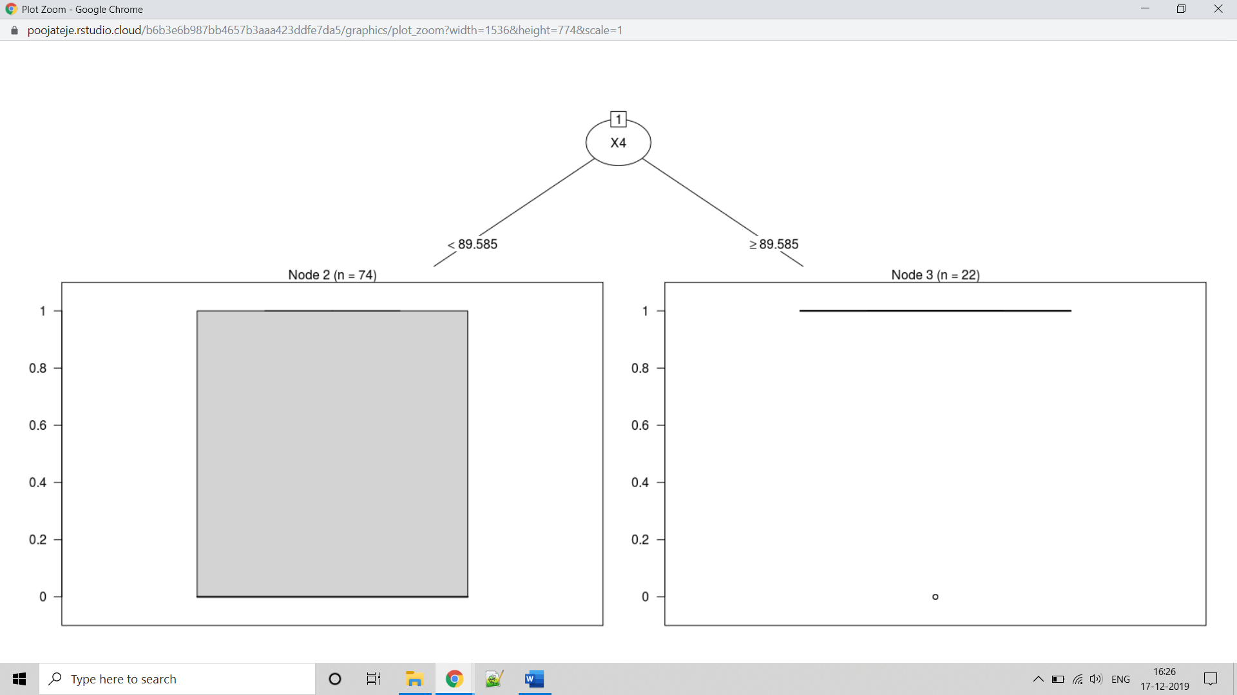

Accuracy for Decision tree using X data for group 0: 0.736486486486487

|  |  |
| --- | --- |
| **Without handling null values** | **With handling null values** |
| Accuracy: 0.736486486486487 | Accuracy: 0.736486486486487 |
| n= 96  CP nsplit rel error xerror xstd  1 0.40909091 0 1.0000000 1.0000000 0.1109532  2 0.04545455 1 0.5909091 0.6590909 0.1022464 | n= 96  CP nsplit rel error xerror xstd  1 0.4090909 0 1.0000000 1.0000000 0.1109532  2 0.0625000 1 0.5909091 0.6363636 0.1012151 |

**Decision tree using Y data for group 0**

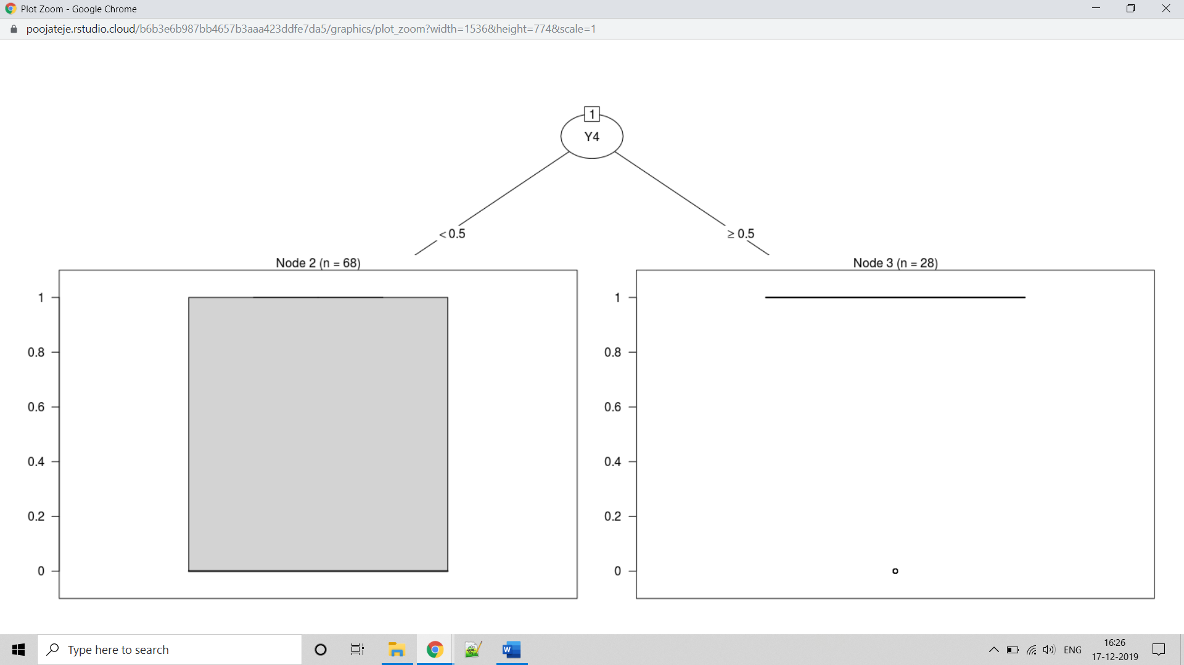

Accuracy for Decision tree using Y data for group 0: 0.668918918918919

|  |  |
| --- | --- |
| **Without handling null values** | **With handling null values** |
| Accuracy: 0.668918918918919 | Accuracy: 0.668918918918919 |
| n= 96  CP nsplit rel error xerror xstd  1 0.3636364 0 1.0000000 1.0000000 0.1109532  2 0.0100000 1 0.6363636 0.6363636 0.1012151 | n= 96  CP nsplit rel error xerror xstd  1 0.36363636 0 1.0000000 1.0000000 0.1109532  2 0.01363636 1 0.6363636 0.6363636 0.1012151 |

**Decision tree using X & Y data for group 0**

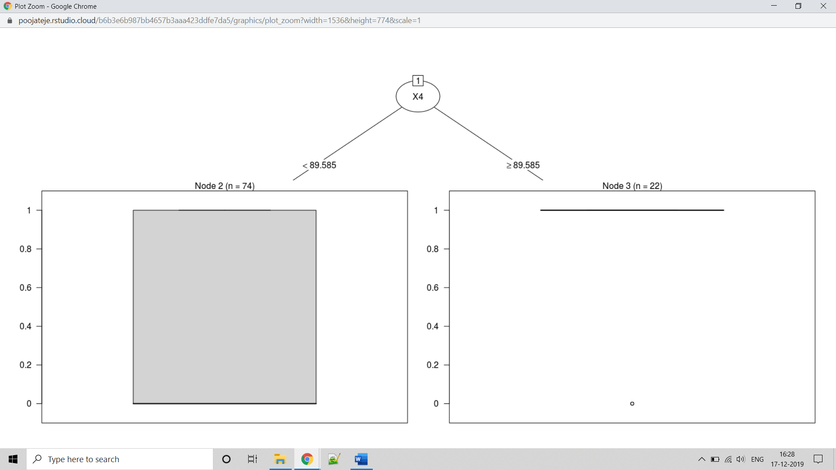

Accuracy for Decision tree using X & Y data for group 0: 0.736486486486487

|  |  |
| --- | --- |
| **Without handling null values** | **With handling null values** |
| Accuracy: 0.736486486486487 | Accuracy: 0.736486486486487 |
| n= 96  CP nsplit rel error xerror xstd  1 0.40909091 0 1.0000000 1.0000000 0.1109532  2 0.04545455 1 0.5909091 0.6363636 0.1012151 | n= 96  CP nsplit rel error xerror xstd  1 0.4090909 0 1.0000000 1.0000000 0.1109532  2 0.0625000 1 0.5909091 0.6590909 0.1022464 |

**Decision tree using X data for group 1**

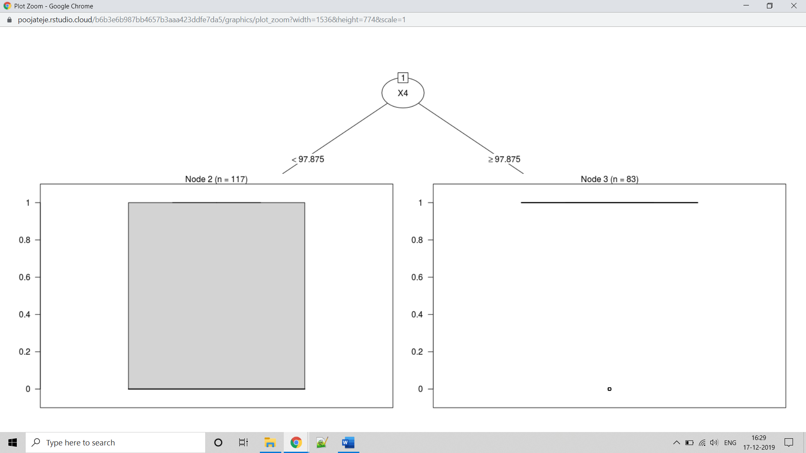

Accuracy for Decision tree using X data for group 1: 0.753378378378378

|  |  |
| --- | --- |
| **Without handling null values** | **With handling null values** |
| Accuracy: 0.756756756756757 | Accuracy: 0.753378378378378 |
| n= 200  CP nsplit rel error xerror xstd  1 0.54081633 0 1.0000000 1.0816327 0.07202376  2 0.06122449 1 0.4591837 0.5510204 0.06406668  3 0.02040816 2 0.3979592 0.5204082 0.06289805  4 0.01020408 4 0.3571429 0.5408163 0.06368769  5 0.01000000 5 0.3469388 0.5102041 0.06248698 | n= 200  CP nsplit rel error xerror xstd  1 0.54081633 0 1.0000000 1.1632653 0.07144315  2 0.03571429 1 0.4591837 0.5306122 0.06329821 |

**Decision tree using Y data for group 1**

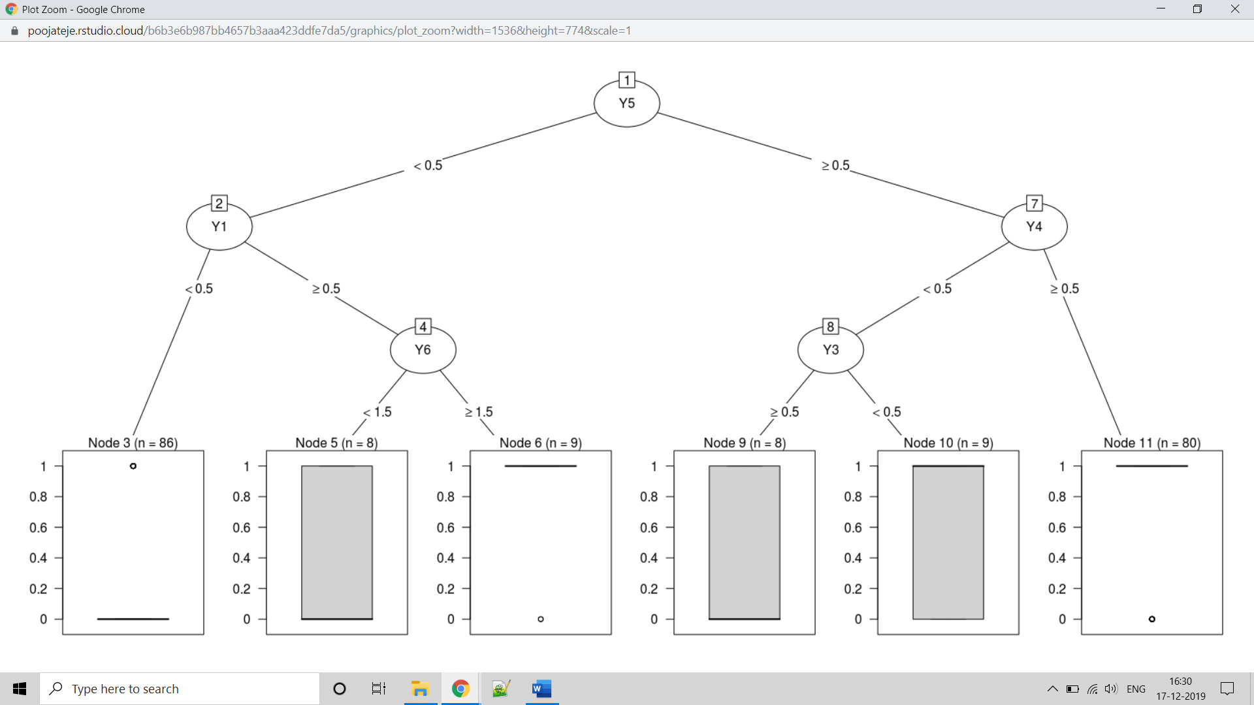

Accuracy for Decision tree using Y data for group 1: 0.77027027027027

|  |  |
| --- | --- |
| **Without handling null values** | **With handling null values** |
| Accuracy: 0.719594594594595 | Accuracy: 0.77027027027027 |
| n= 200  CP nsplit rel error xerror xstd  1 0.51020408 0 1.0000000 1.0000000 0.07213932  2 0.02040816 1 0.4897959 0.5204082 0.06289805 | n= 200  CP nsplit rel error xerror xstd  1 0.51020408 0 1.0000000 1.0612245 0.07209601  2 0.02040816 1 0.4897959 0.5510204 0.06406668  3 0.01020408 3 0.4489796 0.5204082 0.06289805  4 0.01000000 5 0.4285714 0.4897959 0.06163130 |

**Decision tree using X & Y data for group 1 \***

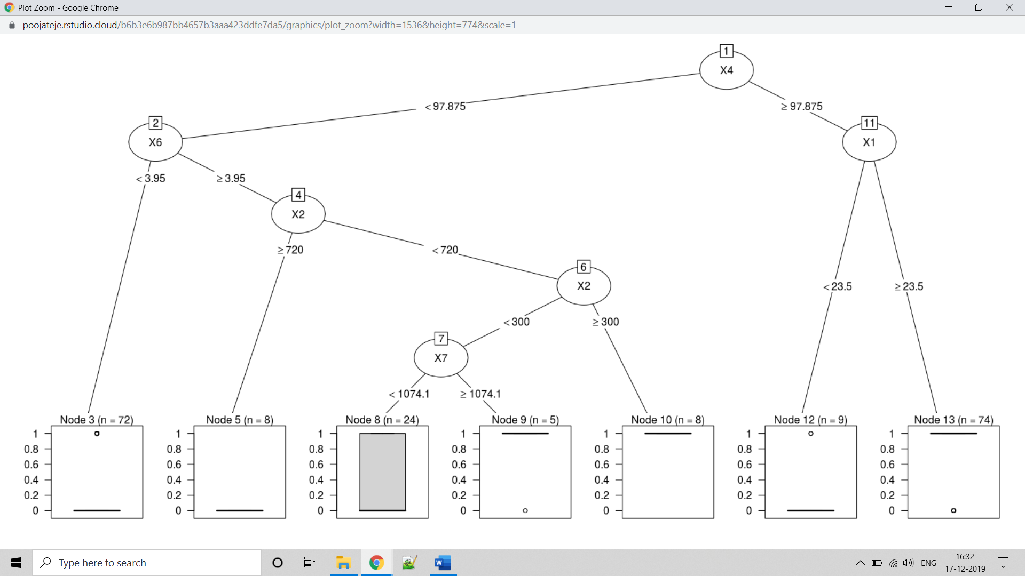

Accuracy for Decision tree using X & Y data for group 1: 0.817567567567568

|  |  |
| --- | --- |
| **Without handling null values** | **With handling null values** |
| Accuracy: 0.766891891891892 | Accuracy: 0.817567567567568 |
| n= 200  CP nsplit rel error xerror xstd  1 0.54081633 0 1.0000000 1.0612245 0.07209601  2 0.06122449 1 0.4591837 0.5510204 0.06406668  3 0.02040816 2 0.3979592 0.5000000 0.06206481 | n= 200  CP nsplit rel error xerror xstd  1 0.54081633 0 1.0000000 1.1632653 0.07144315  2 0.05102041 1 0.4591837 0.5714286 0.06479391  3 0.02721088 2 0.4081633 0.5306122 0.06329821  4 0.01020408 6 0.2959184 0.5204082 0.06289805 |