**Data Visualizations using ‘ggplot2’**

One variable

Continuous

1. geom_area

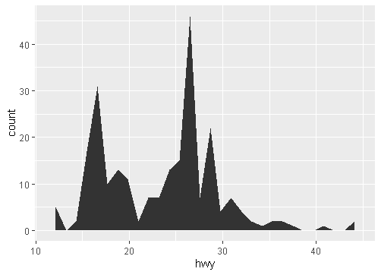

1. geom_density

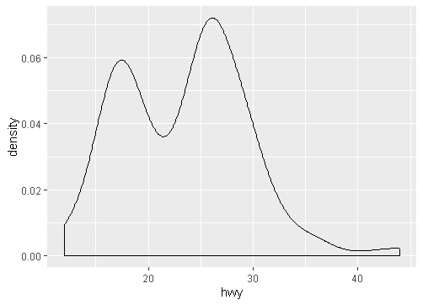

1. geom_dotplot

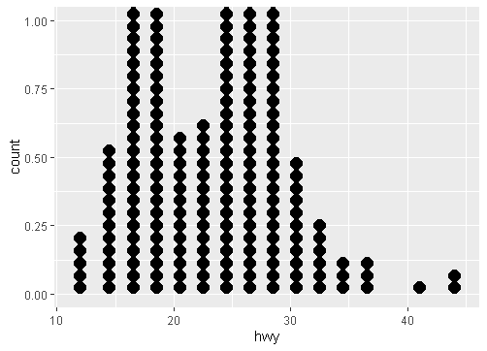

1. geom_freqpoly

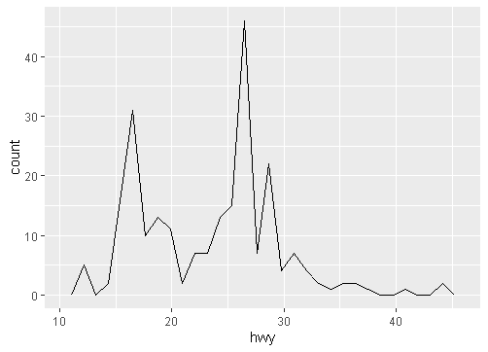

1. geom_histogram

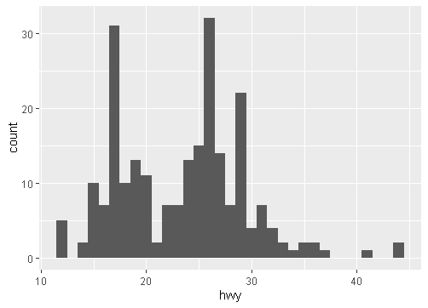

Discrete

1. geom_bar

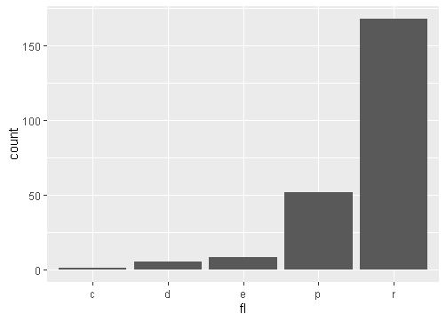

Graphical Primitives

1. geom_polygon

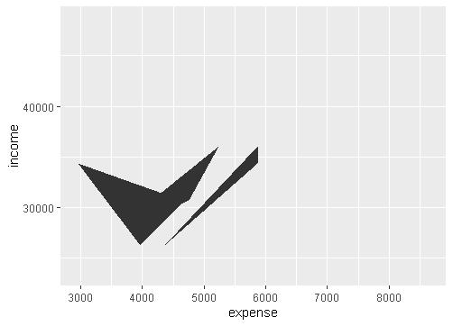

1. geom_path

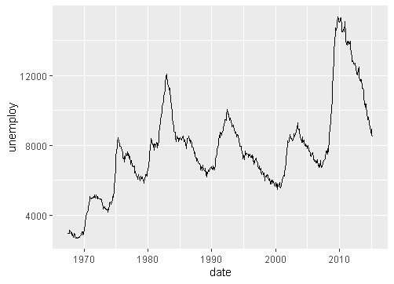

1. geom_ribbon

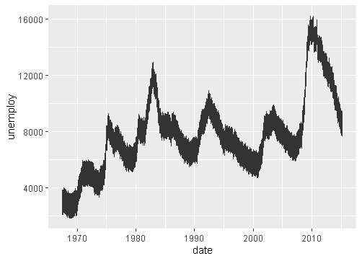

1. geom_segment

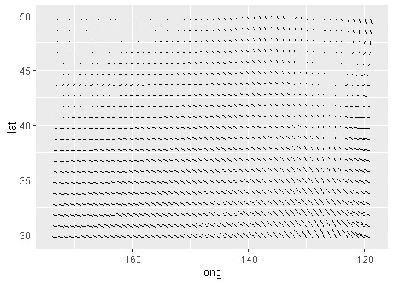

1. geom_rect

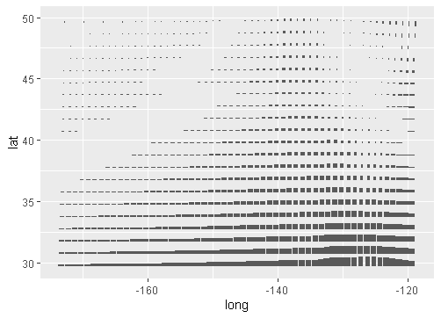

Two Variables

Continuous X, Continuous Y

1. geom_blank

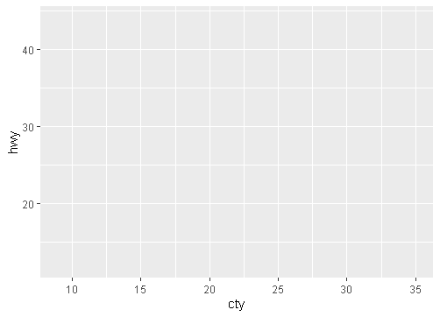

1. geom_jitter

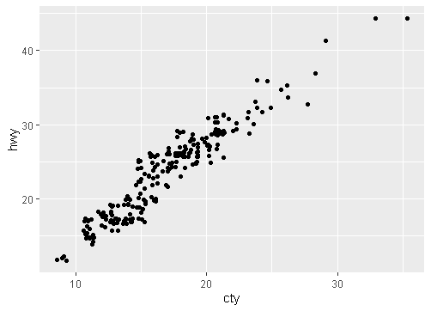

1. geom_point

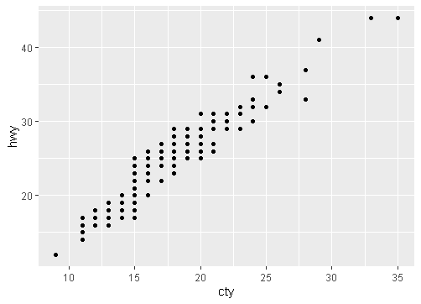

1. geom_quantile

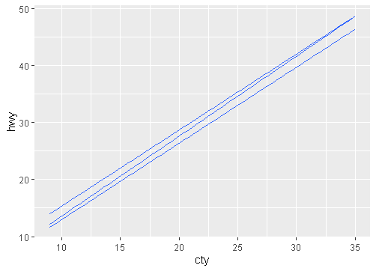

1. geom_rug

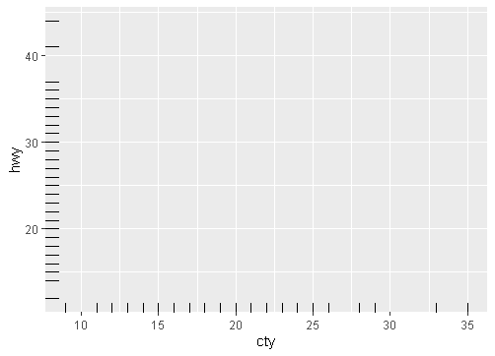

1. geom_smooth

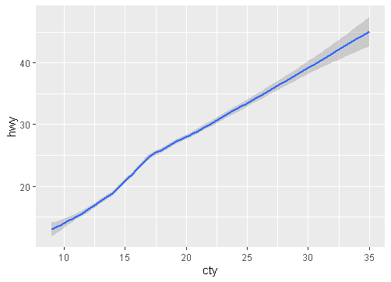

1. geom_text

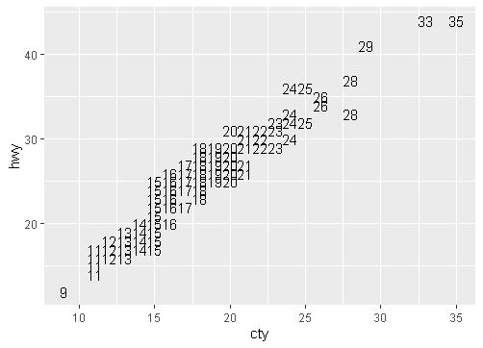

Discrete X, Continuous Y

1. geom_bar

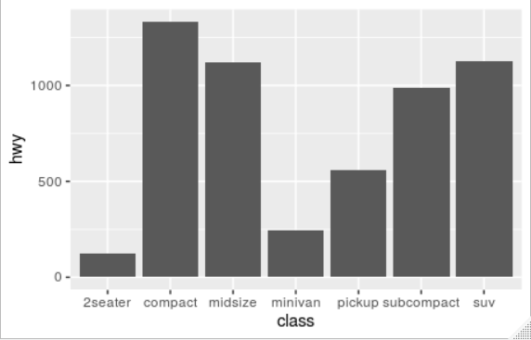

1. geom_boxplot

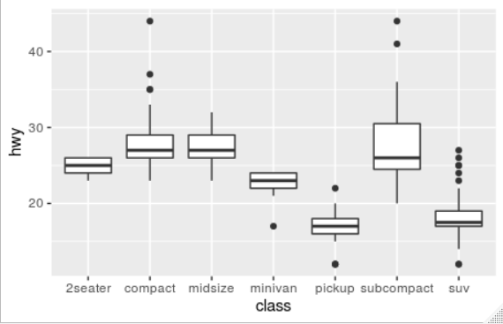

1. geom_dotplot

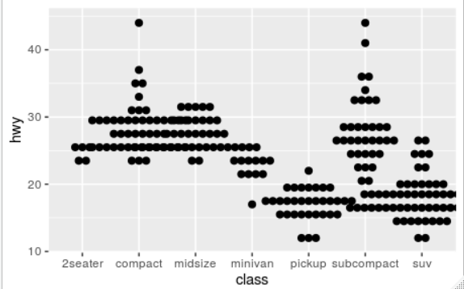

1. geom_violin

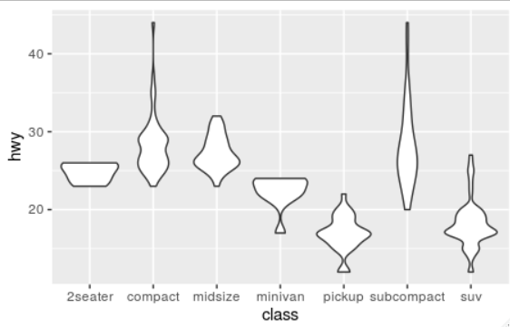

Discrete X, Discrete Y

1. geom_jitter

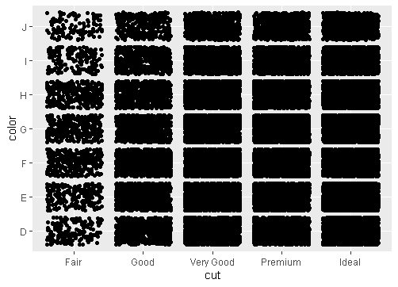

Continuous Bivariate Distribution

1. geom_bin2d

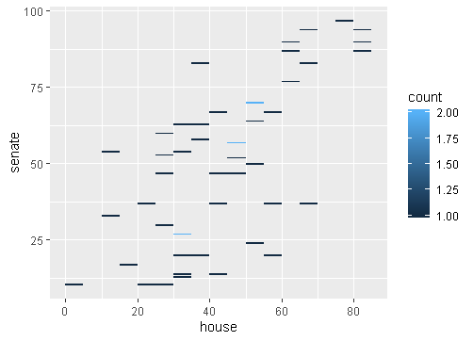

1. geom_density2d

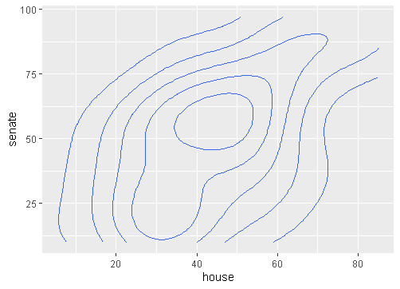

1. geom_hex

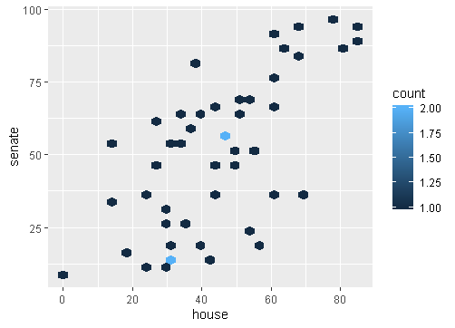

Continuous Function

1. geom_area

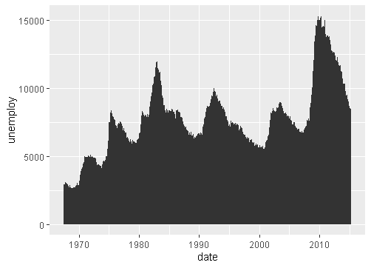

1. geom_line



1. geom_step

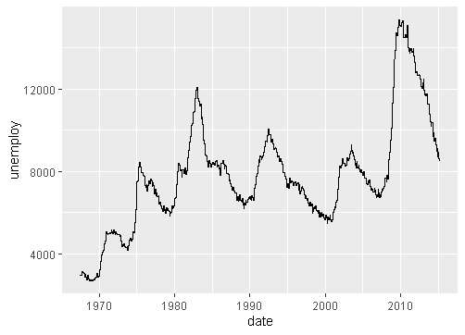

Visualizing error

1. geom_crossbar

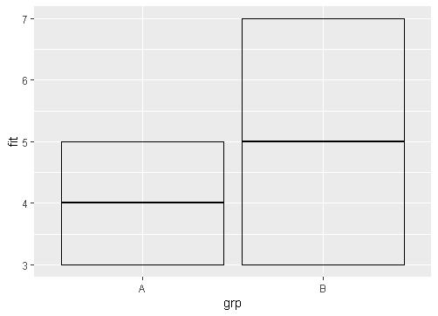

1. geom_errorbar

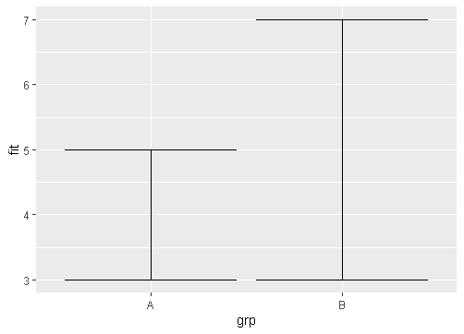

1. geom_linerange

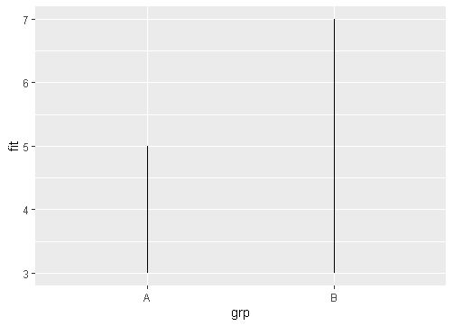

1. geom_pointrange

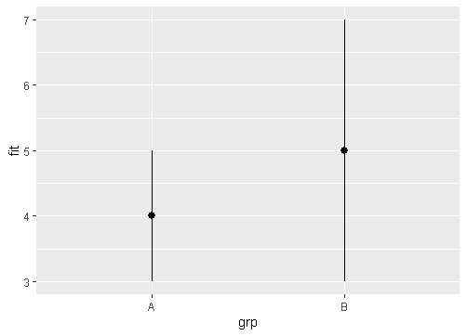

Maps

1. geom_map

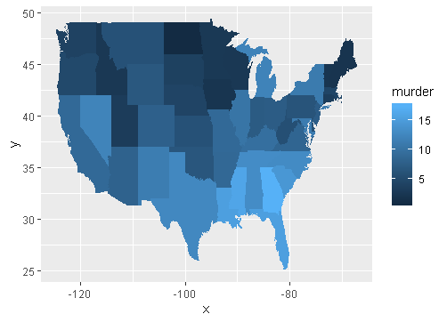

Three Variables

1. geom_contour

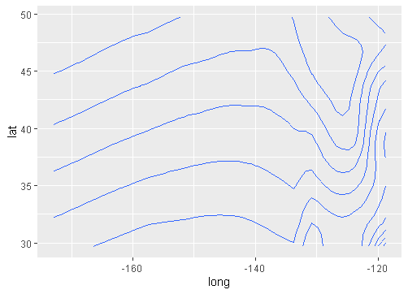

1. geom_raster

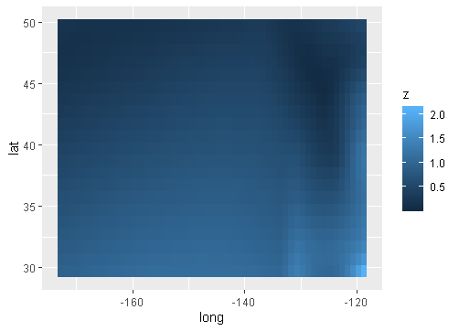

1. geom_tile

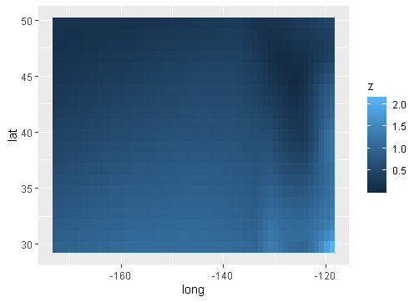

Scales

Discrete

1. scale_fill_brewer

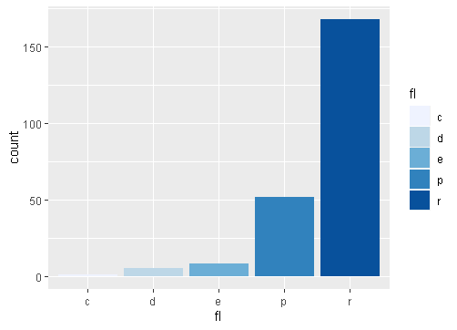

1. scale_fill_grey

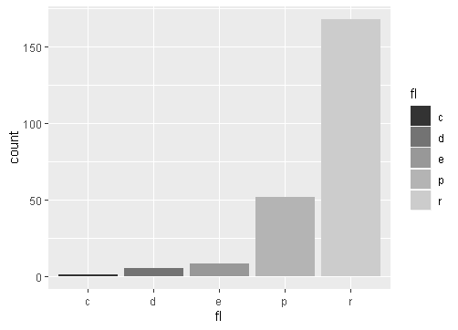

Continuous

1. scale_fill_gradient

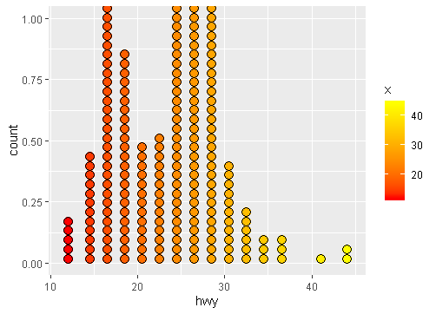

1. scale_fill_gradient2

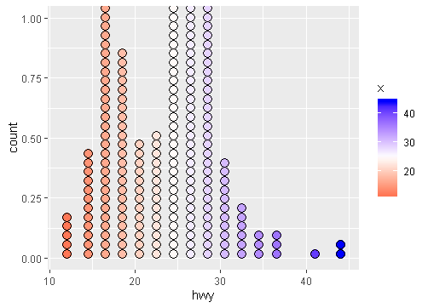

1. scale_fill_gradientn

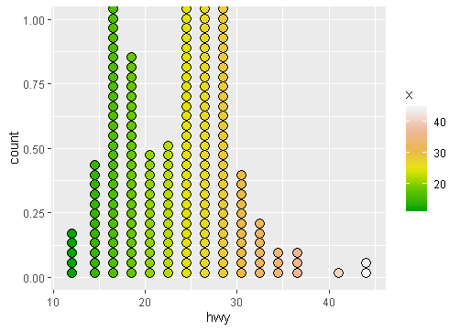

Shape scales

1. scale_shape

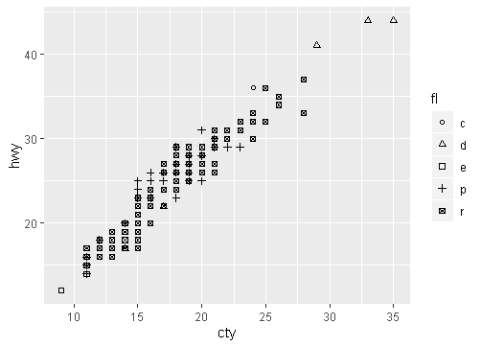

1. scale_shape_manual

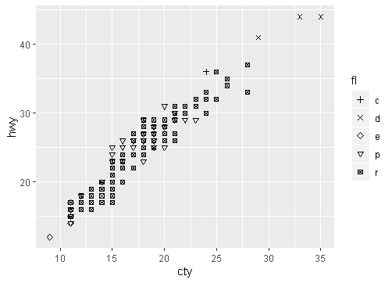

Size scales

1. scale_size_area

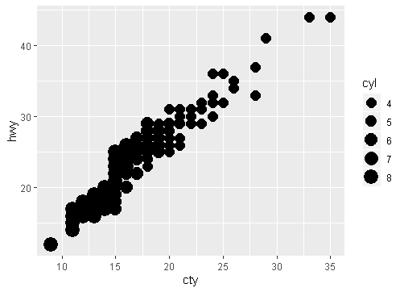

Coordinate Systems

1. coord_cartesian

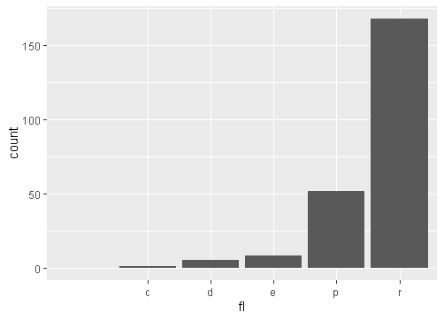

1. coord_fixed

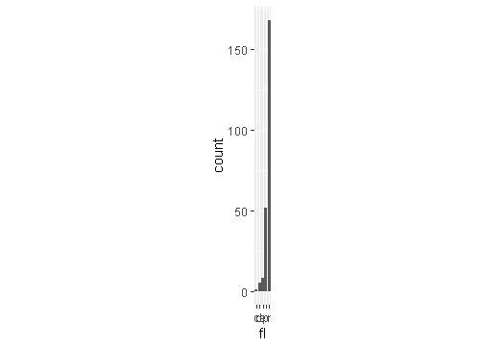

1. coord_flip

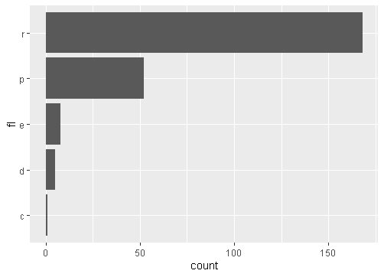

1. coord_polar

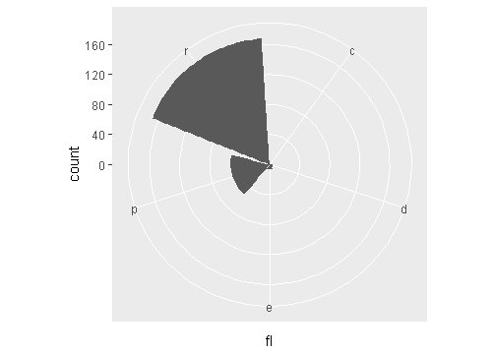

1. coord_trans

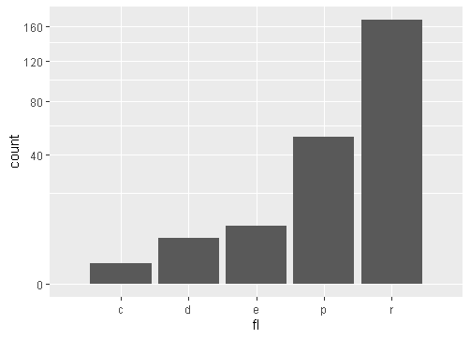

1. coord_map

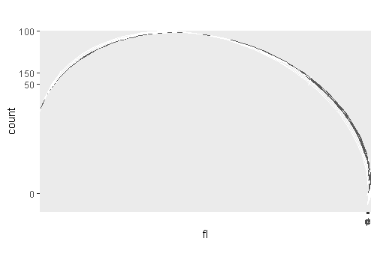

Position Adjustments

1. geom_bar(position = "dodge")

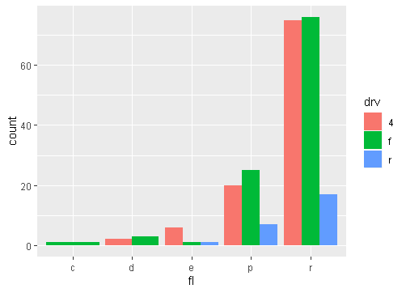

1. geom_bar(position = "fill")

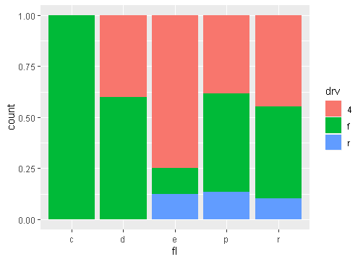

1. geom_bar(position = "stack")

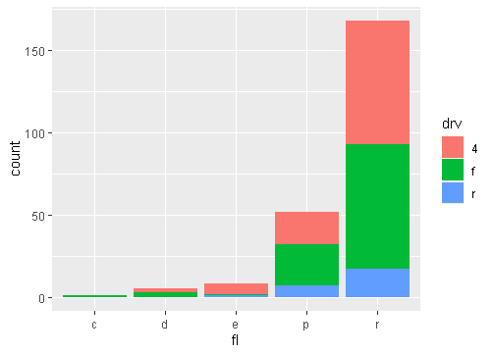

1. geom_point(position = "jitter")

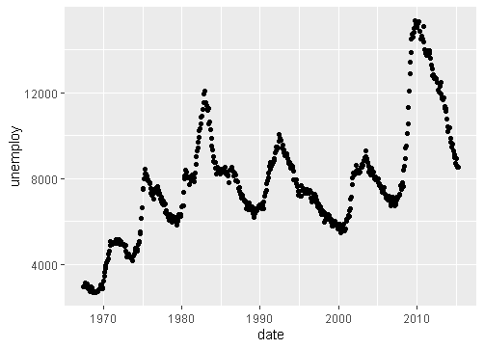

1. geom_bar(position = position_dodge(width = 1))

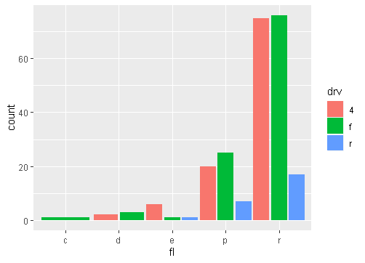

Themes

1. theme_bw

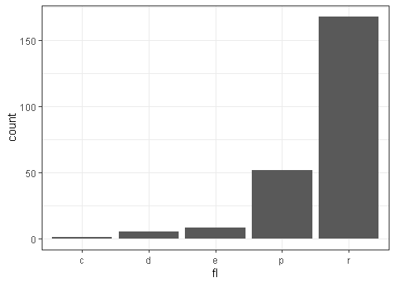

1. theme_grey



1. theme_classic

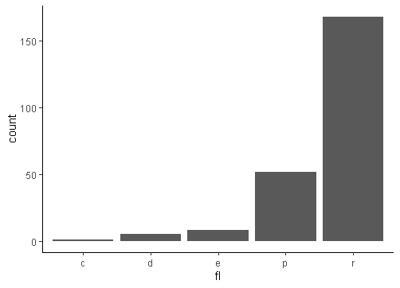

1. theme_minimal

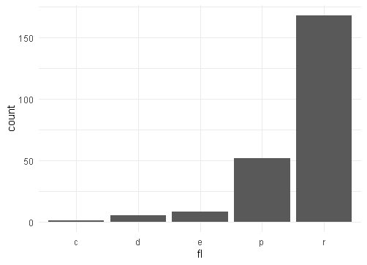

Faceting

1. facet_grid(. ~ fl)

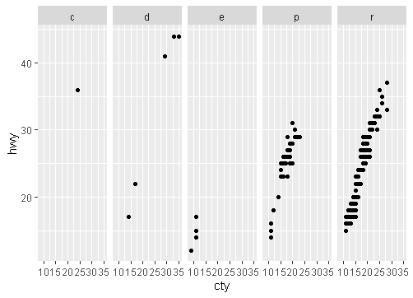

1. facet_grid(year ~ .)

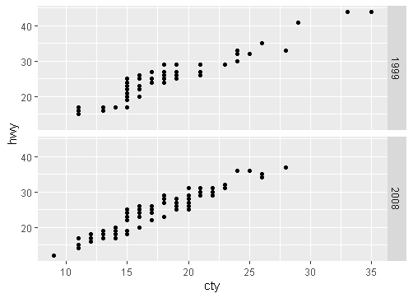

1. facet_grid(year ~ fl)

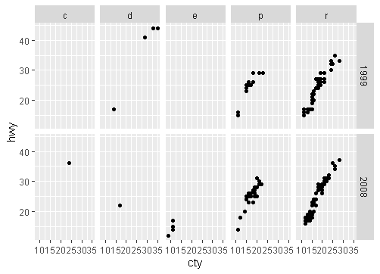

1. facet_wrap(~ fl)

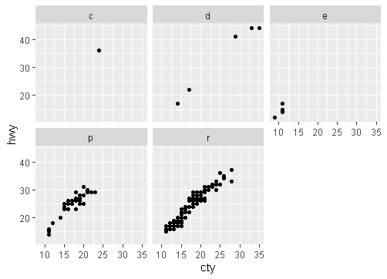

1. facet_grid(. ~ fl, labeller = label_both)

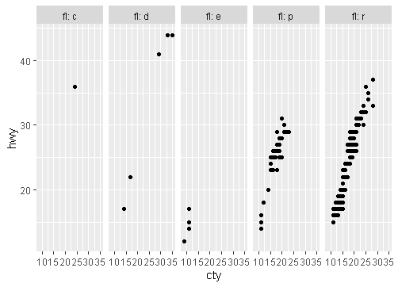

1. facet_grid(. ~ fl, labeller = label_bquote(alpha ^ .(x)))



1. facet_grid(. ~ fl, labeller = label_parsed) facet_grid

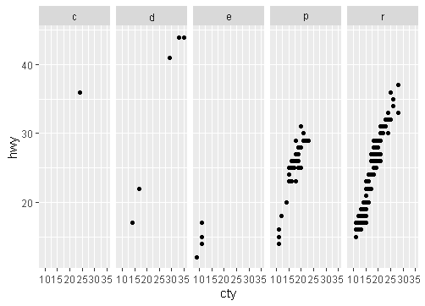

Labels

1. ggtitle

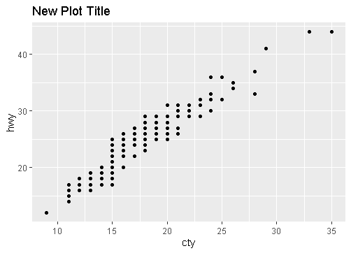

1. xlab

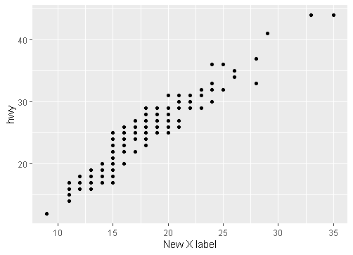

1. ylab

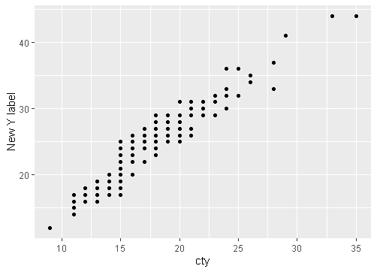

1. labs

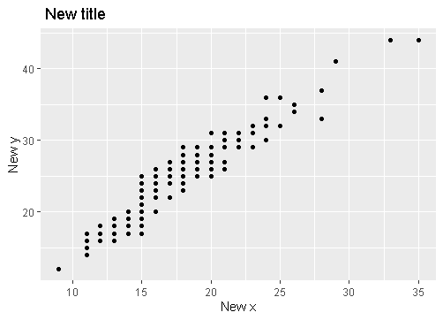

Legends

1. theme



1. guides



1. scale_fill_discrete



Zooming

1. coord_cartesian

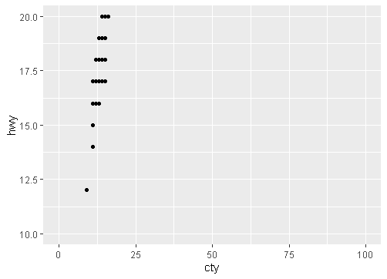

1. xlim



1. scale_x_continuous

