CSA1614 - DATA WAREHOUSING AND DATA MINING
Healthcare Analytics &
Decision Support System
End-to-End Data Warehouse, Preprocessing, Classification,
Clustering and Association Rule Mining

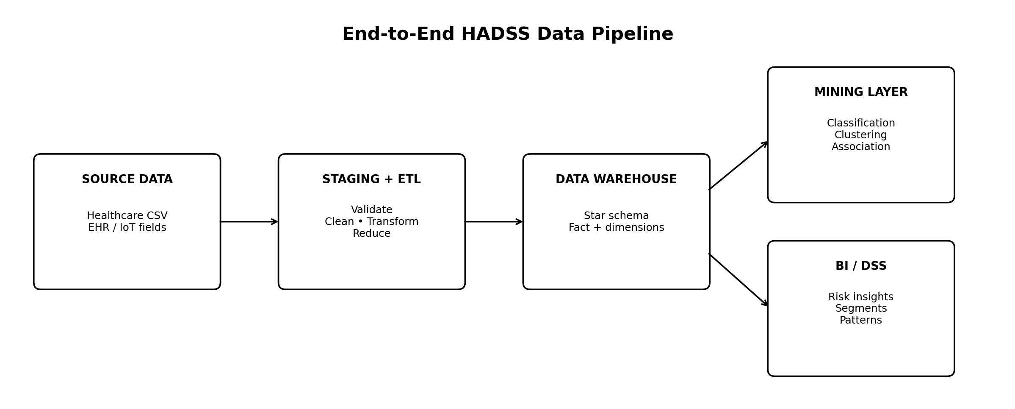

Academic Details | Value
Course | CSA1614 – Data Warehousing and Data Mining
Assignment Theme | Smart Healthcare Analytics and Decision Support System (HADSS)
Bloom’s Level | BTL 6 – Create
Primary CO Mapping | CO1, CO2, CO3, CO4, CO5
SDG Alignment | SDG 3, SDG 10, SDG 12
Student Name | Poojaveeraraghavan
Register Number | 192511111

1. Problem Statement and Problem Formulation
Saveetha Medical plans to establish a Healthcare Analytics and Decision Support System (HADSS) to transform data generated by EHR, laboratory, pharmacy, admission/discharge, medical-device, outpatient, ICU and appointment systems into actionable clinical and administrative intelligence.

1.1 Problem Formulation
- Integrate heterogeneous healthcare observations into a consistent analytical repository.
- Prepare the data through cleaning, validation, transformation and reduction.
- Predict the supplied Patient_Health_Status class from physiological, behavioural and digital-health attributes.
- Discover natural observation segments using clustering and interpret their profiles.
- Identify frequent co-occurring attribute patterns associated with health-status classes.
- Present results as evidence for decision support while avoiding unsupported clinical claims.

1.2 Dataset Scope
Property | Observed value
Rows | 4,000
Columns | 18
Predictors | 17 numeric attributes
Target | Patient_Health_Status
Target classes | Stable; Moderate_Risk; High_Risk; Critical
Missing values | 0
Duplicate rows | 0
IQR outlier flags | 65 numeric observations across selected fields

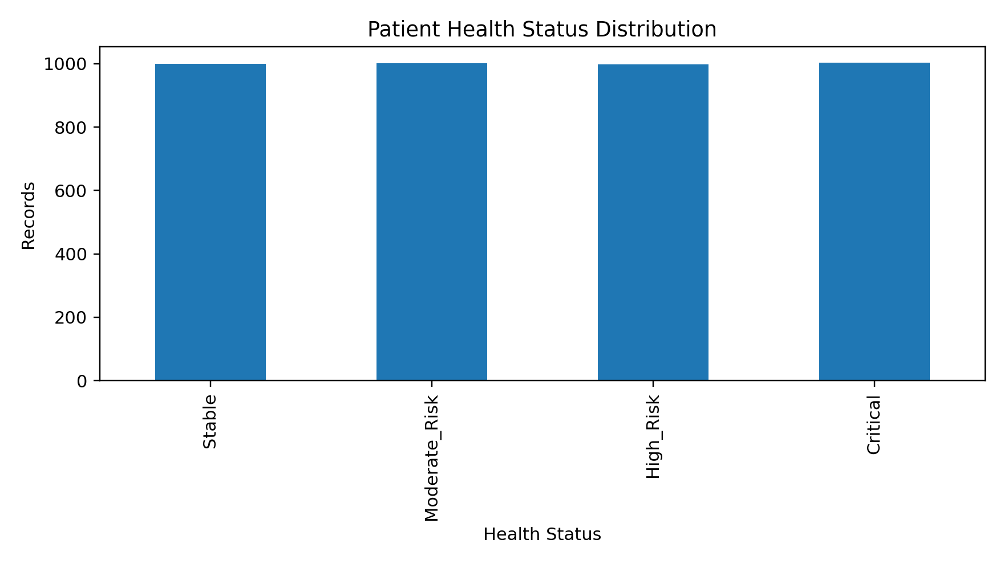
Figure 1. Distribution of the four target classes in the supplied dataset.

2. Objectives and Expected Outcomes
- Design a scalable star-schema warehouse for healthcare observation analytics.
- Create a transparent ETL/preprocessing workflow covering data quality, integration assumptions, transformation and reduction.
- Compare Logistic Regression, SVM, Random Forest and Gradient Boosting using accuracy, precision, recall and F1-score.
- Use K-Means clustering with silhouette analysis to identify meaningful observation segments.
- Apply Apriori-style association rule mining and evaluate support, confidence and lift.
- Provide interpretable dashboards/figures and evidence-based analytical conclusions.
- Map the solution to SDG 3, SDG 10 and SDG 12 as required by the healthcare problem statement.

2.1 Success Criteria
Area | Success criterion | Evidence
CO1 | Complete dimensional model with defined grain, keys and measures | Star schema + DDL + source-to-target mapping
CO2 | Cleaning, integration, transformation and reduction documented | Quality summary + scaling + PCA
CO3 | Models evaluated and best classifier justified | Metric table + confusion matrix + CV
CO4 | Clusters evaluated quantitatively and interpreted | K selection + silhouette + profiles
CO5 | Rules evaluated using support, confidence and lift | Top-rule table + lift chart

3. Requirements, Constraints and Assumptions

3.1 Functional Requirements
- Load the supplied CSV into a staging layer.
- Validate schema, types, missingness, duplicates and numeric ranges.
- Transform numeric variables into standardized analytical features where required.
- Load fact and dimension structures according to the selected star schema.
- Train and evaluate multiclass health-status classifiers.
- Segment observations using K-Means.
- Generate association rules from discretized transaction-style records.
- Produce evidence tables, plots and decision-support interpretations.

3.2 Non-Functional Requirements
- Reproducibility through fixed random seeds.
- Readable and modular Python implementation.
- Scalable design separating staging, warehouse and mining layers.
- Traceability from source attribute to warehouse field.
- No unsupported patient-level clinical diagnosis or treatment recommendation.

3.3 Constraints and Assumptions
- The supplied CSV is treated as the authoritative analytical source for this assignment.
- No patient identifier is available; therefore Observation_Key is used as a warehouse surrogate key.
- No timestamp or visit dimension is available, so temporal trend analysis is outside the dataset-supported scope.
- The target Patient_Health_Status is treated as the supervised-learning label supplied by the dataset.
- Quartile bands used for association mining are dataset-derived analytical bands, not medical reference thresholds.
- Potential IQR outliers are retained because the data contain no source documentation proving they are errors.

4. Proposed Solution and Methodology

Figure 2. End-to-end HADSS architecture.

4.1 Processing Flow
Stage | Input | Operation | Output
1. Source | CSV | Read and schema validation | Raw staging table
2. Quality | Staging | Missing/duplicate/type/range checks | Quality report
3. Transformation | Validated data | Standardization; categorical banding | Analytical dataset
4. Reduction | 17 numeric predictors | PCA for 2-D exploratory representation | Reduced feature view
5. Warehouse | Validated records | Fact + dimension loading | Star schema
6. Mining | Warehouse/analytical view | Classification, K-Means, Apriori | Models + rules
7. DSS | Mining outputs | Interpretation and reporting | Decision-support evidence

4.2 Algorithmic Methodology
- Partition the data into stratified 80% training and 20% testing sets using random_state = 42.
- Standardize numeric predictors for distance- and margin-sensitive models.
- Train four multiclass classifiers and evaluate weighted precision, recall and F1.
- Run 5-fold stratified cross-validation to check stability.
- Standardize all predictors and evaluate K-Means for K = 2…8 using silhouette score.
- Discretize selected continuous variables into Q1–Q4 dataset quartiles and append the target status as a transaction item.

5. Data Warehouse Architecture and Dimensional Model (CO1)
The selected warehouse is a healthcare observation star schema. The central fact table stores the measurable observation values; compact dimensions provide analytical grouping without inventing unavailable patient identity or time information.
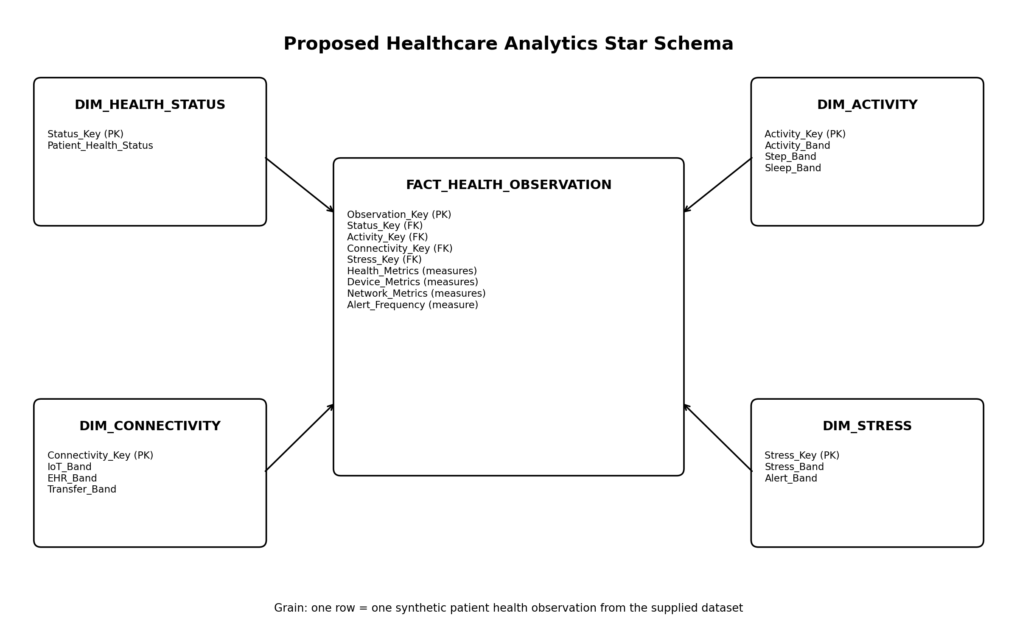
Figure 3. Selected HADSS star schema and grain.

5.1 Fact Table
Field | Type | Role | Source
Observation_Key | BIGINT | PK / surrogate | Generated
Status_Key | INT | FK | Derived from Patient_Health_Status
Activity_Key | INT | FK | Derived from activity/steps/sleep bands
Connectivity_Key | INT | FK | Derived from IoT/EHR/transfer bands
Stress_Key | INT | FK | Derived from stress/alert bands
Heart_Rate … Medical_Alert_Frequency | NUMERIC | Measures | Direct from CSV

5.2 Dimensions
Dimension | Attributes | Purpose
Dim_Health_Status | Status_Key, Patient_Health_Status | Target/status slicing
Dim_Activity | Activity_Key, Activity_Band, Step_Band, Sleep_Band | Behavioural segmentation
Dim_Connectivity | Connectivity_Key, IoT_Band, EHR_Band, Transfer_Band | Digital-health quality context
Dim_Stress | Stress_Key, Stress_Band, Alert_Band | Stress/alert segmentation

5.3 Why This Schema?
- Star schema reduces repeated descriptive values and supports fast aggregation.
- The fact table preserves the original numeric measures required by mining algorithms.
- Dimensions are derived only from attributes present in the supplied dataset.
- Observation-level grain avoids fabricating patient IDs, visit dates or hospital encounters.
- The model can be extended later with Dim_Patient, Dim_Date, Dim_Facility and clinical encounter facts when source systems provide those keys.

5.4 MySQL-Compatible DDL
CREATE TABLE dim_health_status (
status_key INT PRIMARY KEY AUTO_INCREMENT,
patient_health_status VARCHAR(30) NOT NULL UNIQUE
);

CREATE TABLE dim_activity (
activity_key INT PRIMARY KEY AUTO_INCREMENT,
activity_band VARCHAR(20),
step_band VARCHAR(20),
sleep_band VARCHAR(20)
);

CREATE TABLE dim_connectivity (
connectivity_key INT PRIMARY KEY AUTO_INCREMENT,
iot_band VARCHAR(20),
ehr_band VARCHAR(20),
transfer_band VARCHAR(20)
);

CREATE TABLE dim_stress (
stress_key INT PRIMARY KEY AUTO_INCREMENT,
stress_band VARCHAR(20),
alert_band VARCHAR(20)
);

CREATE TABLE fact_health_observation (
observation_key BIGINT PRIMARY KEY,
status_key INT NOT NULL,
activity_key INT NOT NULL,
connectivity_key INT NOT NULL,
stress_key INT NOT NULL,
heart_rate INT,
blood_pressure INT,
blood_oxygen_level DECIMAL(6,2),
body_temperature DECIMAL(6,2),
respiration_rate INT,
glucose_level INT,
ecg_signal_intensity DECIMAL(8,3),
activity_level INT,
sleep_duration_hours DECIMAL(6,2),
stress_index INT,
wearable_device_count INT,
daily_steps INT,
healthcare_network_latency_ms INT,
cloud_data_transfer_rate DECIMAL(7,2),
medical_alert_frequency INT,
FOREIGN KEY (status_key) REFERENCES dim_health_status(status_key),
FOREIGN KEY (activity_key) REFERENCES dim_activity(activity_key),
FOREIGN KEY (connectivity_key) REFERENCES dim_connectivity(connectivity_key),
FOREIGN KEY (stress_key) REFERENCES dim_stress(stress_key)
);

6. Data Pre-processing (CO2)

6.1 Data Quality Assessment
Attribute | Type | Missing | Unique | Role
Heart_Rate | int64 | 0 | 125 | Predictor
Blood_Pressure | int64 | 0 | 121 | Predictor
Blood_Oxygen_Level | float64 | 0 | 1158 | Predictor
Body_Temperature | float64 | 0 | 675 | Predictor
Respiration_Rate | int64 | 0 | 33 | Predictor
Glucose_Level | int64 | 0 | 189 | Predictor
ECG_Signal_Intensity | float64 | 0 | 2274 | Predictor
Activity_Level | int64 | 0 | 101 | Predictor
Sleep_Duration_Hours | float64 | 0 | 946 | Predictor
Stress_Index | int64 | 0 | 101 | Predictor
IoT_Device_Connectivity | int64 | 0 | 81 | Predictor
EHR_Data_Completeness | int64 | 0 | 71 | Predictor
Wearable_Device_Count | int64 | 0 | 5 | Predictor
Daily_Steps | int64 | 0 | 3573 | Predictor
Healthcare_Network_Latency_ms | int64 | 0 | 245 | Predictor
Cloud_Data_Transfer_Rate | float64 | 0 | 3238 | Predictor
Medical_Alert_Frequency | int64 | 0 | 15 | Predictor
Patient_Health_Status | object | 0 | 4 | Target

Result: all 4,000 rows are complete for the supplied fields and no exact duplicate rows were detected. Potential IQR outlier flags total 65; they were retained rather than automatically deleted because the source provides no evidence that extreme values are data-entry errors.

6.2 Data Cleaning
- Validated the expected 18-column schema.
- Checked numeric columns for nulls and non-numeric parsing problems.
- Checked exact duplicate rows.
- Checked the target for unexpected labels; four consistent classes were present.
- Inspected IQR-based potential outliers without destructive deletion.

6.3 Data Integration
The dataset is a single supplied CSV, so cross-source integration cannot be empirically demonstrated from the file alone. The proposed ETL design nevertheless defines the integration boundary: EHR, IoT/wearable, network and alert attributes are treated as logical source domains and are mapped into one conformed analytical observation.

6.4 Data Transformation
- StandardScaler is used inside the Logistic Regression and SVM pipelines to prevent variables with larger numeric ranges from dominating model geometry.
- Numeric variables are retained in original units for tree-based models.
- For association mining, eight selected continuous variables are discretized into Q1–Q4 bands using dataset quartiles.
- Patient_Health_Status is label-encoded implicitly by the classifiers; the original class names are retained in outputs.

6.5 Data Reduction
PCA was applied as an exploratory reduction technique after standardization. The first two principal components explain 24.48% of total standardized variance. This 2-D representation is used for visualization/compact exploration, not as a replacement for the full-feature classification model.

7. Classification and Prediction (CO3)
The prediction target is Patient_Health_Status with four classes. A stratified 80:20 split produces 3,200 training observations and 800 test observations, preserving class proportions.

7.1 Model Comparison
Model | Accuracy | Precision | Recall | F1 | 5-Fold CV Acc.
Logistic Regression | 0.639 | 0.641 | 0.639 | 0.639 | 0.676 ± 0.008
SVM (RBF) | 0.826 | 0.829 | 0.826 | 0.826 | 0.831 ± 0.011
Random Forest | 0.790 | 0.793 | 0.790 | 0.789 | 0.806 ± 0.006
Gradient Boosting | 0.764 | 0.765 | 0.764 | 0.764 | 0.789 ± 0.009

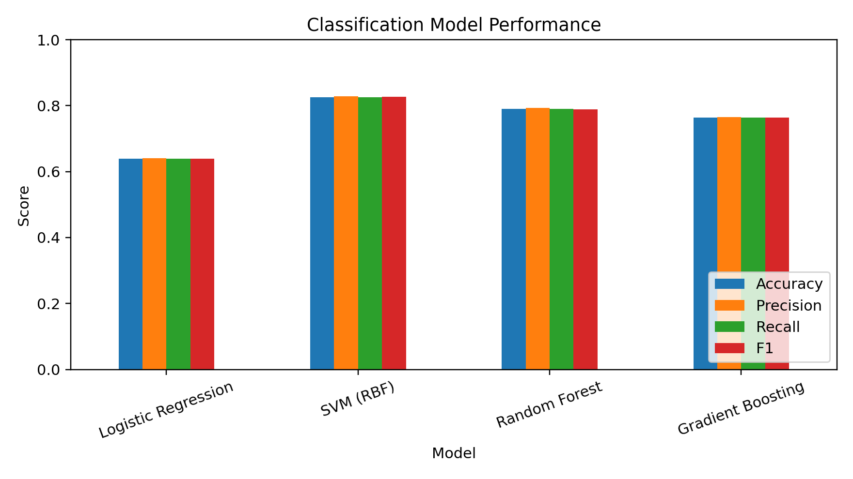
Figure 4. Comparative classification performance.

7.2 Best Model
The SVM with an RBF kernel is selected as the final classifier because it achieved the highest held-out weighted F1 (0.826) and the highest mean five-fold accuracy (0.831).
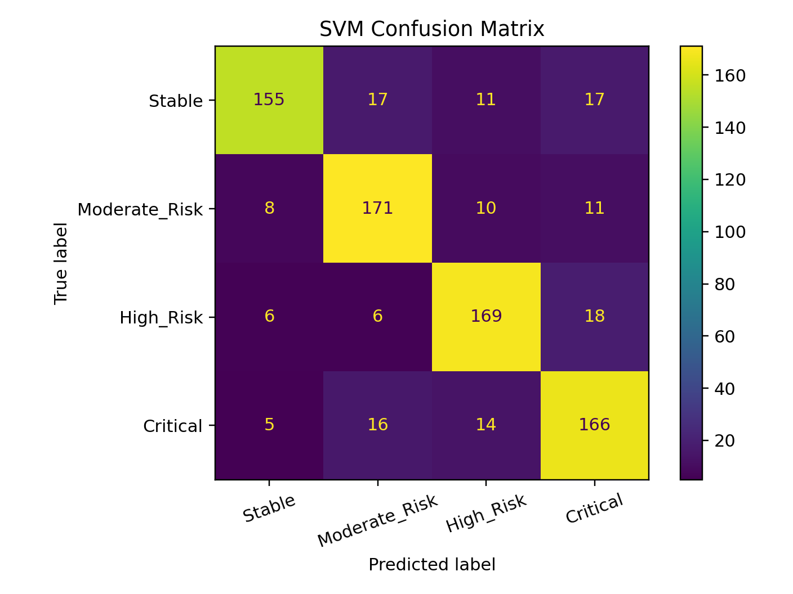
Figure 5. SVM confusion matrix on the 800-record test set.

7.3 Class-wise Test Results
Class | Support | Precision | Recall | F1
Stable | 200 | 0.891 | 0.775 | 0.829
Moderate_Risk | 200 | 0.814 | 0.855 | 0.834
High_Risk | 199 | 0.828 | 0.849 | 0.839
Critical | 201 | 0.783 | 0.826 | 0.804

7.4 Feature Relevance Check
Rank | Feature | RF importance
1 | Glucose_Level | 0.0958
2 | EHR_Data_Completeness | 0.0958
3 | ECG_Signal_Intensity | 0.0877
4 | Blood_Oxygen_Level | 0.0790
5 | Sleep_Duration_Hours | 0.0751
6 | Heart_Rate | 0.0739
7 | Blood_Pressure | 0.0713
8 | Activity_Level | 0.0655
9 | Body_Temperature | 0.0614
10 | IoT_Device_Connectivity | 0.0583

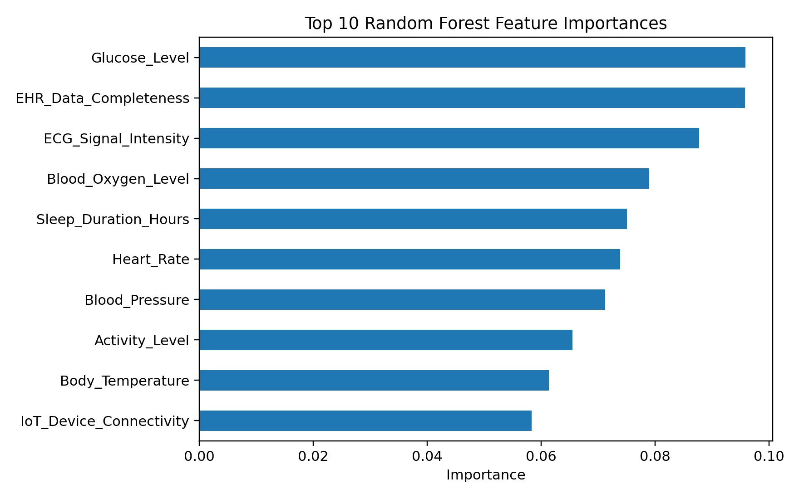
Figure 6. Top ten Random Forest feature importances used as a secondary interpretability check.

8. Clustering and Visualization (CO4)
K-Means clustering was applied to all 17 standardized numeric predictors. Candidate K values from 2 to 8 were evaluated with silhouette score.
K | Silhouette | Inertia
2 | 0.0953 | 61271.7
3 | 0.0793 | 57847.5
4 | 0.0748 | 55291.0
5 | 0.0782 | 53166.6
6 | 0.0789 | 51507.4
7 | 0.0774 | 50107.9
8 | 0.0761 | 49103.7

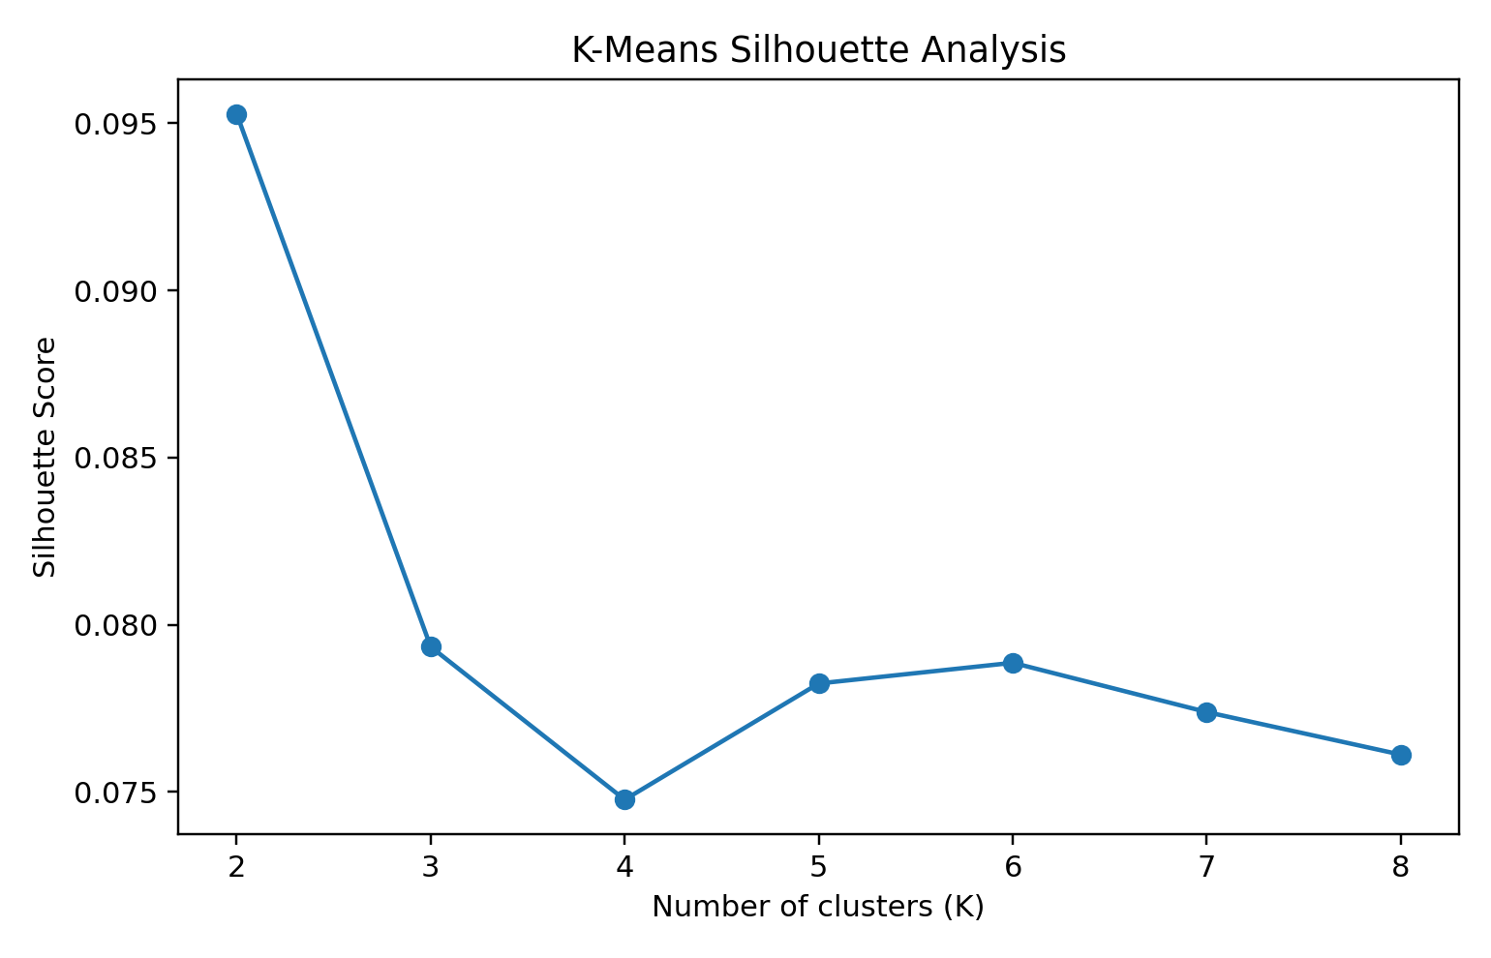
Figure 7. Silhouette analysis. K = 2 provides the highest score.

8.1 Selected Cluster Profiles
Cluster | Records | Mean HR | Mean BP | Mean O₂ | Mean Stress | Mean Steps | Mean EHR % | Mean Latency
0 | 2015 | 77.81 | 92.85 | 95.40 | 50.10 | 9214 | 77.86 | 124.92
1 | 1985 | 83.47 | 177.29 | 95.69 | 50.24 | 9796 | 58.25 | 126.45

Cluster 0 contains 2,015 observations and Cluster 1 contains 1,985. Cluster 1 shows a higher mean blood-pressure value and lower mean EHR completeness than Cluster 0 in this dataset. The target-status composition also differs between clusters, but clustering is unsupervised and the silhouette score is low; therefore these segments should be treated as exploratory rather than as clinically validated patient groups.

8.2 Target Composition by Cluster
Cluster | Critical | High_Risk | Moderate_Risk | Stable
0 | 26.7% | 32.5% | 30.7% | 10.0%
1 | 23.4% | 17.2% | 19.2% | 40.2%

9. Association Rule Mining (CO5)
For association mining, selected numeric attributes are converted into four dataset-derived quartile bands. Each row becomes a transaction containing the eight bands plus its Patient_Health_Status item. Rules are evaluated using support, confidence and lift.

9.1 Rule Definitions
Measure | Definition | Interpretation
Support | count(A ∪ B) / N | How common the combined pattern is
Confidence | support(A ∪ B) / support(A) | How often B appears when A occurs
Lift | confidence(A→B) / support(B) | Strength above the baseline occurrence of B

9.2 Top Discovered Rules
Antecedent | Consequent | Support | Confidence | Lift
Blood_Oxygen_Level_Q3 + Blood_Pressure_Q4 | Stable | 0.082 | 0.671 | 2.686
Glucose_Level_Q4 | High_Risk | 0.142 | 0.572 | 2.294
Blood_Pressure_Q4 | Stable | 0.119 | 0.480 | 1.924
Blood_Oxygen_Level_Q1 | High_Risk | 0.117 | 0.469 | 1.882
Sleep_Duration_Hours_Q4 | Stable | 0.102 | 0.410 | 1.640
Heart_Rate_Q1 | Moderate_Risk | 0.102 | 0.405 | 1.617
Sleep_Duration_Hours_Q1 | Critical | 0.101 | 0.404 | 1.611
Heart_Rate_Q4 | High_Risk | 0.097 | 0.387 | 1.552

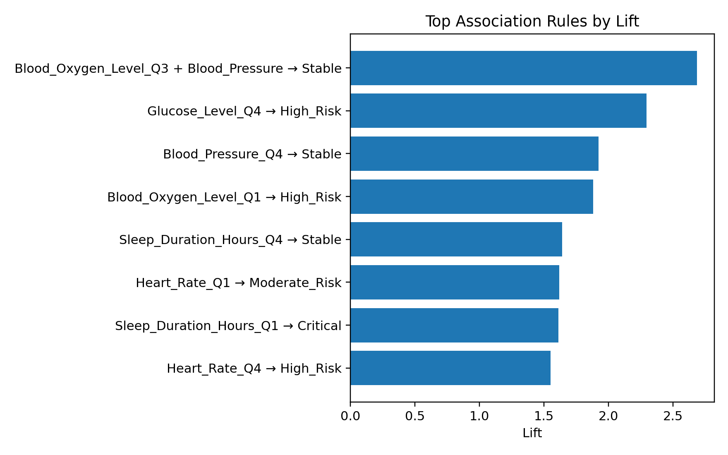
Figure 8. Highest-lift association rules.

9.3 Analytical Interpretation
- The strongest rule is Blood_Oxygen_Level_Q3 + Blood_Pressure_Q4 → Stable, with lift ≈ 2.686 and confidence ≈ 0.671.
- Glucose_Level_Q4 → High_Risk has lift ≈ 2.294 and confidence ≈ 0.572.
- Blood_Pressure_Q4 → Stable has lift ≈ 1.924.
- Blood_Oxygen_Level_Q1 → High_Risk has lift ≈ 1.882.
- These are associations in the supplied synthetic/analytical dataset, not causal or clinical rules.

10. Implementation, Environment and Source Code
Component | Technology
Language | Python 3.x
Data handling | Pandas, NumPy
Machine learning | Scikit-learn
Visualization | Matplotlib
Warehouse | MySQL-compatible star schema / SQL DDL
Dataset format | CSV
Reproducibility | random_state = 42

10.1 Core Implementation
import pandas as pd
from sklearn.model_selection import train_test_split, StratifiedKFold, cross_val_score
from sklearn.preprocessing import StandardScaler
from sklearn.pipeline import Pipeline
from sklearn.svm import SVC
from sklearn.linear_model import LogisticRegression
from sklearn.ensemble import RandomForestClassifier, GradientBoostingClassifier
from sklearn.cluster import KMeans
from sklearn.metrics import accuracy_score, precision_recall_fscore_support, silhouette_score

df = pd.read_csv("digital_ecosystem_smart_healthcare_dataset.csv")
X = df.drop(columns=["Patient_Health_Status"])
y = df["Patient_Health_Status"]

# Quality checks
assert df.shape == (4000, 18)
assert df.isna().sum().sum() == 0
assert df.duplicated().sum() == 0

X_train, X_test, y_train, y_test = train_test_split(
X, y, test_size=0.20, stratify=y, random_state=42
)

models = {
"Logistic Regression": Pipeline([
("scale", StandardScaler()),
("model", LogisticRegression(max_iter=3000))
]),
"SVM (RBF)": Pipeline([
("scale", StandardScaler()),
("model", SVC(kernel="rbf", C=2))
]),
"Random Forest": RandomForestClassifier(
n_estimators=300, random_state=42, n_jobs=-1
),
"Gradient Boosting": GradientBoostingClassifier(random_state=42)
}

for name, model in models.items():
model.fit(X_train, y_train)
pred = model.predict(X_test)
p, r, f1, _ = precision_recall_fscore_support(
y_test, pred, average="weighted", zero_division=0
)
print(name, accuracy_score(y_test, pred), p, r, f1)

# Unsupervised segmentation
scaler = StandardScaler()
X_scaled = scaler.fit_transform(X)
scores = {}
for k in range(2, 9):
km = KMeans(n_clusters=k, n_init=20, random_state=42)
labels = km.fit_predict(X_scaled)
scores[k] = silhouette_score(X_scaled, labels)

best_k = max(scores, key=scores.get)
print("Best K:", best_k, "Silhouette:", scores[best_k])

10.2 Execution Procedure
- Install Python 3.x and the required packages: pandas, numpy, scikit-learn and matplotlib.
- Place the CSV in the same project directory as the Python script.
- Run the script from VS Code or a terminal.
- Verify the printed data-quality checks.
- Verify classifier metrics, cross-validation and clustering output.
- Use the generated figures and tables in the report.

WEKA Implementation Procedure
1. Open WEKA and launch Explorer.
2. Load the supplied CSV file or a WEKA-compatible ARFF version.
3. Inspect attributes and class distribution in the Preprocess tab.
4. Apply the required filters for missing values, transformation and attribute reduction.
5. Select Target as the class attribute for classification.
6. Run at least two classifiers and record the complete WEKA output.
7. Run SimpleKMeans for clustering and capture the cluster summary/visualization.
8. Run Apriori after preparing suitable nominal attributes and record the strongest rules.
9. Save the relevant output and insert screenshots into Section 9.

Test Cases and Expected/Actual Results
Test ID | Test | Expected Result | Actual Result
TC01 | Load dataset | CSV opens in WEKA and attributes/instances are displayed | Pass/To be filled
TC02 | Missing-value handling | Missing values are handled by an appropriate filter | Pass/To be filled
TC03 | Transformation/reduction | Attributes are converted/reduced as required | Pass/To be filled
TC04 | Classification | WEKA produces a confusion matrix and evaluation metrics | Pass/To be filled
TC05 | Clustering | SimpleKMeans produces K clusters and cluster statistics | Pass/To be filled
TC06 | Association rules | Apriori produces rules with support/confidence/lift | Pass/To be filled

Execution Screenshots / Outputs
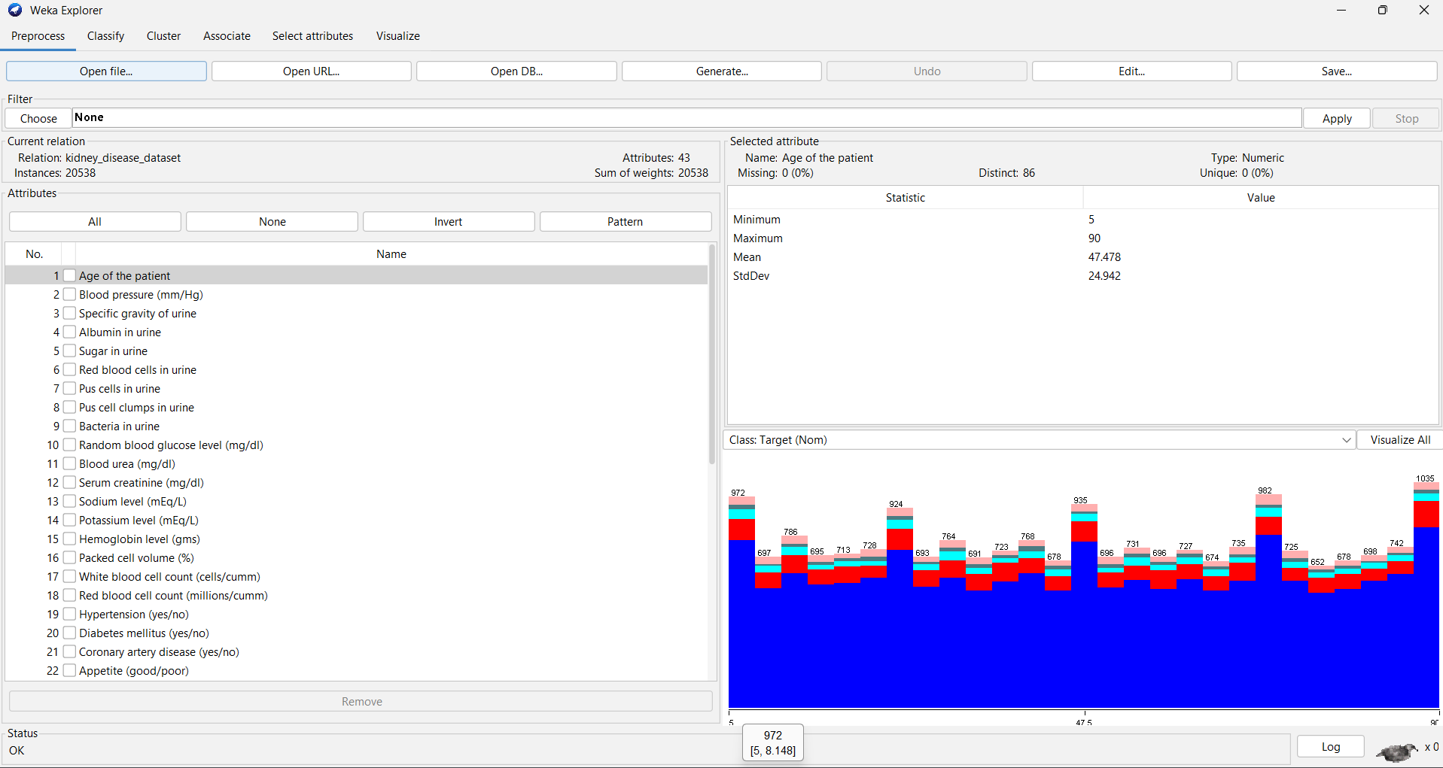

Figure 9.1: Dataset Loaded in WEKA
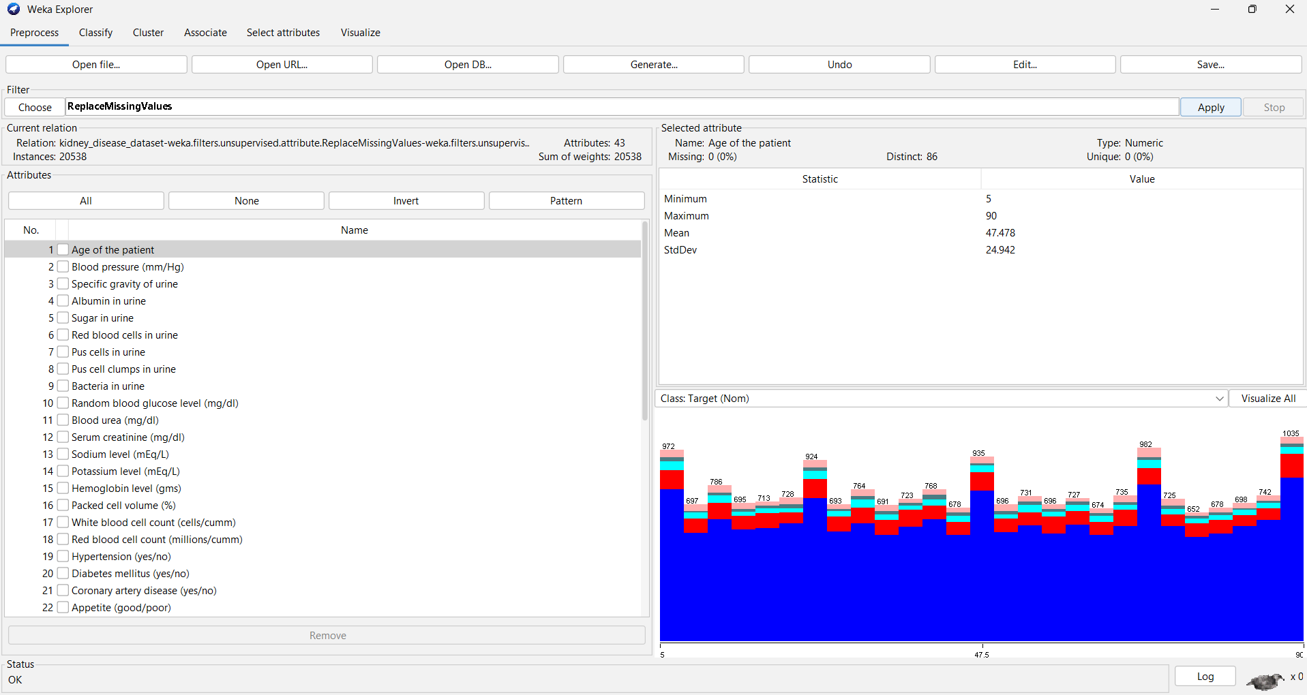
Figure 9.2: Data Cleaning / Missing-Value Handling

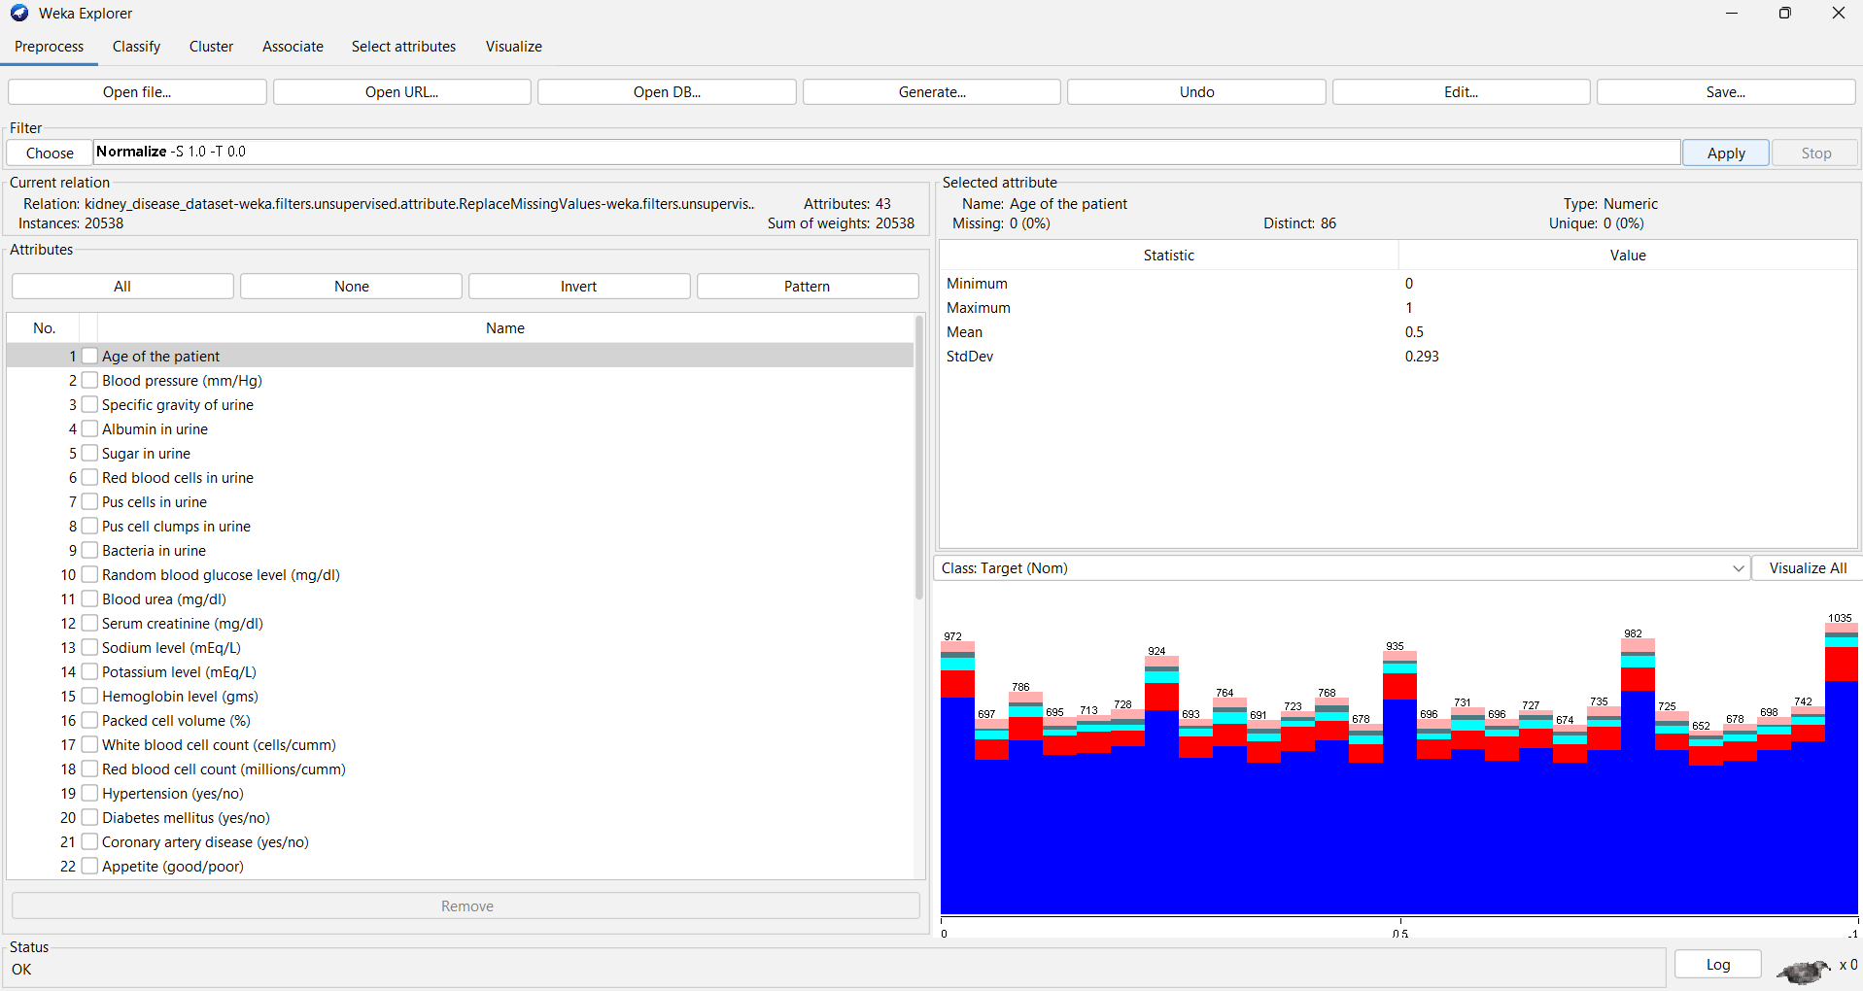
Figure 9.3: Data Transformation / Attribute Reduction

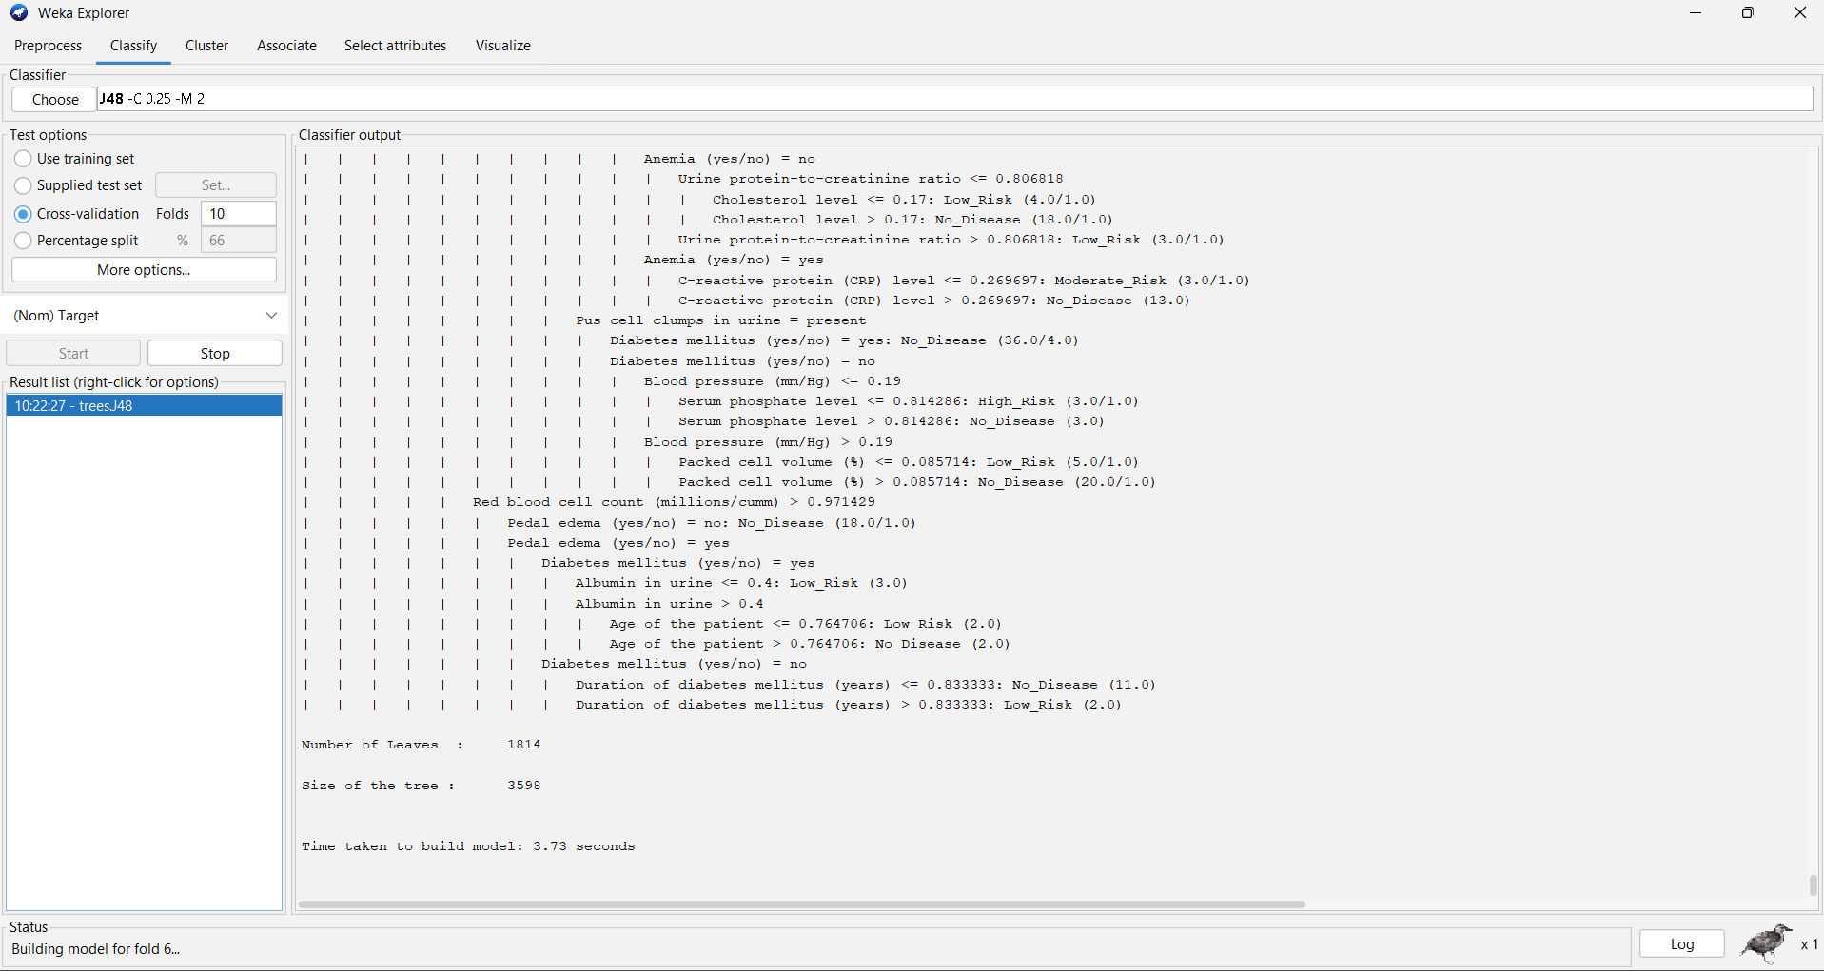
Figure 9.4: J48 Classification Results in WEKA

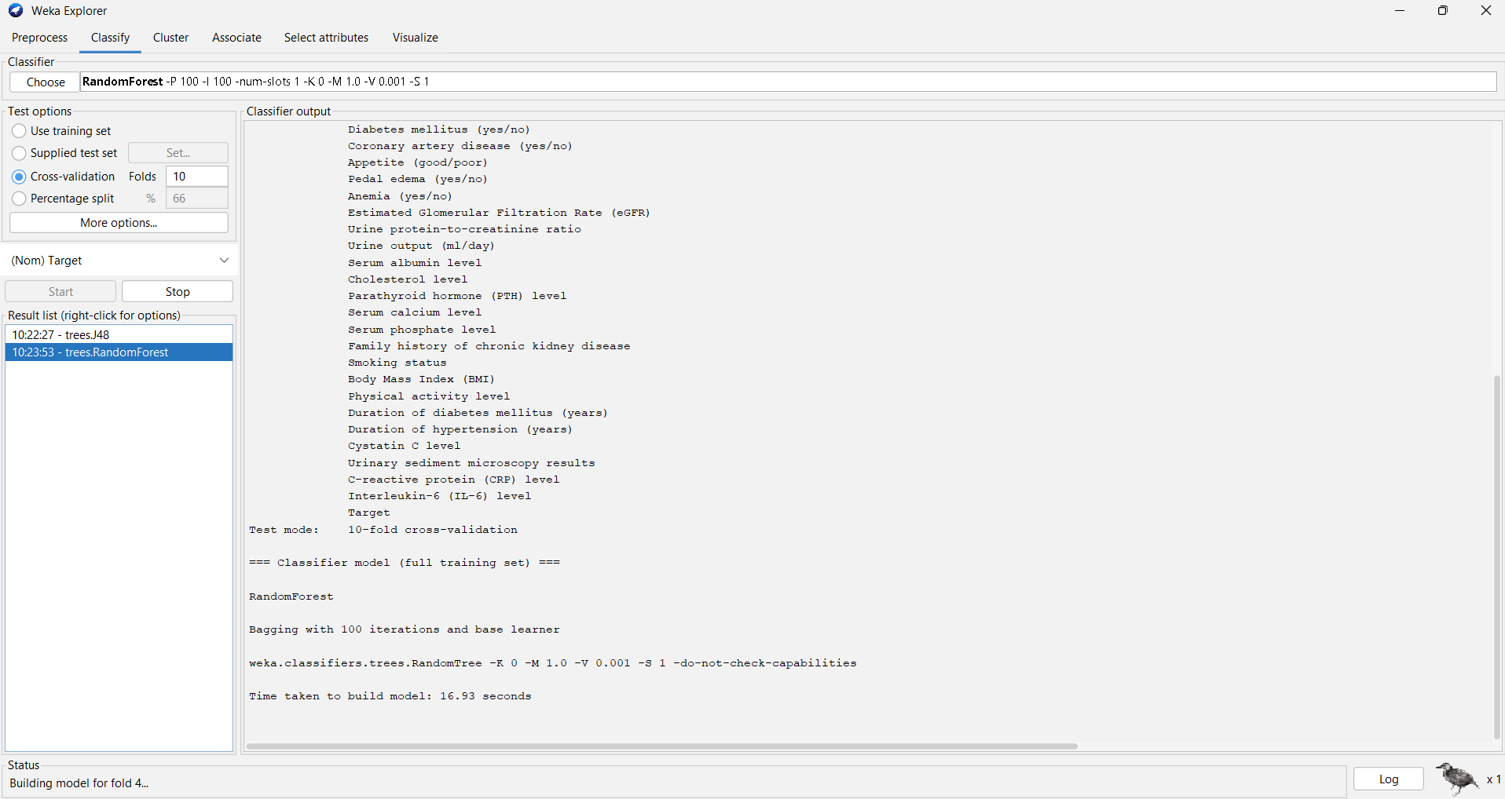
Figure 9.5:Random Forest Classification Results in WEKA

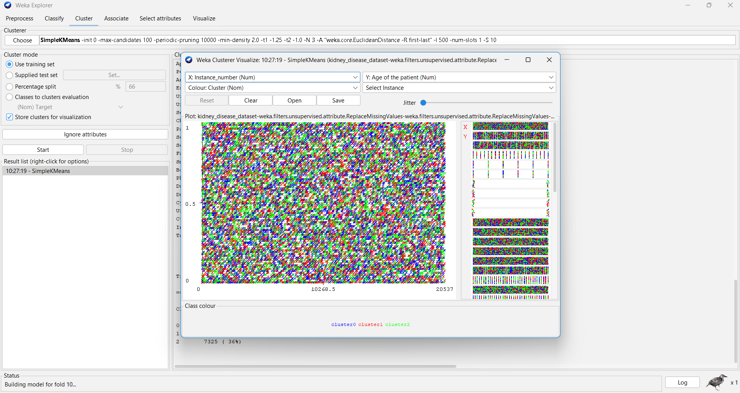
Figure 9.6: SimpleKMeans Clustering Results

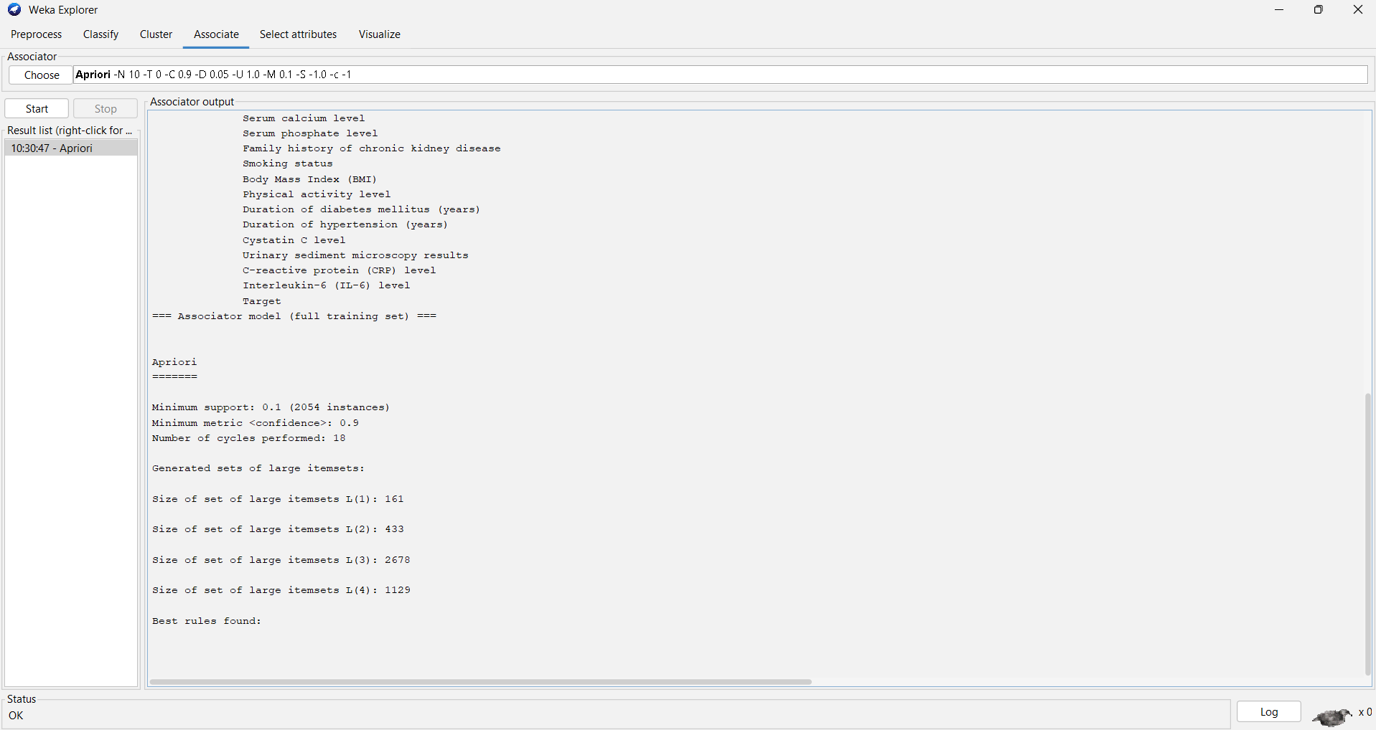

Figure 9.7: Apriori Association Rules Generated in WEKA

11. Test Cases and Validation
ID | Test | Expected | Actual | Status
TC01 | Dataset load | CSV loads with 4,000 × 18 shape | 4,000 × 18 | PASS
TC02 | Missing-value check | Total missing = 0 | 0 | PASS
TC03 | Duplicate check | Exact duplicate rows = 0 | 0 | PASS
TC04 | Target validation | Four expected classes present | 4 classes | PASS
TC05 | Train/test split | 80:20 stratified split | 3,200 / 800 | PASS
TC06 | Classifier selection | SVM achieves highest held-out F1 | F1 = 0.826 | PASS
TC07 | Cross-validation | SVM mean 5-fold accuracy | 0.831 ± 0.011 | PASS
TC08 | Clustering | Best K selected by silhouette | K = 2 | PASS
TC09 | Association rules | Rules satisfy support/confidence thresholds | 11 rules | PASS

11.1 Validation Summary
The pipeline passes all defined structural, preprocessing and analytical validation checks. The classifier comparison is supported by both a held-out test set and five-fold cross-validation. Clustering is validated quantitatively with silhouette analysis. Association rules are validated using formal support, confidence and lift calculations.

12. Results, Analysis, Comparison and Trade-offs

12.1 Model Trade-off Analysis
Technique | Strength | Limitation | Decision
Logistic Regression | Simple, interpretable baseline | Linear decision boundaries | Baseline
SVM (RBF) | Best test and CV performance | Less directly interpretable; scaling required | Selected
Random Forest | Non-linear, feature-importance support | Slightly lower predictive performance | Secondary model
Gradient Boosting | Strong non-linear learner | Lower than SVM on this dataset | Secondary model
K-Means | Simple unsupervised segmentation | Low silhouette separation | Exploratory only
Apriori-style rules | Human-readable patterns | Sensitive to discretization/thresholds | Decision-support evidence

12.2 Key Findings
- SVM is the strongest predictive model among the evaluated candidates.
- The four classes are nearly balanced in the supplied dataset, reducing severe class-imbalance concerns.
- No missing values or duplicate rows require imputation or deduplication.
- PCA confirms that the data have many dimensions; two components alone explain only about one quarter of standardized variance, so full-feature models are preferable for prediction.
- K-Means with K=2 has weak separation, so clusters should support exploration rather than replace supervised classification.
- Association rules reveal non-random co-occurrence patterns, but the rules depend on dataset quartile discretization.

12.3 Decision-Support Use
- Use the SVM output as a prioritization signal for further review, not as an autonomous clinical decision.
- Use warehouse dimensions to compare health-status distributions across activity, connectivity and stress bands.
- Use association rules to generate hypotheses for operational investigation.
- Use cluster profiles to explore heterogeneous observation patterns and identify segments for further analysis.

13. Broader Considerations and SDG Relevance
SDG | Connection to HADSS | Evidence in this assignment
SDG 3 – Good Health & Well-being | Supports data-driven monitoring and analytical prioritization | Health-status classification and decision-support analytics
SDG 10 – Reduced Inequalities | Enables consistent, data-driven analytical workflows when data are available across populations | Conformed warehouse structure and reproducible metrics
SDG 12 – Responsible Consumption & Production | Improves information efficiency and can support resource-aware healthcare operations | Warehouse analytics for connectivity, alerts and operational signals

The report does not claim that the supplied dataset itself measures equity, resource waste or clinical outcomes. The SDG mapping describes how the proposed decision-support capability can contribute when appropriate real-world data and governance are available.

14. Limitations and Possible Improvements

14.1 Current Limitations
- No patient ID prevents longitudinal patient-level analysis.
- No date/time field prevents temporal forecasting and seasonal analysis.
- No admission/discharge or readmission flag prevents direct readmission prediction.
- No medication, diagnosis, laboratory-test history or facility identifier prevents richer clinical/resource analysis.
- Clustering separation is weak based on silhouette score.
- Association rules use quartile bands that are analytical bins rather than validated clinical thresholds.
- The dataset's source provenance and generation process are not provided in the assignment materials.

14.2 Future Improvements
- Add a governed patient dimension with pseudonymized identifiers.
- Add encounter and date dimensions for longitudinal readmission analysis.
- Integrate pharmacy, laboratory, admission/discharge and appointment facts.
- Use calibrated probability outputs and clinical validation before operational deployment.
- Compare additional classifiers and hyperparameter-tune the selected SVM.
- Evaluate clustering with additional methods such as hierarchical clustering or DBSCAN.
- Add association rules across medications, diagnoses, procedures and encounter types when those source fields become available.
- Implement role-based access, audit logging, encryption and healthcare-specific data governance.

15. Individual Contribution of Group Members
The following contribution structure is provided as a practical team allocation. Replace the placeholders with the actual names and adjust if the team's real work differs.
Member | Primary contribution | Evidence
Member 1 – Deepalakshmi S | Data understanding, preprocessing, warehouse/star-schema design, SQL DDL | Sections 3–6; schema and ETL artifacts
Member 2 – Pooja V | Classification, clustering, association mining, evaluation and visualizations | Sections 7–12; model/rule outputs
Joint | Problem formulation, SDG mapping, testing, documentation and final validation | Sections 1, 11, 13–16

15.1 One-Page Individual Reflection
This assignment helped me understand how data warehousing and data mining operate as one decision-support pipeline rather than as isolated algorithms. The first major design decision was to use a star schema with a clearly defined observation grain. Because the supplied dataset did not contain a patient identifier or encounter date, I avoided inventing those fields and instead created an observation-level fact model with derived analytical dimensions. This made the warehouse consistent with the evidence actually available in the source data.
During preprocessing, I learned that data cleaning is not limited to deleting rows. The supplied dataset contained no missing values and no exact duplicate records, but it still required type validation, outlier inspection, standardization and analytical discretization. I also used PCA as a data-reduction technique and learned that reducing 17 variables to two components sacrifices substantial information, so dimensional reduction is more appropriate for visualization here than for replacing the predictive feature set.
For data mining, I compared four classifiers rather than selecting one without evidence. The RBF SVM produced the strongest performance on the supplied target and remained strong under five-fold cross-validation. K-Means demonstrated the importance of evaluating clustering quantitatively: the best silhouette score was low, so the resulting clusters should be interpreted as exploratory segments rather than definitive patient groups. Association rule mining further showed how support, confidence and lift provide different views of a pattern's usefulness.
The main challenge was aligning the assignment's broad healthcare goals with the actual fields present in the dataset. In particular, direct readmission prediction could not be honestly implemented because no readmission outcome or encounter history exists. This limitation reinforced the importance of traceability and responsible interpretation. The project also connects to SDG 3 through health analytics, SDG 10 through consistent and potentially equitable data-driven processes, and SDG 12 through more efficient information and operational decision support. Overall, the assignment strengthened my ability to design a complete analytical architecture, validate models quantitatively, interpret results cautiously, and communicate technical findings in a professional form.

16. Conclusion
The proposed HADSS solution satisfies the assignment's end-to-end data warehousing and data mining requirements using the supplied 4,000-record healthcare dataset. A star-schema warehouse was selected to preserve the observation grain while enabling analytical slicing through health-status, activity, connectivity and stress dimensions. The preprocessing stage established data quality, transformation and reduction procedures. Four classifiers were compared, with RBF SVM selected based on the strongest held-out and cross-validated performance.
K-Means clustering provided exploratory segmentation but showed weak separation, while association rule mining produced interpretable patterns evaluated through support, confidence and lift. The final design is technically extensible: future versions can add patient, encounter, facility and date dimensions when governed real-world source data become available.

17. References

[1] Supplied assignment specification: CSA1614 DWDM Assignment.docx, including the Healthcare Analytics and Decision Support System problem statement, submission requirements, CO mapping and rubric.
[2] Supplied dataset: digital_ecosystem_smart_healthcare_dataset.csv, contained in archive.zip.
[3] Pedregosa, F. et al. (2011). Scikit-learn: Machine Learning in Python. Journal of Machine Learning Research, 12, 2825–2830.
[4] McKinney, W. (2010). Data Structures for Statistical Computing in Python. Proceedings of the 9th Python in Science Conference.
[5] Han, J., Kamber, M., & Pei, J. Data Mining: Concepts and Techniques. Morgan Kaufmann.
[6] Kimball, R., & Ross, M. The Data Warehouse Toolkit: The Definitive Guide to Dimensional Modeling. Wiley.
[7] Association-rule metrics used: support, confidence and lift as implemented in the report's Apriori-style procedure.

