VELALAR COLLEGE OF ENGINEERING AND TECHNOLOGY
Erode – 638012
Department of Computer Science and Engineering
25CST31 – DATABASE MANAGEMENT SYSTEMS
ASSIGNMENT – 3
SQL Query Practice

Student Name: POOJASHREE V
Register Number: 732925CSR111
Course Code:25CST31
Course Name: Database Management Systems
Assignment Title: SQL Query Practice
Date of Assignment: 07.09.2026
Date of Submission: 11.09.2026

• Display all records from the Employee table.
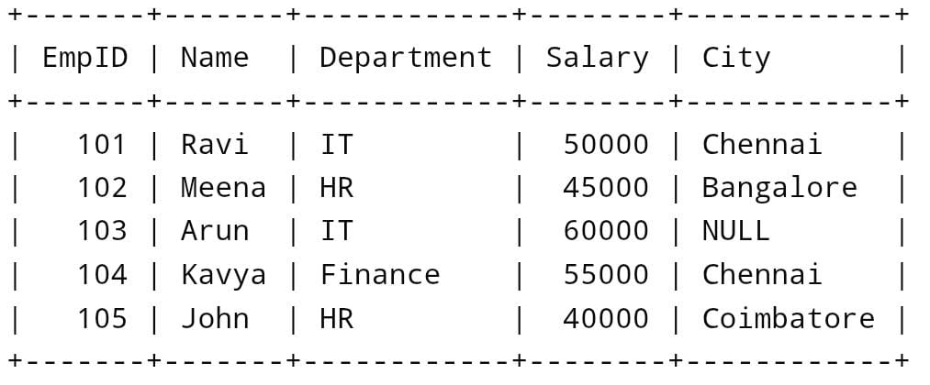
SELECT * FROM Poojashree;
• Display only the Name and Salary of employees.
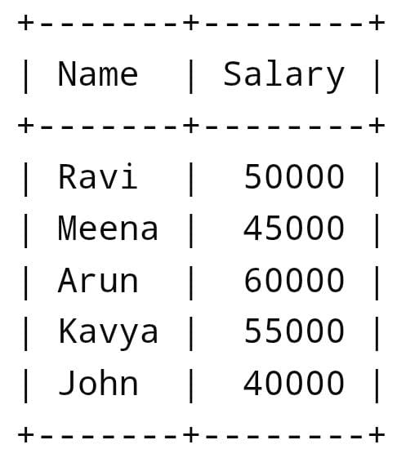
SELECT Name, Salary FROM Poojashree;

• Display employees whose salary is greater than 50,000.
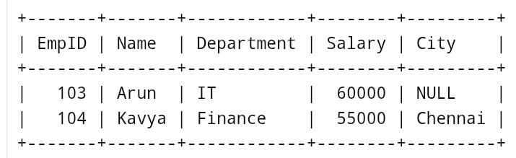
SELECT * FROM Poojashree WHERE Salary > 50000;
• Display employees who belong to the IT department.
SELECT * FROM Poojashree WHERE Department = 'IT';
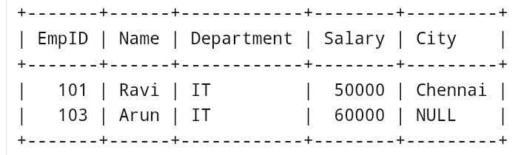
• Display employees whose city is Chennai.
SELECT*FROM Poojashree WHERE City=’Chennai’;

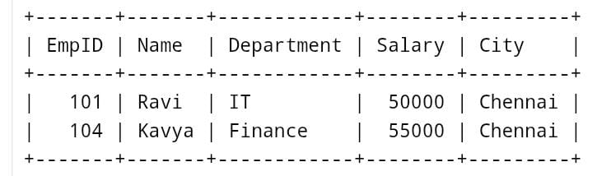
• Display employees whose salary is between 40,000 and 60,000.
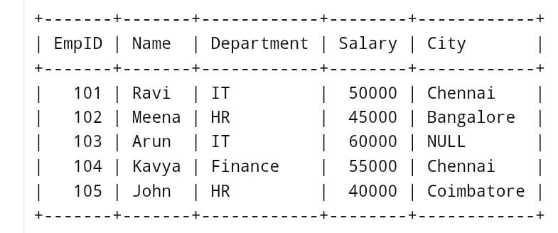
SELECT * FROM Poojashree WHERE Salary BETWEEN 40000 AND 60000;
• Display employee names that start with the letter ‘A’ using the LIKE operator.
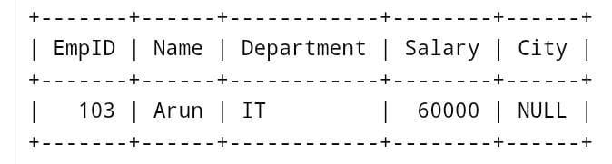
SELECT * FROM Poojashree WHERE Name LIKE ‘A%’;
• Display distinct departments from the Employee table.
SELECT DISTINCT Department FROM Poojashree;

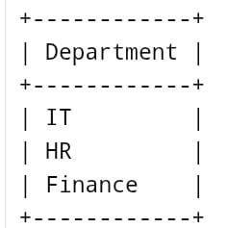
• Display employees whose City value is NULL.
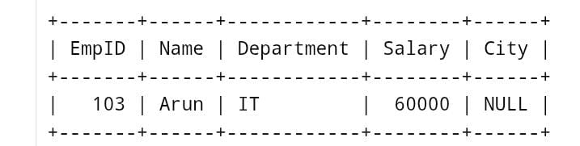
SELECT * FROM Poojashree WHERE City IS NULL;
• Find the total salary paid to all employees.
SELECT SUM(Salary) AS Total_Salary FROM Poojashree;
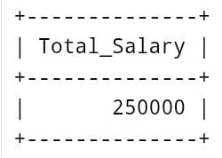
• Find the average salary of employees in the IT department.
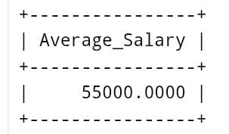
SELECT AVG(Salary) AS Average_Salary FROM Poojashree WHERE Department = ‘IT’;
• Count the number of employees in each department using GROUP BY.
SELECT Department, COUNT(*) AS Employee_Count FROM Poojashree GROUP BY Department;
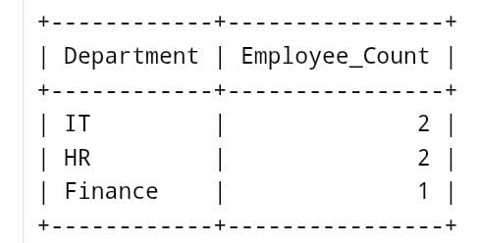
• Display employees whose salary is greater than the average salary (nested
subquery).
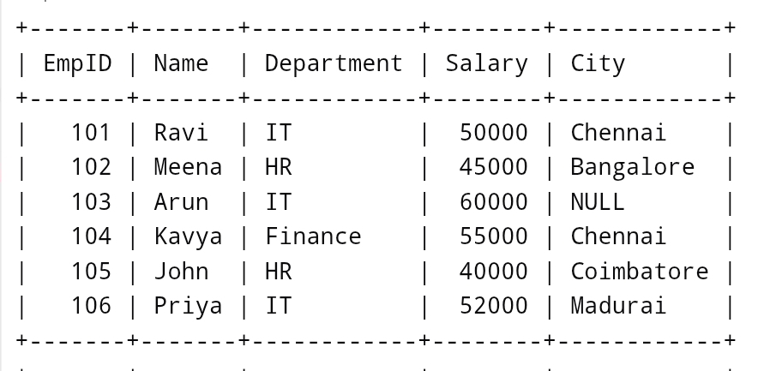
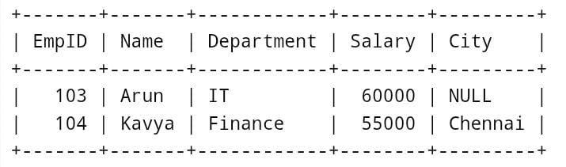
SELECT * FROM Poojashree WHERE Salary > (SELECT AVG(Salary) FROM Poojashree); • Write an SQL statement to insert a new employee record. INSERT INTO Poojashree VALUES (106, 'Priya', 'IT', 52000, 'Madurai'); • Write an SQL query to update the salary of employee with EmpID = 105 to 48000.
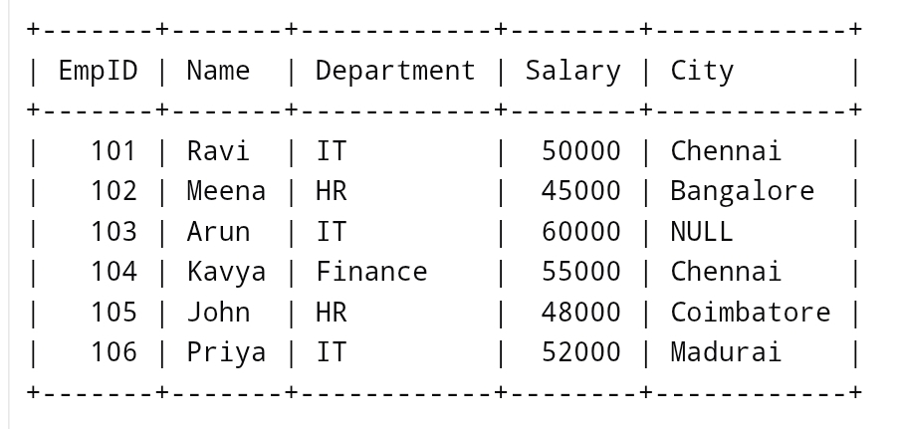
UPDATE Poojashree SET Salary = 48000 WHERE EmpID = 105;

