1:use case diagram

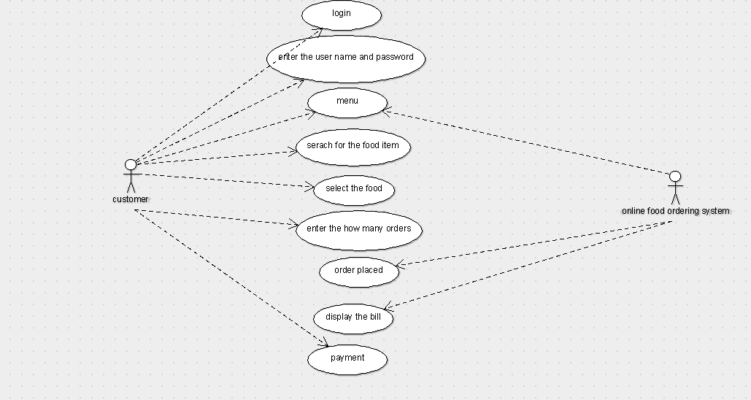

2:class diagram

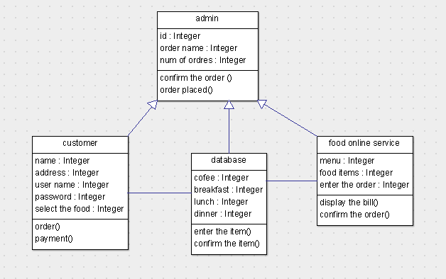

3:activity diagram

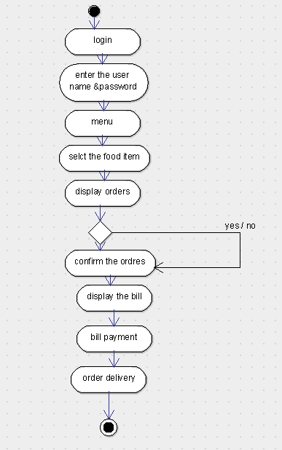

4:sequence diagram

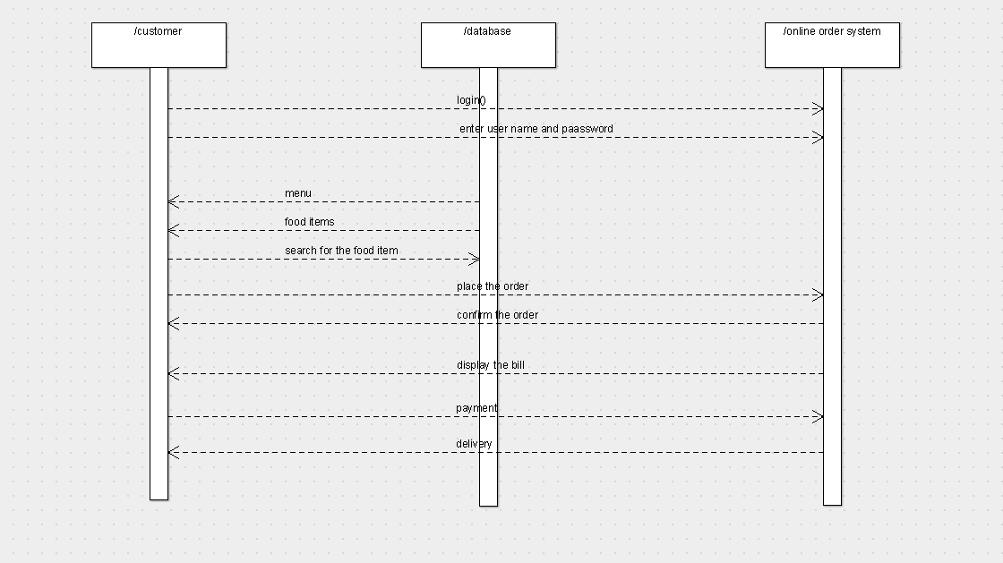

5:collaboration diagram

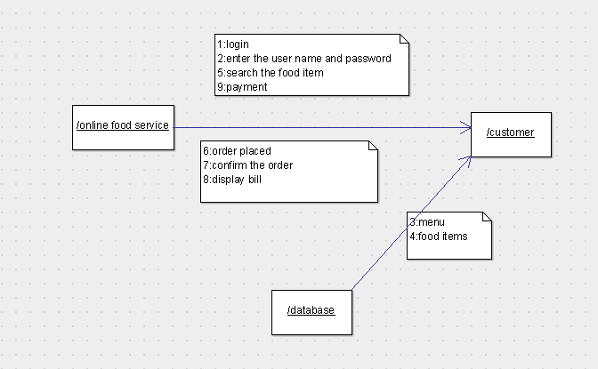

6:state chart diagram:

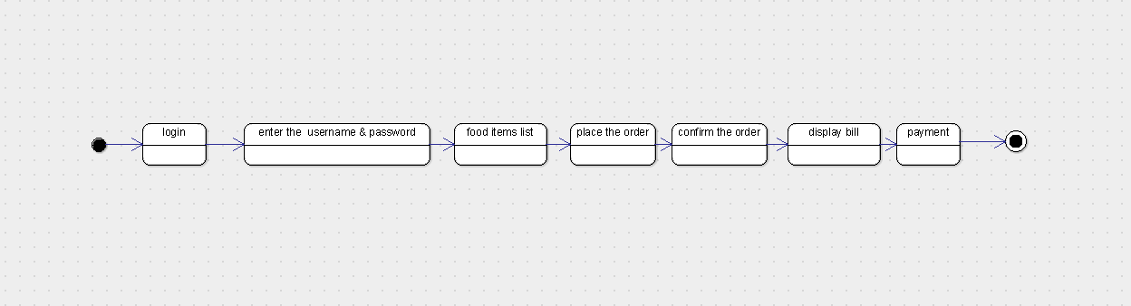

7:component diagram

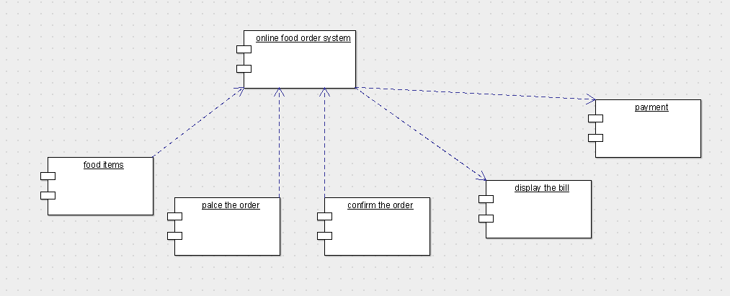

8:deployment diagram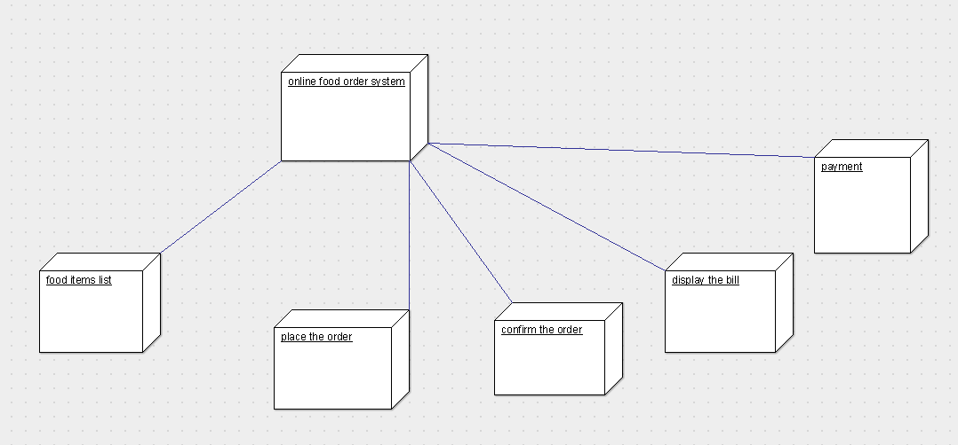

9:package diagram

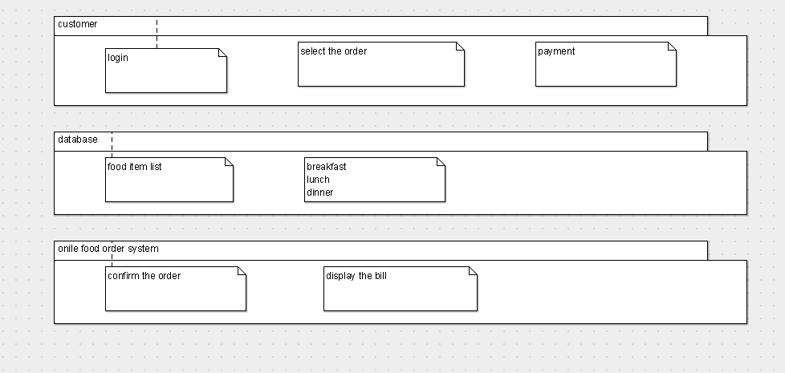

Program coding:

Customer

import java.util.Vector;

public class customer extends admin {

public Integer name;

public Integer address;

public Integer user name;

public Integer password;

public Integer select the food;

public Vector mydatabase;

public void order() {

}

public void payment() {

}

}

Database

import java.util.Vector;

public class database extends admin {

public Integer cofee;

public Integer breakfast;

public Integer lunch;

public Integer dinner;

public Vector mycustomer;

public Vector myfood online service;

public void enter the item() {

}

public void confirm the item() {

}

}

Online food order service

import java.util.Vector;

public class food online service extends admin {

public Integer menu;

public Integer food items;

public Integer enter the order;

public Vector mydatabase;

public void display the bill() {

}

public void confirm the order() {

}

}