**ASSESSMENT -1**

**1. Write a Python program to calculate the area of a rectangle given its length and width.**

length = float (input ("Enter the length of the rectangle:"))

width = float (input ("Enter the width of the rectangle:"))

area = length * width

print ("The area of the rectangle is:", area)

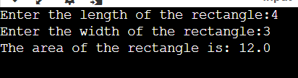

**2. Write a program to convert miles to kilometres.**

miles = float (input ("Enter the distance in miles:"))

kilometres = miles * (1.60934)

print ("The distance in miles is:",kilometres)

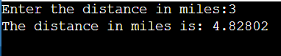

**3. Write a function to check if a given string is a palindrome.**

def palindrome(s):

s = s.replace(" ", "").lower()

return s == s[::-1]

string = input ("Enter a string: ")

if palindrome(string):

print ("The string is a palindrome.")

else:

print ("The string is not a palindrome.")

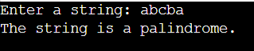

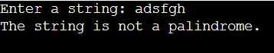

**4. Write a Python program to find the second largest element in a list.**

my_list = map(int,input("enter").split())

sorted_list = sorted(my_list)

second_largest = sorted_list[-2]

print("The second largest element in the list is:", second_largest)

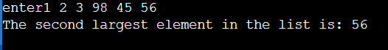

**5. Explain what indentation means in Python.**

In Python, indentation refers to the spaces or tabs placed at the beginning of a line of code

to define the block of code. It is a crucial aspect of Python syntax and is used to indicate the

grouping of statements within control structures like loops, conditionals, function definitions,

and classes. The level of indentation must be consistent within the same block of code.

Indentation helps Python determine the structure and hierarchy of the code, making it more

readable and understandable. It also replaces the need for explicit block delimiters like curly

braces {} in other programming languages.

**6. Write a program to perform set difference operation.**

set1 = set(input())

set2 = set(input())

difference_set = set1 - set2

print("Set Difference:", difference_set)

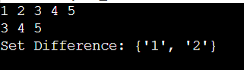

**7. Write a Python program to print numbers from 1 to 10 using a while loop.**

i=1

while(i<=10):

print(i)

i+=1

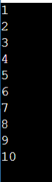

**8. Write a program to calculate the factorial of a number using a while loop.**

i=int(input("Enter:"))

fact=1

while(i>0):

fact*=i

i-=1

print(fact)





**9. Write a Python program to check if a number is positive, negative, or zero using if-elif-else statements.**

i=int(input("Enter:"))

if(i==0):

print("Zero")

elif(i>0):

print("Positive")

else:

print("Negative")

  

**10. Write a program to determine the largest among three numbers using conditional statements.**

a,b,c=map(int,input().split())

l=a

if(b>l):

l=b

if(c>l):

l=c

print("Largest:",l)

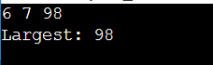 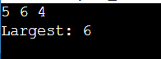 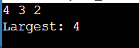

**11. Write a Python program to create a numpy array filled with ones of given shape.**

import numpy as np

rows = int(input("Enter the number of rows: "))

columns = int(input("Enter the number of columns: "))

ones_array = np.ones((rows, columns))

print(ones_array)

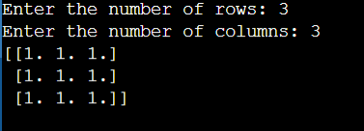

**12. Write a program to create a 2D numpy array initialized with random integers.**

import numpy as np

rows = int(input("Enter the number of rows: "))

columns = int(input("Enter the number of columns: "))

min_value = int(input("Enter the minimum value for random integers: "))

max_value = int(input("Enter the maximum value for random integers: "))

random_array = np.random.randint(min_value, max_value + 1, size=(rows, columns))

print(random_array)

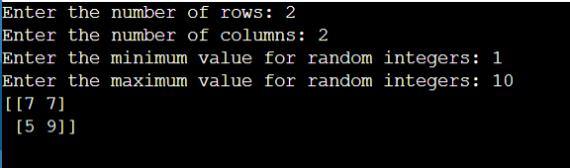

**13. Write a Python program to generate an array of evenly spaced numbers over a specified range using linespace.**

import numpy as np

start = float(input("Enter the start of the range: "))

stop = float(input("Enter the end of the range: "))

num_elements = int(input("Enter the number of elements: "))

evenly_spaced_array = np.linspace(start, stop, num_elements)

print("Array of evenly spaced numbers:")

print(evenly_spaced_array)

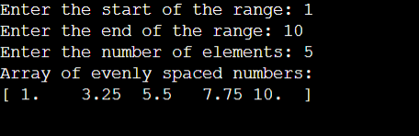

**14. Write a program to generate an array of 10 equally spaced values between 1 and 100 using linspace.**

import numpy as np

equally_spaced_array = np.linspace(1, 100, 10)

print(equally_spaced_array)



**15. Write a Python program to create an array containing even numbers from 2 to 20 using arange.**

import numpy as np

even_numbers_array = np.arange(2, 21, 2)

print(even_numbers_array)

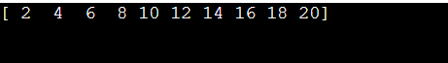

**16. Write a program to create an array containing numbers from 1 to 10 with a step size of 0.5 using arange.**

import numpy as np

numbers_array = np.arange(1, 10.5, 0.5)

print(numbers_array)

