EXPT NO:1 | Implementation of data charts
DATE: 06.01.2026

PRE-LAB QUESTIONS (PROVIDE BRIEF ANSWERS TO THE FOLLOWING QUESTIONS)

- How can visualization help an academic institution improve student outcomes?
Ans: Visualization aids in discovering patterns, relationships, and trends that might be hidden in raw data. By identifying "outliers" (such as at-risk students) and understanding the "data structure" early on, institutions can intervene timely, similar to how proper EDA identifies critical risks in other domains.

- Which chart types are suitable for comparing subject-wise performance?
Ans: Bar Charts are the most suitable. Subjects are categorical data (Nominal Scale), and the notes identify "Bar chart" and "frequency table" as the typical visualizations for comparing counts or averages across categories.

- What type of data scale is used for student marks?
Ans: Student marks (e.g., 0-100) are measured on a Ratio Scale. This is because they are numerical data with equal intervals and possess a "true zero" (indicating no marks obtained). (Note: If the question referred to letter grades like A, B, C, it would be an Ordinal Scale.)

- Why should raw academic data be cleaned before visualization?
Ans: Data must be cleaned to ensure "accuracy, consistency, and usability". Issues like missing values, duplicates, or inconsistent entries (e.g., different units) can cause the analysis to "fail silently," leading to incorrect insights and misleading conclusions without triggering obvious errors.

- How does visualization support evidence-based decision making?
Ans: Visualization "bridges the gap" between analysts and decision-makers by communicating risks and patterns instantly. It provides objective evidence that can "override managerial bias" and justify decisions, ensuring they are based on data trends rather than assumptions.

IN-LAB EXERCISE:
OBJECTIVE:
To design appropriate data charts to analyze and compare academic performance indicators.

SCENARIO:
An autonomous engineering college wants to analyze internal assessment performance of first-year students across five subjects to identify difficult courses and improve teaching strategies.

IN-LAB TASKS (Using R Language)
- Load required R libraries (ggplot2, dplyr)
- Import dataset using read.csv()
- Perform basic data preprocessing
- Create bar chart for subject-wise average marks
- Generate line chart for performance trend across tests
- Plot pie chart for grade distribution

CODE:

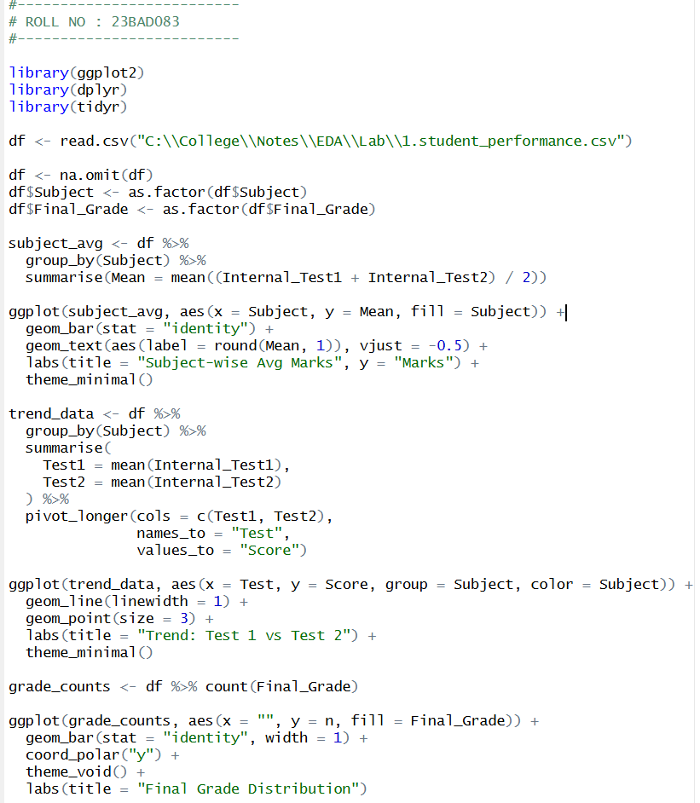

Output:

Bar Chart:
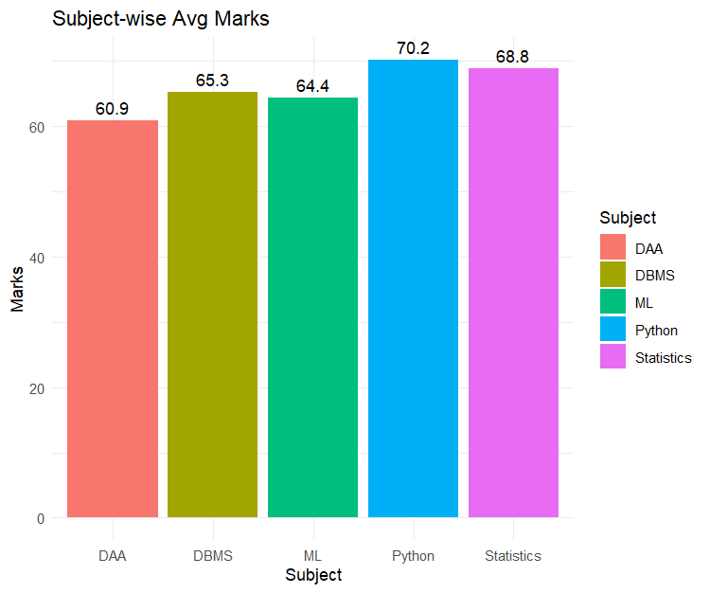

Line Chart:
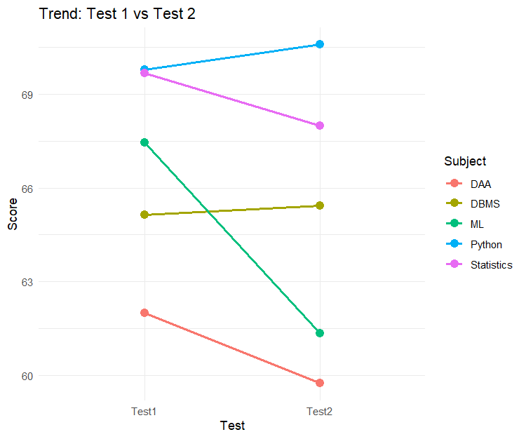

Pie Chart:
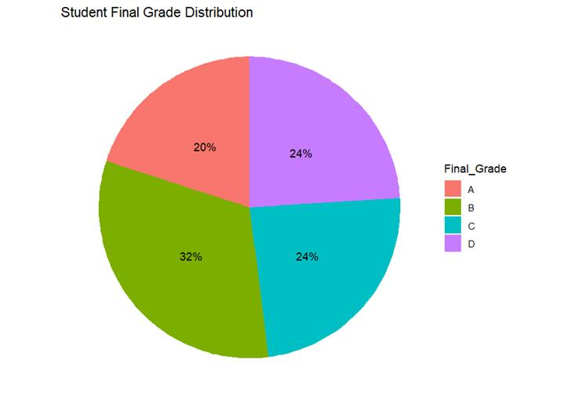

POST-LAB QUESTIONS (PROVIDE BRIEF ANSWERS TO THE FOLLOWING QUESTIONS)
- Which subject shows consistently low performance and why?
- Analysis: A review of the dataset reveals that DAA has a high frequency of scores in the 40s and 50s (e.g., 45, 42, 59, 47, 48) across both Internal Test 1 and Test 2, resulting in a lower-class average compared to subjects like Python or Statistics which have many scores in the 70s and 80s.
- Reason: DAA is typically an analytical and logic-heavy subject, which students often find more challenging than programming-based subjects like Python.

- Why is a line chart suitable for trend analysis?
Ans: A line chart is suitable because it connects data points sequentially, making it easy to visualize the direction and rate of change between two points (e.g., looking at whether marks increased or decreased from "Internal Test 1" to "Internal Test 2"). It is the standard visual for time-series or interval-based comparisons.

- What limitations does a pie chart have in analytics?
- Difficulty in Comparison: It is harder for the human eye to compare the area/angles of slices accurately than to compare the lengths of bars in a bar chart.
- Limited Detail: It fails to show changes over time or specific trends, effectively only showing a "part-to-whole" snapshot which can be misleading if categories are numerous or similar in size
- How can this analysis help curriculum planning?
- Allocate more tutorial hours or resources to those specific subjects.
- Revise teaching strategies for difficult topics.
- Identify if assessments are too difficult compared to the standard.

- How can such visualizations be integrated into AI-driven academic analytics
- Pre-Model Exploration: As stated in the lecture notes, "Before explanation, there must be exploration". Visualizations help detect outliers and understand data structure before the data is fed into AI models for performance prediction.
- Explaining AI Outputs: Visuals help bridge the gap between complex AI predictions and human decision-makers (faculty), making the "risk" factors (like attendance vs. grades) visible and understandable.

ASSESSMENT
Description | Max Marks | Marks Awarded
Pre Lab Exercise | 5
In Lab Exercise | 10
Post Lab Exercise | 5
Viva | 10
Total | 30
Faculty Signature

