EXPT NO:3 | Designing Multivariate Patterns
DATE: 12.01.2026

PRE-LAB QUESTIONS (PROVIDE BRIEF ANSWERS TO THE FOLLOWING QUESTIONS)
- Why is multivariate analysis essential in real-world AI problems?
Ans: Multivariate analysis is essential because real-world AI problems involve multiple interrelated variables. It helps AI models capture complex relationships, interactions, and dependencies between features, leading to more accurate predictions and better decision-making than univariate or bivariate analysis.

- What challenges arise when visualizing high-dimensional data?
Ans: Key challenges include visual clutter, overlapping data points, difficulty in interpreting patterns, loss of information during dimensionality reduction, and cognitive overload for users. Traditional 2D or 3D plots are often insufficient for representing many variables simultaneously.

- How does correlation analysis support feature selection?
Ans: Correlation analysis identifies relationships between features and the target variable, helping select relevant features while removing redundant or highly correlated ones. This improves model efficiency, reduces overfitting, and enhances interpretability.

- What are ethical concerns in healthcare data visualization?
Ans: Ethical concerns include patient privacy and data confidentiality, potential data misrepresentation, bias in visual interpretation, lack of informed consent, and misuse of sensitive health information that could lead to discrimination or incorrect medical decisions.

- Give examples of multivariate data in AI systems.
- Patient records (age, symptoms, lab results, medical history)
- Autonomous vehicle data (speed, location, sensor readings, weather)
- Financial fraud detection (transaction amount, time, location, user behaviour)
- Recommendation systems (user preferences, ratings, browsing history)

IN-LAB EXERCISE:
OBJECTIVE:
To discover relationships among multiple variables using multivariate visualization.

SCENARIO:
A hospital analytics team studies patient health records to identify relationships between age, BMI, glucose levels, and blood pressure for early disease prediction.

IN-LAB TASKS (Using R Language)
- Generate scatter plot matrix
- Apply color encoding for age groups
- Identify correlated health indicators

CODE:
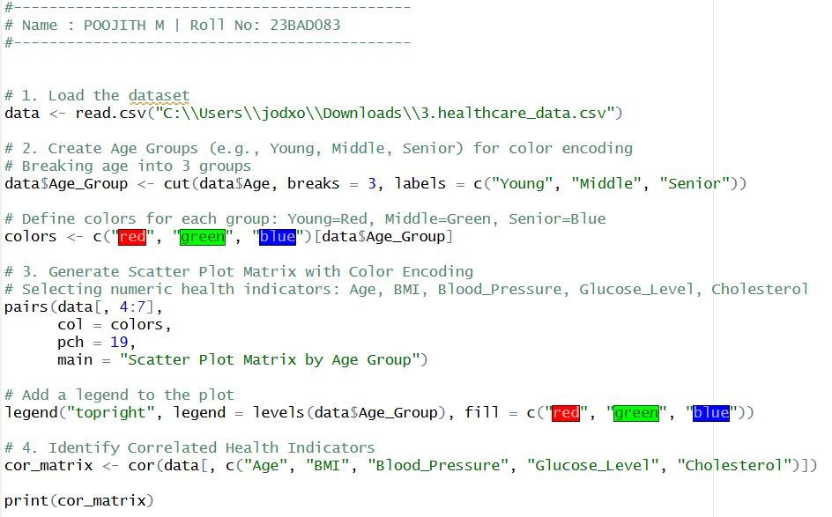

OUTPUT:
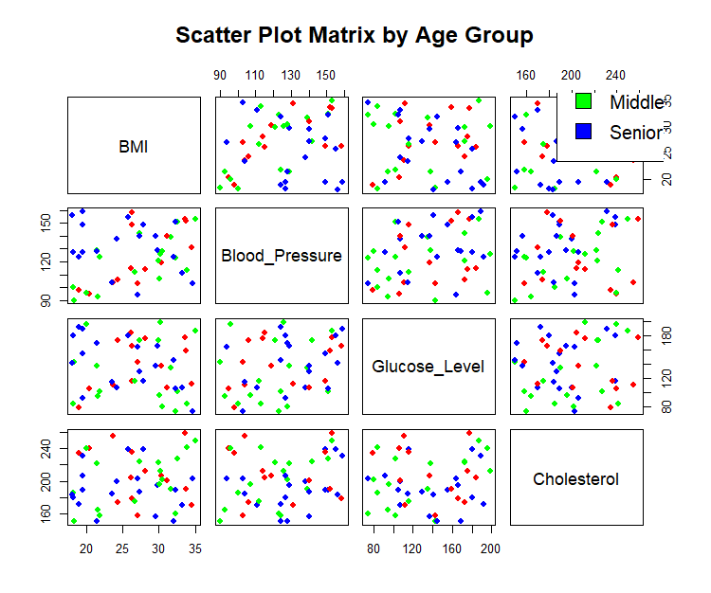
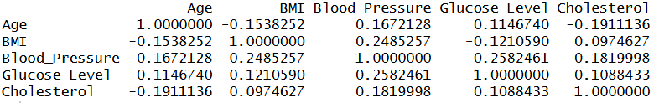

POST-LAB QUESTIONS (PROVIDE BRIEF ANSWERS TO THE FOLLOWING QUESTIONS)
- Which health parameters show strong correlation?
- Blood Pressure and Glucose Level: Show a positive correlation (~0.26).
- Blood Pressure and BMI: Show a positive correlation (~0.25).

- Why correlation does not imply causation in medical data?
Ans: Correlation only indicates that two variables move together, not that one causes the other. In medicine, a "confounding variable" often causes both. For example, high BMI and High Blood Pressure correlate, but being overweight might not directly cause the pressure to rise.

- How can these patterns assist predictive healthcare AI?
Ans: Correlations act as "features" or clues for AI models. If an algorithm learns that High BMI and High Glucose usually appear together with "High Disease Risk," it can weigh these factors heavily to predict risk for a new patient before they even show severe symptoms.

- What visualization limitations exist for high-dimensional data?
- Clutter: Scatter plot matrices become unreadable "hairballs" when you have too many variables (e.g., more than 10).
- Invisibility: You can only easily see 2D relationships (X vs Y). Complex interactions involving 3 or more variables simultaneously (e.g., Age + BMI + Genetics affecting Risk) are impossible to visualize on a standard flat screen.
- How can dimensionality reduction improve visualization?
Ans: Techniques like PCA (Principal Component Analysis) reduce many variables into just two or three "principal components" that capture the most important patterns. This allows you to plot complex, high-dimensional patient data on a simple 2D X-Y graph to easily see clusters (e.g., "Healthy" vs. "At Risk" patients) without needing to compare every single column.

ASSESSMENT
Description | Max Marks | Marks Awarded
Pre Lab Exercise | 5
In Lab Exercise | 10
Post Lab Exercise | 5
Viva | 10
Total | 30
Faculty Signature

