EXPT NO:4 | Visual encoding of data
DATE: 20.01.2026

PRE-LAB QUESTIONS
- How does the human visual system process visual variables?
Ans: It processes them pre-attentively, meaning the brain detects certain features (like colour, orientation, or size) immediately and subconsciously before focused attention is applied. For example, a single red dot in a sea of blue dots is noticed instantly

- Why is improper encoding misleading in analytics?
Ans: It distorts the data's magnitude. For example, using area (like bubbles) to represent linear data is often misleading because humans are poor at judging area differences compared to length (like bar charts). This causes users to over- or underestimate values.

- What are perceptual limitations in visualization?
- Change Blindness: Users often fail to notice significant changes if they occur during a blink or a page refresh.
- Short-term Memory: Humans can only hold a few chunks of information (approx. 4-7) in working memory at once, making complex, multi-view comparisons difficult.
- Visual Clutter: Too many elements overwhelm the visual cortex, preventing pattern recognition.

- How does colour choice affect interpretation?
- Semantics: Colors carry meaning (e.g., Red often implies "danger" or "stop"). Using red for positive growth confuses the user.
- Accessibility: Poor contrast or reliance on red-green distinctions makes charts unreadable for color-blind users.
- Grouping: The brain automatically groups objects of the same color, implying a relationship that might not exist if used randomly.

- Why should AI dashboards be perceptually optimized?
Ans: To reduce cognitive load. AI dashboards often present complex predictions and high-dimensional data. Optimizing for perception ensures that decision-makers can trust and understand the AI's output quickly without misinterpreting the risk or confidence levels.

OBJECTIVE: To apply effective visual encoding principles for meaningful data communication.

SCENARIO: A city traffic department analyzes accident data to identify high-risk zones and accident severity patterns.

IN-LAB TASKS (Using R Language)
• Encode severity using color gradients
• Represent accident frequency using size
• Use shape to indicate accident type

CODE:
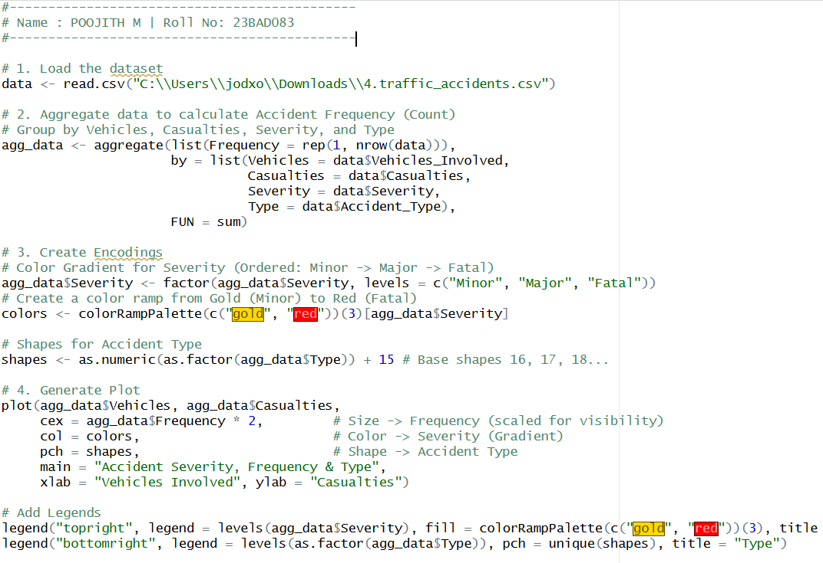

OUTPUT:
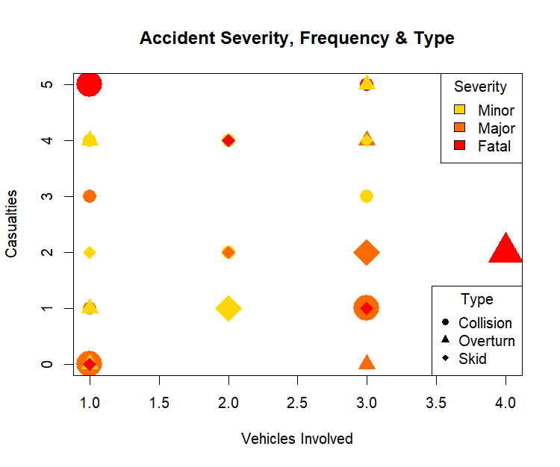
POST-LAB QUESTIONS
- Which visual variable best conveys severity and why?
Ans: Colour Saturation (Intensity) or Value (Lightness). Since "Severity" is an ordered quantity (Low → High), humans intuitively perceive darker or more saturated colours as representing "more" of a quality (e.g., light red for minor injury, dark red for fatal).

- How can poor encoding mislead policy decisions?
Ans: It can distort the perception of magnitude. For example, using radius instead of area to scale circles makes large differences look small. This might cause policymakers to underestimate a critical issue (like accident rates) and under-allocate necessary resources.

- What precautions should be taken for color-blind users?
- Avoid Red-Green combinations, as they are the most common form of color blindness.
- Use Redundant Encoding: Don't rely on color alone; combine it with another variable like Shape or Pattern (e.g., dashed lines vs. solid lines) to distinguish categories.
- Use colorblind-safe palettes (e.g., Viridis or ColorBrewer).

- How does visual encoding affect AI explainability?
Ans: Visual encoding bridges the gap between complex algorithms and human understanding. Effective encoding turns abstract model weights (feature importance) into readable charts (like bar plots). If the encoding is cluttered or confusing, the AI remains a "black box," reducing user trust in the system's predictions.

- Suggest improvements for large-scale public dashboards.
- Overview First, Details on Demand: Show a high-level summary immediately, allowing users to click/zoom for specific details (interactive filtering).
- Simplify: Maximize the "Data-Ink Ratio" by removing unnecessary decorations, 3D effects, or distracting backgrounds.
- Responsiveness: Ensure the dashboard adapts legibly to mobile screens, as public access often happens on phones.

LEARNING OUTCOME: Students learn perceptually effective visual communication for AI systems.

ASSESSMENT
Description | Max Marks | Marks Awarded
Pre Lab Exercise | 5
In Lab Exercise | 10
Post Lab Exercise | 5
Viva | 10
Total | 30
Faculty Signature

