EXPT NO:6 | OVER-PLOTTING REDUCTION TECHNIQUES
DATE: 09.02.2026

PRE-LAB QUESTIONS
- Why is over-plotting common in big data visualization?
Answer: Over-plotting occurs frequently because the number of data points often exceeds the number of available pixels on a screen. In big data contexts, when thousands or millions of points are mapped to a finite plotting area, markers inevitably overlap, obscuring individual data values.
- How does data density affect perception?
Answer: As data density increases, the visual representation can become a solid "blob" of color. This prevents the viewer from perceiving the true distribution or frequency of the data in the dense areas, making it impossible to distinguish between a cluster of 100 points and a cluster of 10,000 points.
- What trade-offs exist between detail and clarity?
Answer: The main trade-off is between "granularity" (seeing every individual data point) and "pattern recognition" (seeing the overall trend). Keeping high detail often results in visual noise and clutter, whereas simplifying for clarity (via aggregation) sacrifices the ability to identify specific outliers or individual user behaviors.
- How do AI datasets increase visualization complexity?
Answer: AI datasets are typically massive in volume and high in dimensionality. Visualizing this requires reducing millions of instances into 2D or 3D space, which exacerbates occlusion (blocking) issues and requires advanced reduction or sampling techniques to make the model's training data interpretable.
- Why is over-plotting a serious analytical risk?
Answer: It creates a false visual impression. Analysts might miss hidden structures, sub-clusters, or gaps within a dense area because they are covered by a top layer of points. This leads to incorrect assumptions about the dataset's uniformity.

OBJECTIVE:
To apply techniques that reduce visual clutter in large-scale datasets.

SCENARIO A social media analytics company visualizes millions of user interactions to study engagement patterns.

IN-LAB TASKS (Using R Language)
• Apply alpha blending
• Implement jittering techniques
• Use aggregation and binning

Code:
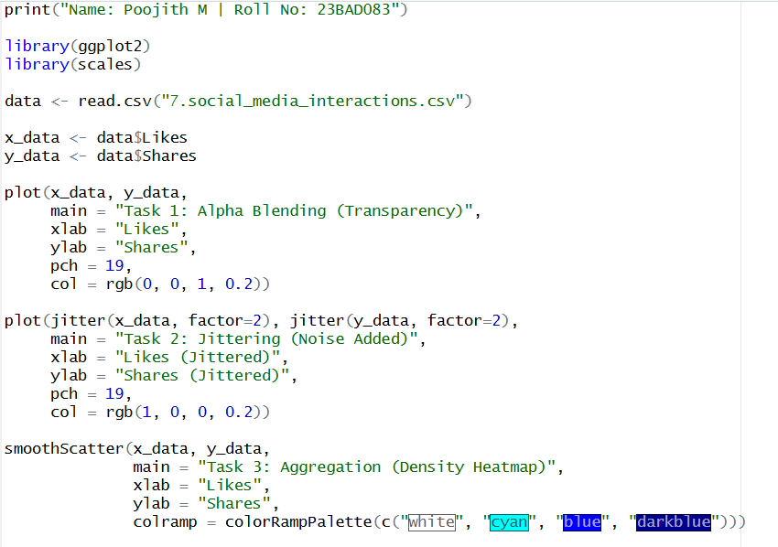
Output:
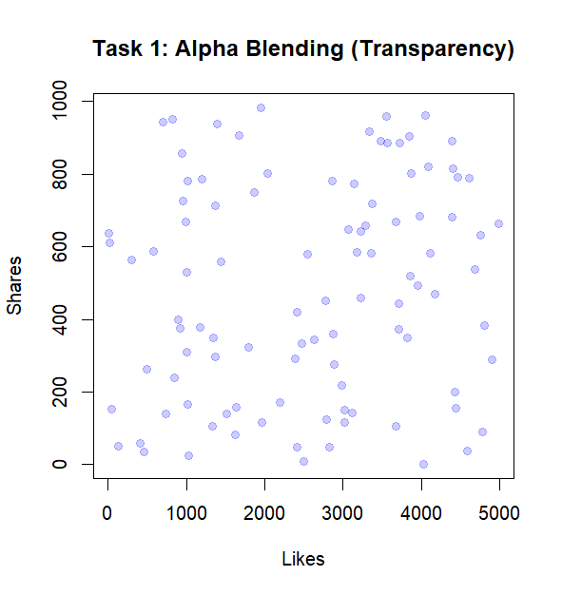
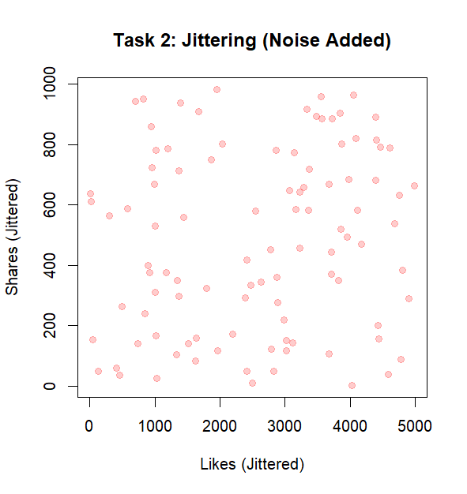
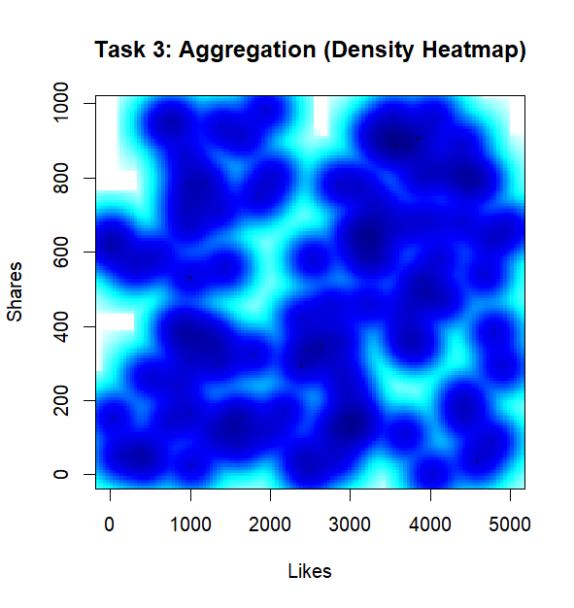
POST-LAB QUESTIONS
- Which technique provided the best clarity and why?
Answer: The Aggregation (Density Heatmap) provided the best clarity. While the Alpha Blending and Jittering plots showed a scattered cloud of data, the Heatmap was the only technique that clearly highlighted distinct "hotspots" (dark blue clusters) of high engagement that were otherwise lost in the visual noise of the scatter plots.
- How does over-plotting distort analytical conclusions?
Answer: In the raw scatter state, the data appeared to be a uniform, random cloud. Over-plotting hid the fact that specific combinations of "Likes" and "Shares" occur much more frequently than others. Without the density view, an analyst would incorrectly assume user engagement is randomly distributed rather than clustered around specific values.
- When should aggregation be preferred over raw plotting?
Answer: Aggregation is preferred when the goal is to visualize probability density rather than individual transactions. As seen in the lab, when the scatter plot becomes a "cloud" with no discernible shape, aggregation is necessary to reveal the underlying structure and gradients of the data.
- How do these techniques support scalable AI analytics?
Answer: These techniques allow data scientists to visualize massive training sets without rendering millions of individual points, which saves computational resources. Furthermore, they help identify "class imbalances", showing if the AI model will be trained heavily on one specific type of user behavior (the dark spots) versus others.
- Explain real-world consequences of ignoring over-plotting.
Answer: If a social media company ignored over-plotting, they might incorrectly conclude that their users have "varied" engagement. In reality, the density map might show that 90% of users are stuck in a low-engagement cluster. Ignoring this could lead to strategic failures, such as creating content for a high-engagement audience that doesn't actually exist in significant numbers.

LEARNING OUTCOME: Students master over-plotting reduction for big data visual analytics.
ASSESSMENT
Description | Max Marks | Marks Awarded
Pre Lab Exercise | 5
In Lab Exercise | 10
Post Lab Exercise | 5
Viva | 10
Total | 30
Faculty Signature

