ENergy Twin with INtegrated Explainability (ENTWINE)

A PROJECT REPORT

Submitted by

MUGILAN Y – 23BAD068
POOJITH M – 23BAD083
SHAILENDRA C – 23BAD108
VIJEY R S – 23BAD126

in partial fulfilment for the award of the degree of

BACHELOR OF TECHNOLOGY
IN
ARTIFICIAL INTELLIGENCE AND DATA SCIENCE


KUMARAGURU COLLEGE OF TECHNOLOGY
(An Autonomous Institution affiliated to Anna University, Chennai)
Coimbatore – 641049

OCTOBER 2026

KUMARAGURU COLLEGE OF TECHNOLOGY
COIMBATORE – 641049.
ARTIFICIAL INTELLIGENCE AND DATA SCIENCE
BONAFIDE CERTIFICATE
Certified that this project report “ENergy Twin with INtegrated Explainability (ENTWINE)” is the bonafide work of “MUGIALN Y(23BAD068), POOJITH M (23BAD083), SHAILENDRA C (23BAD108) and VIJEY R S(23BAD126)” who carried out the project work under my supervision.

SIGNATURE  Dr. PREETHI G  SUPERVISOR  Associate Professor I  Department of Artificial Intelligence and Data Science  Kumaraguru College of Technology, Coimbatore – 641049 | SIGNATURE  Dr. SUDHARSON D  HEAD OF THE DEPARTMENT  Associate Professor  Department of Artificial Intelligence and Data Science  Kumaraguru College of Technology, Coimbatore – 641049

The candidates with college roll numbers 23BAD068, 23BAD083, 23BAD108 and 23BAD126 were examined in the Project Viva-Voce examination held on 31/10/2026.

Internal Examiner External Examiner

ABSTRACT
Energy management is essential for sustainable campus infrastructure, as electricity consumption data can reveal unusual usage patterns, equipment issues, and opportunities for operational improvement. However, conventional monitoring systems often lack explanations for unexpected energy behaviour. ENTWINE (Energy Twin with INtegrated Explainability) is a Digital Twin platform being developed to enable intelligent monitoring and analysis of campus energy infrastructure using real-world data from Kumaraguru College of Technology (KCT).
The proposed system integrates an asset registry, historical energy data layer, and intelligent analysis layer. PostgreSQL manages structured information about buildings, meters, equipment, and baseline parameters, while TimescaleDB stores historical time-series measurements. Historical Excel and CSV files are processed through timestamp normalization, data validation, asset mapping, and reconciliation. The planned analytical modules include GridReason for anomaly detection, GrCF for counterfactual explanations, and CAFA for consistency auditing, with future enhancements covering energy forecasting, RAG-based natural-language queries, and an interactive dashboard.
The initial implementation focuses on the KCT Powerhouse (PH-01), establishing a reliable foundation for future campus-wide expansion. ENTWINE aims to transform raw energy readings into interpretable insights that support facility management, energy monitoring, and data-driven decisions through a modular, traceable, and reproducible architecture.

Keywords: Digital Twin, Energy Monitoring, Anomaly Detection, Explainable Artificial Intelligence, PostgreSQL, TimescaleDB, Counterfactual Explanation, Campus Sustainability.

TABLE OF CONTENTS
S. NO. | CHAPTER / SECTION TITLE | PAGE NO.
 | ABSTRACT | ii
 | LIST OF TABLES | vii
 | LIST OF FIGURES | viii
 | LIST OF SYMBOLS, ABBREVATIONS AND NOMENCLATURE | ix
1 | INTRODUCTION | 1
1.1 | GENERAL INTRODUCTION | 1
1.2 | BACKGROUND OF THE PROJECT | 2
1.3 | PROBLEM STATEMENT | 2
1.4 | MOTIVATION | 3
1.5 | OBJECTIVES | 4
1.6 | SCOPE OF THE PROJECT | 4
1.7 | APPLICATIONS | 5
2 | LITERATURE REVIEW | 6
2.1 | INTRODUCTION | 6
2.2 | DIGITAL TWIN TECHNOLOGY | 6
2.3 | ENERGY MONITORING AND TIME-SERIES DATA MANAGEMENT | 7
2.4 | ANOMALY DETECTION IN ENERGY SYSTEMS | 7
2.5 | EXPLAINABLE ARTIFICIAL INTELLIGENCE | 8
2.6 | COUNTERFACTUAL EXPLANATIONS | 8
2.7 | FAIRNESS AND CONSISTENCY AUDITING | 9
2.8 | RESEARCH GAP | 10
2.9 | SUMMARY | 10
3 | PROPOSED SYSTEM AND METHODOLOGY | 11
3.1 | EXISTING SYSTEM | 11
3.2 | LIMITATIONS OF THE EXISTING SYSTEM | 11
3.3 | PROPOSED SYSTEM | 12
3.4 | SYSTEM ARCHITECTURE | 13
3.5 | ASSET REGISTRY | 14
3.6 | HISTORICAL DATA INGESTION | 15
3.7 | DIGITAL TWIN STATE LAYER | 16
3.8 | ANOMALY DETECTION USING GRIDREASON | 17
3.9 | COUNTERFACTUAL EXPLANATION USING GRCF | 18
3.10 | CONSISTENCY AUDITING USING CAFA | 19
3.11 | FUTURE FORECASTING MODULE | 20
3.12 | NATURAL-LANGUAGE QUERYING AND RAG | 21
3.13 | DASHBOARD AND API INTEGRATION | 22
3.14 | ALGORITHMS AND WORKFLOW | 23
4 | SYSTEM IMPLEMENTATION | 24
4.1 | DEVELOPMENT ENVIRONMENT | 24
4.2 | TECHNOLOGIES USED | 24
4.3 | DATABASE IMPLEMENTATION | 24
4.4 | ASSET REGISTRY IMPLEMENTATION | 25
4.5 | DATA INGESTION IMPLEMENTATION | 25
4.6 | DATA VALIDATION AND RECONCILIATION | 26
4.7 | MODULE INTEGRATION PLAN | 26
4.8 | SECURITY AND DATA INTEGRITY | 27
4.9 | IMPLEMENTATION STATUS | 27
5 | RESULTS AND DISCUSSION | 28
5.1 | EXPERIMENTAL SETUP | 28
5.2 | ASSET REGISTRY VALIDATION | 28
5.3 | HISTORICAL DATA INGESTION VALIDATION | 29
5.4 | DATA QUALITY AND RECONCILIATION | 30
5.5 | PLANNED MODEL EVALUATION | 31
5.6 | EVALUATION METRICS | 32
5.7 | DISCUSSION AND LIMITATIONS | 33
6 | CONCLUSION AND FUTURE WORK | 33
6.1 | CONCLUSION | 34
6.2 | FUTURE ENHANCEMENTS | 35
7 | REFERENCES | 36
8 | APPENDICES

LIST OF TABLES
TABLE NO. | CHAPTER / SECTION TITLE | PAGE NO.
4.1 | TECHNOLOGIES AND THEIR ROLES | 24
4.2 | MODULE IMPLEMENTATION STATUS | 26
5.1 | ASSET REGISTRY VALIDATION RESULTS | 29
5.2 | HISTORICAL DATA INGESTION RESULTS | 30
5.3 | MODEL EVALUATION | 31

LIST OF DIAGRAMS
FIGURE NO. | CHAPTER / SECTION TITLE | PAGE NO.
3.1 | PROPOSED ENTWINE SYSTEM ARCHITECTURE | 13
3.2 | ASSET REGISTRY WORKFLOW | 15
3.3 | HISTORICAL DATA INGESTION FLOWCHART | 16
3.4 | DIGITAL TWIN DATA ORGANIZATION | 17
3.5 | GRID REASON ANAMOLY DETECTION WORKFLOW | 18
3.6 | GRCF COUNTERFACTUAL EXPLANATION WORKFLOW | 19
3.7 | CAFA CONSISTENCY AUDITING WORKFLOW | 20
3.8 | RAG WORKFLOW | 22

LIST OF SYMBOLS
Symbol / Abbreviation | Meaning
ENTWINE | Energy Digital Twin project for representing, monitoring, explaining, and analysing the KCT campus energy system.
AI | Artificial Intelligence.
API | Application Programming Interface.
CAFA | Context-Aware Fairness Audit; the contextual anomaly detection and fairness-analysis framework.
CSV | Comma-Separated Values; a source-file format used for alarms, events, incidents, and measurements.
DB / SQL | Database / Structured Query Language.
DDPM | Denoising Diffusion Probabilistic Model; used by GrCF for normal-manifold warm-start initialization.
F1 | F1 score, the harmonic mean of precision and recall.
FastAPI | Python framework used to expose the digital twin REST API.
GrCF | Granger-regularised Counterfactual explanations; the counterfactual generation framework.
GridReason | The contextual intelligence and translation layer that converts model deltas into controlled operator alerts.
HTTP / REST | Hypertext Transfer Protocol / Representational State Transfer; the communication style used by the API.
JSON | JavaScript Object Notation; the exchange format used for API payloads and counterfactual tensors.
JSONB | PostgreSQL binary JSON data type used to store counterfactual output.
KCT | Kumaraguru College of Technology.
LLM | Large Language Model; an optional controlled local text-generation component in GridReason.
LSTM | Long Short-Term Memory recurrent neural network.
MAE | Mean Absolute Error; the average absolute difference between predicted and observed real power.
ML | Machine Learning.
NLP | Natural Language Processing.
PH-A-BLK | Canonical building identifier for Powerhouse 1 Block A.
PH-A-MAIN | Canonical meter identifier for the main meter of Powerhouse 1 Block A.
PostgreSQL | Relational database management system used as the project database.
REST | See HTTP / REST.
SQLAlchemy | Python database toolkit and ORM/engine layer used for database connections and transactions.
TimescaleDB | PostgreSQL extension optimized for time-series data.
UTC | Coordinated Universal Time; the standard timezone for stored and processed timestamps.
XLS / XLSX | Microsoft Excel workbook formats used by the historical energy reports.
XGBoost | Gradient-boosted decision-tree library used for contextual real-power prediction.
AE | Autoencoder; a neural network trained to reconstruct normal sequences.
CF | Counterfactual; a generated alternative sequence representing expected normal operation.
IF | Isolation Forest; the unsupervised detector used to flag isolated observations.
PF | Power Factor; ratio/quality indicator describing electrical power utilization.
DG | Diesel Generator; an equipment/source label in the Powerhouse dataset.
VCB | Vacuum Circuit Breaker; switchgear equipment terminology in the source dataset.
kW | Kilowatt; unit of real/active power.
kWh | Kilowatt-hour; unit of energy consumption.
kVA | Kilovolt-ampere; unit of apparent power.
kVAr / kVArh | Kilovolt-ampere reactive / reactive energy units.
A | Ampere; unit of electrical current.
V | Volt; unit of electrical potential difference.
Hz | Hertz; unit of frequency.
ρ | A model or evaluation ratio where used; project-specific interpretation must be stated with its threshold.
t | A timestamp or time index for an energy measurement.
Δx | Difference between an observed feature value and its counterfactual/expected value.
x_cf | Counterfactual feature or sequence generated by GrCF.
x_obs | Observed feature or sequence from the state layer.
A[i,j] | Entry in the Granger causal adjacency matrix; 1 indicates a detected directed causal relationship from feature i to j.
SEQ_LEN | Sequence length used by GrCF; 16 consecutive time steps, normally 15-minute intervals.
CONTAMINATION | Expected proportion of outliers supplied to the Isolation Forest; configured as 0.033.
LAMBDA | Weight applied to a loss or domain penalty during counterfactual optimization.
POWER_IDX | Index of the real-power feature in the GrCF feature tensor; index 0.
state_telemetry | Database table containing normalized historical telemetry in long format.
anomaly_events | Database table containing detector output, counterfactual JSONB, and GridReason explanation.
twin_instances | Database view joining a building with its main meter for convenient twin lookup.
meter_id | Database identifier linking telemetry and anomaly events to a registered meter.
detector_type | Label identifying the detection/explanation combination that created an anomaly event, such as CAFA-GrCF.
natural_language_explanation | Database field containing the controlled GridReason operator alert.
counterfactual_data | JSONB representation of the GrCF tensor, typically 16 time steps by 10 features.
Telemetry | Time-stamped measurements describing the operational state of an energy asset.
Asset Registry | Static structural layer describing buildings, meters, equipment, and baseline parameters.
State Layer | Historical operational layer containing time-series telemetry, source provenance, and quality records.
Intelligence Layer | Model layer containing CAFA, GrCF, GridReason, and orchestration logic.
Presentation Layer | API and dashboard layer used to expose results to operators and other applications.

CHAPTER 1 – INTRODUCTION
1.1 General Introduction
Energy consumption is a major operational consideration in educational institutions, commercial buildings, and industrial facilities. Monitoring electricity usage helps organizations understand consumption patterns, identify unusual behaviour, and improve energy efficiency. With the availability of historical energy measurements and modern data-processing technologies, it is possible to develop intelligent systems that analyse operational data and provide useful insights.
A Digital Twin is a digital representation of a physical system that reflects its structure and operational state. In the context of campus energy management, a Digital Twin can represent buildings, electricity meters, equipment, and their associated energy measurements. By combining asset information with historical operational data, the system can provide a structured representation of the physical energy infrastructure.
ENTWINE, which stands for Energy Twin with INtegrated Explainability, is a Digital Twin platform designed for campus energy monitoring and analysis. The project initially focuses on the KCT Powerhouse, identified as PH-01, and establishes the database and historical data pipeline required for subsequent analytical modules.
The platform is designed to progress beyond basic energy monitoring by incorporating anomaly detection, counterfactual explanations, consistency auditing, forecasting, and natural-language interaction. These capabilities are intended to help users understand not only when unusual energy consumption occurs, but also how the system identifies the behaviour and what additional information can be used to investigate it.

1.2 Background of the Project
Traditional energy monitoring systems commonly display consumption readings, trends, and historical reports. Although these features are useful, identifying the reasons behind unexpected consumption often requires manual investigation and knowledge of the underlying infrastructure.
Energy data also presents practical challenges. Historical files may contain inconsistent timestamps, missing measurements, duplicate records, invalid values, or identifiers that do not map directly to registered physical assets. These issues can affect the reliability of subsequent analysis.
ENTWINE addresses these challenges through a structured data architecture. The Asset Registry records the known physical assets and their relationships. The historical ingestion pipeline processes source files and maps valid measurements to registered assets. The resulting state layer provides the historical operational information needed by future analytical modules.
The project adopts a modular approach so that data management, anomaly detection, explanations, auditing, and user interaction can be developed and validated separately before being integrated into a unified platform.

1.3 Problem Statement
Campus energy infrastructure generates operational data through electricity meters and associated monitoring systems. However, raw energy measurements alone may not provide sufficient information to identify unusual consumption, investigate possible causes, or compare the performance of analytical models across different fault types.
Inconsistent data formats and uncertain asset mappings can further complicate the analysis. Additionally, a system that simply reports an anomaly may not provide enough information for facility staff to understand the detection or investigate the underlying behaviour.
Therefore, there is a need for a structured and explainable Digital Twin platform that integrates physical asset information with historical energy data and supports anomaly detection, counterfactual analysis, and consistency auditing.
ENTWINE aims to establish such a platform by combining reliable data management with explainable analytical methods to support more transparent and informed campus energy management.

1.4 Motivation
The primary motivation for ENTWINE is to improve the usefulness of campus energy data by connecting operational measurements to the physical infrastructure they represent.
The major motivations are:
- Energy efficiency: Help identify unusual consumption patterns that may require investigation.
- Data reliability: Organize historical readings using validation, timestamp normalization, and asset mapping.
- Explainability: Provide a path toward understanding why a model identifies a particular observation as unusual.
- Consistency: Evaluate whether anomaly detection performs consistently across different fault types.
- Scalability: Establish an architecture that can be extended from one initial energy asset to additional campus meters.
- Decision support: Develop a foundation for future forecasting and user-friendly energy analysis.

1.5 Objectives
The main objectives of ENTWINE are:
- To develop a Digital Twin representation of campus energy infrastructure.
- To implement a structured Asset Registry for buildings, meters, equipment, and baseline parameters.
- To build a reproducible pipeline for ingesting historical energy data from Excel and CSV files.
- To normalize timestamps, validate data quality, map records to assets, and generate reconciliation reports.
- To integrate and evaluate GridReason for anomaly detection.
- To investigate counterfactual explanations using GrCF for detected anomalies.
- To evaluate consistency across fault types using CAFA.
- To develop future forecasting capabilities for energy consumption.
- To support natural-language interaction through retrieval-augmented generation.
- To provide an interactive interface for energy monitoring and analysis.
Objectives 5–10 describe the intended analytical and application capabilities; their implementation status must be updated as the project progresses.

1.6 Scope of the Project
The initial scope of ENTWINE is limited to establishing a reliable Digital Twin foundation for the KCT Powerhouse, identified as PH-01.
The scope includes the following stages:
Stage 1 – Asset Registration: Define the physical assets and their relationships in a structured database.

Stage 2 – Historical Data Ingestion: Process historical energy and alarm/event files, validate their contents, normalize timestamps, and map records to registered assets.
Stage 3 – Model Integration: Integrate and evaluate anomaly detection, counterfactual explanations, and consistency auditing.
Stage 4 – Advanced Analytics: Extend the platform with energy forecasting and natural-language querying.
Stage 5 – User Interface: Develop an interactive dashboard for visualizing energy trends, anomalies, and analytical outputs.
The initial implementation provides the foundation for these stages. Forecasting, model evaluation, RAG, and dashboard integration should be reported as completed only after their respective implementations have been tested.

1.7 Applications
ENTWINE is intended to support the following applications:
- Campus electricity consumption monitoring.
- Identification of unusual energy consumption patterns.
- Investigation of potential operational anomalies.
- Analysis of historical energy measurements.
- Evaluation of anomaly detection across fault types.
- Energy forecasting and trend analysis.
- Facility maintenance and operational decision support.
- Expansion toward multi-building energy intelligence.

CHAPTER 2 – LITERATURE REVIEW
2.1 Introduction
Digital Twins, time-series data management, anomaly detection, and explainable artificial intelligence are important technologies for developing intelligent monitoring systems. These technologies provide complementary capabilities: Digital Twins represent physical systems, databases preserve operational information, anomaly detection identifies unusual behaviour, and explainability methods help users understand analytical outputs.
This chapter reviews the major concepts relevant to ENTWINE and identifies the need for a unified architecture that connects energy data with interpretable analysis.

2.2 Digital Twin Technology
A Digital Twin is a digital representation of a physical entity or system. Depending on its application, it may contain information about physical assets, operational measurements, system relationships, and analytical models.
In an energy management application, a Digital Twin may represent buildings, meters, equipment, and their measured consumption over time. Historical measurements help describe the system's observed behaviour, while analytical methods can identify deviations and support future operational decisions.
For ENTWINE, the Digital Twin is organized into three conceptual components:
- Asset Layer: Represents registered buildings, meters, equipment, and associated metadata.
- State Layer: Stores historical energy measurements and relevant operational events.
- Intelligence Layer: Supports anomaly detection, explanation, auditing, forecasting, and future user interaction.
The separation of these components improves maintainability and allows analytical functionality to be extended without redesigning the entire data architecture.

2.3 Energy Monitoring and Time-Series Data Management
Energy monitoring systems generate observations associated with timestamps. Such data is commonly treated as time-series data because the sequence and timing of measurements are essential to understanding consumption behaviour.
Relational database systems are suitable for storing structured asset information and maintaining relationships through primary keys and foreign keys. Time-series extensions can support the efficient organization and querying of timestamped measurements.
ENTWINE uses PostgreSQL for structured asset metadata and TimescaleDB for historical time-series data. This arrangement separates the relatively stable physical asset definitions from the changing operational measurements.
Before analysis, historical data must be processed to address timestamp inconsistencies, invalid values, missing information, duplicates, and uncertain asset mappings. These checks help improve data quality and make subsequent experiments reproducible.

2.4 Anomaly Detection in Energy Systems
Anomaly detection identifies observations or patterns that differ significantly from expected behaviour. In energy systems, unusual observations may arise from changes in demand, operational events, equipment issues, measurement errors, or other conditions requiring investigation.
An anomaly detection system can assist users by identifying potentially abnormal measurements that might otherwise be overlooked in large historical datasets.
However, detecting an anomaly does not necessarily establish its physical cause. A flagged observation should therefore be treated as a candidate for investigation rather than definitive proof of an equipment fault.
ENTWINE plans to use GridReason as its anomaly detection component. Its performance will be evaluated using appropriate classification metrics after the model has been integrated and tested against the project's data.

2.5 Explainable Artificial Intelligence
Explainable Artificial Intelligence (XAI) refers to methods that help users understand the behaviour or outputs of machine learning systems.
In operational monitoring, an unexplained anomaly flag may be difficult for maintenance personnel to act upon. An explanation layer can provide additional information about the factors associated with a model's decision and help users investigate unusual behaviour.
ENTWINE is designed to connect anomaly detection with an explanation component so that future users can examine both the detected event and its associated explanation.
The explanation must be interpreted within the limitations of the available data and model. A model explanation alone does not prove that a particular physical event caused the anomaly.

2.6 Counterfactual Explanations
Counterfactual explanations describe how an input would need to change for a model to produce a different output. They are useful for investigating model decisions because they present hypothetical alternatives to the observed situation.
For example, if an energy observation is classified as anomalous, a counterfactual method may identify changes to selected input features that would cause the model to classify the observation differently.
Such results can help users understand model sensitivity and explore possible alternatives. However, a mathematically valid counterfactual does not automatically represent a physically achievable or causally effective intervention. Operational constraints and domain knowledge must be considered before interpreting counterfactual results as recommendations.
ENTWINE plans to use GrCF for counterfactual explanations and evaluate the generated outputs for validity, proximity, sparsity, and diversity where applicable.

2.7 Fairness and Consistency Auditing
The performance of an anomaly detection system may vary across different classes of faults or operating conditions. Aggregate performance metrics can conceal weak detection performance for particular categories.
Consistency auditing examines whether a model behaves acceptably across defined groups or fault categories. For energy monitoring, this can help identify categories that require additional data, model improvements, or further investigation.
ENTWINE plans to use CAFA to assess detection consistency across relevant fault types. The categories, definitions, and evaluation methodology must be established using the available labels and data.
The audit is intended to reveal performance differences rather than assume that all fault types have identical characteristics.

2.8 Research Gap
Existing monitoring approaches may focus primarily on displaying energy measurements or reporting unusual observations. Such outputs may not provide a unified workflow connecting asset identification, validated historical data, anomaly detection, counterfactual explanations, and consistency auditing.
ENTWINE addresses this design gap by proposing an integrated architecture in which asset metadata and historical measurements provide a common foundation for downstream analysis.
The platform emphasizes traceable ingestion and modular development. This allows the quality of the input data to be evaluated separately from the performance of the analytical models.
The proposed approach also creates a foundation for future natural-language querying and dashboard-based interaction. These features are intended to make the results more accessible to users who may not directly interact with database queries or machine learning outputs.

2.9 Summary
The reviewed concepts establish the technical foundation for ENTWINE. Digital Twin technology provides the system representation, database systems manage asset metadata and historical observations, anomaly detection identifies unusual behaviour, counterfactual explanations support interpretation, and consistency auditing evaluates model performance across relevant categories.
ENTWINE combines these concepts within a modular campus energy management architecture. Its effectiveness will depend on data quality, appropriate experimental design, validated model outputs, and careful interpretation of results.

CHAPTER 3 – PROPOSED SYSTEM AND METHODOLOGY
3.1 Existing System
Conventional energy monitoring systems often rely on meter readings, spreadsheets, historical reports, and visualization tools. Users may manually inspect consumption trends to identify unusual patterns and investigate possible operational issues.
Although these methods provide basic monitoring capabilities, they can require substantial manual effort when data is distributed across multiple files or assets. Raw observations may also lack consistent metadata, making it difficult to associate measurements with specific buildings or meters.
In addition, identifying an unusual reading does not necessarily explain why the model flagged it. Without additional analytical methods, users may need to investigate the event manually.

3.2 Limitations of the Existing System
The principal limitations are:
- Fragmented data: Historical readings may be distributed across multiple source files.
- Data quality issues: Missing values, duplicates, and timestamp inconsistencies can affect analysis.
- Asset mapping challenges: Source identifiers may not directly correspond to registered physical assets.
- Limited explanations: Anomaly detection alone may not explain a model's decision.
- Limited consistency analysis: Aggregate model performance may conceal weak performance for particular fault types.

- Manual investigation: Users may need to examine several data sources to understand an event.
- Limited integration: Data management, analytics, and user interaction may operate as separate components.
3.3 Proposed System
ENTWINE proposes a modular Digital Twin platform that connects campus energy asset information with historical operational data and analytical methods.
The system begins with an Asset Registry that records known buildings, meters, equipment, and baseline parameters. Historical source files are processed through an ingestion pipeline that normalizes timestamps, validates data quality, maps records to registered assets, and generates reconciliation reports.
The validated measurements are stored in the historical state layer. This layer is intended to provide a common source of operational information for downstream analytical modules.
The planned intelligence layer combines GridReason for anomaly detection, GrCF for counterfactual explanations, and CAFA for consistency auditing. Future modules will extend the system with energy forecasting, natural-language querying, retrieval-augmented generation, and a dashboard.
The initial implementation focuses on PH-01, providing a controlled starting point before the architecture is extended to additional campus meters.

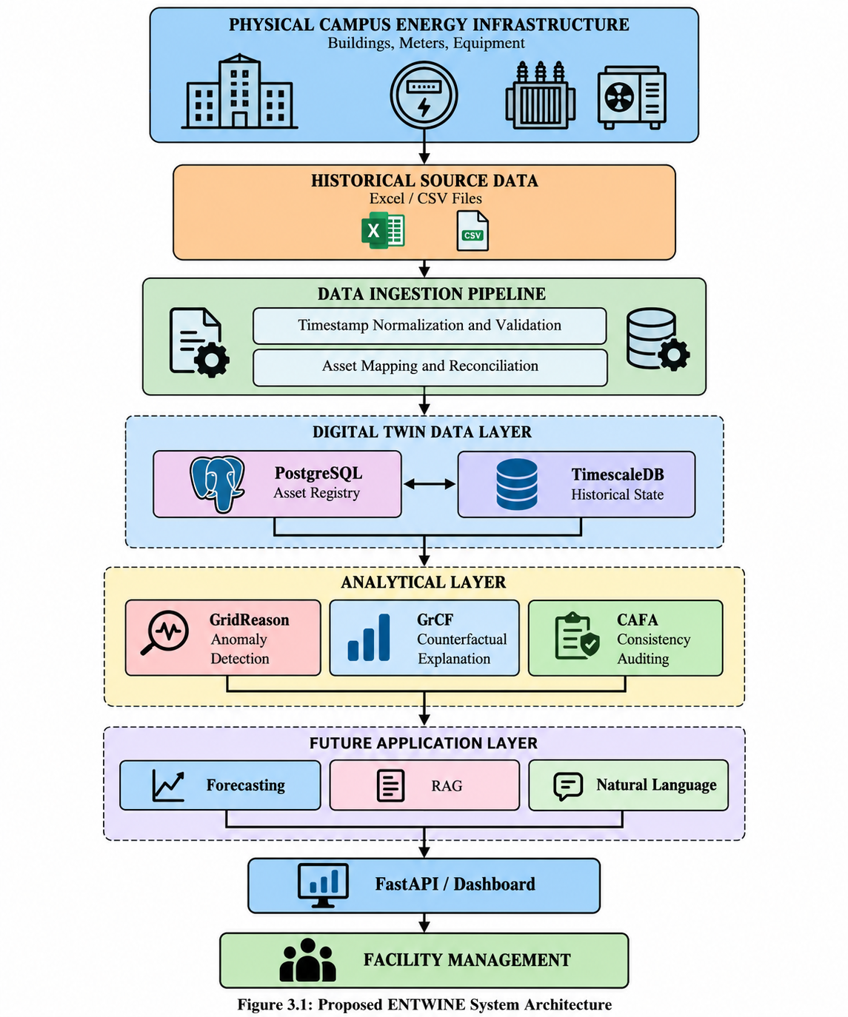
3.4 System Architecture

Explanation: The asset registry and historical state layer provide the data foundation. The analytical components are intended to consume validated data and generate outputs for the future application layer. The forecasting, RAG, API, and dashboard components represent planned extensions unless their implementations have been completed and tested.
3.5 Asset Registry
The Asset Registry is the structural foundation of ENTWINE. It maintains information about the physical components represented by the Digital Twin.
The registry includes structured tables for buildings, meters, equipment, and baseline parameters. Relationships between these entities are maintained using relational database constraints.
The registry supports the following functions:
- Maintaining stable asset identifiers.
- Associating meters with the appropriate registered assets.
- Storing relevant equipment and baseline metadata.
- Preventing inconsistent relationships through database constraints.
- Providing a trusted reference for historical data mapping.
- Validating the database schema and initial seed records.
The initial registry is configured for PH-01, the KCT Powerhouse. The implementation also maintains an asset mapping file to document source identifiers and mapping decisions.
Unknown asset details are not treated as confirmed facts. Uncertain mappings should be documented and validated before they are used for downstream analysis.
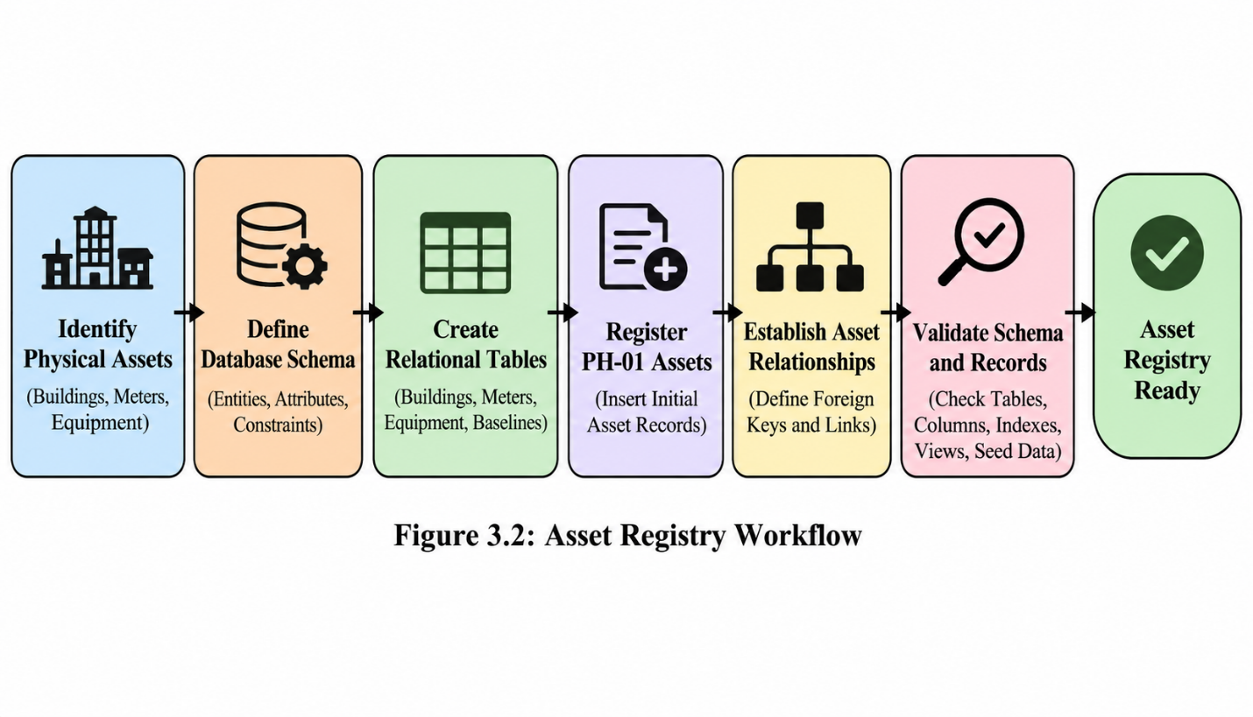
3.6 Historical Data Ingestion
The historical data ingestion module converts raw energy and operational files into structured records suitable for storage and analysis.
Source files may contain Excel-based energy reports and CSV-based alarm or event records. Since the files may use different formats, timestamps, and identifiers, they must be processed before their contents can be used reliably.
The ingestion pipeline performs source discovery, checksum auditing, file reading, timestamp normalization, data-quality validation, asset mapping, and state-layer migration. Reconciliation reports are generated to record the results of ingestion and validation.
The pipeline is designed to preserve traceability between source data and processed records. Invalid or uncertain records should be identified and reported rather than silently treated as reliable measurements.
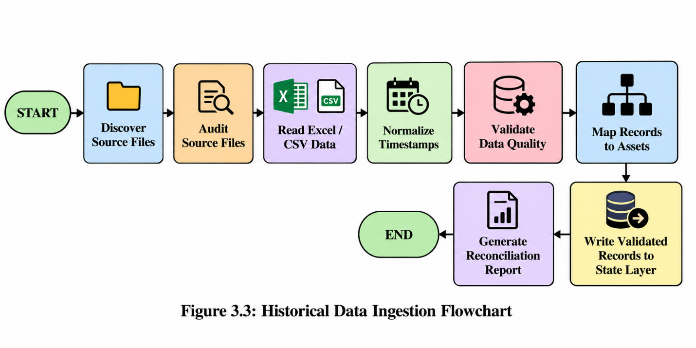

Note: The precise handling of invalid records, duplicate measurements, and missing values should follow the implemented ingestion rules. Do not claim that all such records are automatically corrected unless the code actually performs those corrections.

3.7 Digital Twin State Layer
The state layer represents the historical operational condition of the energy infrastructure. Unlike the Asset Registry, which describes what assets exist, the state layer stores observations associated with those assets over time.
TimescaleDB is used for historical time-series storage. This allows measurements to be organized around timestamps and associated asset identifiers.
The state layer is designed to support:
- Historical energy consumption queries.
- Time-based comparisons.
- Identification of unusual consumption patterns.
- Preparation of data for model evaluation.
- Retrieval of operational history for explanations.
- Future energy forecasting.
The separation between asset metadata and time-series observations provides a clear distinction between the structure of the physical system and its changing operational behaviour.
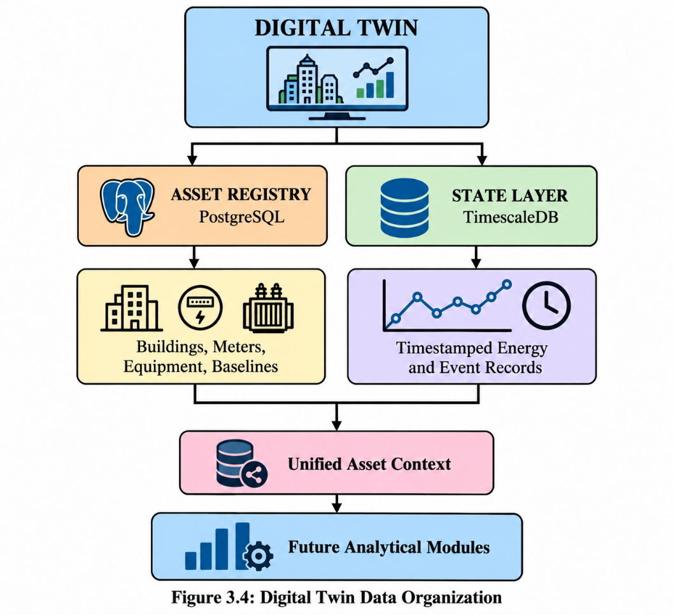
3.8 Anomaly Detection Using GridReason
GridReason is the planned anomaly detection component of ENTWINE. Its purpose is to identify observations that differ from the expected behaviour represented by the model.
After the historical data has been validated and mapped to the appropriate assets, the model can be evaluated against the relevant observations. Each model output should be associated with the corresponding asset, timestamp, prediction, and available ground-truth label.
The model's performance should be evaluated using suitable metrics, including precision, recall, F1-score, and AUROC when the data and prediction format support them.A detected anomaly should be treated as an indication that further investigation may be required. It should not automatically be interpreted as proof of a physical equipment fault.
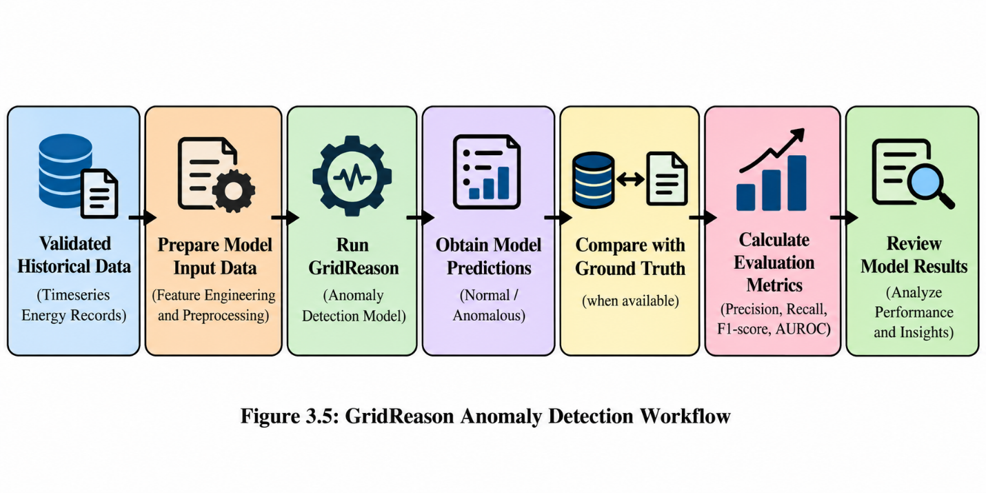
Implementation status: GridReason integration and evaluation remain a milestone to complete and verify. Any performance figures should be reported only after the corresponding experiment has been run and its results reproduced.

3.9 Counterfactual Explanation Using GrCF
GrCF is intended to provide counterfactual explanations for selected model predictions. A counterfactual explanation identifies a hypothetical change in the input features that would alter the model's output.
In ENTWINE, this component is intended to support the investigation of energy observations identified as anomalous. It may help users examine which input changes are associated with a different prediction.

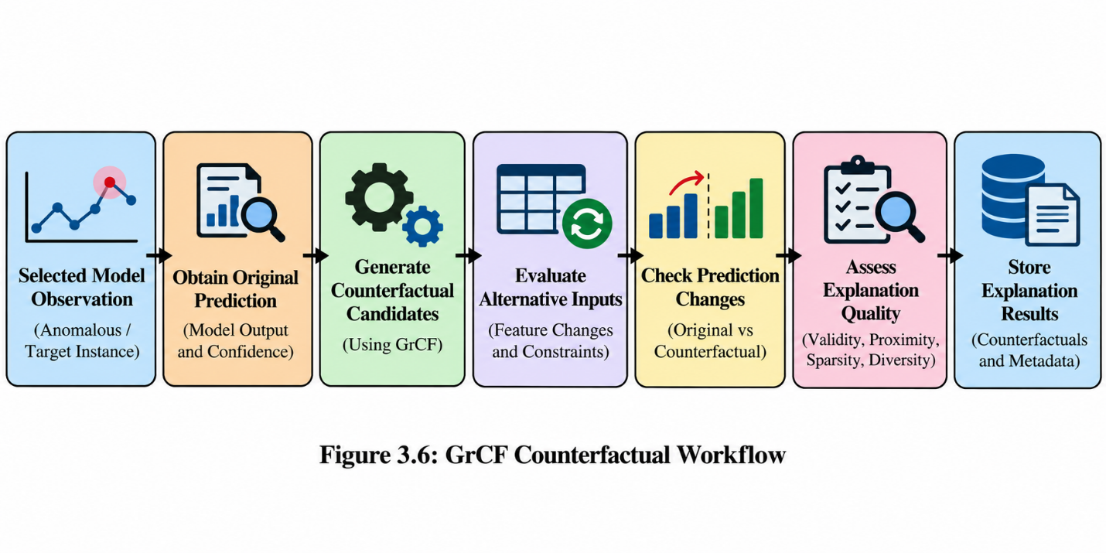

Counterfactual results should be evaluated for validity and quality. Relevant metrics may include validity, proximity, sparsity, and diversity, depending on the method and experimental design.
The resulting explanations must be interpreted carefully. A counterfactual describes a hypothetical model input; it does not necessarily prove the physical cause of an anomaly or guarantee that the suggested change is operationally achievable.

3.10 Consistency Auditing Using CAFA
CAFA is intended to audit whether the anomaly detection system performs consistently across the fault types represented in the evaluation data.
A model may achieve acceptable overall performance while performing poorly for particular categories. Therefore, the evaluation should examine category-level results in addition to aggregate metrics.

The CAFA module will use the available fault-type labels and model predictions to compare detection performance across the selected categories. Its results can help identify groups that require further investigation.
The exact audit methodology, including the definition and interpretation of any project-specific metric such as rho, must be documented from the actual implementation or the method's authoritative specification.
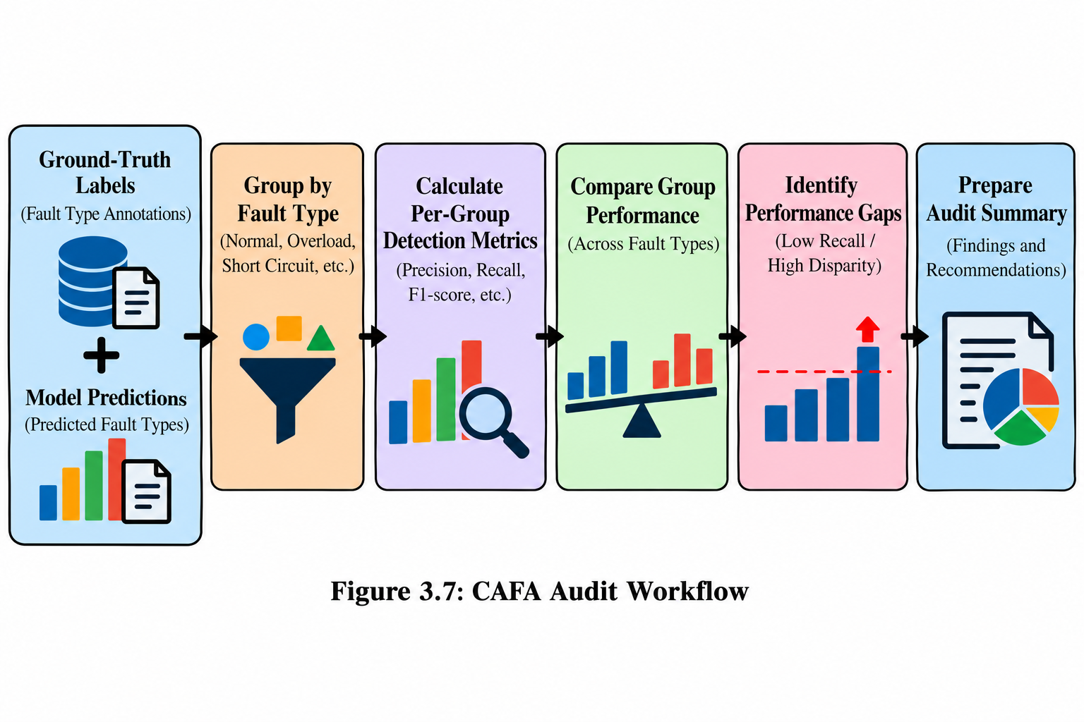

3.11 Future Forecasting Module
The planned forecasting module will estimate future energy consumption using historical measurements and relevant temporal features.
Forecasting can help users understand expected consumption trends and identify deviations between predicted and observed values. The forecasting component may also provide information for energy planning and operational monitoring.
Before a forecasting model is selected, the historical data must be examined for sampling frequency, missing intervals, seasonality, data volume, and potential leakage between training and test periods.
Forecasting performance may be evaluated using Mean Absolute Error (MAE), Root Mean Squared Error (RMSE), and Mean Absolute Percentage Error (MAPE), where these metrics are appropriate for the data.
This module is a planned enhancement and should be described as implemented only after model training, evaluation, and testing have been completed.

3.12 Natural-Language Querying and RAG
Retrieval-Augmented Generation (RAG) is a technique that combines information retrieval with a language model. The retrieval component identifies relevant information from a knowledge source, and the language model uses that information to generate a response.
ENTWINE plans to use RAG to make energy information more accessible through natural-language questions. For example, users may eventually ask about historical consumption, detected anomalies, or the explanations associated with a particular asset.
A future implementation may retrieve relevant asset records, energy summaries, model results, and documentation before generating an answer. The response should be grounded in the retrieved data, and the system should distinguish known results from missing or unavailable information.
The language model is intended to explain and summarize verified outputs rather than replace the numerical analysis performed by the backend.
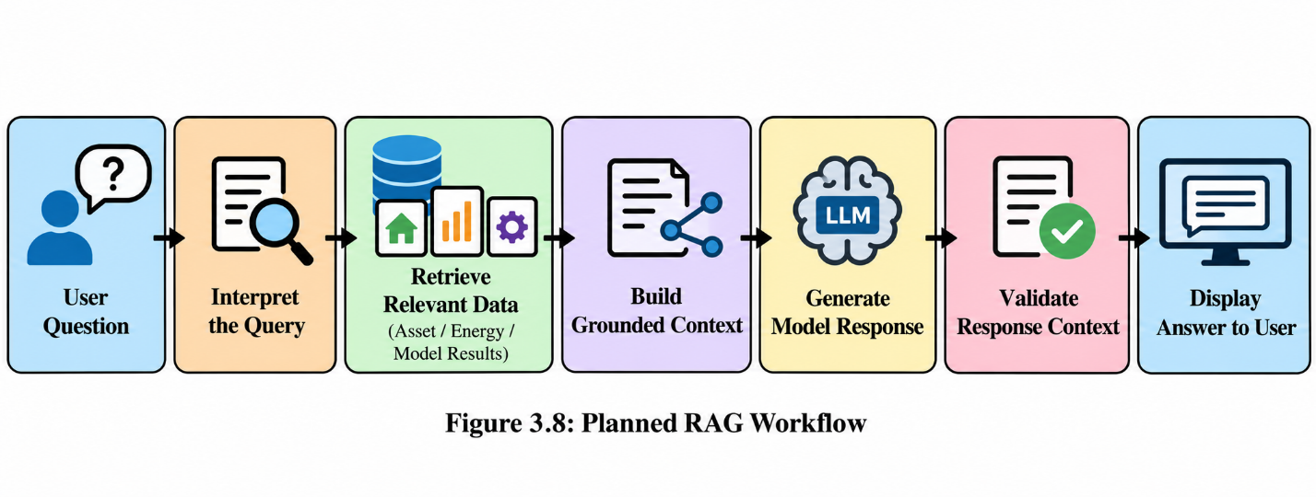

Implementation status: RAG and natural-language querying are planned modules. The workflow above describes the intended design, not a claim that the complete functionality is currently operational.

3.13 Dashboard and API Integration
The planned dashboard will provide an interface for viewing energy information and analytical results. It may display consumption trends, asset details, anomaly summaries, explanations, and audit results.
A backend API layer, potentially implemented using FastAPI, will mediate communication between the dashboard and the underlying data and analytical services.
The API will be responsible for processing requests, retrieving relevant information, and returning structured responses. The frontend should communicate with the backend API instead of directly accessing the database.
This separation is intended to improve maintainability, security, and modularity.

3.14 Algorithms and Workflow
The overall workflow of ENTWINE begins with the identification and registration of physical assets. Historical files are then processed and validated before being stored in the state layer.
The next stage is to integrate the analytical components with the validated data. Anomaly detection identifies observations for further investigation, counterfactual explanations provide hypothetical alternatives for selected predictions, and consistency auditing compares model performance across relevant categories.
The future forecasting and natural-language interaction modules will extend the system's analytical and user-facing capabilities.

CHAPTER 4 – SYSTEM IMPLEMENTATION
4.1 Development Environment
ENTWINE is being developed using a modular Python project structure. The development environment includes a Python virtual environment and pinned dependencies to support consistent package versions.
Docker is used to configure the local PostgreSQL and TimescaleDB environment. This provides a reproducible database setup and reduces differences between development environments.The project also contains configuration files, database initialization scripts, validation utilities, and documentation to support repeatable setup and execution.
The current implementation emphasizes reliable data storage and ingestion before introducing additional analytical and application components.

4.2 Technologies Used
Table 4.1: Technologies and Their Roles
Technology | Purpose
Python | Data processing, validation, and future model integration
PostgreSQL | Structured asset metadata and relational data management
TimescaleDB | Historical energy time-series storage
Docker | Reproducible local database environment
SQL | Database schema, relationships, and queries
Excel / CSV | Historical source data formats
Git and GitHub | Version control and source code management
FastAPI | Planned backend API
Dashboard framework | Planned user interface
Local language model | Planned natural-language interaction
Vector retrieval and embeddings | Planned RAG functionality
Only list FastAPI, dashboard frameworks, and language-model tools as implemented technologies if the corresponding code is present and working. Otherwise, retain them as planned technologies.

4.3 Database Implementation
The database architecture separates structured asset information from historical operational measurements.
PostgreSQL maintains the Asset Registry. Its relational schema includes tables for buildings, meters, equipment, and baseline parameters. Primary keys, foreign keys, and indexes support data integrity and efficient access. A twin_instances view provides a convenient summary of relevant asset information.
TimescaleDB is used for the historical state layer. Its purpose is to organize timestamped energy observations for subsequent querying and analysis.
Docker configuration is used to establish the local database environment. Database initialization and validation scripts support repeatable setup and checks of the schema and initial data.

4.4 Asset Registry Implementation
The Asset Registry implementation establishes the structural representation of the initial energy system.
The schema and seed data are maintained separately to make the database structure and initial records easier to inspect. An idempotent initialization process is used so that repeated initialization does not create duplicate seed records.
A validation script checks the database connection, expected tables, columns, indexes, view, and seed values.
The initial scope focuses on PH-01. An asset mapping file records the relationship between source identifiers and registered assets. Unknown or uncertain mappings are documented rather than silently treated as confirmed.

4.5 Data Ingestion Implementation
The historical data ingestion module is implemented to process source files and prepare them for the state layer.
The pipeline includes source-file discovery, checksum auditing, Excel and CSV readers, timestamp normalization, quality validation, asset mapping, state-layer migration, and reconciliation reporting.
A command-line execution flow is provided through ingestion/run.py. This makes it possible to run the ingestion pipeline in a structured manner and inspect its generated reports.
The separation between raw source files and validated database records improves traceability and helps identify problems before the data is used by analytical models.

4.6 Data Validation and Reconciliation
Data validation is important because the reliability of downstream analytical results depends on the quality of the input data.
ENTWINE's ingestion process includes validation and audit logic intended to identify invalid or incomplete records and document the outcome of processing.
Reconciliation reports provide a record of the ingestion results. They can be used to examine the relationship between source data, processed records, and the data stored in the state layer.
The validation process should document the number of records discovered, accepted, rejected, skipped, or otherwise handled, where these counts are available from the actual execution logs.

4.7 Module Integration Plan
The project is organized into modules so that each stage can be developed and validated independently.
Table 4.2: Module Implementation Status
Module | Description | Current status
Phase 0 | Environment and infrastructure setup | Complete
Module 1 | Asset Registry | Complete
Module 2 | Historical ingestion and state layer | Implemented and integrated
Module 3 | GridReason, GrCF, and CAFA validation | Next major milestone
Module 4 | Forecasting | Planned
Module 5 | RAG and natural-language querying | Planned
Module 6 | API and dashboard integration | Planned
The implementation status should be updated before submission if any of the later modules have since been completed and tested.

4.8 Security and Data Integrity
The database architecture uses relational constraints and structured validation to support data integrity. Asset identifiers and their relationships are maintained centrally to reduce the risk of incorrect associations between operational measurements and physical assets.Configuration files and environment-specific settings are separated from the main application logic. The project also uses version control and configuration practices intended to prevent local credentials and virtual-environment files from being committed to the repository.
Before production deployment, additional security measures should be evaluated, including access control, credential management, input validation, logging, backup procedures, and API authentication if a user-facing API is implemented.

4.9 Implementation Status
The current implementation establishes the foundation required for a Digital Twin platform. The development environment, database infrastructure, Asset Registry, and historical ingestion workflow have been implemented.
The Asset Registry provides structured metadata for the initial PH-01 scope. The ingestion pipeline prepares historical operational data for storage and later analysis.
The next major milestone is the integration and validation of the analytical components. Forecasting, RAG, natural-language querying, and dashboard integration remain future development tasks unless subsequent implementation and testing demonstrate otherwise.
This staged approach helps ensure that the analytical layers are built on validated data and documented asset relationships.

CHAPTER 5 – RESULTS AND DISCUSSION
5.1 Experimental Setup
The initial experimental environment is designed around the KCT Powerhouse, identified as PH-01. The development infrastructure uses Python, PostgreSQL, TimescaleDB, and Docker.The experiments are intended to validate the database structure, verify the asset registration process, evaluate historical data ingestion, and establish the data foundation for subsequent model testing.
The model evaluation stage will use suitable historical observations and ground-truth labels where available. The evaluation data, preprocessing procedures, model configurations, and metrics must be documented to support reproducibility.

5.2 Asset Registry Validation
The Asset Registry validation process checks whether the expected database structure and initial asset records have been created correctly.
The validation utility examines the database connection, tables, columns, indexes, view, and seed values. These checks help identify structural or configuration errors before the data ingestion and analysis stages depend on the registry.

Table 5.1: Asset Registry Validation Results
Test | Expected outcome | Actual result
Database connection | Successful connection | PASS — successful TimescaleDB connection recorded.
Required tables | All expected tables exist | PASS — buildings, meters, equipment, and baseline_parameters exist.
Column validation | Expected columns are present | PASS — 37/37 required columns present.
Index validation | Required indexes exist | PASS — 4/4 required indexes present.
View validation | twin_instances is available | PASS — twin_instances view exists with the expected columns.
Seed data validation | PH-01 records match expected values | PASS — PH-01 building and PH-01-MAIN meter values match the seed.
Relationship validation | Asset relationships are valid | PASS — required foreign-key relationships are valid.

5.3 Historical Data Ingestion Validation
The ingestion pipeline is designed to process historical Excel and CSV files, normalize timestamps, validate records, map observations to registered assets, and write the processed data into the state layer.
The validation stage should compare the records discovered in the source files with the records processed and stored by the pipeline.

Table 5.2: Historical Data Ingestion Results
Validation measure | Actual value
Number of source files discovered | 29 files
Number of source records read | 351,519 rows
Number of records accepted | 284,462 curated records
Number of records rejected or skipped | 67,057 rejected as unresolved feeders; 0 skipped in the initial ingest run
Number of records mapped to assets | 284,462 curated records; 10 source mappings resolved and 2 feeder mappings quarantined
Number of records written to the state layer | 284,462 curated records across state tables, including 281,895 interval telemetry rows
Timestamp validation outcome | PASS — timestamps normalized and recorded as valid UTC values
Reconciliation report generated | PASS — logs/module2_reconciliation_20260826T155643Z.md

5.4 Data Quality and Reconciliation
Data quality checks are necessary to ensure that the state layer represents the source data as accurately as possible.
Timestamp normalization provides a consistent representation of temporal information. Asset mapping connects source records to registered assets. Validation and reconciliation help identify inconsistencies between the original files and the processed data.
The reconciliation results should be reviewed to identify invalid records, unresolved mappings, duplicate observations, missing measurements, and other issues supported by the actual validation reports.
Any unresolved issues should be documented as limitations or items requiring further investigation.

5.5 Planned Model Evaluation
The next major analytical milestone is the integration and evaluation of GridReason, GrCF, and CAFA.
GridReason will be evaluated for its ability to distinguish anomalous observations from normal observations. GrCF will be assessed for the quality of its generated counterfactual explanations. CAFA will be used to investigate differences in detection performance across the fault types represented in the evaluation data.
The models must be evaluated using the actual project data and a documented experimental procedure. Baseline figures from previous project materials should not be presented as ENTWINE's achieved results unless the corresponding experiment has been executed and reproduced within the current implementation.

Table 5.3: Planned Model Evaluation
Component | Evaluation objective | Possible metrics
GridReason | Measure anomaly detection performance | Precision, Recall, F1-score, AUROC
GrCF | Assess counterfactual quality | Validity, Proximity, Sparsity, Diversity
CAFA | Compare detection performance across fault types | Per-category Recall, Recall Disparity, applicable audit statistics
Forecasting | Measure prediction error | MAE, RMSE, MAPE
RAG | Evaluate retrieval and answer quality | Context Precision, Context Recall, Faithfulness, Answer Relevancy
The metrics used in the final report must correspond to the actual implementation and evaluation methodology. Some metrics require specific types of labels or outputs and may not be appropriate for every model.
5.6 Evaluation Metrics
Precision: Precision measures the proportion of observations predicted as positive that are actually positive.
$$\text{Precision}=\frac{TP}{TP+FP}$$
where $TP$represents true positives and $FP$represents false positives.
Recall: Recall measures the proportion of actual positive observations that the model correctly identifies.
$$\text{Recall}=\frac{TP}{TP+FN}$$
where $FN$represents false negatives.
F1-Score: The F1-score is the harmonic mean of precision and recall.
$$F1=2×\frac{\text{Precision}×\text{Recall}}{\text{Precision}+\text{Recall}}$$
It provides a combined measure of precision and recall and can be useful when both false positives and false negatives are important.
Mean Absolute Error: Mean Absolute Error measures the average absolute difference between actual and predicted numerical values.
$$MAE=\frac{1}{n}\sum_{i=1}^{n}{∣}y_{i}-{\hat{y}}_{i}∣$$
where $y_{i}$is the actual value and ${\hat{y}}_{i}$is the predicted value.
MAE may be used for evaluating a future energy forecasting model.

5.7 Discussion and Limitations
The current implementation establishes the database and historical ingestion foundation for ENTWINE. The separation between the Asset Registry and state layer provides a structured approach to representing physical assets and their changing operational measurements.
The modular design also supports traceability. Source data can be processed and validated before being made available to analytical components, reducing the risk of using unverified records without investigation.
However, the usefulness of subsequent model outputs will depend on the quality and completeness of the available data, the correctness of asset mappings, the availability of suitable labels, and the validity of the evaluation methodology.
The current project should not be considered a fully operational campus-wide energy intelligence system until the analytical components have been integrated, evaluated, and connected to the intended user-facing interface.
The initial PH-01 scope also limits the conclusions that can be drawn about performance across the entire campus. Additional buildings and meters will require appropriate asset mapping and data validation before the system can be generalized.

CHAPTER 6 – CONCLUSION AND FUTURE WORK
6.1 Conclusion
ENTWINE (Energy Twin with INtegrated Explainability) is being developed as a Digital Twin platform for campus energy infrastructure, with an initial focus on the KCT Powerhouse, PH-01. The project aims to connect physical asset information with historical operational measurements and intelligent analytical methods to support more transparent energy monitoring.
The current implementation establishes the development environment, database infrastructure, Asset Registry, and historical data ingestion pipeline. PostgreSQL maintains structured asset metadata, while TimescaleDB supports historical time-series storage. The ingestion workflow includes source discovery, timestamp normalization, data-quality validation, asset mapping, and reconciliation reporting.
These components provide the foundation required for subsequent analytical development. The next major milestone is the integration and validation of GridReason for anomaly detection, GrCF for counterfactual explanations, and CAFA for consistency auditing. Future extensions include energy forecasting, RAG-based natural-language interaction, and an interactive dashboard.
Overall, ENTWINE adopts a modular and data-oriented approach to Digital Twin development. Its intended contribution is to establish a traceable connection between physical energy infrastructure, historical observations, analytical results, and future decision-support capabilities. The effectiveness of the complete platform will need to be demonstrated through model validation, experimental results, and integrated system testing.

6.2 Future Enhancements
The following enhancements are planned for future development.
1. Analytical Model Integration
Integrate GridReason, GrCF, and CAFA with the validated state layer and evaluate their performance using documented experimental procedures.
2. Energy Forecasting
Develop forecasting models that estimate future energy consumption and evaluate their performance using appropriate error metrics.
3. Natural-Language Interaction
Introduce a natural-language interface that allows users to ask questions about assets, historical consumption, and analytical results.
4. Retrieval-Augmented Generation
Integrate a retrieval mechanism that supplies relevant project data and documentation to a language model so that responses are grounded in available information.
5. Interactive Dashboard
Develop a dashboard that displays consumption trends, anomaly summaries, counterfactual explanations, and audit results.
6. Multi-Asset Expansion
Extend the Asset Registry and state layer from PH-01 to additional campus buildings and meters after validating their identifiers and source data.
7. Real-Time Data Integration
Investigate integration with live meter feeds or monitoring systems to support regular updates to the Digital Twin state.
8. Reliability and Security
Introduce further testing, access controls, monitoring, backup procedures, and deployment practices as the system progresses toward production use.
REFERENCES
- Himeur, Y., Ghanem, K., Alsalemi, A., Bensaali, F., & Amira, A. (2021). Artificial intelligence based anomaly detection of energy consumption in buildings: A review, current trends and new perspectives. Applied Energy, 287, 116601. https://doi.org/10.1016/j.apenergy.2021.116601
- Chen, Z., Xiao, F., Guo, F., & Yan, J. (2023). Interpretable machine learning for building energy management: A state-of-the-art review. Advances in Applied Energy, 9, 100123. https://doi.org/10.1016/j.adapen.2023.100123
- Li, C., Lu, P., Zhu, W., Zhu, H., & Zhang, X. (2023). Intelligent monitoring platform and application for building energy using information based on digital twin. Energies, 16(19), 6839. https://doi.org/10.3390/en16196839
- Arsecularatne, B. P., Rodrigo, N., & Chang, R. (2024). Review of reducing energy consumption and carbon emissions through digital twin in built environment. Journal of Building Engineering, 98, 111150. https://doi.org/10.1016/j.jobe.2024.111150

- Zhang, X., Zheng, J., Li, P., Yang, Y., Ye, Y., Causone, F., & Shi, X. (2025). A review of building digital twins: Framework and enabling technologies. Journal of Building Engineering, 111, 113117. https://doi.org/10.1016/j.jobe.2025.113117
- Chen, Y., Guo, M., Chen, Z., Chen, Z., & Ji, Y. (2022). Physical energy and data-driven models in building energy prediction: A review. Energy Reports, 8, 2656–2671. https://doi.org/10.1016/j.egyr.2022.01.162
- Yu, J., Chang, W.-S., & Dong, Y. (2022). Building energy prediction models and related uncertainties: A review. Buildings, 12(8), 1284. https://doi.org/10.3390/buildings12081284
- Pan, Y., Zhu, M., Lv, Y., Yang, Y., Liang, Y., Yin, R., et al. (2023). Building energy simulation and its application for building performance optimization: A review of methods, tools, and case studies. Advances in Applied Energy, 10, 100135. https://doi.org/10.1016/j.adapen.2023.100135
- Li, Y., Ji, M., Chen, J., Wei, X., Gu, X., & Tang, J. (2025). A large language model-based building operation and maintenance information query. Energy and Buildings, 334, 115515. https://doi.org/10.1016/j.enbuild.2025.115515
- Yang, Y., Duan, Q., & Samadi, F. (2025). A systematic review of building energy performance forecasting approaches. Renewable and Sustainable Energy Reviews, 223, 116061. https://doi.org/10.1016/j.rser.2025.116061

