Capture Moments-Aws powered Photographer booking system

Project Description:
At Capture Moments Photography, the growing client base has created challenges in managing bookings and connecting customers with the right photographers. The manual booking process was inefficient and prone to errors, causing scheduling conflicts and customer dissatisfaction.
To solve this, Capture Moments developed a cloud-based Photographer Booking Platform. Using Flask for backend development, AWS EC2 for hosting, and DynamoDB for managing data, the system allows clients to register, log in, and book photographers online. This cloud-based solution enhances the booking experience, providing seamless service for all clients while optimizing photographer scheduling and data management.

Scenarios:
Scenario 1: Efficient Booking System for Clients
In the Capture Moments Booking Platform, AWS EC2 ensures a reliable infrastructure to manage multiple clients accessing the platform simultaneously. For example, a client can log in, navigate to the booking page, and easily submit a request for their preferred photographer. Flask handles backend operations, efficiently retrieving and processing user data in real-time. The cloud-based architecture allows the platform to handle a high volume of booking requests during peak wedding seasons, ensuring smooth operation without delays.
Scenario 2: Centralized Booking Management
When clients book photography sessions, the Capture Moments Booking System processes these requests through a streamlined workflow. For instance, a client books a wedding photographer, and Flask processes the request, storing all the booking details securely in DynamoDB. This centralized database approach ensures all booking information is maintained in a single source of truth, allowing administrative staff to track upcoming appointments, manage photographer schedules, and maintain complete records of client preferences and requirements.
Scenario 3: Easy Access to Photography Services
The Capture Moments Booking Platform provides clients with easy access to available photographers and packages. For example, a client logs in and views the list of available photographers specializing in their event type. They can quickly check availability for specific dates or book immediately. Flask manages real-time data fetching from DynamoDB, while EC2 hosting ensures the platform performs seamlessly even when multiple clients access it simultaneously during popular booking periods, offering a smooth and uninterrupted user experience.

AWS ARCHITECTURE
This AWS-based architecture powers a scalable and secure web application using Amazon EC2 for hosting the backend, with a lightweight framework like Flask handling core logic. Application data is stored in Amazon DynamoDB, ensuring fast, reliable access, while user access is managed through AWS IAM for secure authentication and control. Real-time alerts and system notifications are enabled via Amazon SNS, enhancing communication and user engagement.
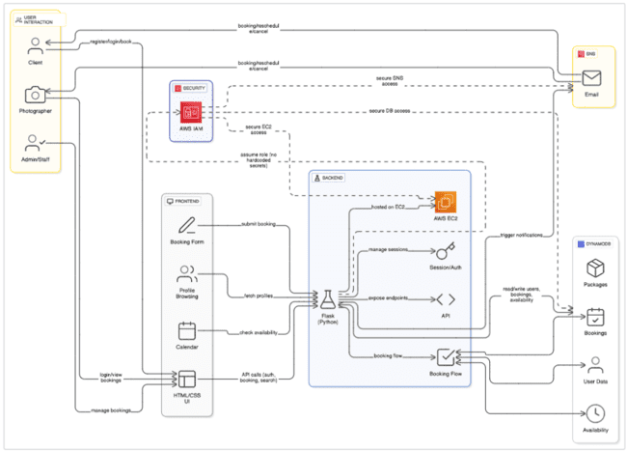

Entity Relationship (ER)Diagram:
An ER (Entity-Relationship) diagram visually represents the logical structure of a database by defining entities, their attributes, and the relationships between them. It helps organize data efficiently by illustrating how different components of the system interact and relate. This structured approach supports effective database normalization, data integrity, and simplified query design.

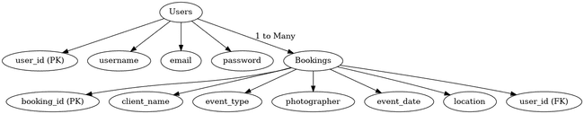

Pre-requisites:
- AWS Account Setup:https://docs.aws.amazon.com/accounts/latest/reference/getting-started.html
- AWS IAM (Identity and Access Management):
https://docs.aws.amazon.com/IAM/latest/UserGuide/introduction.html
- AWS EC2 (Elastic Compute Cloud):
https://docs.aws.amazon.com/AWSEC2/latest/UserGuide/concepts.html
- AWS DynamoDB: https://docs.aws.amazon.com/amazondynamodb/Introduction.html
- Amazon SNS: https://docs.aws.amazon.com/sns/latest/dg/welcome.html
- Git Documentation: https://git-scm.com/doc
- VS Code Installation (download the VS Code using the below link or you can get that in Microsoft store):https://code.visualstudio.com/download

Project Flow:

Milestone 1. Backend Development and Application Setup

Develop the Backend Using Flask.

Integrate AWS Services Using boto3.

Milestone 2. AWS Account Setup and Login

Set up an AWS account if not already done.

Log in to the AWS Management Console

Milestone 3. DynamoDB Database Creation and Setup

Create a DynamoDB Table.

Configure Attributes for User Data and Book Requests.

Milestone 4. IAM Role Setup

Create IAM Role

Attach Policies

Milestone 5. EC2 Instance Setup

Launch an EC2 instance to host the Flask application.

Configure security groups for HTTP, and SSH access.

Milestone 6. Deployment on EC2

Upload Flask Files

Run the Flask App

Milestone 7. Testing and Deployment

Conduct functional testing to verify user signup, login, about us, photographers and bookings.

Milestone 1: Web Application Development and Setup

Backend Development and Application Setup focuses on establishing the core structure of the application. This includes configuring the backend framework, setting up routing, and integrating database connectivity. It lays the groundwork for handling user interactions, data management, and secure access.

Important Instructions:

Start by creating the necessary HTML pages and Flask routes (app.py) to build the core functionality of your application.

During the initial development phase, store and retrieve data using Python dictionaries or lists locally. This will allow you to design, test, and validate your application logic without external database dependencies.

Ensure your app runs smoothly with local data structures before integrating any cloud services.

Post Troven Access Activation:

Once Troven Labs access is provided (valid for 3 hours), you must immediately proceed with Milestone 1 of your Guided Project instructions.

At this point, modify your app.py and replace local dictionary/list operations with AWS services (such as DynamoDB, RDS, or others as per project requirements).

Using the temporary credentials provided by Troven Labs, securely connect your application to AWS resources.

Since the AWS configuration is lightweight and already instructed in the milestones, you should be able to complete the cloud integration efficiently within the allotted time.

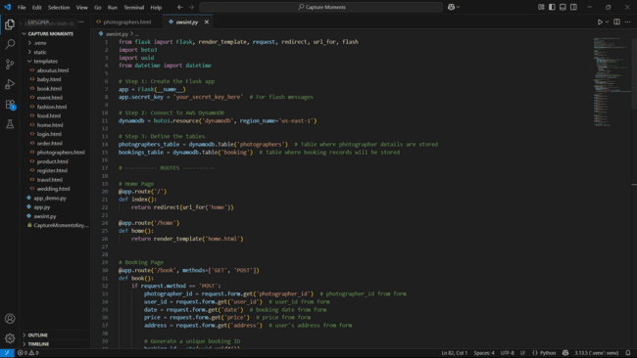

Description of code:

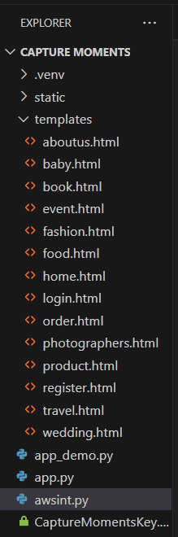

1. Imports:

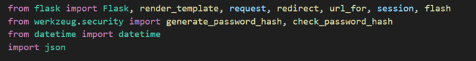

Flask: Main class to create the web app.

render_template: Loads HTML templates.

request: Handles form data (like login form).

redirect, url_for: Redirect users to different pages.

session: Stores logged-in user data securely.

flash: Shows quick alert messages like "Logged in successfully".

generate_password_hash, check_password_hash: Secures user passwords.

datetime: Used to store booking time.

json: Used to view/debug users/bookings in JSON format.

2. Flask App Initialization:

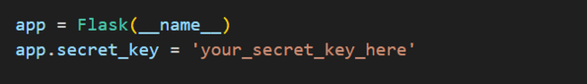

app = Flask(__name__): Starts the Flask application.

app.secret_key: Required to safely use sessions and flashes.

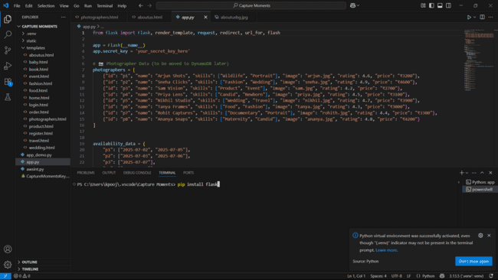

3.Boto3 Initialization:

You typically install it via the terminal using pip, like this:

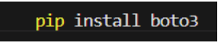

Description: -This command tells Python’s package manager (pip) to download and install the boto3 library from the Python Package Index. Dependencies Installed Along with boto3 When you run the above command, it also installs.

• botocore – Low-level core functionality shared across AWS SDKs

• jmespath – Used for filtering JSON responses

• s3transfer – For efficient file uploads and downloads from S3

• urllib3, python-dateutil, and docutils – Used internally by botocore

After installation, the terminal will show: Successfully installed boto3-x.x.x botocore-x.x.x jmespath-x.x.x ...

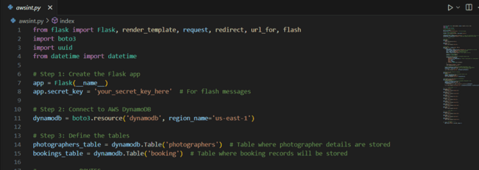

4.Route for Web Pages:

Login Route:

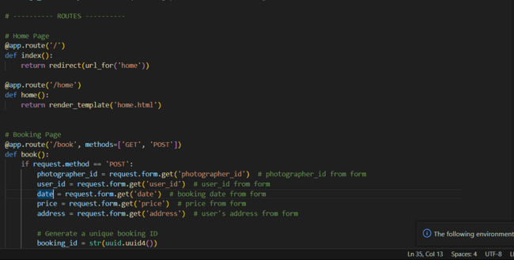

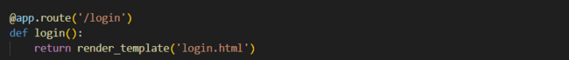

Booking Route:

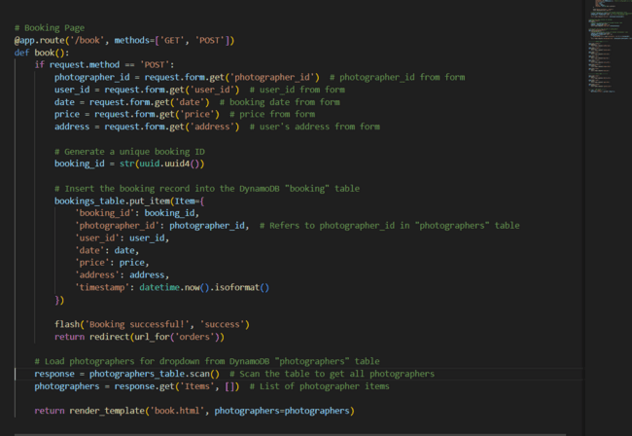

Order page:

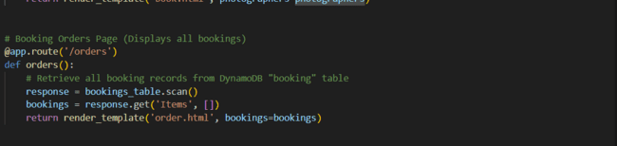

Photographers Page:

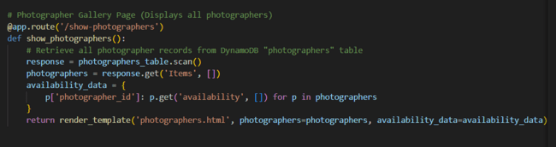

Service Pages:

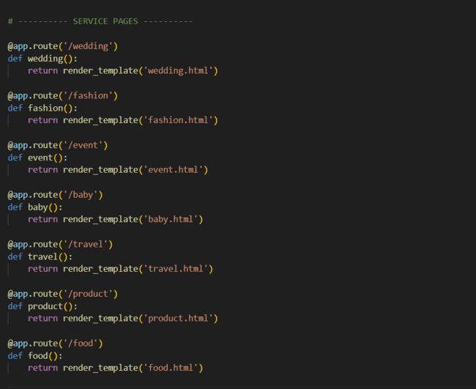

Static pages:

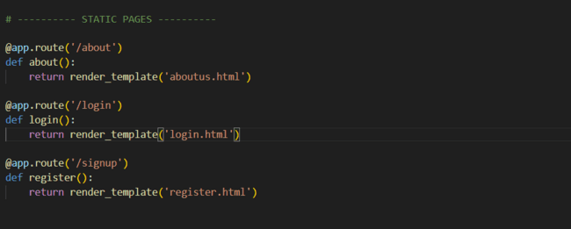

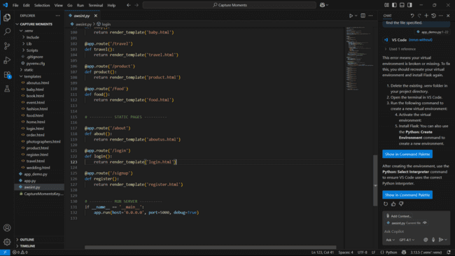

Milestone 2: AWS Account Setup

Important Notice: Use Troven Labs for AWS Access

Students are strictly advised not to create their own AWS accounts, as doing so may incur charges. Instead, we have set up a dedicated section called “Labs” on the Troven platform, which provides temporary and cost-free access to AWS services.

Once your website is locally deployed and fully functional, you must proceed with integrating AWS services only through the Troven Labs environment. This ensures secure, controlled access to AWS resources without any risk of personal billing.

All steps involving AWS (such as deploying to EC2, connecting to DynamoDB, or using SNS) must be carried out within the Troven Labs platform, as we've configured temporary credentials for each student.
Reminder: You must complete the Web Development task before gaining access to Troven. Once accessed, the AWS Console via Troven is available for only 3 hours—please plan your work accordingly.

Please follow the provided guidelines and access AWS exclusively through Troven to avoid unnecessary issues.

Pleasehttps://drive.google.com/file/d/1HzWc7AMJ2BrxhV-uaw5s0vWtcd-28qgI/view?usp=sharing

Activity 2.1: Set up an AWS account if not already done.

Go to the AWS website (https://aws.amazon.com/).

Click on the "Create an AWS Account" button.

Follow the prompts to enter your email address and choose a password.

Provide the required account information, including your name, address, and phone number.

Enter your payment information. (Note: While AWS offers a free tier, a credit card or debit card is required for verification.)

Complete the identity verification process.

Choose a support plan (the basic plan is free and sufficient for starting).

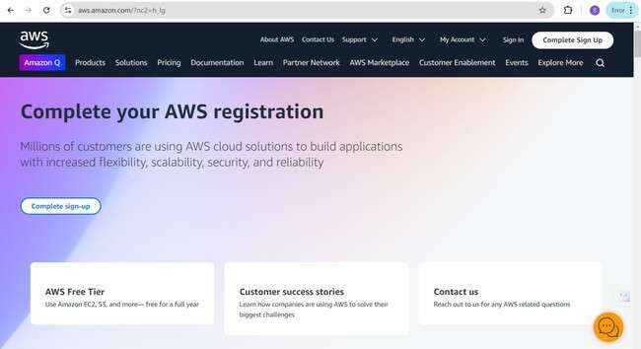
Once verified, you can sign in to your new AWS accounts.

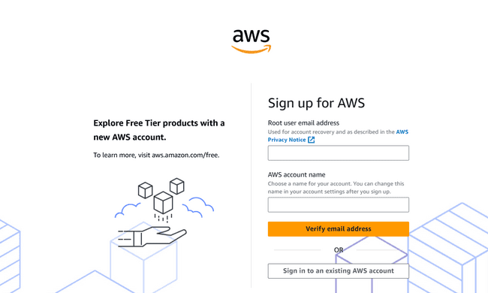

Activity 2.2: Log in to the AWS Management Console

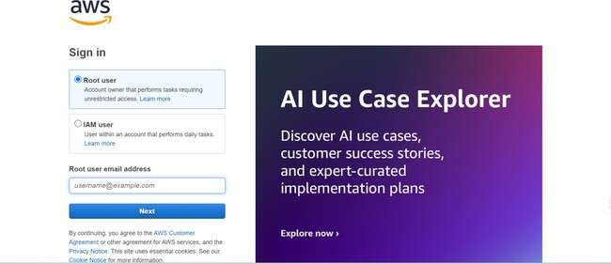
After setting up your account, log in to the AWS Management Console.

Milestone 3: DynamoDB Database Creation and Setup

This outlines the steps to create and configure Amazon DynamoDB tables for a user and transaction management system. It involves accessing the DynamoDB console, creating two tables, defining their primary keys and attributes (including data types like String, Decimal, and ISO formatted datetime), and setting up Global Secondary Indexes for efficient querying by email and user ID.

Activity 3.1: Navigate to the DynamoDB

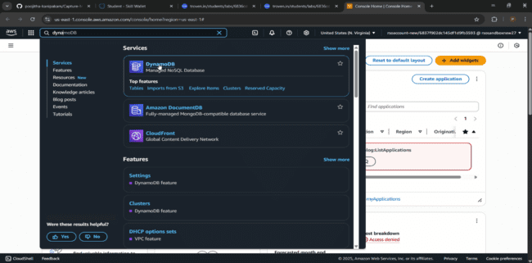
In the AWS Console, navigate to DynamoDB and click on create tables.

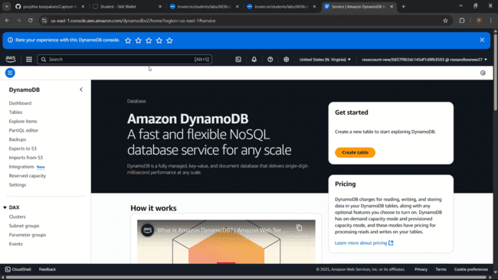

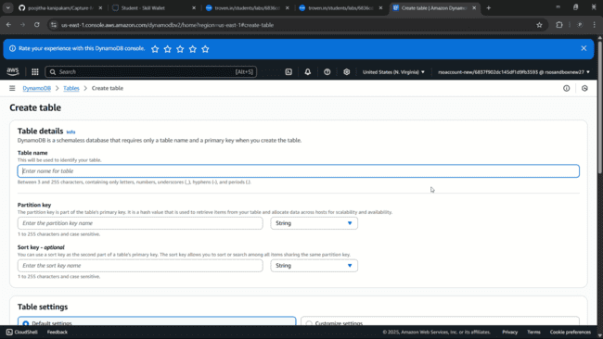

Activity 3.2: Create a DynamoDB table for storing registration details and book requests.
- Create photographer table with partition key “photographer_id” with type String and click on create tables.
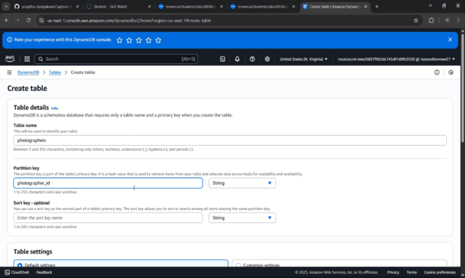

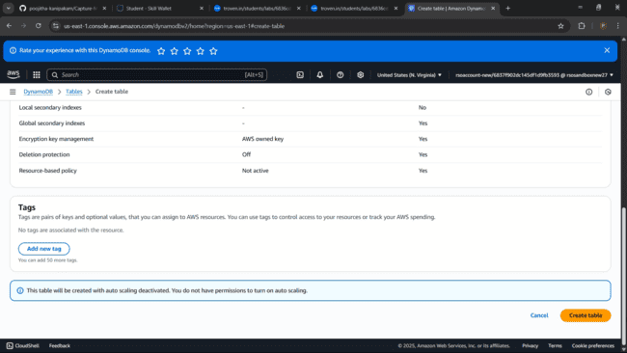

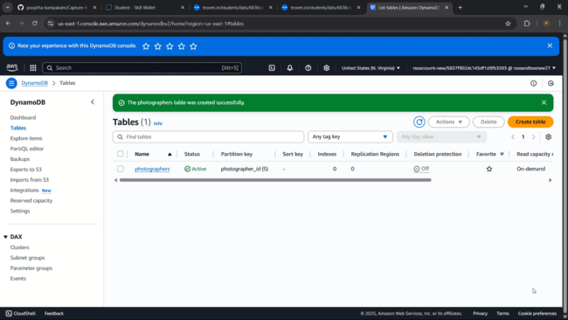

- Follow the same steps to create a booking table with booking_id as the primary key for book requests data.

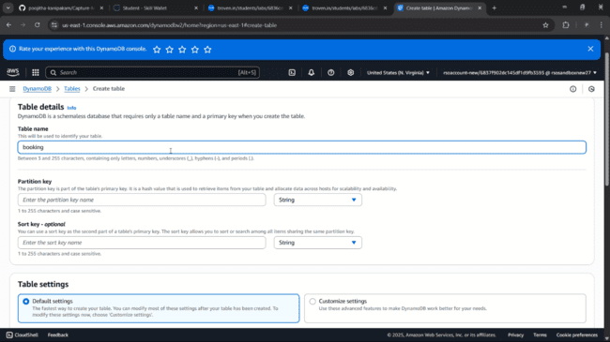

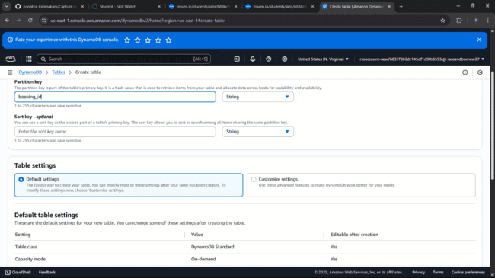

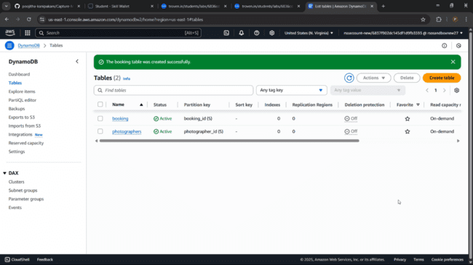
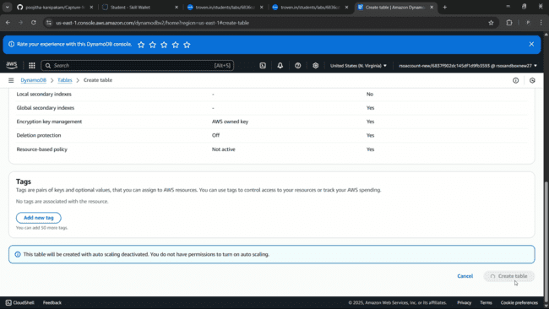

Milestone 4: IAM Role Setup

IAM (Identity and Access Management) role setup involves creating roles that define specific permissions for AWS services. To set it up, you create a role with the required policies, assign it to users or services, and ensure the role has appropriate access to resources like EC2, S3, or RDS. This allows controlled access and ensures security best practices in managing AWS resources.

Activity 4.1: Create IAM Role.
- In the AWS Console, go to IAM and create a new IAM Role for EC2 to interact with DynamoDB.
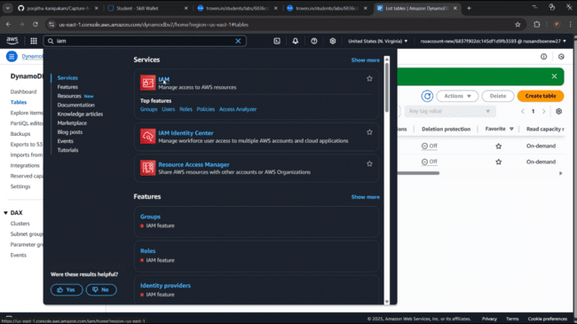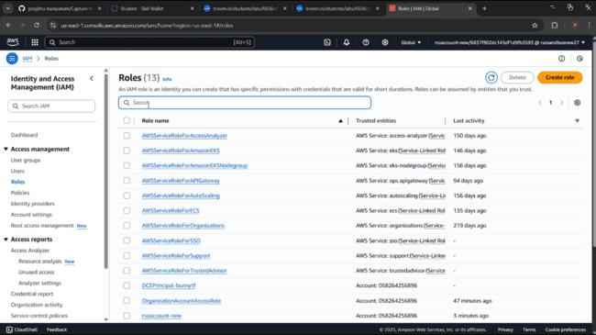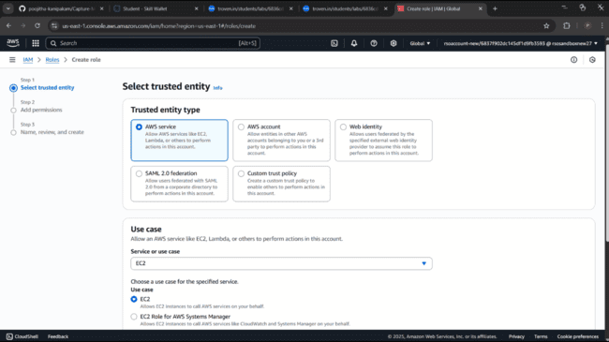

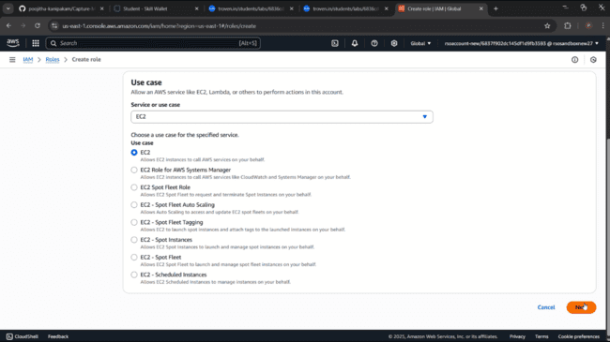

Activity 4.2: Attach Policies.
Attach the following policies to the role:
- AmazonDynamoDBFullAccess: Allows EC2 to perform read/write operations on DynamoDB.
- AmazonSNSFullAccess: Grants EC2 the ability to send notifications via SNS.
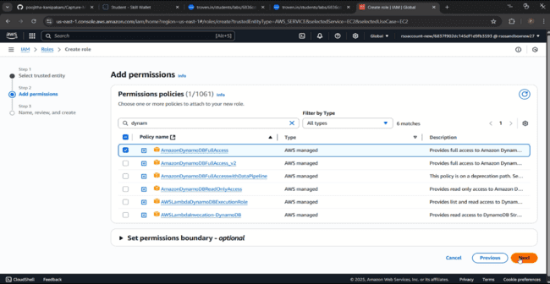

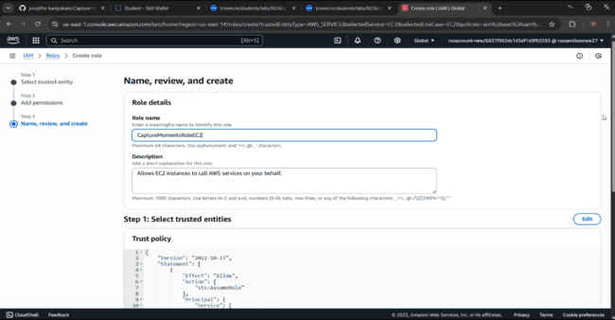

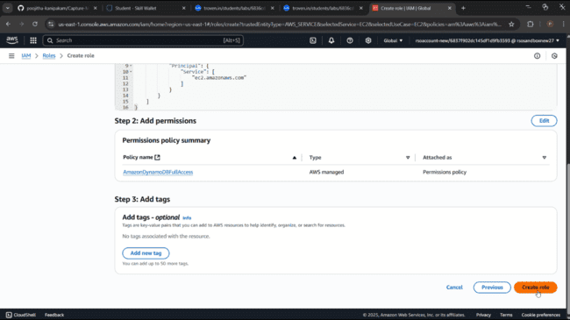

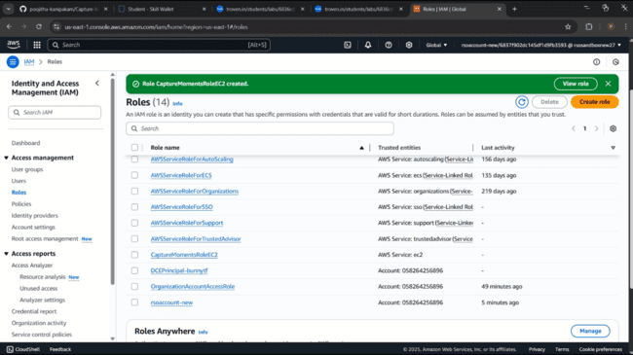

Milestone 5: EC2 Instance Setup
- Note: Load your Flask app and Html files into GitHub repository.

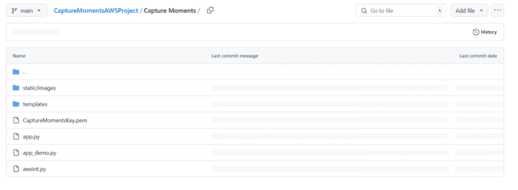

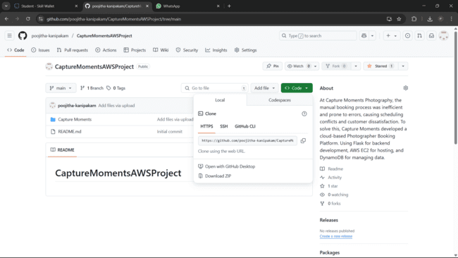

GitHub link: CaptureMomentsAWSProject

Activity 5.1: Launch an EC2 instance to host the Flask application.

Launch EC2 Instance
    - In the AWS Console, navigate to EC2 and launch a new instance.
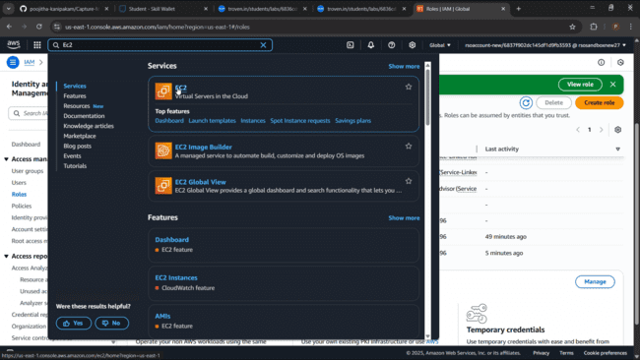
- Click on Launch instance to launch EC2 instance
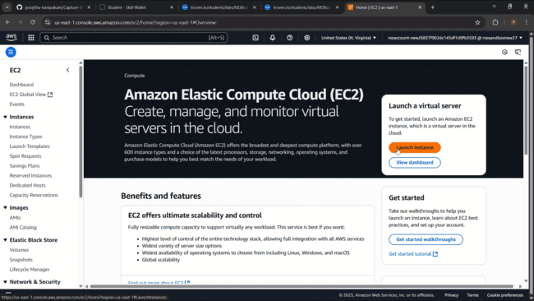

  - Choose Amazon Linux 2 or Ubuntu as the AMI and t2.micro as the instance type (free-tier eligible).

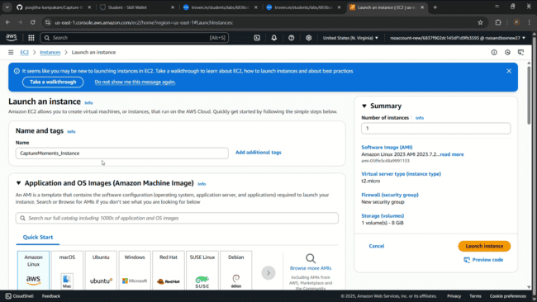

- Create and download the key pair for Server access.
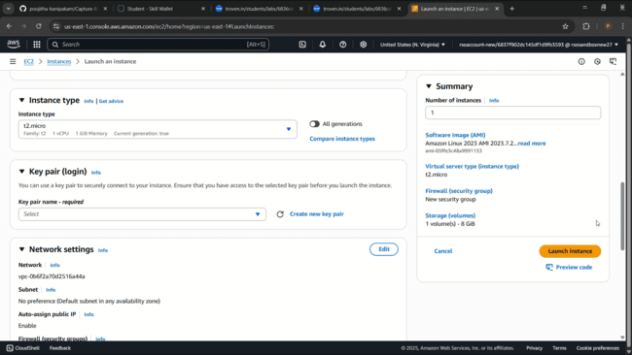

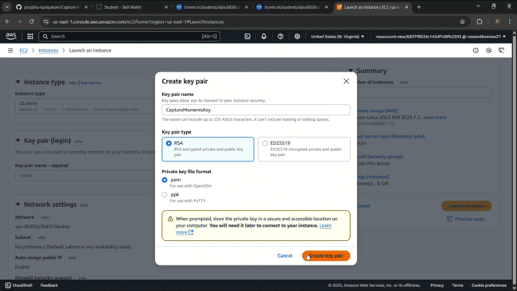

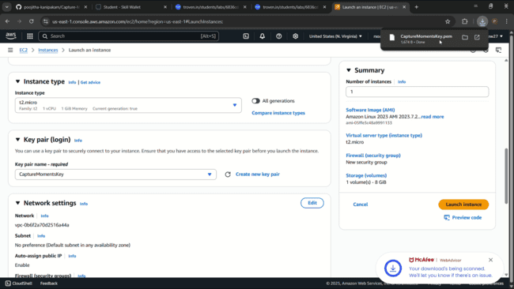

Activity 5.2: Configure security groups for HTTP, and SSH access.

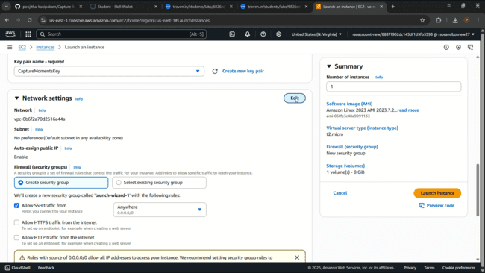

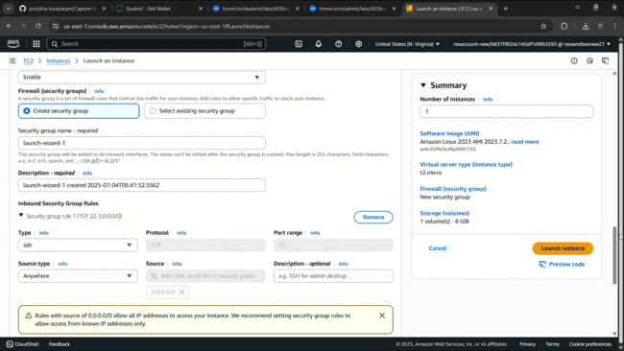

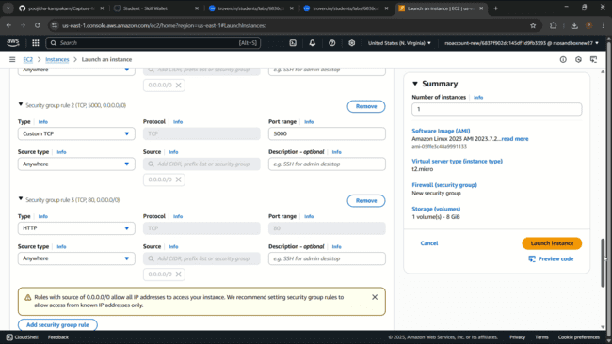

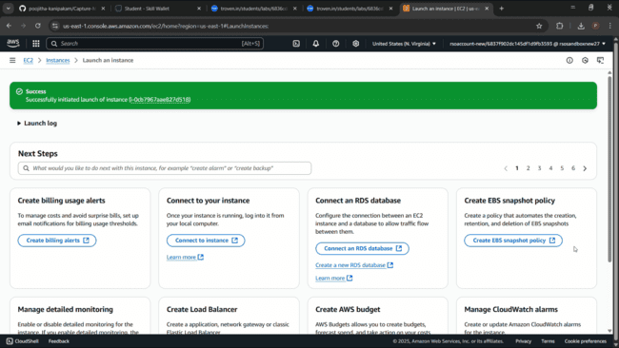

- To connect to EC2 using EC2 Instance Connect, start by ensuring that an IAM role is attached to your EC2 instance. You can do this by selecting your instance, clicking on Actions, then navigating to Security and selecting Modify IAM Role to attach the appropriate role. After the IAM role is connected, navigate to the EC2 section in the AWS Management Console. Select the EC2 instance you wish to connect to. At the top of the EC2 Dashboard, click the Connect button. From the connection methods presented, choose EC2 Instance Connect. Finally, click Connect again, and a new browser-based terminal will open, allowing you to access your EC2 instance directly from your browser.

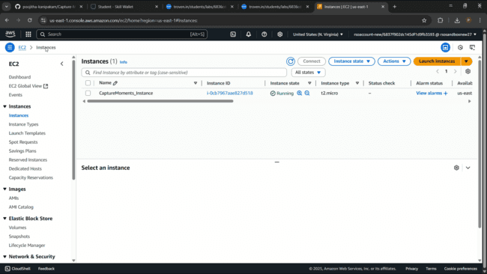

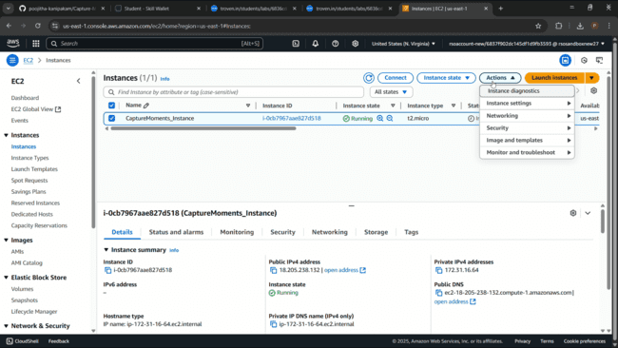

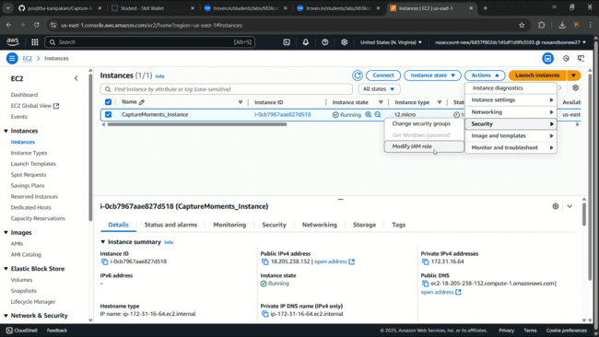

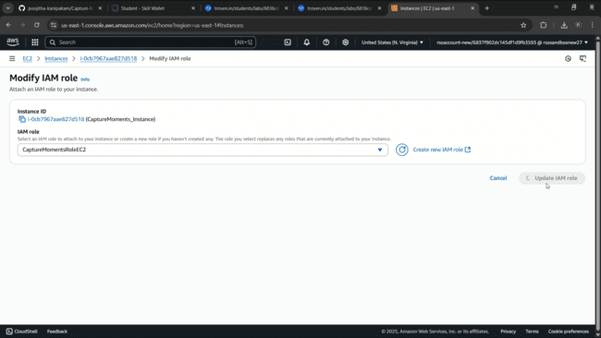

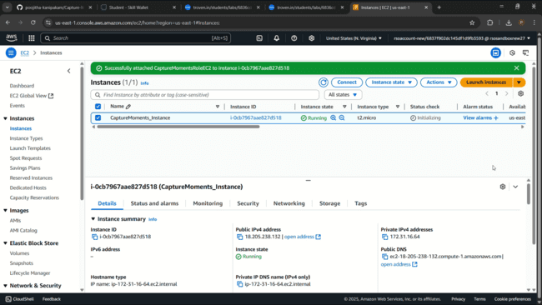

- Now connect the EC2 with the files

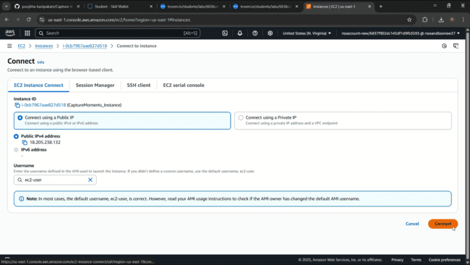
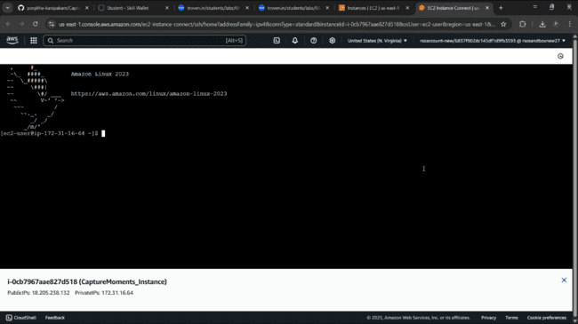

Milestone 6: Deployment using EC2

Deployment on an EC2 instance involves launching a server, configuring security groups for public access, and uploading your application files. After setting up necessary dependencies and environment variables, start your application and ensure it's running on the correct port. Finally, bind your domain or use the public IP to make the application accessible online.

Activity 6.1: Install Software on the EC2 Instance
Install Python3, Flask, and Git:
- On Amazon Linux 2:
sudo yum update -y
sudo yum install python3 git
sudo pip3 install flask boto3
- Verify Installations:
flask --version
git --version

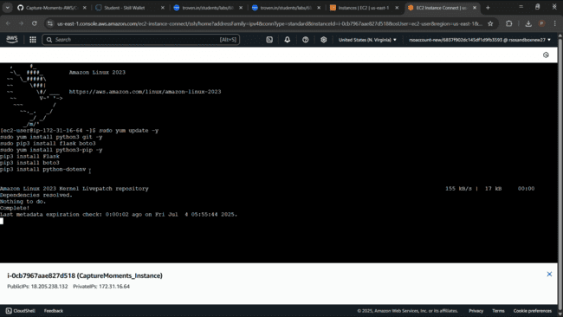

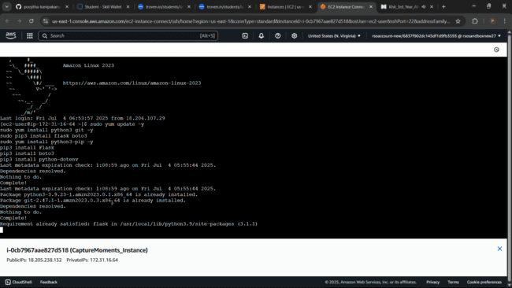

Activity 6.2: Clone Your Flask Project from GitHub
Clone your project repository from GitHub into the EC2 instance using Git.
Run: ‘git clone https://github.com/your-github-username/your-repository-name.git’
Note: change your-github-username and your-repository-name with your credentials here:
‘git clone https://github.com/poojitha-kanipakam/CaptureMomentsAWSProject.git’
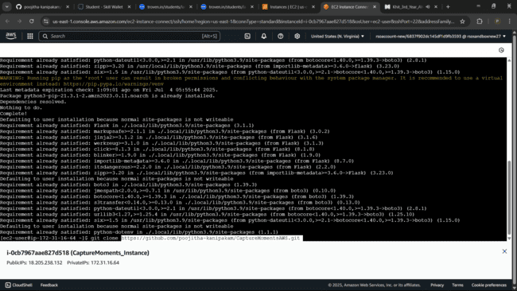

- This will download your project to the EC2 instance.

To navigate to the project directory, run the following command:
cd CaptureMomentsAWS
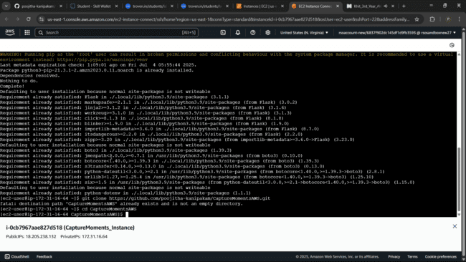

Once inside the project directory, configure and run the Flask application by executing the following command with elevated privileges:
Run the Flask Application “python3 awsint.py”

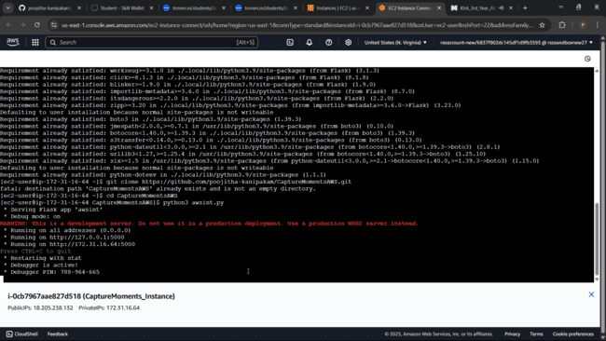

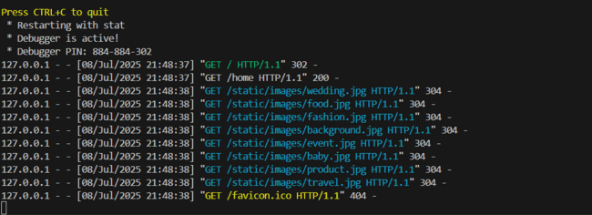

Verify the Flask app is running: http://your-ec2-public-ip
- Run the Flask app on the EC2 instance



Access the website through:
Public IPs: http://18.205.238.132:5000

Milestone 8: Testing and Deployment

Activity 8.1: Conduct functional testing to verify user signup, login, about us, photographers and bookings.

Home Page:

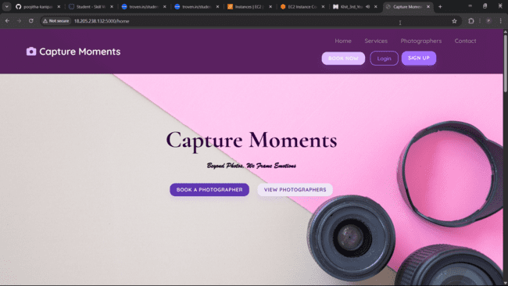

Login Page: 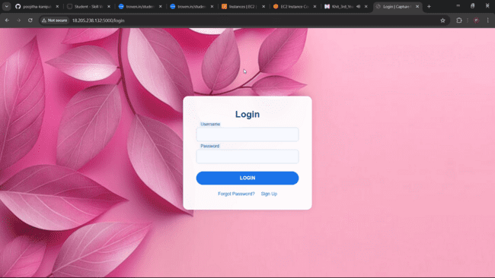

Sign Up Page:

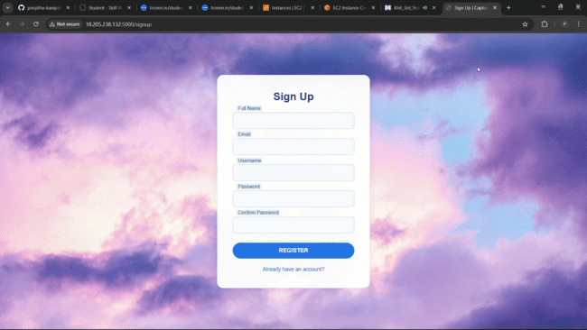

About Us page:

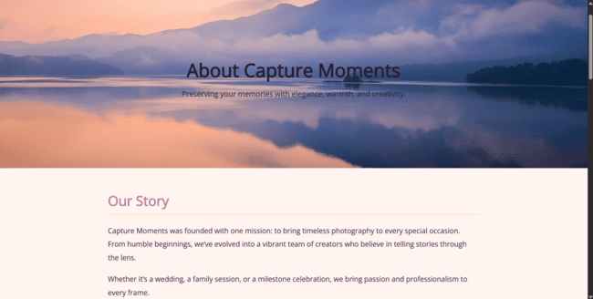

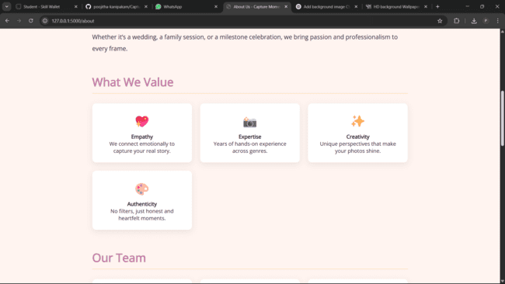

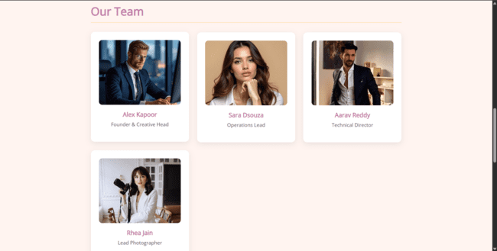

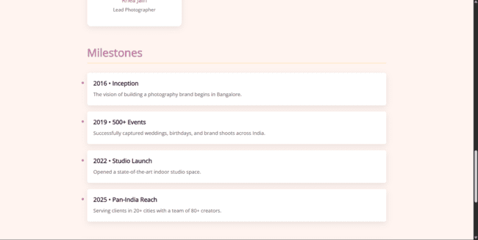

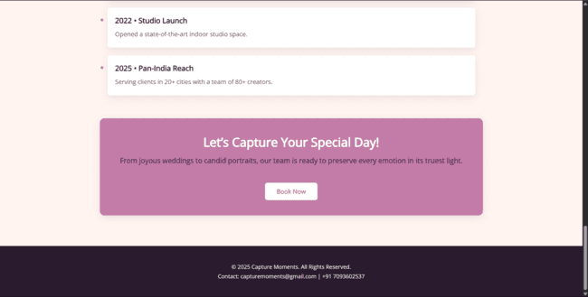

Contact Page:
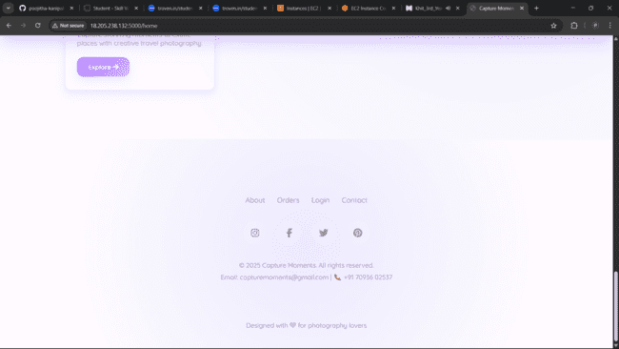

Services Page:
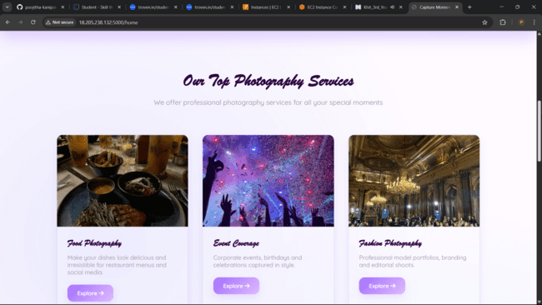

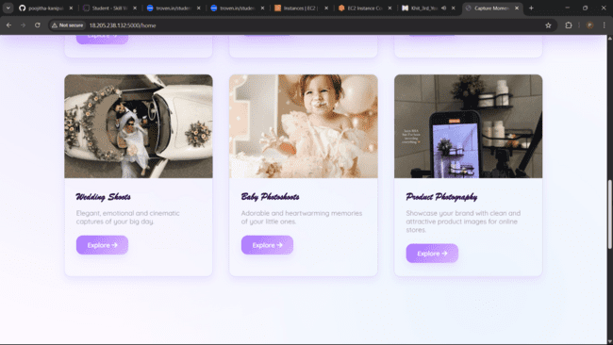

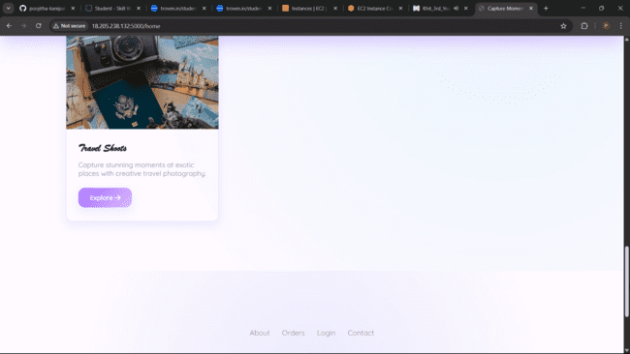

Photographers Page:
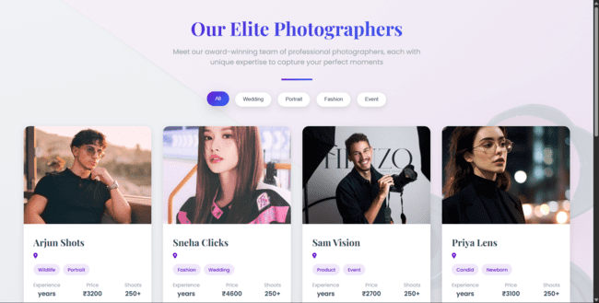
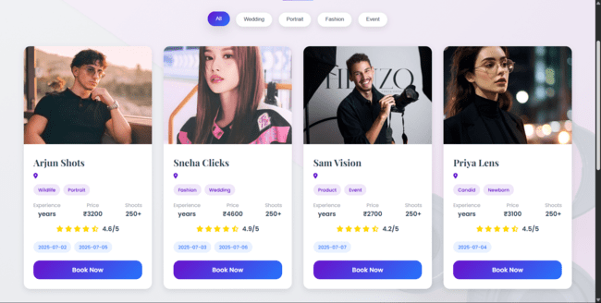
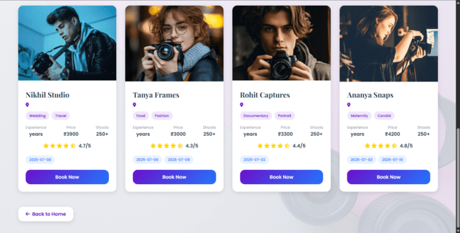

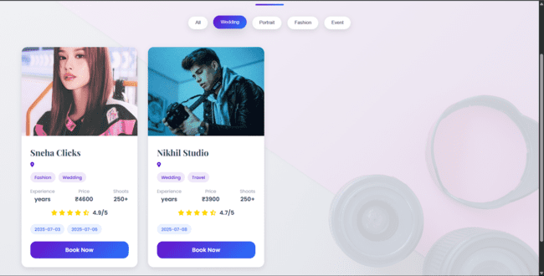

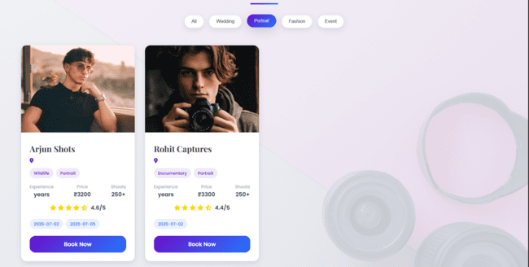

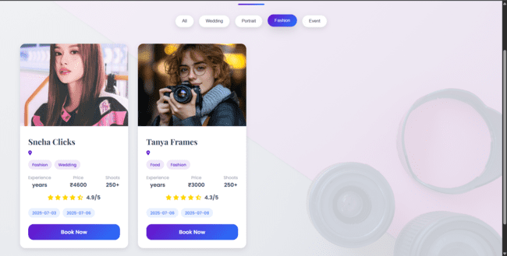

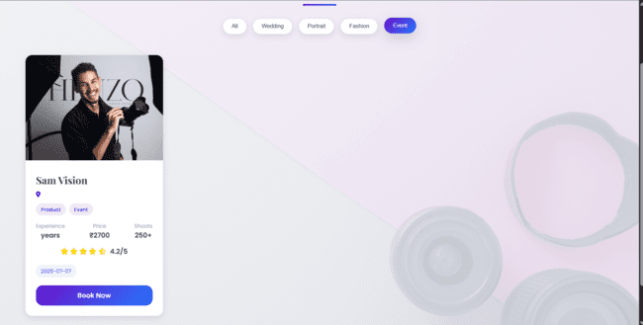

Booking Page:
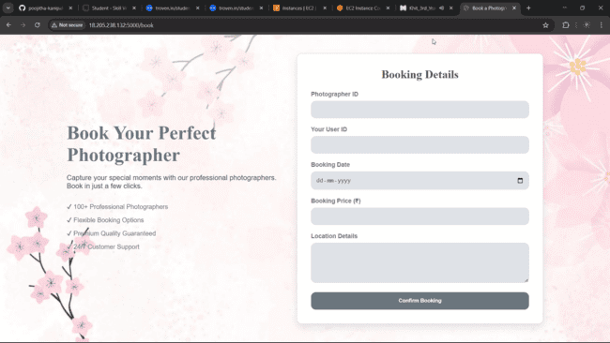

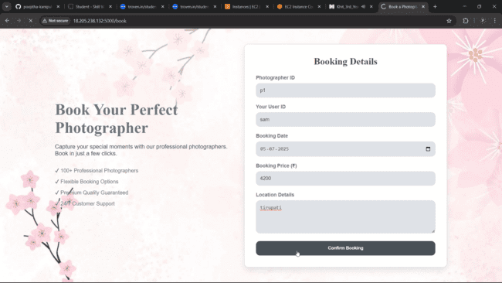

Order Confirmation Page:
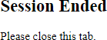
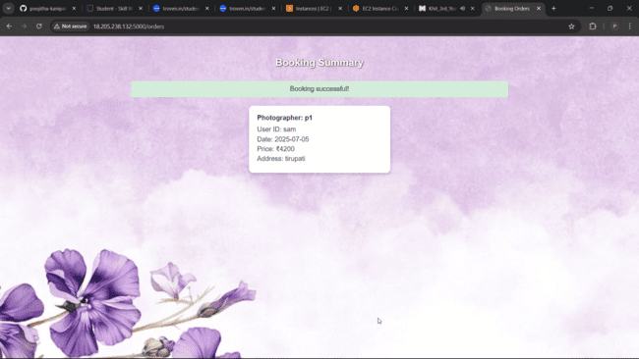

Demo video link: Demo Video

DynamoDB Database updates:

- Booking table:
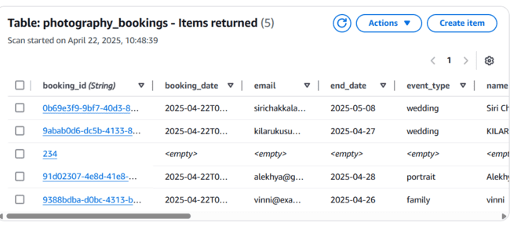

2.Photographers table:
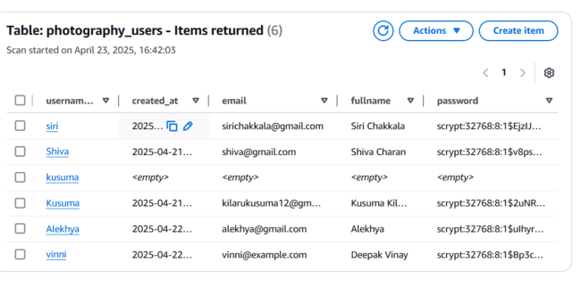
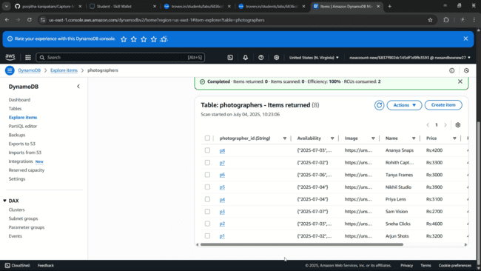

Conclusion
The Capture Moments platform has been successfully developed and deployed using a reliable cloud-based architecture tailored for seamless event photography management. Leveraging AWS services such as EC2 for hosting and DynamoDB for efficient data storage, the system ensures high availability, scalability, and quick access to media content. Designed to address the common challenges of disorganized photo sharing and limited storage, the platform offers a centralized and user-friendly interface for uploading, organizing, and accessing event photos. Flask powers the backend operations, enabling smooth workflows for user authentication, album creation, and secure photo management. Throughout the testing phase, all core functionalities—from user registration to photo uploads and album navigation—were validated for performance and reliability. In conclusion, Capture Moments showcases the potential of cloud-native solutions to transform traditional event experiences by simplifying the way memories are captured, stored, and shared. This project stands as a modern, efficient response to the evolving needs of digital photo management in dynamic event settings.

