**Pre-processing Results**

**#Loading the data**

**#Getting info of the data**

**#Dropping the unnecessary columns**

**#Checking the NA values in the data**

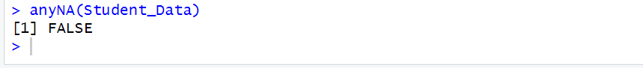

**#Saving the clean Data**

