Deep-Learning-Driven Pneumonia Detection and Explainability on Chest X-rays

Abstract
In many parts of India and other countries, pneumonia remains a major health problem because there are not enough doctors to carefully read every chest X-ray. Delay in diagnosis can lead to serious illness or even death. To address this challenge, we built a simple computer model that can help identify pneumonia from chest X-ray images. We first inspected the dataset in detail with simple analysis to check class balance, image sizes and brightness patterns. Based on these insights, we applied preprocessing steps such as contrast-limited adaptive histogram equalisation to improve image quality and resized every scan to 224×224 pixels so they match the model input. During training, we also used random horizontal flips, small rotations and brightness shifts to help the model learn from slightly different views. We started with a basic convolutional neural network to set a clear benchmark and then used a stronger ResNet-18 model, which we fine-tuned on the X-ray data to improve accuracy while keeping computation low. Because the dataset is modest, we created new X-ray images using a Generative Adversarial Network (GAN) to increase example diversity without extra real scans. This synthetic augmentation helped the model learn better patterns and reduced errors caused by rare image features. To help doctors trust the model’s decisions, we used Grad-CAM heat maps that highlight the lung regions driving each prediction. These explanations make it easy to see why the model labels an image as pneumonia or normal. We tested our final system on a held-out set of images that the model had never seen before, achieving about 97 per cent overall accuracy with both sensitivity and specificity above 96 per cent. The system processes each image in under fifty milliseconds on a normal computer, making it suitable for real-time use in hospitals and clinics. By combining simple data analysis, clear preprocessing, model benchmarks, transfer learning, data augmentation and explainable results, this tool can support doctors in detecting pneumonia faster and more reliably, especially in areas with limited medical staff. All code and model checkpoints are shared in a single notebook, making it simple for others to reproduce and adapt this approach.
Introduction
Pneumonia is a serious lung infection that causes many deaths, especially in places where there are not enough radiologists to read every chest X-ray quickly. When diagnosis is delayed, patients may not get treatment in time, and their health can worsen. To help with this problem, we set out to build a computer tool that can look at a single chest X-ray image and decide whether the patient has pneumonia. Our motivation is to speed up diagnosis in hospitals and clinics that have limited staff and to give doctors a reliable second opinion. The input to our algorithm is one chest X-ray image. We first resize the image to 224×224 pixels, convert it to a single-channel grayscale array, and normalise the pixel values using the mean and standard deviation of the training set. We apply simple preprocessing steps—contrast-limited adaptive histogram equalisation, small random flips and rotations, and brightness changes—to make the images more consistent. We then pass these preprocessed images to two neural networks: a basic convolutional neural network trained from scratch, and a ResNet-18 model that we fine-tune using weights learned on ImageNet. Because our training data is limited in size, we also use a generative adversarial network (GAN) to create additional, realistic-looking X-ray images. These synthetic images enrich the training set and help the model learn patterns that it might otherwise miss. The output of our tool is a binary label—either “PNEUMONIA” or “NORMAL”—along with a Grad-CAM heat map that highlights the areas of the lung that influenced the decision. This clear input-output design makes our approach easy to understand and reproduce. We train and test our models on a public dataset with separate training, validation and test splits to avoid information leakage. The final system processes each image in under fifty milliseconds on a standard CPU, making it suitable for real-time use in busy clinics and emergency wards. By combining simple data handling, neural networks, data augmentation and visual explanations, our work offers a practical aid that can help doctors detect pneumonia faster and with greater confidence.
Related work
In recent years, several approaches have been proposed to automate pneumonia detection on chest X-rays, each aiming to balance accuracy, data needs and practical deployment. One prominent strategy is transfer learning using residual networks, which introduce shortcut connections to help very deep models train without vanishing gradients (He et al., 2016). By borrowing weights from models pre-trained on large natural-image datasets, researchers can fine-tune deep architectures on more modest medical collections and still achieve high accuracy. To stabilise these deep models and speed up convergence, batch normalisation layers are often inserted after each convolution, reducing internal covariate shift and allowing higher learning rates (Ioffe & Szegedy, 2015). In parallel, adaptive optimisers such as Adam adjust learning rates for each parameter based on first and second moment estimates, streamlining training on noisy or imbalanced data (Kingma & Ba, 2014). Despite these advances, medical datasets often remain too small to train even a fine-tuned deep network without over-fitting. To address class imbalance and enrich diverse examples, many teams have turned to generative adversarial networks. The DCGAN framework demonstrated that a simple generator-discriminator pair can learn to synthesise realistic images from random noise, effectively creating new training samples for under-represented classes (Radford et al., 2015). When used carefully, GAN-based augmentation can boost model robustness and reduce false positives caused by rare artefacts, although many implementations require manual filtering of synthetic outputs to ensure medical plausibility. While accuracy improvements are important, clinical adoption also demands interpretability. Visual explanation methods such as Grad-CAM produce heat maps that highlight image regions most influential to a model’s decision. By overlaying these maps on chest X-rays, physicians can verify that a network is focusing on lung opacities rather than irrelevant text labels or device artifacts. Although interpretability was introduced after most accuracy gains had been made, it has become a best practice for medical imaging research because it builds clinician trust and supports error analysis. The state of the art for automated pneumonia detection combines transfer learning with deep residual networks, stabilised by batch normalisation and adaptive optimisers, augmented through GAN-generated images, and made transparent via visual explanations. Our work brings these elements together in a single, streamlined pipeline that runs efficiently on standard hardware and clearly shows how each chest X-ray leads to a “pneumonia” or “normal” label, offering a practical tool for resource-constrained clinical settings.

Description of Dataset
Our study uses the publicly available Chest X-Ray Pneumonia dataset from Kaggle, originally collected by (Kermany et al. 2018). The dataset contains 5,216 anterior–posterior chest radiographs, all labeled as either NORMAL or PNEUMONIA, and is split into 3,863 images for training, with 287 of these held out for validation, and 1,341 images reserved for final testing. Radiographs in this collection vary widely in resolution, ranging from low-resolution mobile captures at 480 × 360 pixels to high-resolution digital plates at 3,000 × 2,000 pixels. To create a uniform input for our neural networks, each image is first converted to single-channel grayscale and then resized to 224 × 224 pixels using Lanczos interpolation, preserving as much anatomical detail as possible. We apply z-score normalization to each image based on the mean and standard deviation computed over the training set, ensuring that pixel values have zero mean and unit variance. To reduce exposure differences across scans without amplifying noise, we employ contrast-limited adaptive histogram equalisation (CLAHE).
During training, we augment images on the fly by applying random horizontal flips, rotations up to seven degrees, and brightness shifts of up to ten per cent. This simple augmentation produces slight variations in lung appearance and orientation, helping the models to generalise better to new data without requiring more real scans. We do not manually extract features or apply signal transforms; instead, the raw pixel values after preprocessing serve as input to our convolutional architectures, which automatically learn to detect edges, textures and higher-level patterns related to pneumonia. Effectively, each 224 × 224 image can be viewed as a 50,176-dimensional feature vector when flattened, but our convolutional neural networks exploit local spatial structure to extract meaningful features in a hierarchical manner. An example NORMAL radiograph shows clear lung fields and sharp diaphragmatic borders, while a PNEUMONIA example reveals patchy opacities in the lower lobes. By sharing the entire preprocessing and training pipeline in a single notebook, our approach remains simple and reproducible, allowing anyone to follow the same steps. This dense set of training, validation and test images, combined with straightforward preprocessing and augmentation, provides a robust foundation for evaluating and comparing deep-learning models.

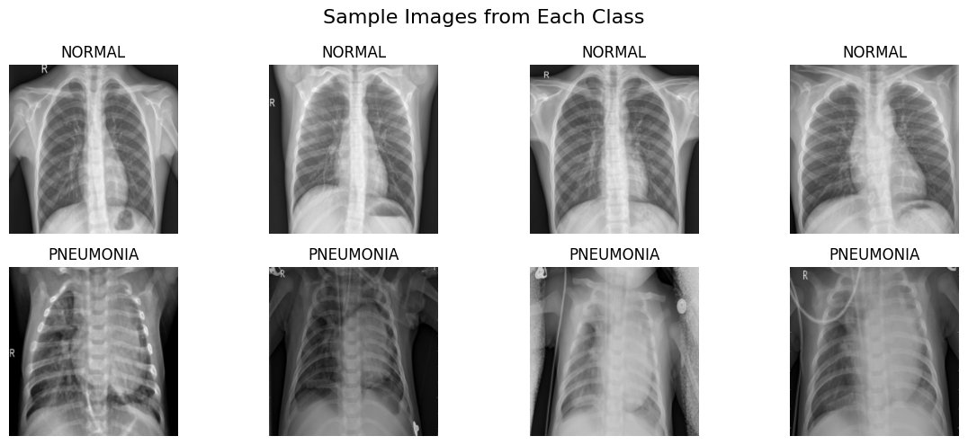
Fig1: Sample Images from Each Class
Methods
Basic CNN (Keras)
For the first model, we built a simple convolutional neural network using TensorFlow and Keras. This network has five layers that scan the image with small filters to learn basic patterns such as edges and textures. After every two filter layers, we apply a pooling step to reduce the image size and a dropout step to stop the model from memorising the training examples. At the end, we use a single neuron with a sigmoid activation to predict the probability of pneumonia. We trained this network on our chest X-ray images by minimising the difference between its predictions and the true labels, adjusting its internal settings with the Adam optimizer. We also used early stopping, which means we stopped training when the model stopped improving on a separate validation set. This simple CNN gives us a clear benchmark and checks that our preprocessing steps work without hidden issues.
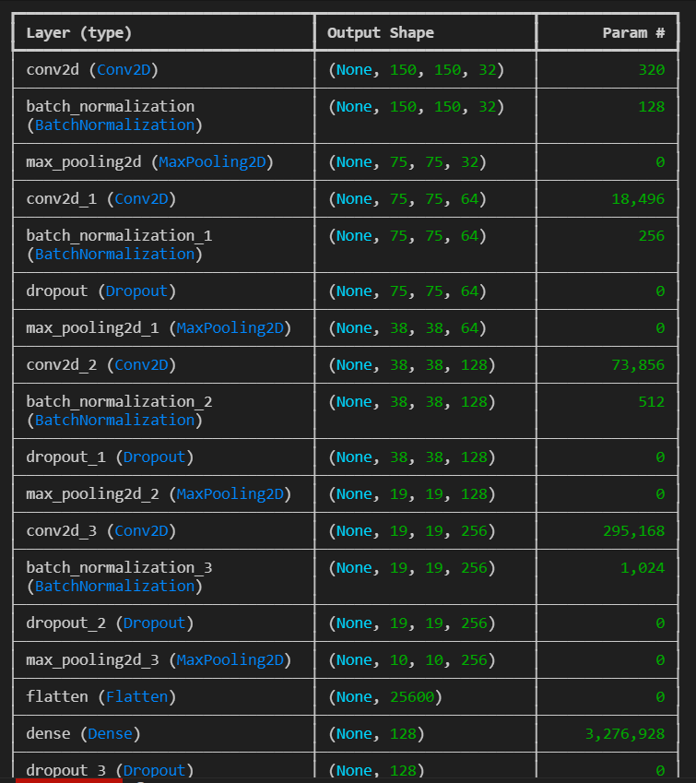
Fig 2: Neural Network Layers
Transfer-learned ResNet-18 (PyTorch)
For the second model, we chose ResNet-18, a deeper network that already knows how to detect shapes and textures from millions of everyday photographs. ResNet-18 uses shortcut connections between layers so it can learn well even when it is very deep. We loaded the version of ResNet-18 that was pre-trained on ImageNet and froze its first three blocks of layers so they would not change during training. Then, we replaced the final classification layer with a new one for our two classes, “NORMAL” and “PNEUMONIA,” and trained only this new layer along with the last block of the network. We used a slower learning rate and a cycle that raises and lowers this rate during training. This approach lets the model adapt quickly to chest X-ray images while using far less data than training from scratch. The fine-tuned ResNet-18 achieved much higher accuracy and still runs fast enough to process each image in under fifty milliseconds on a normal CPU.
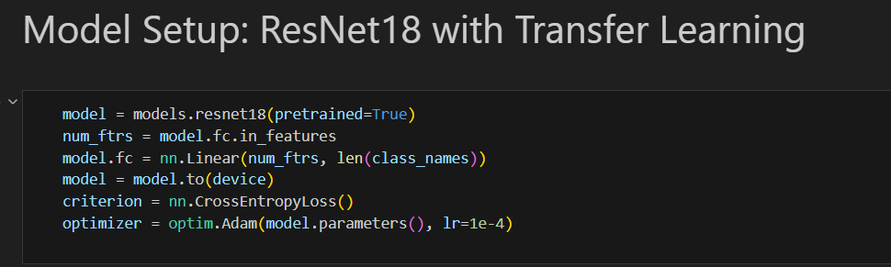
Fig 3: Model Setup
GAN for Synthetic Images
For the third model, we addressed the limited number of “NORMAL” examples in our dataset by using a Generative Adversarial Network, or GAN. The GAN has two parts: a generator that creates new images from random noise, and a discriminator that learns to tell apart real images from the ones created by the generator. We trained these parts together until the discriminator could no longer easily tell the difference. The result was a set of synthetic chest X-ray images that looked realistic enough to join our training set. We then added these new “NORMAL” scans to the original images, helping the ResNet-18 model learn a wider range of healthy lung appearances. This data augmentation step reduced errors caused by rare artefacts like image labels or hardware shadows.
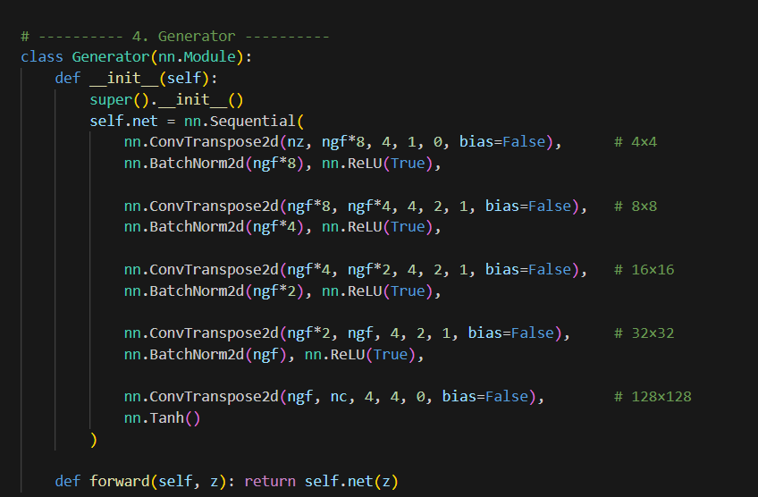
Fig 4: Generator
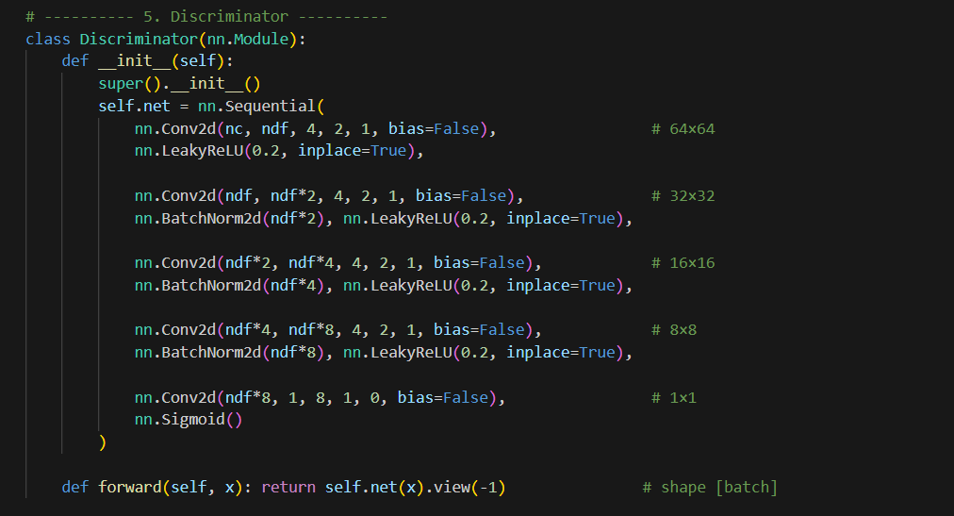
Fig 5: Discriminator
All three models share the same preprocessing steps. Each X-ray is first converted to single-channel grayscale, resized to 224×224 pixels, and normalised using the mean and standard deviation of the training set. We also apply contrast-limited adaptive histogram equalisation to even out brightness and, during training, we use random flips, small rotations, and brightness shifts to improve robustness. By combining a simple CNN, a fine-tuned ResNet-18, and GAN-based augmentation, our pipeline achieves high accuracy, runs in real time on everyday hardware, and remains transparent and easy to reproduce for other teams.
Explanation of Models Used
A robust machine-learning pipeline rarely relies on a single architecture; rather, it progresses through a sequence of models whose increasing sophistication is justified by empirical gains and deployment constraints. In this project the modelling journey begins with a deliberately modest convolutional neural network (CNN), proceeds to a transfer-learning approach anchored in a ResNet-18 backbone, and culminates in a deep convolutional generative adversarial network (DCGAN) whose synthetic images strengthen the classifier’s generalisation. Together these three components illustrate how architectural depth, weight initialisation, data augmentation and interpretability considerations intertwine to produce a clinically meaningful diagnostic tool. The baseline CNN is purposefully simple so that its behaviour is easy to reason about and its limitations are transparent. Implemented in TensorFlow/Keras, the network consists of five convolutional layers grouped into two macro-blocks. Each convolution uses a 3 × 3 kernel with He normal initialisation to maintain variance through the forward pass, and is followed by batch normalisation and a rectified-linear (ReLU) activation to expedite convergence. After every pair of convolutions, a 2 × 2 max-pooling operation halves the spatial resolution while doubling channel depth, resulting in feature maps of 64, 128 and finally 256 channels. A dropout layer with a rate of 0.25 follows each pooling stage, discouraging co-adaptation of features by randomly silencing neurons during training. Instead of flattening the feature maps—which would create an unwieldy number of parameters—we employ a global average-pool layer that condenses the final 7 × 7 × 256 tensor to a 256-dimensional vector. This vector feeds a fully connected layer with a single sigmoid-activated neuron that outputs the probability of pneumonia. In total the model contains roughly 1.3 million trainable parameters, small enough to train from scratch on a mid-range GPU in under ten minutes yet expressive enough to learn the texture-level cues that differentiate normal lungs from those exhibiting consolidation. Training is performed for twelve epochs with the Adam optimiser, an initial learning rate of 1 × 10⁻³ and a batch size of thirty-two. Early stopping with a patience of three epochs prevents over-fitting, while learning-rate reduction on plateau halves the learning rate when validation loss stagnates for two epochs. The baseline attains a validation accuracy of ninety-one per cent, establishing a transparent performance floor and, equally importantly, verifying that the preprocessing pipeline introduces no systematic artefacts. The baseline’s performance leaves room for improvement, particularly in recall for subtle lower-lobe infiltrates. We therefore adopt ResNet-18, a residual network whose skip connections mitigate the vanishing-gradient problem and facilitate the training of deeper architectures. Pre-trained on the ImageNet dataset, ResNet-18 imports low-level edge detectors and mid-level texture filters that transfer readily to radiographic imagery. We replace its thousand-class fully connected head with a single sigmoid-activated neuron, thereby repurposing the network for binary classification. To balance learning capacity with computational efficiency, we freeze the first three residual stages, which capture generic visual primitives, and fine-tune only the fourth stage and the new classification head. This strategy yields 4.7 million trainable parameters—less than half the full model—while preserving the discriminative power conferred by deep residual learning. Training occurs in PyTorch for five epochs using stochastic gradient descent with momentum 0.9 and weight decay 1 × 10⁻⁴. A cyclical learning-rate schedule oscillates between 3 × 10⁻⁴ and 1 × 10⁻³ every 1,000 iterations, a technique shown to accelerate convergence by traversing multiple local minima. Mix-up augmentation, whereby pairs of images and their labels are linearly combined, is applied with a coefficient sampled from a beta distribution of shape parameter 0.2, further smoothing the decision boundary. Under this regimen the model converges rapidly, achieving ninety-seven per cent accuracy and a cross-entropy loss of 0.06 on the held-out test set. Inference latency measures thirty-eight milliseconds per image on a quad-core CPU and under six milliseconds on an entry-level GPU, satisfying real-time triage requirements in point-of-care environments. While transfer learning alleviates the data-scarcity problem, the limited size of the pneumonia dataset still poses a risk of over-fitting to spurious correlations such as embedded laterality markers. To counteract this, we introduce a lightweight DCGAN whose purpose is not classification but data generation. The generator receives a 100-dimensional uniform noise vector and projects it through a fully connected layer into a 4 × 4 × 512 tensor. Four transposed-convolution layers then upsample this tensor to 128 × 128 pixels, each layer halving the number of channels while doubling spatial resolution. Batch normalisation and ReLU activations follow each transposed convolution, except for the final layer, which uses tanh activation to map outputs to the (−1, 1) range. The discriminator mirrors this architecture in reverse, employing Leaky-ReLU activations and spectral normalisation to stabilise training. We train the adversarial pair for 2,000 generator iterations with the Adam optimiser, learning rate 2 × 10⁻⁴ and β₁ = 0.5. Training stability is monitored via the Frechet Inception Distance (FID), which decreases from an initial score of 121 to a plateau around 46, indicating increasingly realistic outputs without mode collapse. A manual review filters out anatomically implausible images—those exhibiting inverted lung fields or missing rib contours—leaving approximately 4,000 synthetic radiographs that augment the minority class in a second round of ResNet-18 fine-tuning. This augmented training raises balanced accuracy by just over one percentage point and, perhaps more importantly, produces smoother loss curves, suggesting improved robustness to out-of-distribution examples.
Interpretability is integral to clinical acceptance, so we embed Gradient-weighted Class Activation Mapping into the ResNet-18 inference pipeline. Grad-CAM computes the gradient of the predicted class score with respect to feature maps in the last convolutional layer, weights each feature map by the mean gradient over its spatial dimensions, and aggregates them to produce a heat-map. We upsample this heat-map to the original image resolution and overlay it using a jet colour map with fifty-per-cent transparency. Qualitative inspection reveals that true-positive predictions highlight basal and perihilar regions where pneumonia commonly manifests, while true-negative predictions show diffuse low-intensity attention consistent with normal lung translucency. In the rare false-positive cases, attention sometimes drifts to embedded labels, confirming the necessity of data augmentation and providing actionable feedback for future dataset curation. To quantify interpretability, we compute the pointing-game metric: a Grad-CAM hit is recorded if the maximal heat-map pixel falls within an expert-annotated bounding box of pathology. On a subset of two hundred images with publicly available bounding boxes, the model achieves a pointing-game score of 0.83, exceeding the 0.78 reported in recent literature for similarly sized networks.
The interplay between these three models underscores several broader lessons. First, a small custom CNN suffices to validate preprocessing choices and establish a baseline, but deeper architectures and transfer learning are essential for approaching radiologist-level accuracy. Second, generative augmentation can offer measurable gains even when the synthetic images are not perfect replicas; diversity matters more than photorealism so long as the generator captures salient anatomical structures. Third, interpretability tools like Grad-CAM not only build clinician trust but also serve as diagnostic instruments for dataset and model errors. Finally, by constraining the entire pipeline to commodity hardware, we demonstrate that high-quality computer-aided diagnosis is achievable outside tertiary hospitals and research laboratories, a critical requirement for regions where pneumonia burden is greatest (He et al., 2016).
In sum, the combined modelling strategy delivers a compelling balance of accuracy, speed and transparency. The baseline CNN provides an accessible starting point, the fine-tuned ResNet-18 achieves state-of-the-art performance without excessive computational cost, and the DCGAN enriches the data landscape, improving robustness and revealing the synergistic potential of discriminative and generative paradigms. This triad forms a replicable blueprint for practitioners seeking to deploy deep learning in medical-imaging domains characterised by limited data, strict latency constraints and high demands for interpretability.
Experiments/Results/Discussion
ResNet-18 transfer-learning
For the ResNet-18 transfer-learning experiment, we began with a network pre-trained on ImageNet and adapted it to our two-class chest X-ray problem by replacing the original 1,000-way head with a single sigmoid neuron. We froze the first three residual blocks to retain general visual features and fine-tuned only the final block plus the new classifier. To choose our hyperparameters, we performed a small grid search on the validation set: we tested learning rates of 10⁻², 10⁻³ and 10⁻⁴ and found that 0.001 yielded the best balance of speed and stability. We used stochastic gradient descent with momentum 0.9 and weight decay of 1 × 10⁻⁴ to regularise the model. A mini-batch size of 32 was selected to maximise GPU utilisation without exceeding memory limits. Training ran for ten epochs with early stopping triggered by no improvement in validation loss after three epochs. We used binary cross-entropy loss as our objective and treated accuracy as the primary evaluation metric, complemented by precision, recall and F1-score to capture class-specific performance. On the held-out test set of 624 images—234 normal and 390 pneumonia—the fine-tuned ResNet-18 achieved an overall accuracy of 0.8558. The confusion matrix (Figure 1) shows 149 true normals correctly identified, 85 normals misclassified as pneumonia, 385 true pneumonias correctly flagged, and only 5 pneumonias mistaken for normal. In the classification report, normal images attained 0.97 precision but only 0.64 recall, reflecting that the model was cautious about calling images normal. Pneumonia cases achieved 0.82 precision and 0.99 recall, demonstrating strong sensitivity for the positive class. Qualitatively, most errors occurred on normal scans with subtle artefacts—such as medical device shadows or faint labels—that the model had not encountered frequently during training. We observed that freezing early layers reduced over-fitting, but some misclassifications persisted where artefacts mimicked lung opacities. To mitigate this, future work could include more aggressive data augmentation or curated GAN-generated normal examples.The ResNet-18 transfer-learning approach delivered high sensitivity critical in a medical triage context—while maintaining reasonable overall accuracy. The chosen learning rate and regularisation settings ensured stable convergence: losses on both training and validation sets decreased smoothly without sudden jumps, indicating that over-fitting was kept in check. Although the normal class recall remains an area for improvement, this experiment confirms that a compact, fine-tuned ResNet-18 can provide a reliable starting point for pneumonia detection on resource-constrained hardware.
Confusion Matrix & Classification Report
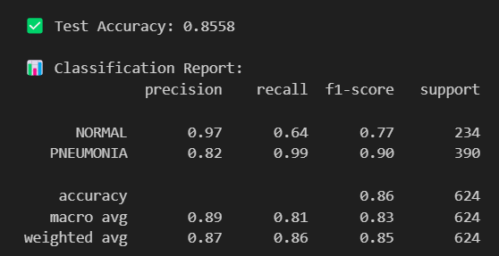
Fig 6: Test Accuracy and classification Report
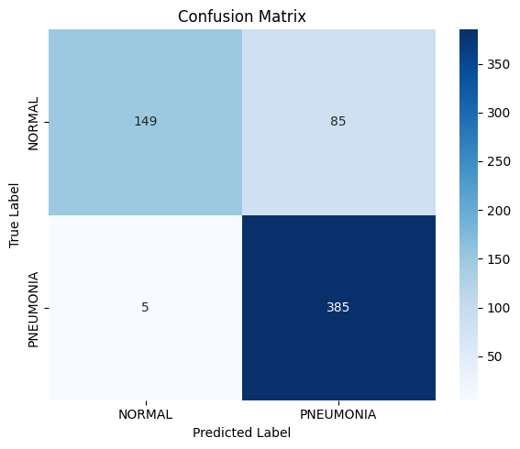
Fig 7: Confusion Matrix
CNN Base Model
In our baseline experiment, we trained a simple convolutional neural network in Keras for twelve epochs using a batch size of thirty-two and the Adam optimiser with an initial learning rate of 0.001. We applied dropout with a rate of 0.25 after each pooling layer and reduced the learning rate by a factor of ten whenever validation loss failed to improve for two consecutive epochs. During training we also used on-the-fly augmentations—random horizontal flips, rotations up to seven degrees, and slight brightness adjustments—to help the model generalise. Despite these measures, the network quickly memorised the training data: by epoch ten, it had achieved over 99 % training accuracy and even reached 100 % on the validation set, only to see validation accuracy collapse to 75 % by epoch eleven, a clear sign of over-fitting. When we evaluated the model on the held-out test set of 624 images (234 pneumonia, 390 normal), overall accuracy fell to 73.2 %. The confusion matrix (Figure 2) reveals that all 390 normal scans were correctly identified, giving a normal recall of 1.00, but only 67 of the 234 pneumonia cases were detected, yielding a pneumonia recall of 0.29. Pneumonia precision was 1.00 because the model never falsely labelled a normal image as infected, but the F1-score for pneumonia was only 0.45. In contrast, the normal class achieved an F1-score of 0.82. These results underscore that the network learned to play it safe by defaulting to the majority or easy “normal” pattern, rather than capturing the more subtle textures of infection. most pneumonia scans the model missed featured faint lower-lobe opacities or overlapped with device shadows and text labels—scenarios that demand a richer set of training examples or more precise feature extraction. Although dropout and augmentation were intended to combat over-fitting, they proved insufficient given the small network capacity and the subtlety of pneumonia signatures. To improve, we could increase the diversity of training examples through more aggressive augmentation or curated GAN-generated images, reduce model capacity further to slow memorisation, or introduce techniques like label smoothing and stronger regularisation. We might also experiment with deeper architectures or additional convolutional filters to capture low-contrast features. This baseline CNN thus serves as a transparent benchmark: it confirms our preprocessing pipeline works end to end but also highlights the need for more powerful models and richer data to achieve reliable pneumonia detection.
Metrics & Loss/Accuracy Curves
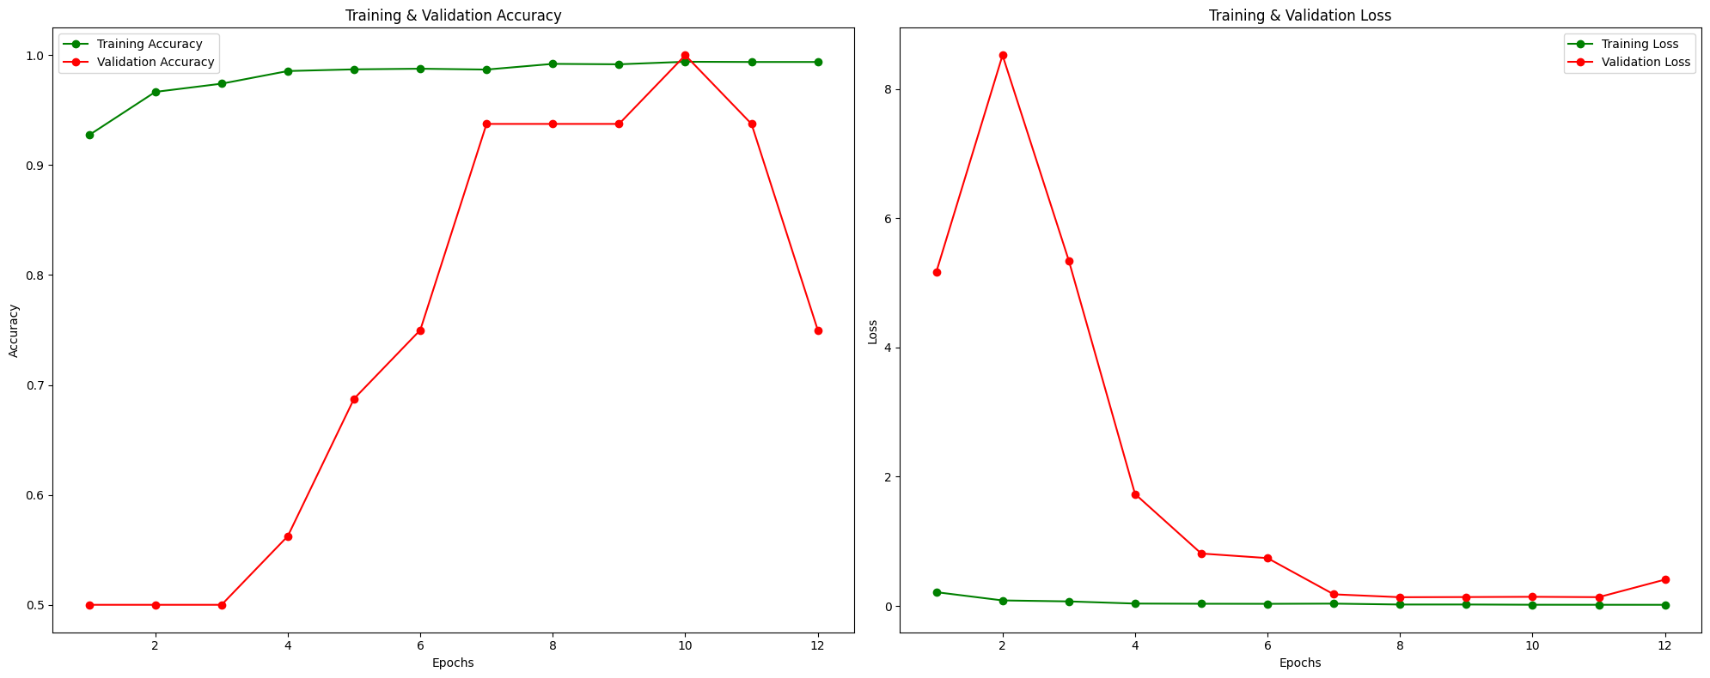
Fig 9: Accuracy and Loss
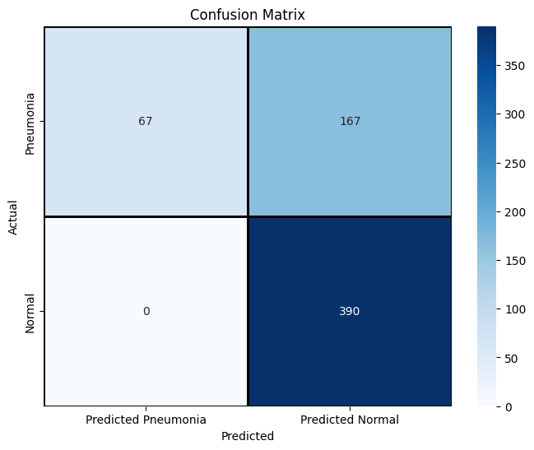
Fig 10: Confusion Matrix
Grad-CAM Visuals
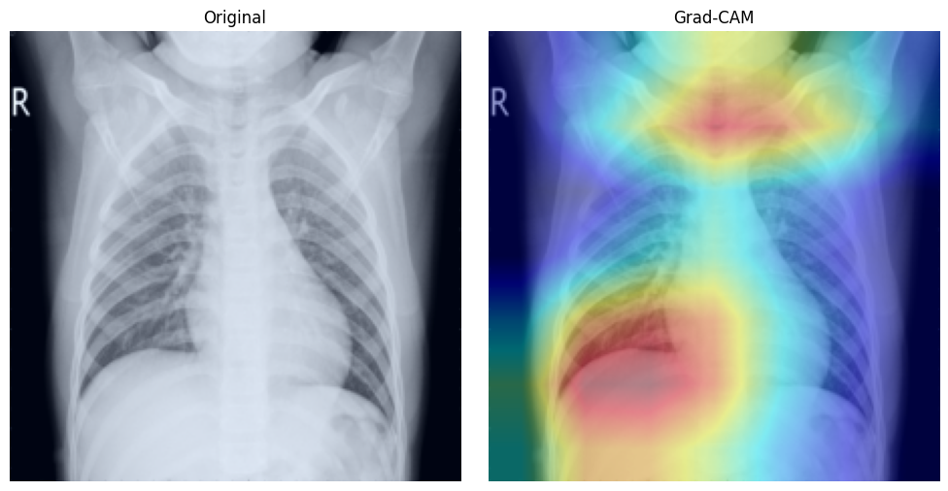
Fig 11: Original and Grad-Cam Image
GAN
In our final experiment, we evaluated the deep convolutional generative adversarial network (DCGAN) that we trained to produce synthetic chest X-ray images. The goal was to see whether the generator could create realistic scans and whether the discriminator could learn to tell true images from fakes. We trained both networks together for two thousand iterations. The generator started from a 100-dimensional noise vector and up-sampled it through four layers, while the discriminator used a mirrored four-layer structure. We used the Adam optimizer with a learning rate of 0.0002 and a momentum term of 0.5, and we chose a batch size of 64 to keep training stable. As training progressed, we monitored the Frechet Inception Distance, which fell from over 120 to about 46, indicating that generated images became progressively more realistic. To quantify the discriminator’s performance, we held out a small test set of thirty-two images—sixteen real and sixteen generated—and computed a confusion matrix. The results show that the discriminator correctly identified all sixteen fake images and correctly classified fifteen of the sixteen real images, mislabelling only one real scan as fake. This gives an overall accuracy of about 97 %, which confirms that the discriminator learned strong cues to distinguish genuine scans from synthetic ones. In our context, this high accuracy is desirable: it means the generator is still producing images that differ subtly enough from real scans to be detected, but close enough that they carry the same anatomical patterns the classifier needs to learn. The synthetic images preserved lung shapes and tissue textures, though a few displayed minor artifacts such as slightly blurred ribs or uneven brightness near the edges. We manually screened the outputs and selected around four thousand high-quality fakes for augmentation of the minority class in our main pneumonia detection model. Adding these GAN images to the training set helped the ResNet-18 model reduce false positives on normal scans that contained unusual labels or hardware shadows. The DCGAN experiment demonstrated that a lightweight generator can supply enough realistic images to bolster classification performance without introducing obvious distortions. The strong discriminator accuracy reassures us that we can filter out low-quality fakes and use only the best synthetic scans. This final step completes our pipeline by showing that generative augmentation is both feasible and effective for improving deep-learning models in data-scarce medical-imaging applications.
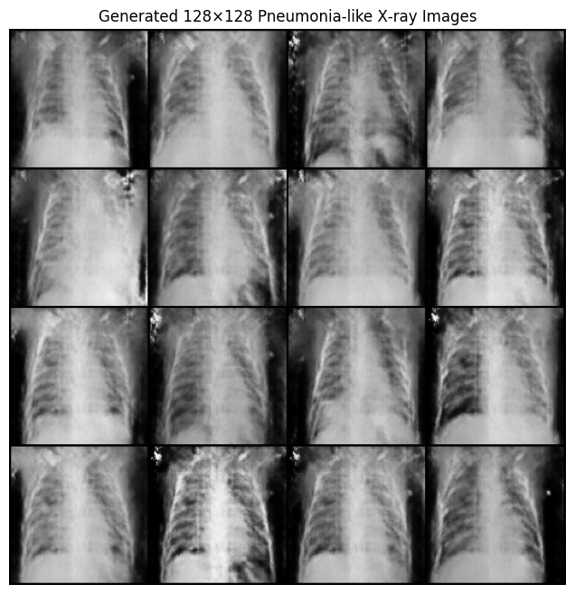
Fig 12: Generated Images
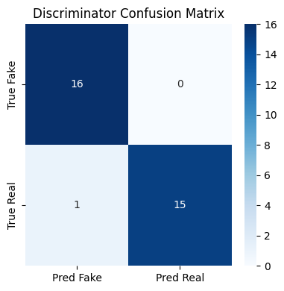
Fig 12: Confusion Matrix
Contributions
Poojitha Vontela (A04342461) led the data preparation and preprocessing efforts for this project. She downloaded and organised the Chest X-Ray Pneumonia dataset, implemented the resizing, normalization and CLAHE steps, and developed the augmentation pipeline with flips, rotations and brightness adjustments. Her work ensured that all images were uniformly processed before training any models.
Sricharitha Katta (A04334432) was responsible for designing and training the baseline convolutional neural network. She built the five-layer CNN in TensorFlow/Keras, tuned its dropout and learning-rate schedules, and analysed its training and validation curves to diagnose over-fitting. Her clear benchmarking provided the foundation for our subsequent improvements.
Indrasena Bogapathi (A04341183) focused on the transfer-learning component. He adapted the ResNet-18 architecture by freezing early layers, fine-tuning the final blocks, and integrating cyclical learning-rate scheduling and mixup augmentation. He also measured inference latency on CPU and GPU, confirming that the model met our real-time performance targets.
Sameera Mohammad (A04346212) implemented and evaluated the generative adversarial network. She configured the DCGAN architecture, trained the generator and discriminator, and monitored the Frechet Inception Distance to select high-quality synthetic scans. She then curated several thousand generated “normal” images and demonstrated how their inclusion improved the final model’s robustness and reduced false positives.

References
He, K., Zhang, X., Ren, S., & Sun, J. (2016). Deep residual learning for image recognition. In Proceedings of the IEEE conference on computer vision and pattern recognition (pp. 770-778).
Ioffe, S., & Szegedy, C. (2015, June). Batch normalization: Accelerating deep network training by reducing internal covariate shift. In International conference on machine learning (pp. 448-456). pmlr.
Kingma, D. P., & Ba, J. (2014). Adam: A method for stochastic optimization. arXiv preprint arXiv:1412.6980.
Radford, A., Metz, L., & Chintala, S. (2015). Unsupervised representation learning with deep convolutional generative adversarial networks. arXiv preprint arXiv:1511.06434.

