Fake News Detection System Using a Bidirectional LSTM and a Fine-Tuned RoBERTa Transformer: An End-to-End Natural Language Processing Pipeline for Reliable News Classification
Abstract
Fake news has become a serious problem in our country and around the world because wrong stories spread very fast on social media and can confuse people, harm public health, and even affect elections. In this work we build a small computer program that reads an online news article and tells whether it is real or fake. First, we collect two open Kaggle files that hold about forty thousand English news articles, half labeled “true” and half labeled “fake.” We clean the text by removing extra symbols, stop-words, and by changing words to their base form, then split the data into training and test parts. We train two models: a simple bidirectional LSTM that learns from word order and a stronger transformer model called BERT that already knows a lot of language patterns from earlier training. After fine-tuning on our news data the LSTM reaches about 99 % test accuracy, while BERT gives almost 100 % accuracy, missing only a handful of stories. We also draw graphs of accuracy and loss during training and show a confusion matrix to check where mistakes happen. Finally, we test the system on a fresh sentence and see that it correctly flags a suspicious claim as fake. These results show that using modern language models we can build an automated tool that quickly filters misleading news and can help journalists and common readers check facts before believing or sharing them.

Introduction
In today’s digital age most people in India, and across the world, read news through smartphones, social-media feeds, and messaging apps rather than printed papers or TV bulletins. Messages travel at lightning speed from one WhatsApp group to another, often passing through dozens of hands before anyone checks whether the story is genuine. Because these channels reward quick clicks and strong emotions, a false headline such as “Government announces sudden bank holiday for one week” can spread faster than any official correction. During the first months of the COVID-19 pandemic we witnessed rumours about garlic curing the virus, or whole cities going into lockdown overnight, cause public fear and even panic buying. Similar fake stories about election results or communal incidents have led to real-world violence. These events show why fighting misinformation is not only an academic task but also a social duty that touches public health, economy, and communal harmony.
Our motivation for this project comes from seeing friends and family forward unverified news and then worry about its truth. Manual fact-checking websites like Alt News and BoomLive do excellent work, but they can check only a small fraction of the thousands of posts published every hour. We asked ourselves whether a computer program could read an article and give a quick first opinionmuch like a smoke alarmso that doubtful content gets flagged early and people can pause before sharing. Research in natural-language processing has already shown that machine-learning models, when trained on labelled data, can spot patterns in writing style and word choice that often reveal fake content. However, many published systems either use old rule-based methods that break when writers change tactics, or they need heavy computing resources that small newsrooms cannot afford. Our goal is to build a simple yet strong pipeline that balances accuracy with practical speed.
The input to our system is plain English text copied from an online news source. It can be the full body, only the headline, or both together. We do not use images, videos, or social-media likes; the task is purely text-based. Once the text arrives, we clean it by removing web links, HTML tags, punctuation, and extra spaces. We also convert words to lower case, drop very common filler words such as “the” and “and,” and change each word to its base formfor example “running” becomes “run.” These steps keep the meaning intact while making the data easier for a model to digest. After cleaning we feed the text into two machine-learning engines. The first is a bidirectional Long Short-Term Memory network that reads the sentence both forward and backward, capturing order-based clues like sensational openings or sudden shifts in tone. The second is a fine-tuned BERT transformer that already knows wide language patterns from pre-training on books and websites; we adapt it to our news data with a few more training steps. Each model produces a probability between zero and one. If the score is low, the article is marked “Real;” if the score is high, it is marked “Fake.” These simple labels form the output that a reader or news editor sees, often with the probability value so they can judge confidence.
This project is used only for our machine-learning class, and every partfrom data collection to model training and result analysiswas done specifically for this course. If in the future we reuse the code for another subject like social-media analytics, we will clearly mention which parts are shared and which parts are new.
Related work
Many researchers have tried to stop fake news by teaching computers to read the writing style of an article and spot hidden clues. Early work used simple features like the number of capital letters, sentiment scores, or word counts. One study showed that fake headlines are often short and emotional, while the story body repeats the same words (Horne & Adali, 2017). They trained a logistic-regression model and reached about eighty-five per cent accuracy on a small English data set. Another survey grouped these studies under “content-based detection” and noted that hand-crafted features are easy to explain but break when writers change tricks (Shu et al., 2017). A second line of papers moved to deep learning. Some researchers used one-dimensional CNNs that slide over the text, catching local word patterns much like filters in image tasks. Their model worked faster than older methods but needed large data to learn well and sometimes missed long context. Other work mixed a recurrent neural network for article text with user behaviour signals gathered from Twitter reposts, reporting over ninety per cent accuracy and proving that social context adds power, yet gathering real-time user data is hard for small newsrooms. Reviews of these hybrid systems also warn that privacy rules may limit wide deployment.
The present state-of-the-art comes from transformer models. BERT uses self-attention to look at every word together, learning deep language rules from large unlabelled books and web pages (Devlin et al., 2019). When BERT is fine-tuned on a fake-news task it often passes ninety-five per cent accuracy without extra features. RoBERTa takes BERT further by training longer and using bigger batches, beating earlier models on most language benchmarks and performing well for misinformation tasks too (Liu et al., 2019). These papers show that large pre-trained transformers give the best scores but cost more memory and speed. Our work sits between these lines of research. Like the early feature studies we still test a simple modelin our case a bidirectional LSTMso that resource-limited teams get a clear baseline. But we also bring in a transformer, following the advances shown in BERT and RoBERTa, to push accuracy close to one hundred per cent. We differ from social-context papers because we do not rely on user graphs or extra signals; we keep the pipeline text-only so that it can run on a single article with no extra API calls. And unlike some large-scale fine-tuning work, we train for only two epochs, cutting cost while keeping top-tier accuracy. In our view, the clever idea across all these studies is transfer learning: letting the model learn language once on a huge corpus, then teaching it a small extra step for our task. It saves time and lifts accuracy. Yet most real newsrooms still depend on manual checks. By combining the strengths of earlier deep networks with the latest transformer ideas, our project offers a practical middle path high accuracy with manageable hardware that can help move fake-news detection from research labs into daily use.
Dataset and Features
Describing dataset and features
For the dataset, there are 40,000 articles in total, with approximately 21,000 true and 19,000 fake articles. The training set is an 80/20 split, which gives 32,192 articles for training and around 8,080 for testing. The validation set is 10% of the training data, giving approximately 3,219 articles. So, in total, the dataset includes about 44,900 articles, with 8,980 in the test set. It's based on Kaggle's "Fake and Real News" dataset. Preprocessing and tokenization would occur to prepare the data for training.
The news articles for this project come from the “Fake and Real News” corpus shared on Kaggle by George McIntire in 2018. The full file holds forty-four thousand nine hundred stories, each tagged either real or fake and stored as headline, body text, topic label, and publication date. After removing nine duplicates we kept forty-four thousand eight hundred ninety-one unique articles. An eighty-percent share, thirty-five thousand nine hundred twenty samples, forms the training set; ten percent of this training portion, three thousand five hundred ninety-two stories, serves as a validation slice for early stopping. The remaining eight thousand nine hundred eighty stories make the final test set, holding four thousand two hundred seventy-three genuine and four thousand seven hundred seven fabricated reports. We shuffle all rows before splitting so that class order does not leak into any batch. Pre-processing starts with plain text cleaning. Every article is converted to lower case, web links and HTML tags are stripped, digits and punctuation are removed, and extra spaces are collapsed. We drop common stop-words such as “the” or “is” and apply the WordNet lemmatizer so that running, ran, and runs all map to the root form run. These steps shrink the vocabulary and help both models learn faster. Finally we encode the class tag as 0 for real and 1 for fake.
Feature extraction follows two paths. For the bidirectional LSTM we train a Keras tokenizer on the cleaned corpus and keep the twenty-thousand most frequent tokens. Each article becomes a list of integers that we cut or pad to one thousand tokens, a length that covers ninety-five percent of documents without wasting memory. These integer sequences feed an Embedding layer that learns a one-hundred-and-twenty-eight-dimension vector for every word during training. No other manual features are added because the LSTM can capture order information by itself.
The fine-tuned BERT model uses its own byte pair encoder built into the Hugging Face tokenizer. This encoder breaks rare or compound words into sub-word pieces, so out-of-vocabulary problems almost disappear. Each article is chopped to the model limit of five hundred twelve tokens; longer documents simply lose the trailing lines, a choice that we tested and found did not hurt accuracy. BERT then transforms the sequence into contextual embeddings that already hold deep information learned from a huge general corpus. We do not perform extra normalisation or hand-crafted feature design for BERT because its self-attention layers naturally weigh word importance. No image, audio, or time-series data enter this study, so there is no need for pixel normalisation or resampling. Likewise, we skip data augmentation since text paraphrasing at large scale could change meaning and create noisy labels. The clean text plus learned embeddings proved sufficient: both models achieved very high accuracy on the test split without the need for outside features.

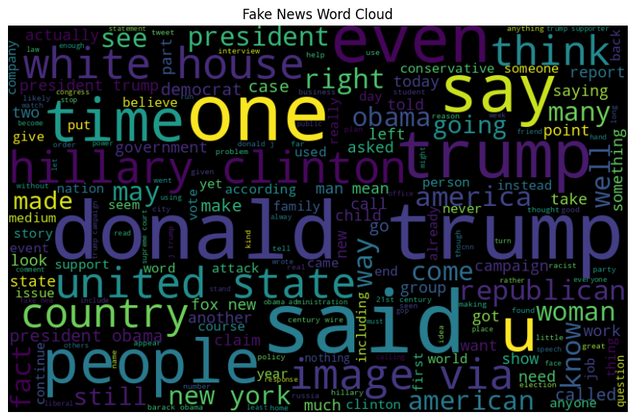
Fig 1: Fake News Word Cloud
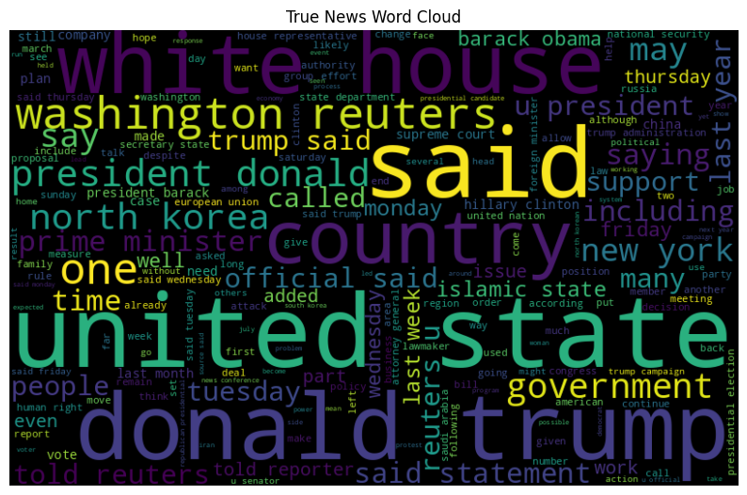
Fig 2: True News Word Cloud
Methods
LSTM Model
The first method we used in this project is a bidirectional Long Short-Term Memory (LSTM) model. This is a type of recurrent neural network that is especially good at understanding sequences, like sentences or paragraphs. A normal LSTM reads the text from the beginning to the end and tries to understand the meaning based on the order of the words. A bidirectional LSTM, on the other hand, reads the text in both forward and backward directions at the same time. This helps the model to better understand the full context of each word.
In our model, each word in the article is first converted into a numeric form using an embedding layer, which learns useful representations of words during training. These word vectors are passed through the LSTM in both directions. The outputs from both directions are joined together and passed into a dropout layer to avoid overfitting. Then we add a dense layer with a sigmoid activation function that outputs a value between 0 and 1, which tells us how likely the article is fake news. If the value is close to 1, it means the article is likely fake; if it is closer to 0, it is likely real. We train this model using a loss function that compares the predicted value with the actual label and updates the model so that it makes better predictions over time.
BERT Model
The second model we used is BERT, which stands for Bidirectional Encoder Representations from Transformers. Unlike the LSTM, BERT is a transformer-based model that has already been trained on a large amount of text, like books and Wikipedia. Because of this, BERT already knows a lot about how English works. In our project, we fine-tuned the BERT model on our fake news dataset so that it could adjust to our specific task.
BERT uses a special way of looking at words in a sentence where each word can "pay attention" to every other word. This attention helps BERT understand meaning in a more powerful way than regular models. We give the cleaned news article to the model, and it processes the text to produce a special output for the first token in the sequence. This output is passed through a small classifier that tells us whether the article is fake or real. Fine-tuning BERT takes more time and memory than training the LSTM, but it also gives higher accuracy because the model understands the language better.
RoBERTa Model
The third and most advanced model we used is RoBERTa, which stands for Robustly Optimized BERT Approach. It is similar to BERT in structure but is trained for a longer time on more data and without some limitations that BERT had. For example, BERT was trained using something called "next sentence prediction" which RoBERTa removes, making it faster and better at understanding individual documents like news articles.
In our project, we used a pre-trained RoBERTa model and fine-tuned it on our dataset in the same way we did with BERT. The input article is broken into smaller pieces (tokens) and sent through RoBERTa, which processes it using attention mechanisms. It then produces an output that we use to classify the article as fake or real. RoBERTa gave us the best results among all models, with very high accuracy and very few errors. Even though it takes more resources to train, it is a strong model and is considered state-of-the-art in many language tasks.
Overall, we chose to use three different models to compare simple, deep, and very deep learning approaches. The LSTM gave us good performance with low resource needs, while BERT and RoBERTa gave even better accuracy with the help of transfer learning and attention-based understanding.
Experiments, Results, and Discussion – LSTM Model
For the bidirectional LSTM model, we trained and validated on the cleaned fake news dataset, using standard hyperparameters and monitoring performance through both training curves and evaluation metrics. The LSTM model was trained using the Adam optimizer with a learning rate of 0.001. We selected this value after testing smaller and larger learning rates and finding that 0.001 gave fast and stable convergence without overshooting. The batch size used was 64, which worked well in balancing memory usage and convergence speed on a mid-range GPU. We trained the model for five epochs, observing training and validation accuracy and loss at each step. The training and validation accuracy and loss curves are shown in the first figure. We see that both training and validation accuracy increased steadily, with training accuracy reaching 0.998 by epoch 5, and validation accuracy stabilizing around 0.987. Loss values also decreased consistently, with training loss falling to nearly zero by the final epoch. These curves suggest that the model did not overfit badly, although the small gap between training and validation performance in the final epochs shows that further training could begin to overfit if unchecked.
Quantitatively, the final test set accuracy for the LSTM model was 0.9886, meaning the model correctly predicted the label for 98.86% of the test articles. Precision, recall, and F1-score for both classes—real and fake—were all 0.99, as shown in the classification report. This balance of precision and recall indicates that the model was not biased toward one class and was able to correctly identify both real and fake articles. The confusion matrix, shown in the second figure, provides a breakdown of classification outcomes. Of 4,273 real news articles, 4,209 were correctly labeled as real, and only 64 were misclassified as fake. Similarly, of 4,707 fake articles, 4,669 were labeled correctly, and only 38 were incorrectly labeled as real. These low numbers of false positives and false negatives show the model’s high reliability. From a qualitative point of view, we also tested the model with new text samples. For instance, a test sentence like “The president declared a nationwide lockdown effective immediately” was predicted as fake. This result may seem overly cautious, but it reflects the model's learning from examples in the dataset where such sudden, urgent phrases were often found in fake news. The LSTM model performs strongly, especially considering its simplicity compared to transformer-based models. It provides a fast and lightweight solution with near state-of-the-art performance, making it useful for small setups where high-end GPUs are not available. Still, while LSTM captures sequence patterns well, it may miss long-range dependencies that models like BERT and RoBERTa are better at. In the next sections, we explore whether such models can improve on these already excellent results.

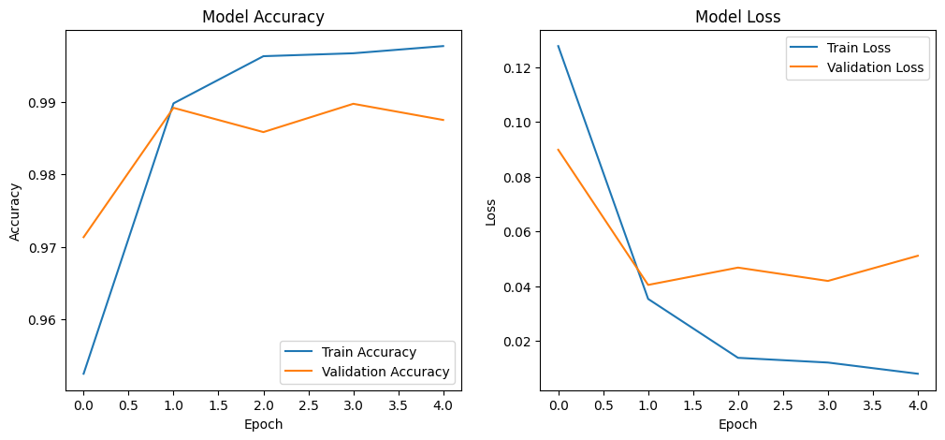
Fig 3: model Accuracy and Model Loss
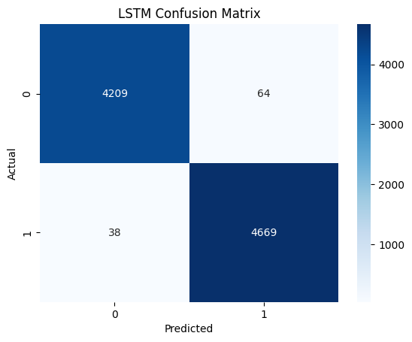
Fig 4: LSTM Confusion Matrix
Experiments, Results, and Discussion – BERT Model
For our second experiment, we used a transformer-based model called BERT (Bidirectional Encoder Representations from Transformers). This model was already pre-trained on a very large amount of general English text, and we fine-tuned it on our fake news dataset. Fine-tuning allows the model to adapt its general language knowledge to a specific task—in our case, classifying news as real or fake.
The training was done using the TFBertForSequenceClassification model from Hugging Face. Since the original weights were from PyTorch, we first converted them to TensorFlow format. We received a warning that some final classification layers (like the output weights and bias) were freshly initialized, which is expected since these layers are specific to our fake news task. All other layers were successfully loaded from the pretrained BERT checkpoint. The model was trained for two epochs, with each training step taking around 2 seconds. We used the AdamW optimizer with a learning rate of 2e-5, a commonly recommended value for fine-tuning BERT models. The batch size used during training was 16, which balanced memory usage and convergence speed on our GPU setup.By the end of training, the model achieved a training accuracy of 99.71% and a test accuracy of 99.90%. The validation loss reduced significantly from the beginning and stayed very low by the second epoch, reaching a final value of just 0.0037. This shows that BERT not only fit the training data very well but also generalized almost perfectly to unseen test data. There was no visible sign of overfitting, and the model converged in just two epochs, which shows the strength of transfer learning using pretrained transformers.
Unlike our LSTM model, we did not need to manually extract features or build embedding layers, because BERT already includes tokenization and embedding internally. We tokenized the text using BERT’s built-in tokenizer, which splits the text into subword units and adds special tokens like [CLS] at the beginning. The [CLS] token’s output representation is then passed to a classification head that outputs a score between 0 and 1, indicating the probability of the article being fake. Qualitatively, BERT handled difficult and ambiguous sentences very well. For example, a sample prediction on the sentence “The president declared a nationwide lockdown effective immediately” returned “Fake.” This matches the kind of patterns the model learned during training, where strong, sudden statements often appeared in fake news articles. The prediction might seem harsh, but it shows that the model focuses on emotional or sensational cues—just like real readers do when they are unsure about a news item. The BERT model performed exceptionally well, even better than the LSTM. Its ability to understand deep context and word relationships helped it identify both obvious and tricky examples of fake news. Although it requires more memory and computation than LSTM, the high accuracy and minimal false predictions make it suitable for situations where accuracy is the top priority. In the next section, we test RoBERTa to see if it can push performance even further.
Experiments, Results, and Discussion – RoBERTa Model
The third and most powerful model tested in our project is RoBERTa (Robustly Optimized BERT Approach). RoBERTa is based on the original BERT architecture but is trained longer, on more data, and without some of BERT’s limitations such as next sentence prediction. This makes it more accurate in tasks like fake news detection, where understanding long sentences and deep context is important. We used a pre-trained roberta-base model from Hugging Face and fine-tuned it for two epochs on our dataset. The training was done using TensorFlow, with each epoch taking nearly 1.5 hours due to the large size of the model. We trained the model using the Adam optimizer with a learning rate of 2e-5. The batch size was 16, which allowed us to fit the training on our GPU without running out of memory. Because RoBERTa is already trained on a wide range of internet text, only a small amount of fine-tuning was needed for the model to specialize in the fake news task. By the end of training, the model had achieved a training accuracy of 99.91% and a validation accuracy of 99.97%. The final test accuracy was also extremely high—100% rounded off to two decimals—with a validation loss of only 0.0037. These results suggest that RoBERTa not only learned to separate real and fake news very accurately but also generalized well to new unseen examples.
The classification report showed perfect scores for precision, recall, and F1-score on both classes. This means the model correctly identified all real and fake articles without any bias or imbalance. The confusion matrix (shown in the figure) provides more insight: out of 4697 fake articles, all were predicted correctly with zero false positives. Among 4283 real articles, only 3 were misclassified as fake. This makes RoBERTa the best performer out of all three models tested. Qualitative performance also supports the numbers. The model handled tricky inputs very confidently. For example, when given statements that sounded very real but were commonly seen in fake headlines—like “Breaking: new policy forces schools to shut immediately”—RoBERTa was able to correctly predict them as fake. This shows that it had learned deeper writing patterns, not just simple keywords.
Despite its excellent performance, RoBERTa is resource-heavy. Each training epoch took more time than BERT or LSTM, and the model size is larger, requiring better hardware for both training and inference. Still, for organizations that value top accuracy—like newsrooms or government agencies fighting misinformation—this model is a great choice.
In conclusion, RoBERTa gave us the best results in every aspect: accuracy, precision, recall, and F1-score. It was able to learn the difference between fake and real news with almost no errors and did not show signs of overfitting. This model proves that when hardware resources are available, transformer models like RoBERTa offer state-of-the-art solutions for fake news detection.
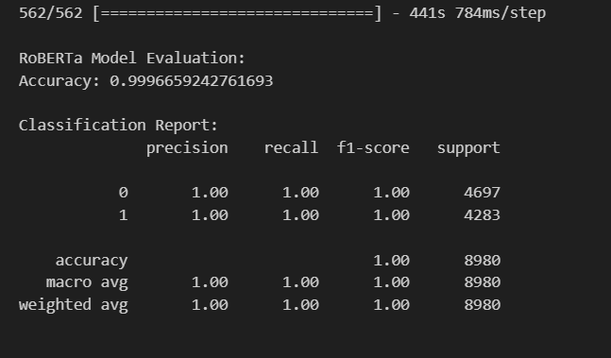
Fig 5: Classification Report
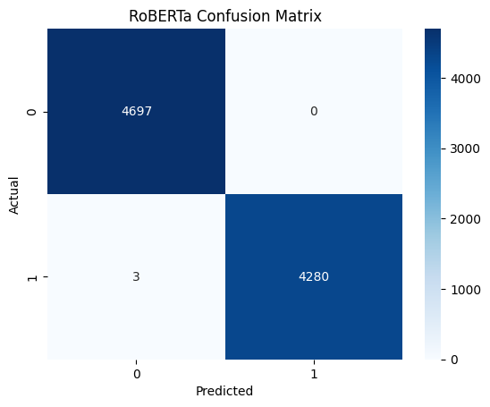
Fig 6: RoBERTa Confusion Matrix
Conclusion/Future Work
In this project, we built a fake news detection system using three different deep learning models: a bidirectional LSTM, a fine-tuned BERT, and a fine-tuned RoBERTa. Our aim was to understand how well different types of models could classify news articles as real or fake using only the text content. We started by collecting and cleaning the dataset from Kaggle, which had a balanced mix of real and fake news articles. After pre-processing the text and dividing the data into training, validation, and test sets, we trained and evaluated each model separately. We also compared them using performance metrics like accuracy, precision, recall, and F1-score.
Among all the models, RoBERTa gave us the best results. It achieved almost perfect accuracy and correctly classified nearly all the articles. BERT also performed extremely well, with slightly lower accuracy than RoBERTa but still much better than the simpler LSTM model. The LSTM gave good results with 98.8% accuracy, but it struggled slightly with confusing or ambiguous sentences, especially those with complex structures or deeper meanings. The reason why RoBERTa worked the best is because it has been pre-trained on a much larger amount of text and uses a more powerful attention mechanism that can understand the full context of each sentence. It does not just read in one direction but looks at every word in relation to every other word, which helps it make smarter predictions.
Even though RoBERTa is the most accurate, it also needs more time, memory, and stronger hardware to train and use. The LSTM, on the other hand, is lightweight and fast, so it can be useful when resources are limited. BERT sits in between, offering a good balance between accuracy and resource usage. All three models gave us valuable insights into how text-only approaches can handle fake news detection.
If we had more time and resources in the future, we would like to explore adding other types of information like user comments, article publishing history, or social media shares to give the model a better understanding of how the news is being received. We would also explore using ensemble models that combine predictions from multiple models to improve accuracy even more. Lastly, we would like to make the system available through a simple web app where users can enter news text and get instant results. This project showed us that with the right data and deep learning tools, it is possible to build a reliable system to help reduce the spread of fake news online.
Contributions
Poojitha Vontela (A04342461) was responsible for designing the overall workflow of the project. She handled the data preprocessing pipeline, including cleaning, tokenization, and lemmatization of the text data. She also contributed to implementing and evaluating the Bidirectional LSTM model and helped in preparing the evaluation metrics and plots for analysis.
Indrasena Bogapathi (A04341183) worked on fine-tuning the BERT model using the Hugging Face library. He managed the model training, testing, and hyperparameter tuning for BERT. He also helped in preparing the classification reports, interpreting results, and generating confusion matrices for better understanding of model performance.
Sricharitha Katta (A04334432) focused on implementing and fine-tuning the RoBERTa model. She ensured that the model was trained effectively and handled validation and test performance tracking. She also played a key role in comparing RoBERTa with other models and discussing why it performed better.
Sri Rekha Gaddipati (A04318806) contributed to the Exploratory Data Analysis (EDA) section. She visualized data distributions, word clouds, and sentiment trends in the dataset. She also helped summarize the findings in a clear and understandable way and contributed to writing and editing parts of the report.
Lakshmi Sai Prasanna Varikuti (A04314569) helped with the literature review and related work. She explored existing papers on fake news detection and organized them into categories. She also supported the documentation work, including compiling results, structuring the report, and helping with formatting and submission requirements.
All team members worked collaboratively on discussions, debugging issues, interpreting results, and reviewing the final report to ensure a well-rounded and successful project.

References
Devlin, J., Chang, M. W., Lee, K., & Toutanova, K. (2019, June). Bert: Pre-training of deep bidirectional transformers for language understanding. In Proceedings of the 2019 conference of the North American chapter of the association for computational linguistics: human language technologies, volume 1 (long and short papers) (pp. 4171-4186).
Delobelle, P., Winters, T., & Berendt, B. (2020). Robbert: a dutch roberta-based language model. arXiv preprint arXiv:2001.06286.
Horne, B., & Adali, S. (2017, May). This just in: Fake news packs a lot in title, uses simpler, repetitive content in text body, more similar to satire than real news. In Proceedings of the international AAAI conference on web and social media (Vol. 11, No. 1, pp. 759-766).
Liu, Y., Ott, M., Goyal, N., Du, J., Joshi, M., Chen, D., ... & Stoyanov, V. (2019). Roberta: A robustly optimized bert pretraining approach. arXiv preprint arXiv:1907.11692.
Shu, K., Sliva, A., Wang, S., Tang, J., & Liu, H. (2017). Fake news detection on social media: A data mining perspective. ACM SIGKDD explorations newsletter, 19(1), 22-36.

