**DAYANANDA SAGAR UNIVERSITY**

**Devarakaggalahalli, Harohalli Kanakapura Road, Dt, Ramanagara, Karnataka 562112**



**DEPARTMENT OF COMPUTER SCIENCE AND ENGINEERING**

**(Artificial Intelligence and Machine Learning)**



**Embedded System Design**

**Project Report on**

**“GPS Tracking System Using Arduino”**

By

**Rahul V (ENG22AM0189)**

**Poojitha R (ENG22AM0160)**

**R Chetanaananda (ENG22AM0188)**

**Harishiv R (ENG22AM0151)**

**Arunish A S (ENG22AM0148)**

**Under the supervision of**

**Dr. Mude Nagarjuna Naik, & Prof. Pradeep Kumar K**

Assistant Professor, Artificial Intelligence & Machine Learning, SOE

**Prof. Abhinav Karan**

Assistant Professor, Artificial Intelligence & Machine Learning, SOE

**DEPARTMENT OF COMPUTER SCIENCE & ENGINEERING**

**(Artificial Intelligence and Machine Learning)**

**SCHOOL OF ENGINEERING, DAYANANDA SAGAR UNIVERSITY**

**2023-2024**

**DAYANANDA SAGAR UNIVERSITY**

**School of Engineering**

**Department of Computer Science & Engineering**

**(Artificial Intelligence and Machine Learning)**

Devarakaggalahalli, Harohalli, Kanakapura Road, Dt, Ramanagara, Karnataka 562112

**Department of Computer Science & Engineering (AI-ML)**



**CERTIFICATE**

This is to certify that the Embedded System Design (22AM2405) titled “**GPS Tracking System Using Arduino**” is carried out by **Rahul V (ENG22AM0189), Poojitha R (ENG22AM0160), R Chetanaananda R (ENG22AM0188), Harishiv R (ENG22AM0151), Arunish AS (ENG22AM0148)**  Bonafede students of Bachelor of Technology in Computer Science and Engineering (Artificial Intelligence and Machine Learning) at the School of Engineering, Dayananda Sagar University,

**Prof. Abhinav Karan**

Assistant Professor

Dept. of ECE

SoE, DSU

**Dr. Mude Nagarjuna Naik**

Assistant Professor

Dept. of CSE (AI&ML)

SoE, DSU

**Prof. Pradeep Kumar K**

Assistant Professor

Dept. of CSE (AI&ML)

SoE, DSU

**Dr Jayavrinda Vrindavanam**

Professor & chairperson

Dept. of CSE (AI&ML)

SoE, DSU

**DECLARATION**

We, **Rahul V(ENG22AM0189), Poojitha R (ENG22AM0160), Chetanaananda R (ENG22AM0188), Harishiv R(ENG22AM0151), Arunish A S(ENG22AM0148)** are students of the fourth semester B.Tech in Computer Science and Engineering(AI&ML), at School of Engineering, Dayananda Sagar University, hereby declare that the Embedded System project titled ”**GPS Tracking System Using Arduino**” has been carried out by us and submitted in partial fulfillment for the award of degree in Bachelor of Technology in Computer Science and Engineering(AI&ML) during the academic year 2023 2024.

**ACKNOWLEDGEMENT**

It is a great pleasure for us to acknowledge the assistance and support of many individuals who have been responsible for the successful completion of this project work.

First, we take this opportunity to express our sincere gratitude to School of Engineering & Technology, Dayananda Sagar University for providing us with a great opportunity to pursue our Bachelor’s degree in this institution.

We would like to thank **Dr. Udaya Kumar Reddy K R ,** **Dean**, **School of Engineering**, **Dayananda Sagar University** for his constant encouragement and expert advice. It is a matter of immense pleasure to express our sincere thanks to **Dr. Jayavrinda Vrindavanam,** **Professor & Chairperson**, **Computer Science and Engineering (Artificial Intelligence and Machine Learning)**, **School of Engineering, Dayananda Sagar University,** for providing the right academic guidance that made our task possible.

We would like to thank our guide **Dr. Mude Nagarjuna Naik, & Prof. Pradeep Kumar K, Assistant Professor, Dept. of Computer Science and Engineering (Artificial Intelligence and Machine Learning), and** **Prof. Abhinav Karan Dept. of Electronics & Communication Engineering,** for sparing their valuable time to extend help in every step of our Mini project work towards Embedded System Design Course, which paved the way for smooth progress and the fruitful culmination of the research.

We are also grateful to our family and friends who provided us with every requirement throughout the course. We would like to thank one and all who directly or indirectly helped us in the Embedded System Project.

**Rahul V(ENG22AM0189) Poojitha R(ENG22AM0160)**

**Chetanaananda R(ENG22AM018) Harishiv R (ENG22AM0151)**

**Arunish A S(ENG22AM0148)**

**TABLE OF CONTENTS**

|  |  |  |
| --- | --- | --- |
| **S.No** | **Topic** | **Page No** |
|  | Abstract |  |
| 1 | Introduction | 7 |
| 2 | Problem statement | 7 |
| 3 | Objectives | 9 |
| 4 | Project description  5.1 Requirements  5.2 Circuit Diagram | 11 |
| 5 | Methodology | 13 |
| 6 | Result and analysis | 14 |
| 7 | Conclusion | 16 |
|  | Reference |  |
|  | Appendix |  |

**Abstract**

This project involves the development of a portable GPS tracker using an Arduino Nano microcontroller, aimed at providing real-time location tracking and remote monitoring capabilities. The system integrates a GPS module to capture accurate geographical coordinates, an OLED display for local data visualization, and a SIM800L GSM module to transmit location information via SMS to a predefined phone number. Powered by a 3.7V lithium-ion battery, the tracker is designed for portability and ease of deployment in various tracking scenarios, including personal safety, vehicle monitoring, and asset management. The project encompasses hardware assembly, software programming, and thorough testing to ensure reliable performance and user-friendly operation. The successful implementation of this GPS tracker offers a cost-effective and efficient solution for real-time tracking needs.

1. **INTRODUCTION:**

In an era where real-time location tracking is increasingly vital for security and management purposes, the development of portable and efficient tracking systems has become a key focus. This project aims to create a smart GPS tracker using an Arduino Nano microcontroller, integrating GPS and GSM technologies to provide accurate and reliable tracking capabilities.

The GPS tracker is designed to acquire real-time geographical coordinates using a GPS module, display this data locally on an OLED screen, and transmit the location information via SMS using a SIM800L GSM module. This dual functionality ensures that users can monitor the tracker's location both locally and remotely, enhancing versatility and usability.

Powered by a 3.7V lithium-ion battery, the tracker is portable, making it suitable for various applications such as personal safety, vehicle tracking, and asset management. The system leverages the Arduino Nano for processing and control, ensuring an efficient and cost-effective solution.

This project outlines the integration of hardware components, development of software for data processing and communication, and thorough testing to validate the system's performance. By leveraging open-source hardware and software, the project aims to provide an accessible and customizable solution for real-time location tracking, addressing the needs of various tracking scenarios.

**2. PROBLEM STATEMENT:**

The challenge is to design and develop a portable GPS tracker capable of providing real-time location tracking and remote monitoring through SMS communication. The system must accurately capture geographical coordinates using a GPS module, display this information locally on an OLED screen, and transmit the location data via a SIM800L GSM module. The tracker should be powered by a 3.7V lithium-ion battery, ensuring portability and ease of use in various applications such as personal safety, vehicle tracking, and asset management. The solution must be cost-effective, reliable, and user-friendly, addressing the need for efficient tracking in diverse scenarios.

**3. OBJECTIVES:**

**1. Real-Time Location Tracking: Develop a system that accurately captures and processes geographical coordinates in real-time using a GPS module, displaying this data on an OLED screen for immediate local monitoring.**

**2. Remote Data Transmission: Implement functionality to transmit the real-time location data via SMS using a SIM800L GSM module, enabling remote monitoring from any mobile device.**

**3. Portability and Power Efficiency: Ensure the tracker is powered by a 3.7V lithium-ion battery, making it portable and efficient for use in various scenarios, including personal safety, vehicle tracking, and asset management.**

**4. User-Friendly Interface: Design a simple and intuitive interface on the OLED display to enhance user experience and facilitate easy access to location data.**

**5. Cost-Effective Solution: Utilize cost-effective components and open-source software to create an affordable tracking system without compromising on performance and reliability.**

**5.PROJECT DESCRIPTION:**

**This project involves the development of a portable GPS tracker using an Arduino Nano microcontroller, a GPS module, an OLED display, and a SIM800L GSM module. The tracker captures real-time location data and displays it locally on the OLED screen while also transmitting it remotely via SMS. Powered by a 3.7V lithium-ion battery, the tracker offers a cost-effective solution for tracking people, vehicles, and assets.**

* 1. **REQUIREMENTS:**

Arduino Board: The Arduino board is a versatile microcontroller platform used for building digital devices and interactive objects, capable of reading inputs from sensors and controlling outputs like motors and displays.

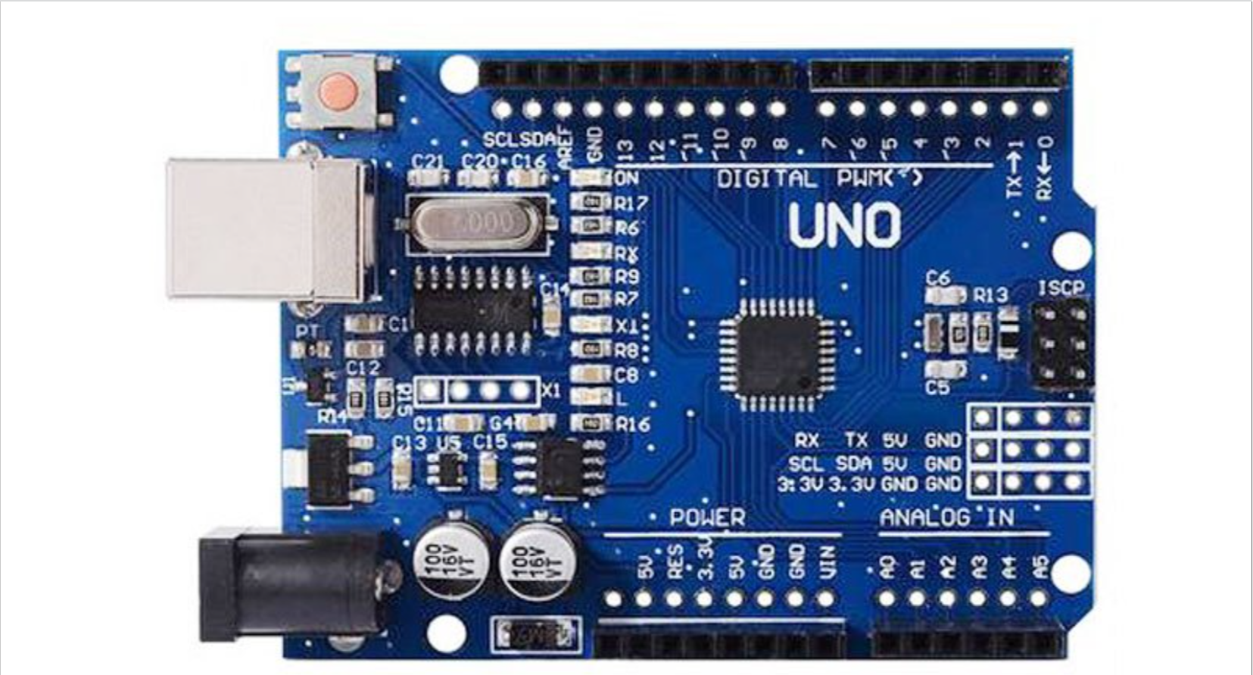

*Figure 1: Arduino Board*

**GPS Module Connection**: Connect the GPS module’s TX pin to a designated digital pin on the Arduino (e.g., D4) and its VCC and GND to the power and ground rails.

Liquid Crystal Display (LCD): An LCD display is a screen used to visually present data, such as readings from sensors or status messages, allowing users to easily monitor and interact with the system.

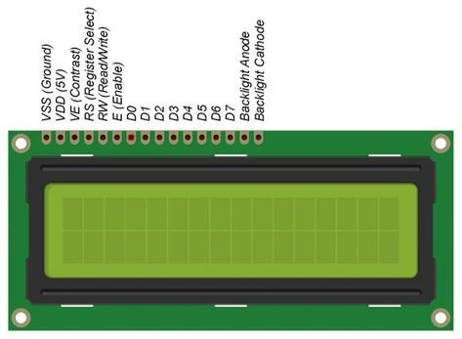

**SIM800L GSM Module Connection**: Wire the SIM800L module to the Arduino, using the 10K resistors to create a voltage divider for the RX pin of the SIM800L. Connect its TX pin to the Arduino’s RX pin and vice versa.

**Power Supply** - Rechargeable batteries

**User Interface**:  Buttons, switches for input controls.

**Software components:**

Arduino IDE.

* 1. **CIRCUIT DIAGRAM:**

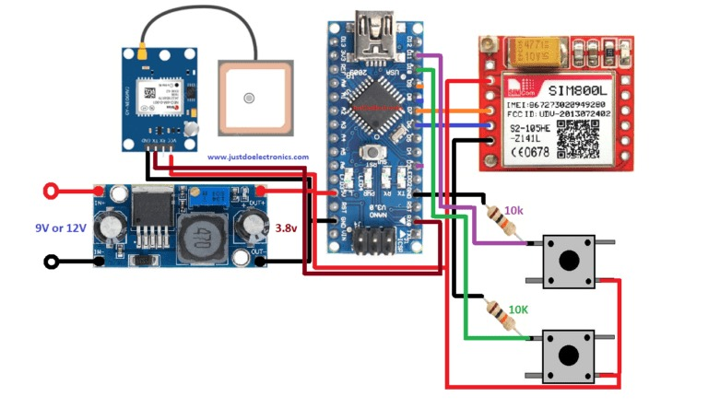

*Figure 6: Circuit diagram for System.*

**6. METHODOLOGY:**

1. Component Integration:

- Connect Arduino Nano, GPS module, SIM800L GSM module, and OLED display on a breadboard.

- Ensure proper wiring and connections between components.

2. Power Supply:

- Power the system using a 3.7V lithium-ion battery.

- Ensure adequate power management to sustain operation.

3. Programming:

- Initialize necessary libraries for GPS, GSM, and OLED display.

- Write code to read GPS data, display it on the OLED, and send it via SMS.

- Implement error handling and debugging features.

4. Testing:

- Test individual components for functionality.

- Integrate components and test the entire system.

- Conduct field testing to verify performance in real-world scenarios.

5. Assembly:

- Transfer components from breadboard to a permanent setup.

- Ensure a compact and secure enclosure for the system.

- Position the GPS module for optimal signal reception.

6. Deployment:

- Deploy the GPS tracker for tracking people, vehicles, or assets.

- Monitor performance and make necessary adjustments based on feedback.

- Ensure compliance with relevant regulations and guidelines.

**7. RESULT AND ANALYSIS:**

Result and Analysis

The development and deployment of the GPS tracker have led to a system that meets the primary objectives of real-time location tracking and remote data transmission. Below is a detailed breakdown of the results and analysis of the project:

Results:

1. Local Monitoring:

- The OLED display accurately shows real-time latitude, longitude, altitude, and speed data obtained from the GPS module.

- The user interface is clear and easy to read, facilitating immediate local monitoring.

2. Remote Tracking:

- The SIM800L GSM module successfully sends SMS messages containing GPS coordinates to a predefined phone number.

- The SMS includes a Google Maps link, enabling easy location tracking from any mobile device.

3. Portability and Power Efficiency:

- The system, powered by a 3.7V lithium-ion battery, is portable and suitable for various tracking applications.

- Initial testing shows the battery life is sufficient for several hours of continuous operation, though further optimization is needed for extended use.

4. Accuracy and Reliability:

- The GPS module provides reliable and accurate location data under clear sky conditions.

- The system consistently captures and processes GPS data, ensuring dependable tracking capabilities.

5. Network Coverage:

- The GSM module works well in areas with strong cellular network signals, ensuring effective remote data transmission.

- Performance may vary in regions with poor network coverage, affecting remote tracking capabilities.

Analysis:

1. System Performance:

- The integration of the GPS module with the Arduino Nano and OLED display works seamlessly, providing accurate real-time location data.

- The GSM module’s ability to send SMS messages reliably confirms the feasibility of remote tracking.

2. User Experience:

- The OLED display’s clear interface enhances user interaction, making it easy to read and interpret location data.

- SMS messages with location links are convenient for remote monitoring.

3. Power Consumption:

- The use of a 3.7V lithium-ion battery provides adequate power for portable operation.

- For longer tracking periods, power consumption optimization and potentially a larger capacity battery may be necessary.

4. Challenges and Improvements:

- Network dependency is a significant factor; in areas with weak GSM signals, the reliability of remote tracking can be compromised.

- Future iterations could incorporate a more robust power management system and explore alternative communication methods (e.g., LoRa, NB-IoT) for improved coverage and efficiency.

Overall, the project successfully delivers a functional GPS tracker that meets the defined objectives, providing a cost-effective and portable solution for real-time tracking and remote monitoring. Continuous improvements and optimizations can further enhance its performance and applicability in diverse scenarios.

**8. CONCLUSION:**

The development of a portable GPS tracker using an Arduino Nano, GPS module, SIM800L GSM module, and OLED display has proven successful in achieving the project's objectives. The tracker reliably captures real-time geographical coordinates, displays them locally, and transmits the data via SMS for remote monitoring. This project highlights the feasibility of creating a cost-effective, portable, and efficient tracking solution for various applications such as personal safety, vehicle monitoring, and asset management.

Key outcomes include the accurate and reliable performance of the GPS module, effective SMS-based remote tracking through the GSM module, and user-friendly local monitoring via the OLED display. The use of a 3.7V lithium-ion battery ensures portability, though further optimization for power consumption is recommended to extend operational duration.

The project's success demonstrates the potential of integrating open-source hardware and software to create practical and customizable tracking solutions. Future improvements could focus on enhancing power management, exploring alternative communication methods to mitigate network dependency issues, and further refining the user interface for improved usability.

In conclusion, this GPS tracker project provides a robust foundation for developing advanced tracking systems, offering a practical tool for real-time location tracking and monitoring in a variety of contexts.

**REFERENCES:**

**[1] L. U. Khan, W. Saad, Z. Han, E. Hossain and C. S. Hong, "Federated Learning for Internet of Things: Recent Advances, Taxonomy, and Open Challenges," in IEEE Communications Surveys & Tutorials, vol. 23, no. 3, pp. 1759-1799, third quarter 2021, doi: 10.1109/COMST.2021.3090430**

**[2] M. Savi and F. Olivadese, "Short-Term Energy Consumption Forecasting at the Edge: A Federated Learning Approach," in IEEE Access, vol. 9, pp. 95949-95969, 2021,doi: 10.1109/ACCESS.2021.3094089.**

**Appendix**

**Source Code:**