Assignment submitted by –Poojitha . B

@title Math Assessment - Combinations and Geometry
@description: Assessment covering counting principles and geometric measurements
@question: A school cafeteria offers 4 different main dishes, 3 different side dishes, and 2 different desserts. If a student must choose exactly 1 main dish, 1 side dish, and 1 dessert, how many different meal combinations are possible?
@instruction: Select the correct number of possible meal combinations.
@difficulty: moderate
@Order 1
@option 9
@option 12
@option 24
@option 36
@explanation To find the total number of meal combinations, we use the multiplication principle. Since the student must choose 1 main dish, 1 side dish, and 1 dessert, we multiply the number of choices for each category: 4 × 3 × 2 = 24 different meal combinations.
@subject Mathematics
@unit Counting and Probability
@topic Multiplication Principle
@plusmarks 1
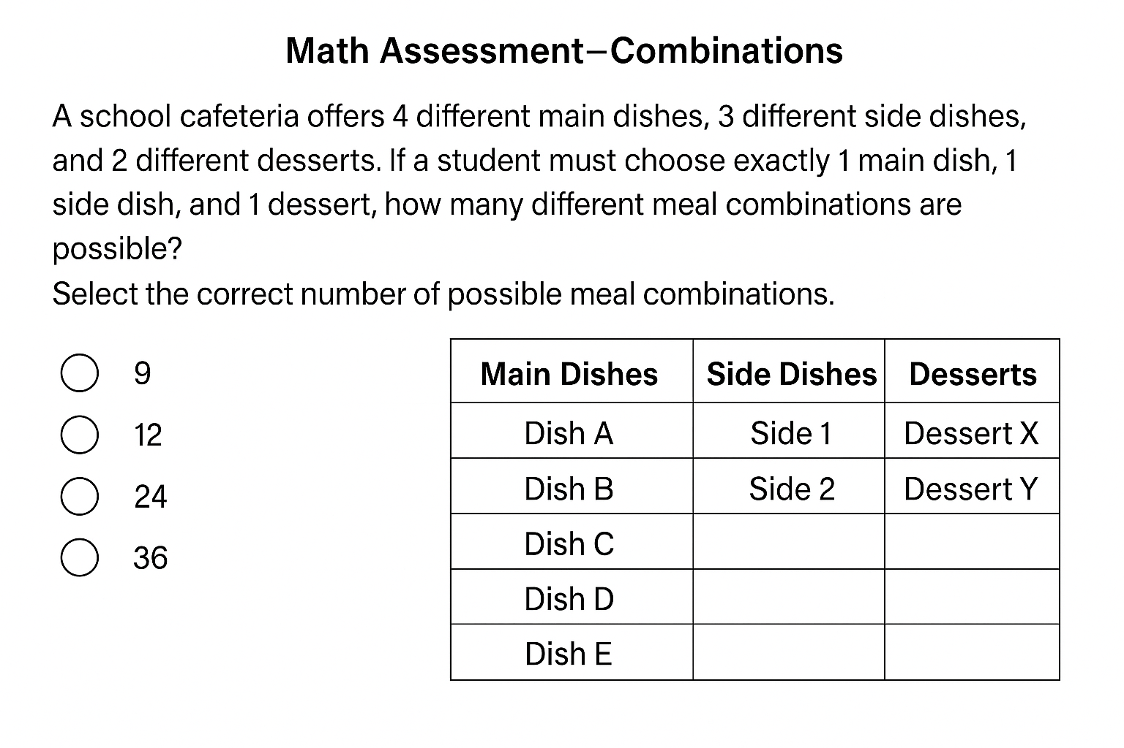

@title Math Assessment - Volume of Cylinder
@description Assessment covering geometric measurements and volume calculation
@question A cylindrical container has a height of 12 centimeters and a radius of 5 centimeters. If the container is filled with water to 80% of its capacity, what is the volume of water in cubic centimeters? (Use π ≈ 3.14)
@instruction Calculate the volume of water in the container and select the closest answer.
@difficulty moderate
@Order 2
@option 600π
@option 480π
@option 754.8
@option 942.5
@explanation First, calculate the total volume of the cylinder: V = πr²h = π(5²)(12) = π(25)(12) = 300π cubic centimeters. Since the container is 80% full, multiply by 0.8: 300π × 0.8 = 240π. Using π ≈ 3.14: 240 × 3.14 = 753.6 cubic centimeters. The closest answer is 754.8.
@subject Mathematics
@unit Geometry and Measurement
@topic Volume of Cylinders
@plusmarks 1
