MP-CO-2

SLOW LEARNERS SESSIONS 1-7

ADVANCED LEARNERS SESSIONS 1-10

SESSION 1:

Duality in Linear programming

Duality in linear programming is essentially a unifying theory that develops the relationships between a given linear program and another related linear program stated in terms of variables with this shadow-price interpretation. The importance of duality is two fold. First,fully understanding the shadow-price interpretation of the optimal simplex multipliers can prove very useful in understanding the implications of a particular linear-programming model. Second, it is often possible to solve the related linear program with the shadow prices as the variables in place of or in conjunction with, the original linear program, there by taking advantage of some computational efﬁciencies.

DEFINITION OF THE DUAL PROBLEM:

Let the primal problem be:

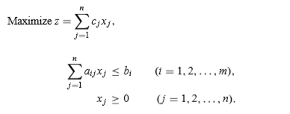

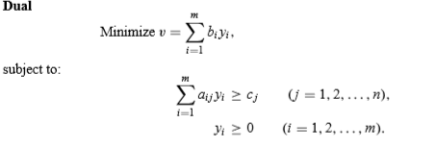

These primal and dual relationships can be conveniently summarized as in fig

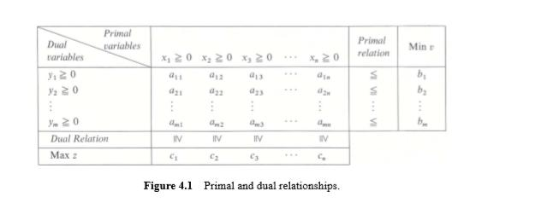

THE FUNDAMENTAL DUALITY PROPERTIES:

We consider the primal problem in inequality form so that the primal and dual problems are symmetric. Thus,

The Fundamental Duality Properties

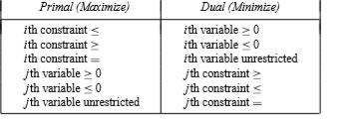

Duality in general:

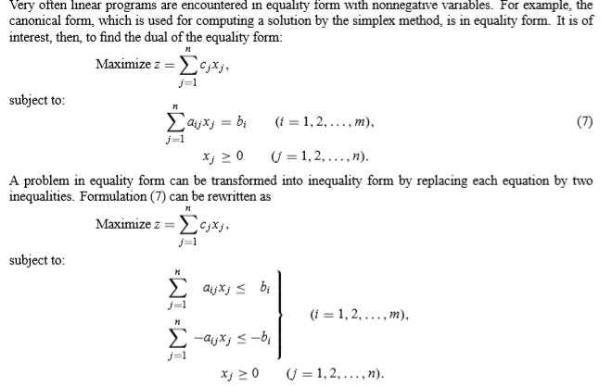

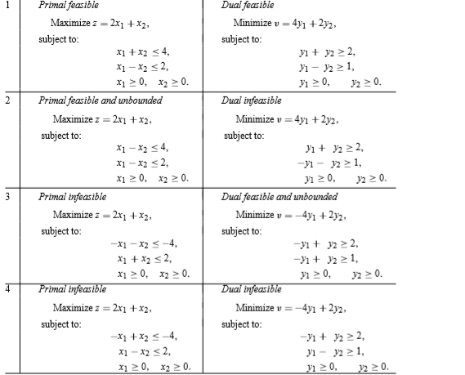

Important characteristics of Duality

1. Dual of dual is primal

2. If either the primal or dual problem has a solution then the other also has a solution and their optimum values are equal.

3. If any of the two problems has an infeasible solution, then the value of the objective function of the other is unbounded.

4. The value of the objective function for any feasible solution of the primal is less than the value of the objective function for any feasible solution of the dual.

5. If either the primal or dual has an unbounded solution, then the solution to the other problem is infeasible.

6. If the primal has a feasible solution, but the dual does not have then the primal will not have a finite optimum solution and vice versa.

Advantages and Applications of Duality

1. Sometimes dual problem solution may be easier than primal solution, particularly when the number of decision variables is considerably less than slack / surplus variables.

2. In the areas like economics, it is highly helpful in obtaining future decision in the activities being programmed.

3. In physics, it is used in parallel circuit and series circuit theory.

4. In game theory, dual is employed by column player who wishes to minimize his maximum loss while his opponent i.e. Row player applies primal to maximize his minimum gains. However, if one problem is solved, the solution for other also can be obtained from the simplex tableau.

5. When a problem does not yield any solution in primal, it can be verified with dual.

6. Economic interpretations can be made and shadow prices can be determined enabling the managers to take further decisions.

Write the dual of the given problem

EX:2 Obtain dual of the LPP

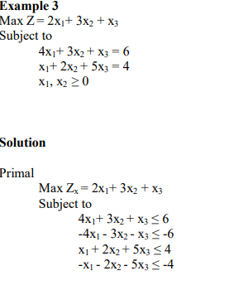

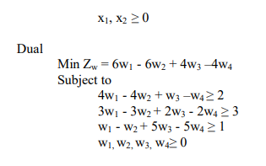

EX 4: Find the dual LPP for the LPP

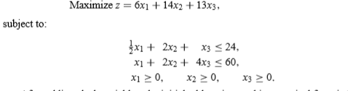

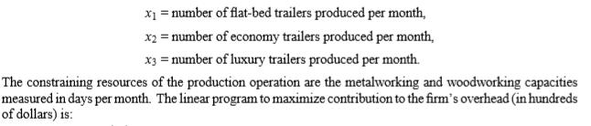

Solution:

Dual LPP is

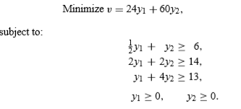

SESSION 2:

To find Solution of dual problem using primal lpp solution of the above problem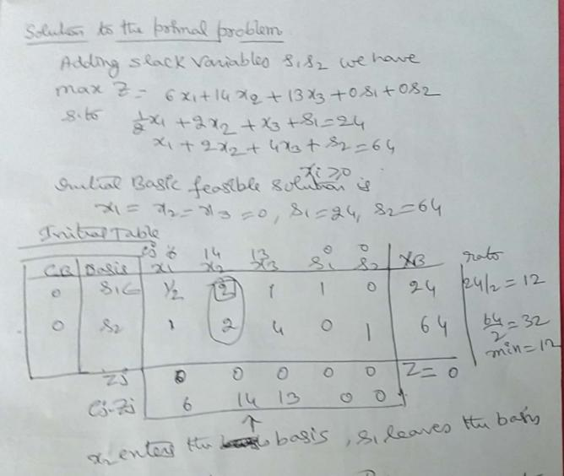

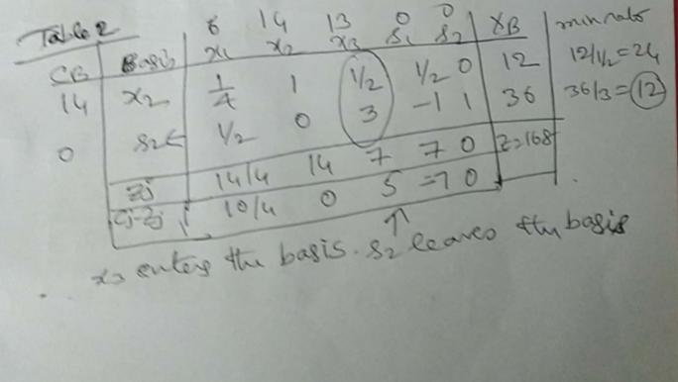

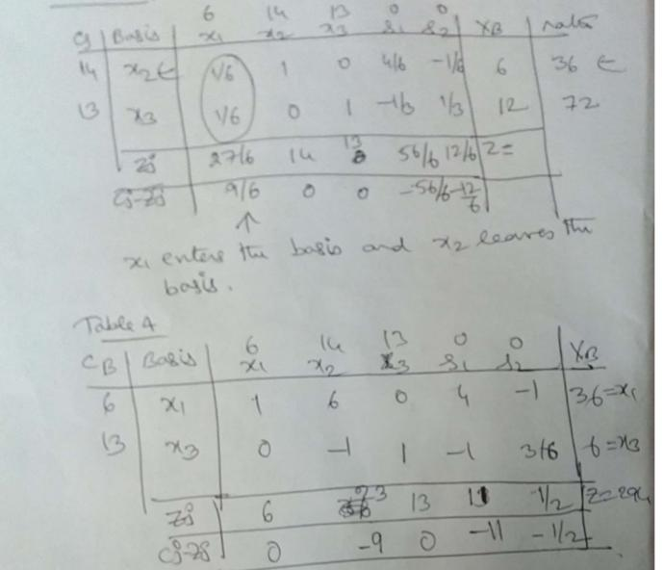

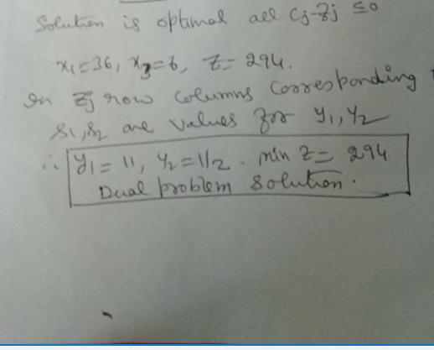

Find the solution of dual problem of LPP

Max Z=5x1+3x2

Subject to the constraints x1+ x2 <= 2, 5x1+2x2<=10, 3x1+8x2 <= 12x1,x2 >=0

Solution of the primal (given lpp):

.

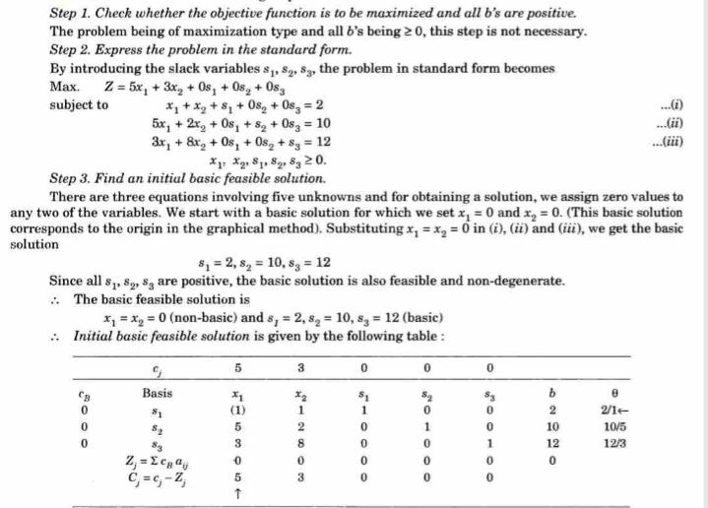

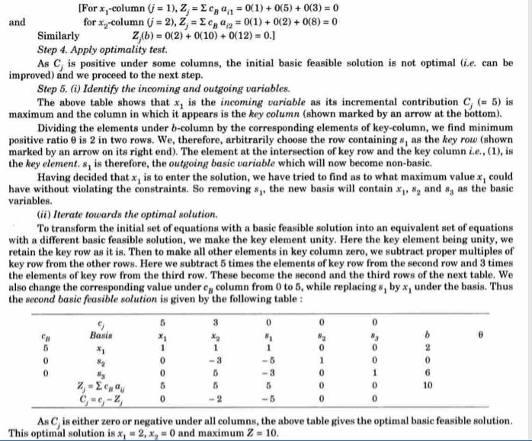

Dual problem:

Min Z’=2 y1+10 y2+12 y3

s.to the constraints y1+5y2+3y3 >= 5 ,

y1+2 y2+8y3 >= 3, y1,y2,y3 >=0

Solution of dual problem using primal lpp solution:

Using Zj row corresponding to s1,s2,s3 are 5,0,0 gives values for y1,y2,y3 respectively and optimum value for Z & Z’ same min Z’=10.

EX:2

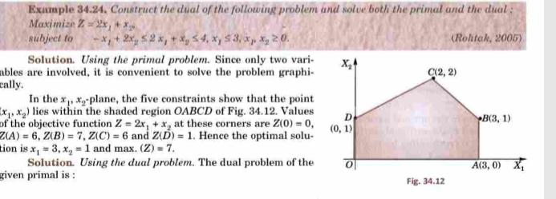

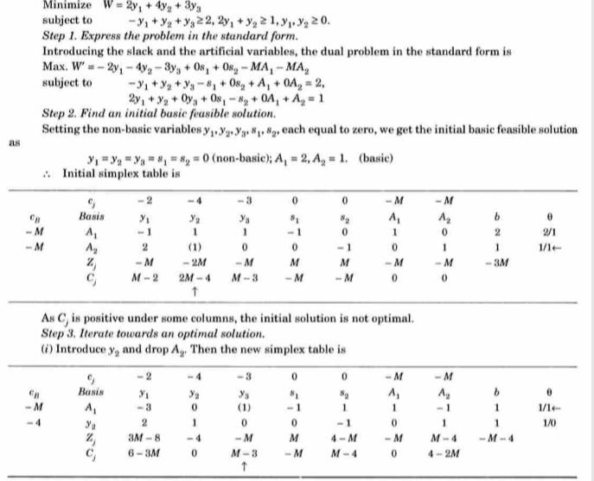

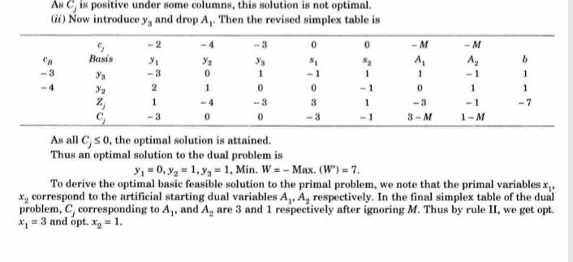

Problems:

1)

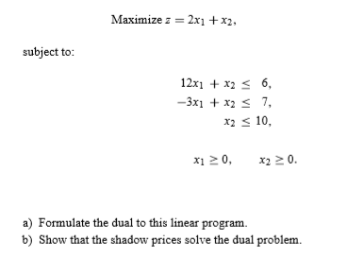≤

2

Find the dual associated with LPP

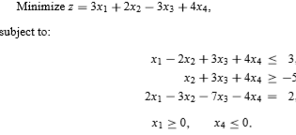

3

Find the dual associated with LPP

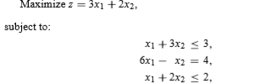x1,x2 >=0

4. Write the dual of the given primal problem: Max. z =23x+32y, subject to 10x+6y,

5x+10y, and x y

SESSION 3

DUAL SIMPLEX METHOD: Dual simplex method was introduced by Lemke.

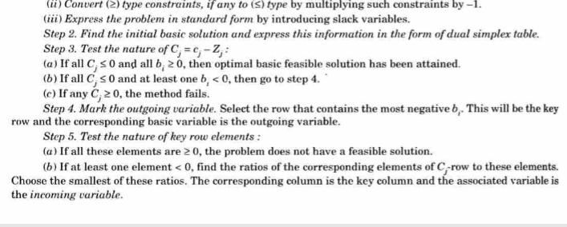



SESSINO-4 DUAL SIMPLEX METHOD

Ex:

Use dual simplex method solve the LPP

Maximize Z= -3x1-x2

Subject to x1+x2 ≥ 1,2x1+3x2 ≥ 2; xi ≥ 0 i=1,2

Ex Use the dual simplex method to solve the following problem:

Maximize z = : , and .

Use the dual simplex method to solve the following problem:

Maximize z = : , and .

Ex:

Use the dual simplex method to solve the following problem:

Minimize Z=2x1+x2,

Subject to 3x1+x2 ≥3, 4x1+3x2≥6,x1+2x2≤3, x1,x2 ≥0

SENSITIVITY ANALYSIS

SESSINON-5,6 Discuss Sensitivity analysis in changing cost coefficients in the basic variables and non basic variables in the final optimal solution.

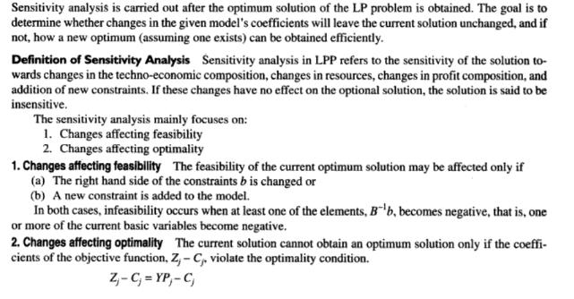

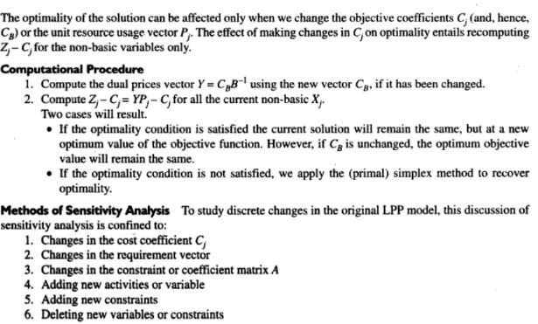

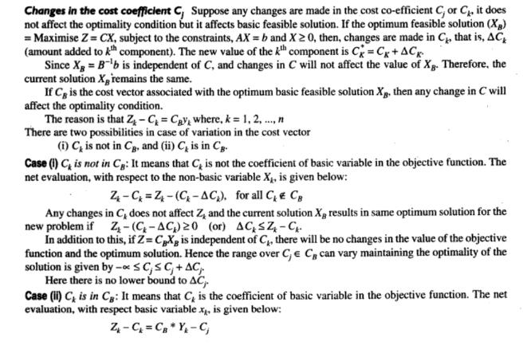

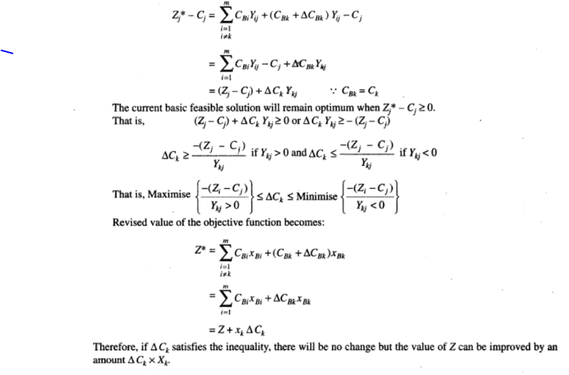

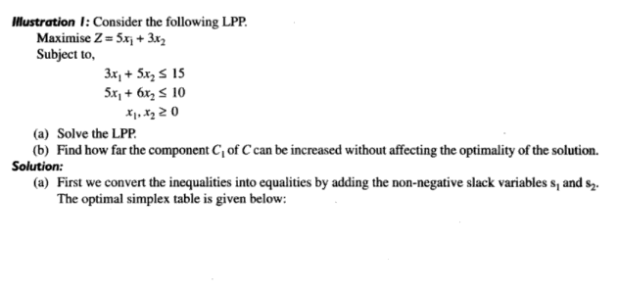

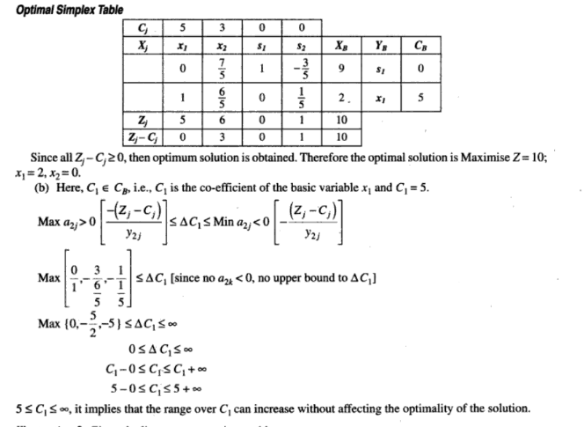

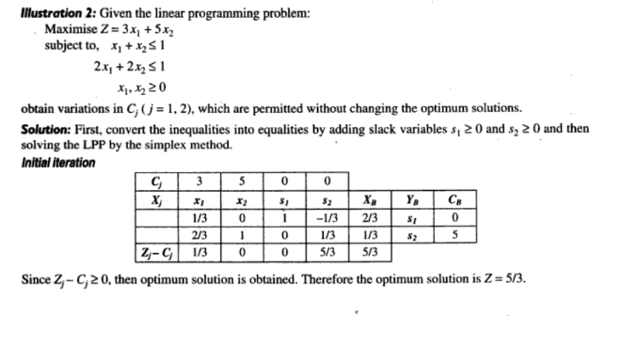

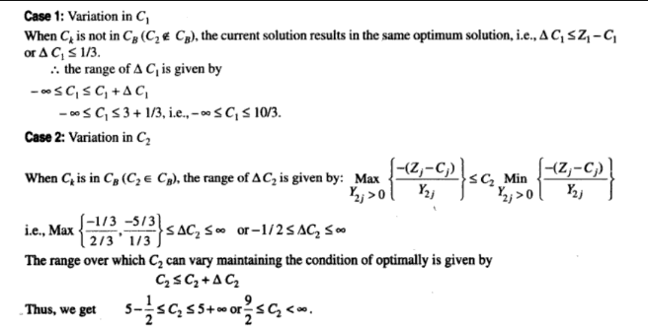

**PROBLEMS:**

**1. Solve the problem and discuss sensitivity analysis of changing c vector(cost values of decision variables**

**Maximize z = 2 ,**

**subject to ,**

**3,**

**and**

**2. Solve using the Simplex method and discuss sensitivity analysis of changing c vector(cost values 0f decision variables**

**Maximize z = 16 x1 + 15x2 ,**

**Subject to:  40x1 +31x2  ≤ 124 ,  – x1­ + x2 ≤ 1 , x1 ≤ 3 , x1, x2 ≥ 0.**

**SESSSIN -7**



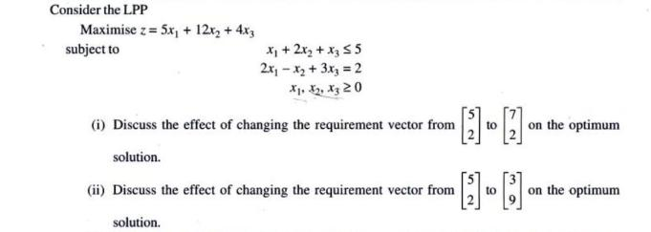

**SOLUTION: Big- M method final table is as follows**

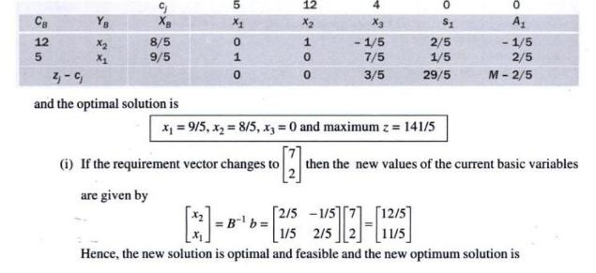



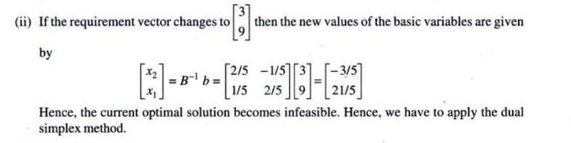

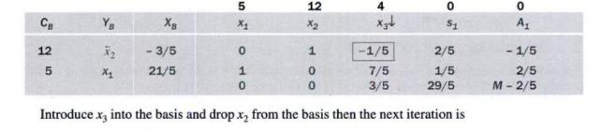

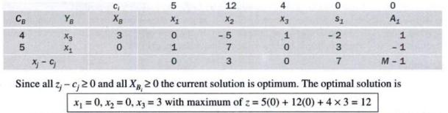

ADVANCED LEARNERS

**SESSION -8**

**ADDITION OF NEW CONSTRAINT:**

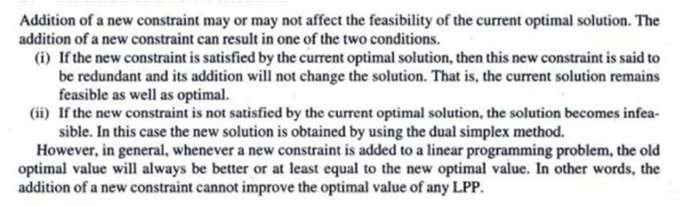

EX:

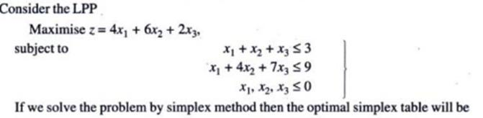

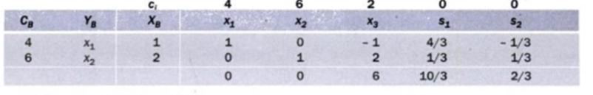



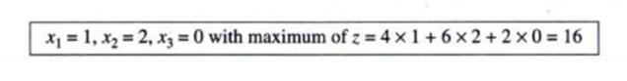



Doesnot satisfy the additional constraint.The current optimal solution is not optimal for the modified problem. Let S3 be the slack variable for the new constraint the modified table will be

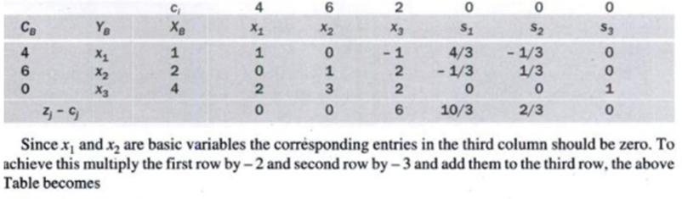

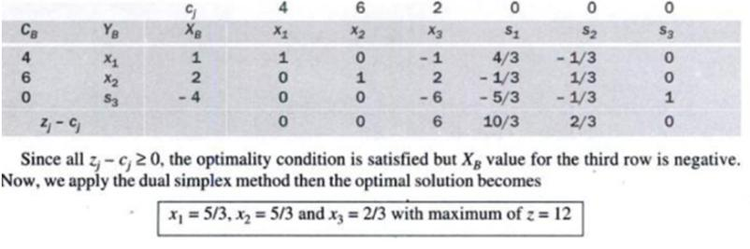

**SESSIONS 9,10 : Discussion sensitivity of LPP by adding a new variable**

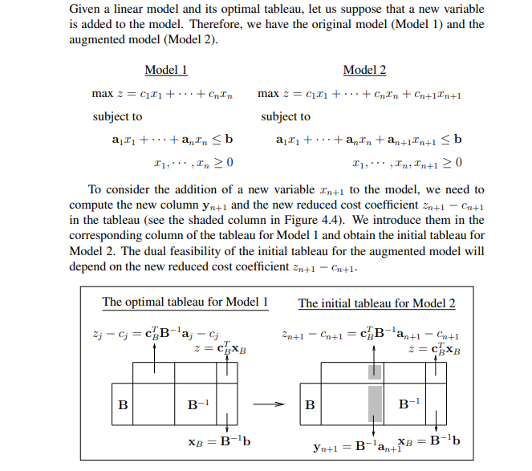

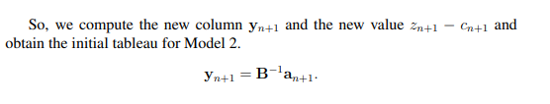

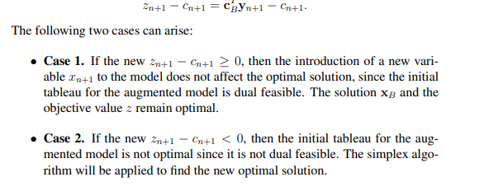

**Let us analyse addition of new variable in two cases**

**Ex:**

