**Code:**

*# setting up my environment*

import numpy as np

import pandas as pd

import seaborn as sns

from plotly.subplots import make_subplots

import matplotlib.pyplot as plt

!pip install itables

from itables import init_notebook_mode

from itables import show

import plotly.express as px

from plotly.offline import iplot, init_notebook_mode

import plotly.offline as py

py.init_notebook_mode(connected=True)

import warnings

warnings.filterwarnings('ignore')

*# plotting world population trend since 1970*

plt.subplots(figsize=(10,5))

trend = df.iloc[:,5:13].sum()[::-1]

sns.lineplot(x=trend.index, y=trend.values, marker="o")

plt.xticks(rotation=45)

plt.ylabel("Population")

plt.title("World Population Trend (1970-2022)")

plt.show()

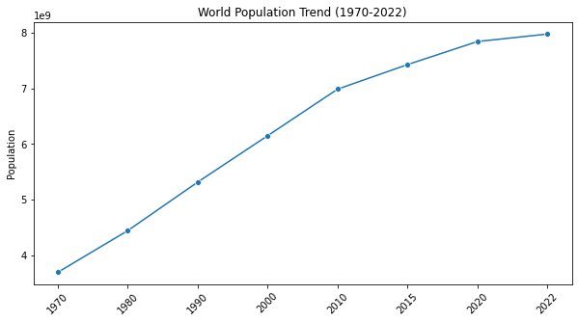

continent_df['2022'].plot(kind = 'pie', figsize=(10,5), shadow=True, autopct='**%1.1f%%**') *# autopct create %*

plt.title(' Population Distribution by Continent')

plt.axis('equal')

plt.show()

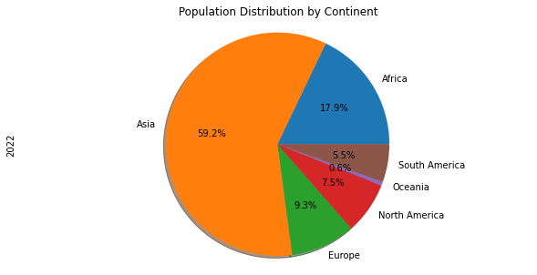

fig = px.bar(data_frame= df.groupby('Continent' , as_index= False).sum().sort_values('2022', ascending=False), x= 'Continent' , y= '2022')

fig.update_layout(title= 'Current (2022) World Population per Continent', title_x= 0.5)

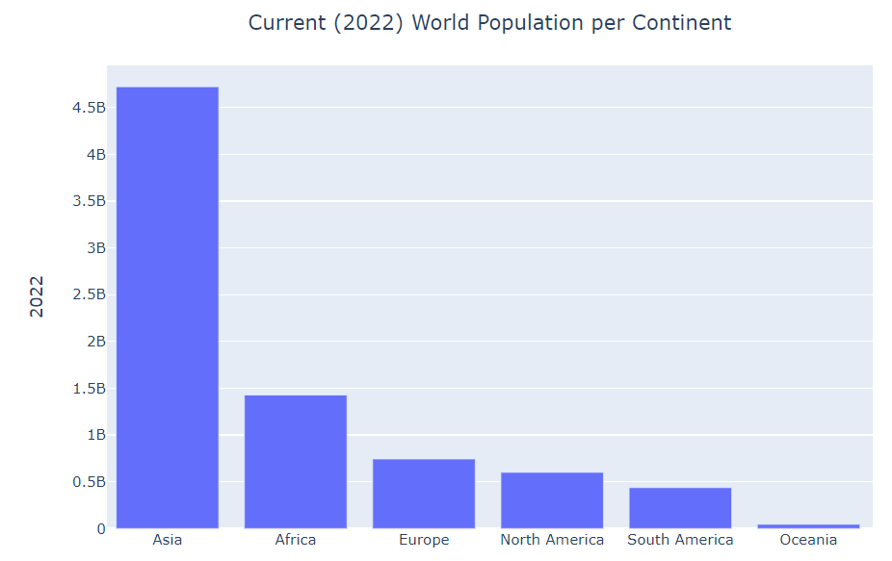

df_country=df['Continent'].value_counts()

fig=px.bar(x=df_country.index,

y=df_country.values,

color=df_country.index,

color_discrete_sequence=px.colors.sequential.YlOrRd,

text=df_country.values,

title= 'Number of Countries By Continent')

fig.update_layout(xaxis_title="Countries",

yaxis_title="Count")

fig.show()

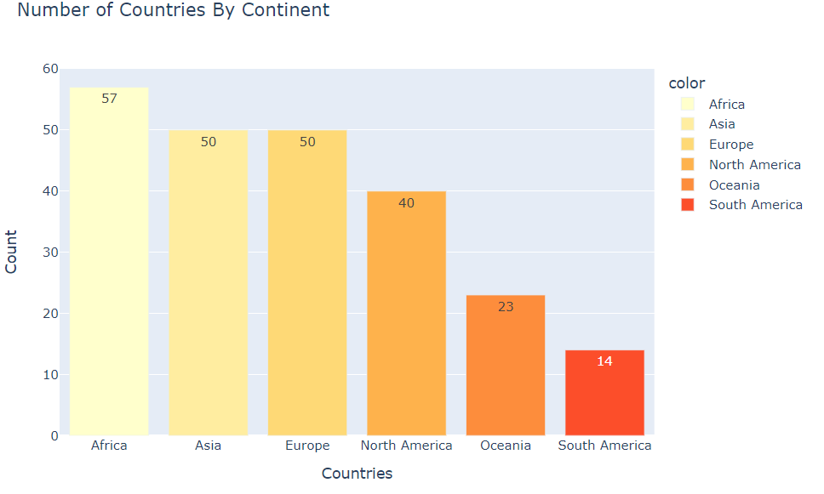

fig, ax = plt.subplots(figsize=(16,8))

plt.plot(gwr_top10['Country'], gwr_top10['2020'], label='2020', marker='o')

plt.plot(gwr_top10['Country'], gwr_top10['1990'], label='1990', marker='d')

plt.xlabel('Country')

plt.ylabel('Growth Rate')

plt.grid(linewidth=0.3)

plt.title('Top 10 Countries with Highest Growth Rate in the last 30 years')

plt.legend()

plt.show()

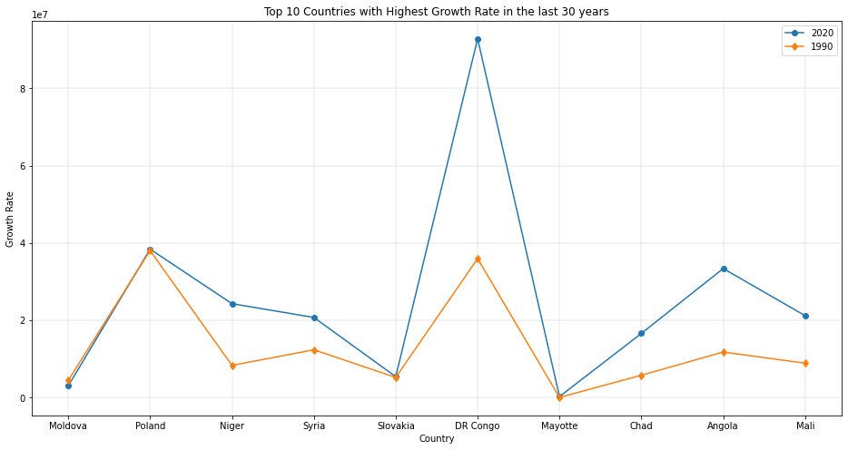

*# plotting wolrd population difference decade-by-decade percent change 70s - 2010s*

fig, ax = plt.subplots(figsize=(16,8))

plt.plot(decade_diff['Continent'], decade_diff['70s'], label='70s', marker='o', color='green')

plt.plot(decade_diff['Continent'], decade_diff['80s'], label='80s', marker='d', color='red')

plt.plot(decade_diff['Continent'], decade_diff['90s'], label='90s', marker='o', color='blue')

plt.plot(decade_diff['Continent'], decade_diff['00s'], label='00s', marker='d', color='orange')

plt.plot(decade_diff['Continent'], decade_diff['10s'], label='10s', marker='d', color='skyblue')

plt.grid(linewidth=0.4)

plt.title("World Population Difference Decade-By-Decade Percent Change 1970s to 2010s")

plt.xlabel('Continents')

plt.ylabel('Population')

plt.legend()

plt.show()

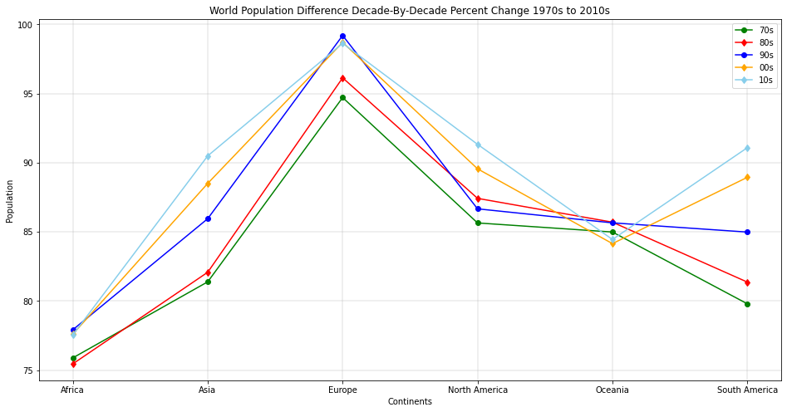

df_top10.plot(kind='barh', figsize=(10, 10), color='darkblue')

plt.xlabel('Population')

plt.title('Top 10 Countries With MOST Population 2022')

plt.show()

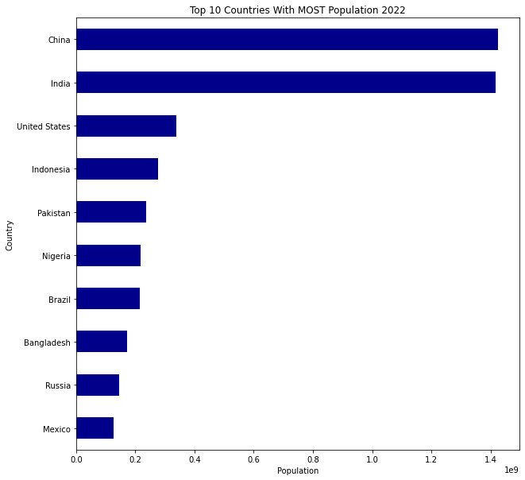

*# top 10 countries with least population trend.*

inplace = True

df_copy.sort_values(by='2022', ascending=False, axis=0, inplace=True)

df_bttm10 = df_copy.tail(10)

df_bttm10 = df_bttm10[years].transpose()

df_bttm10.index = df_bttm10.index.map(int)

df_bttm10.plot(kind='line', figsize=(14, 8))

plt.title('Trend of Top 10 Countries with LEAST population')

plt.ylabel('Populaton')

plt.xlabel('Years')

plt.show()

