CLEAN CDR TABLE
IN IICS
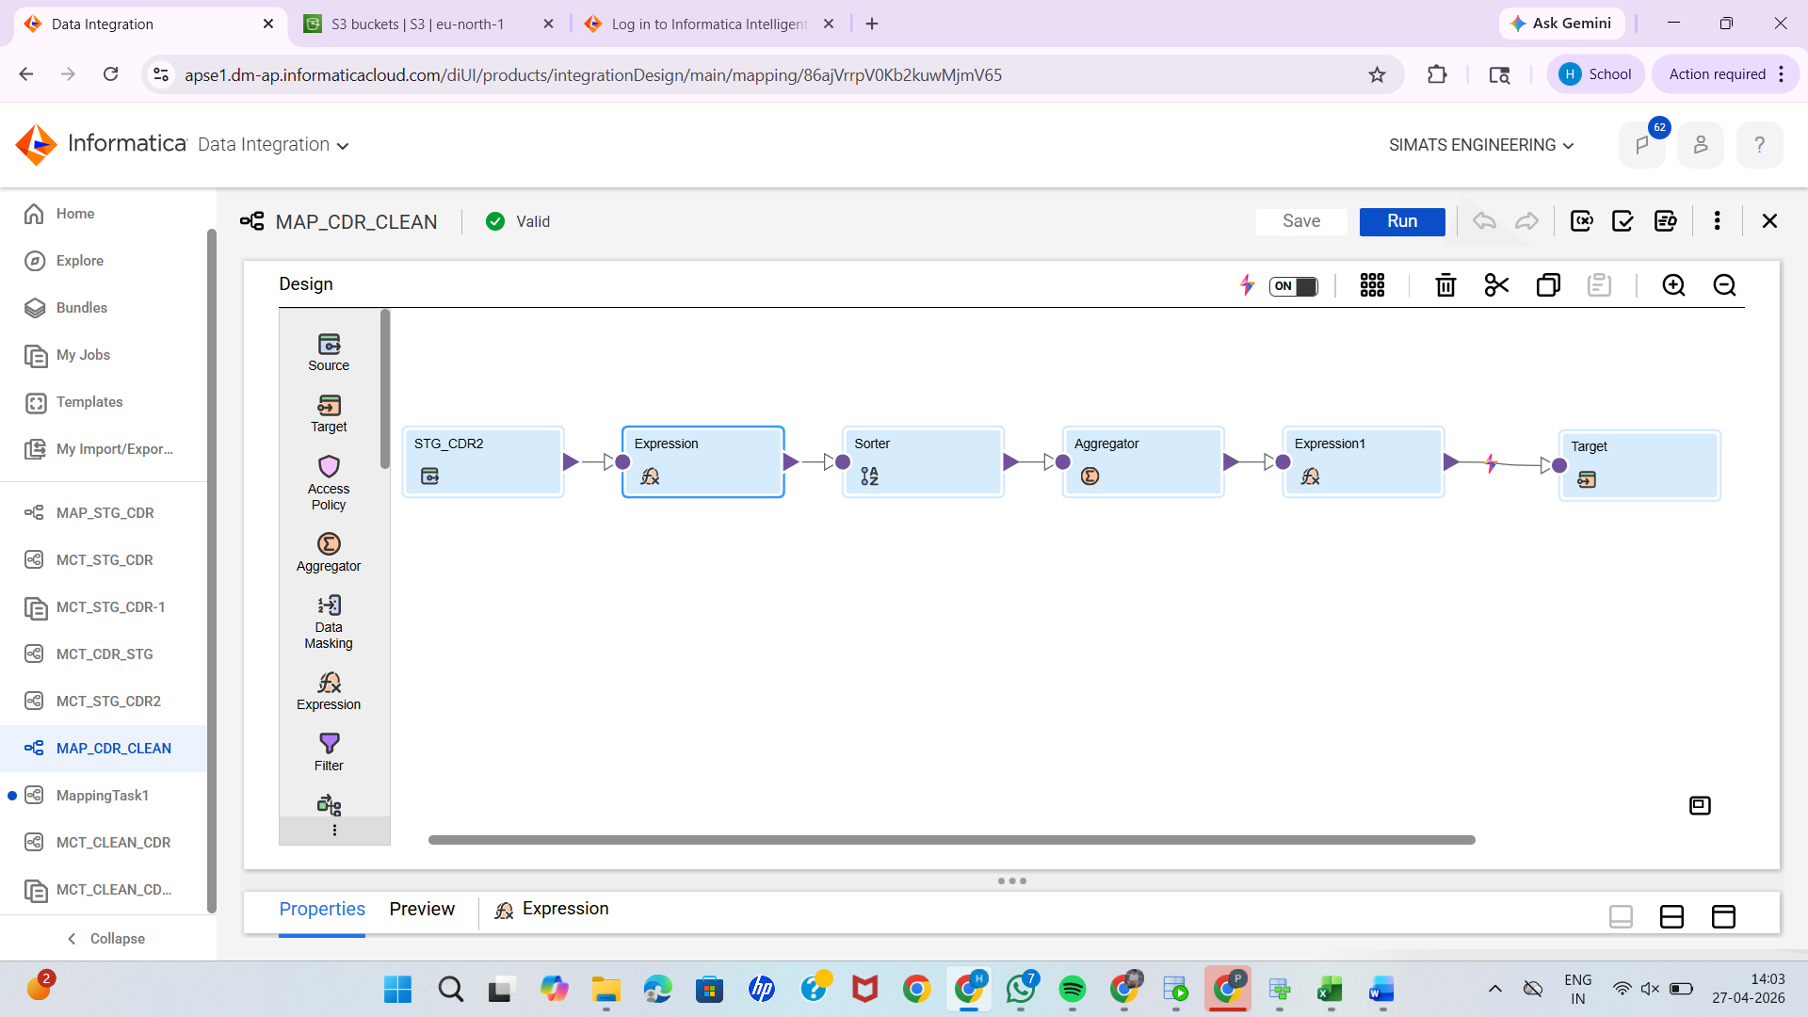
1.SOURCE:
STG_CDR2
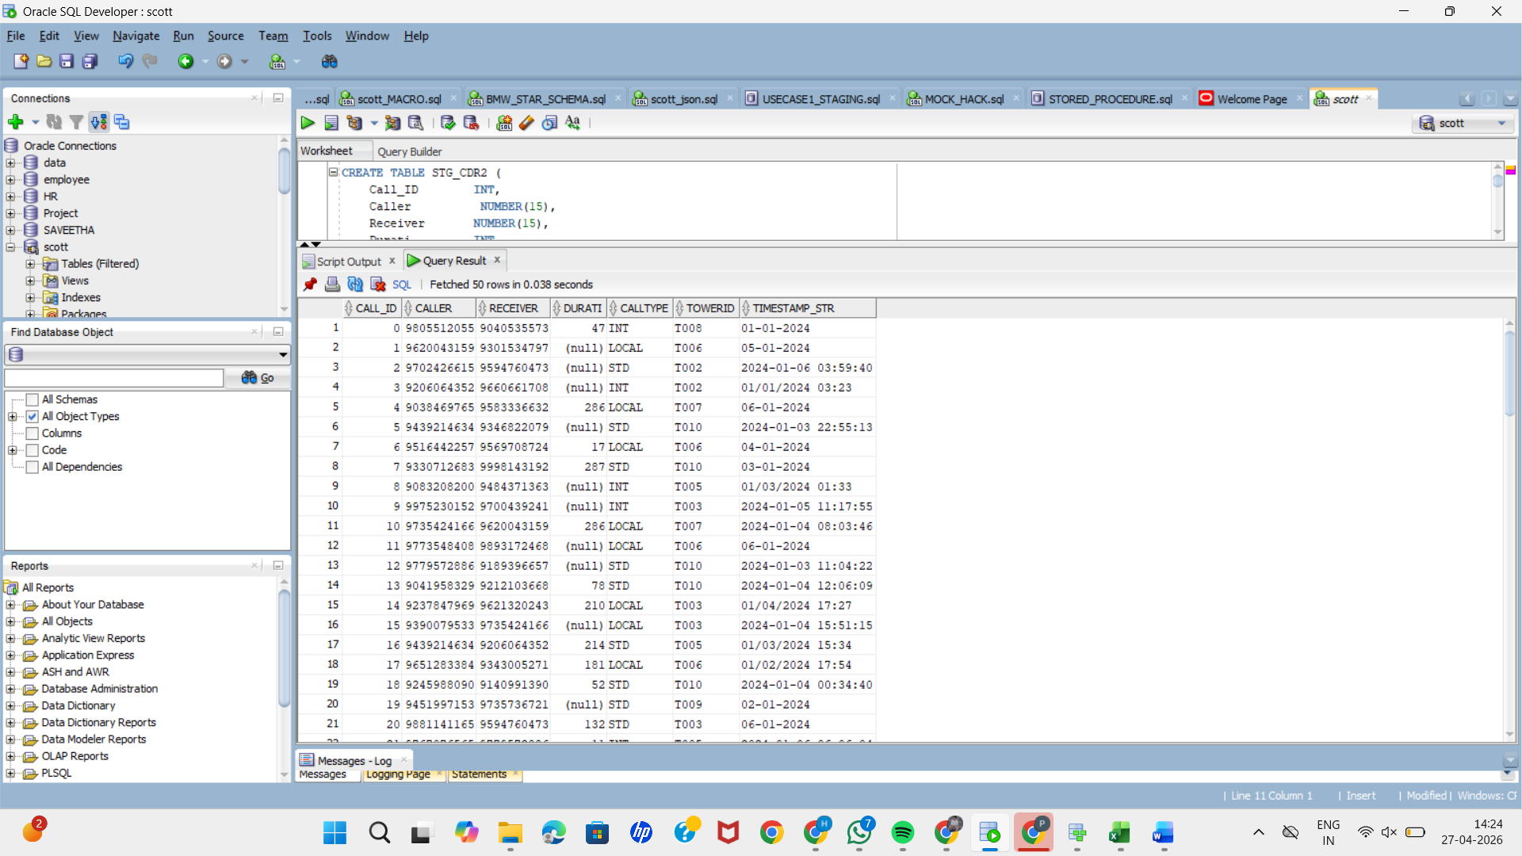

2.EXPRESSION:
1.To handle missing duration :O_DURATION
IIF(ISNULL(DURATI),0, DURATI)
2.To handle date inconsistency:
IIF(
LENGTH(TIMESTAMP_STR)=19,
TIMESTAMP_STR,
IIF(
INSTR(TIMESTAMP_STR,'/')>0,
TO_CHAR(
TO_DATE(TIMESTAMP_STR,'MM/DD/YYYY HH24:MI'),
'YYYY-MM-DD HH24:MI:SS'
),
TO_CHAR(
TO_DATE(TIMESTAMP_STR,'DD-MM-YYYY'),
'YYYY-MM-DD HH24:MI:SS'
)
))
3.SORTER:
To sort based on call_id
4.AGGREGATER
To handle duplicate date
GROUP BY call_id
5.EXPRESSION
To add new fields
1.Revenue:
DURATION*0.02
2.ISINTERNATIONAL
IIF(CALLTYPE='INT',1,0)

5.TARGET:
CLEAN_CDR2
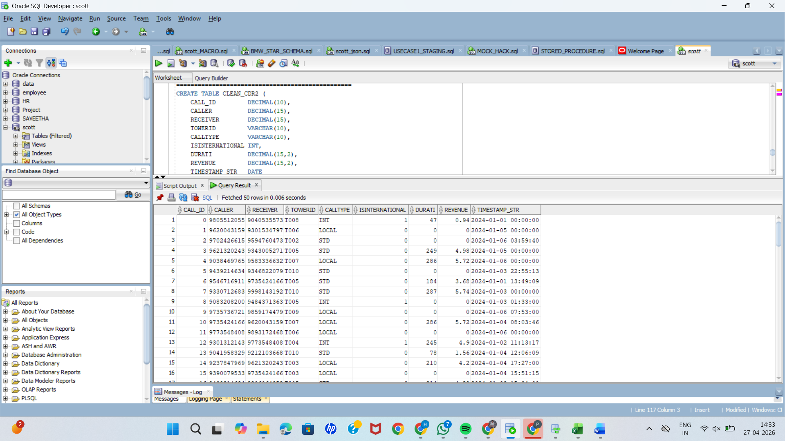

1.USE CASE: REVENUE DATA
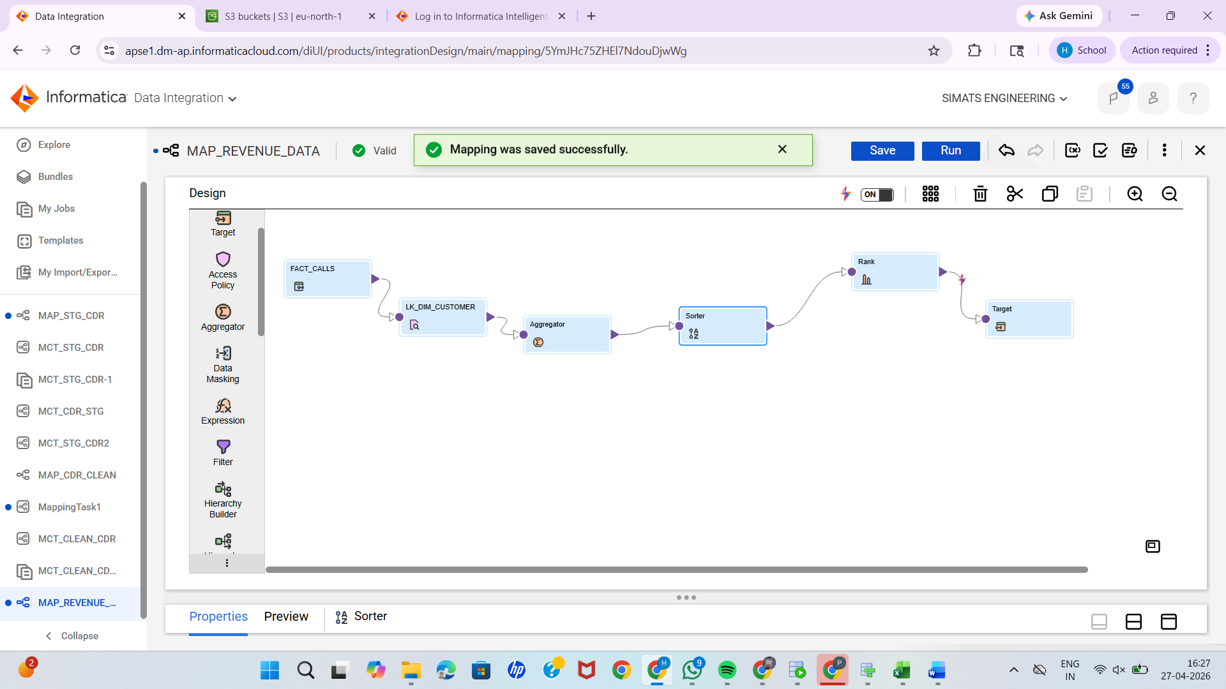
SOURCE: FACT_CALLS


2.LOOKUP: DIM_CUSTOMER
--To get customer name from dim_customer using customer_key as condition

3.AGGREGATER
--To calculate total revenue per customer and total calls
--Group by customer_key and customer_name
4.SORTER
--To sort the total revenue in desc order
5.Target
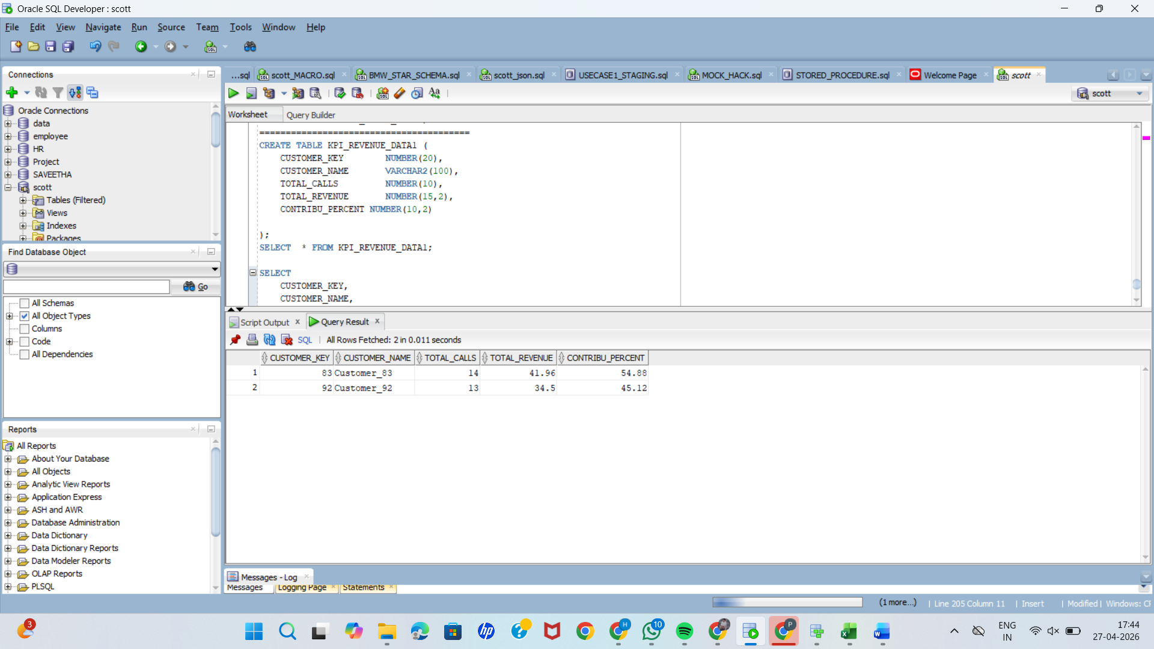
--USING ORACLE
TO CALCUALTE CONTRIBUTION
SELECT
CUSTOMER_KEY,
CUSTOMER_NAME,
TOTAL_CALLS,
TOTAL_REVENUE,
ROUND(
TOTAL_REVENUE /
SUM(TOTAL_REVENUE) OVER() * 100,
2) AS CONTRIBU_PERCENT
FROM KPI_REVENUE_DATA1;

