FOSN IMP Questions
1 | Define Social Network?
2 | What is “Random Walk”?
3 | Describe Paths & Connectivity?
4 | What is tie strength?
5 | Describe Web Search technique.
6 | Define Hypertext?
7 | Explain the popularity as a Network Phenomenon.
8 | Describe the effects of a search tool?
9 | Explain about Six Degree separation?
10 | Give examples of direct observations?
11 | What is Graph?
12 | Describe Triadic Clouser.
13 | What is the World wide web?
14 | Describe Link Analysis.
15 | What is Power Law?
16 | Describe the unpredictability of Rich get Richer effect?
17 | Describe Core Periphery Structure.

Unit-1
- Describe The Empirical Study of Social Network?
- Explain Snow ball sampling in detail with example?
- Explain in detail about “The Small World Experiment”
- What is Contact Tracing, explain?
- Explain in detail about “The Small World Experiment”
- What is the impact of Interviews & Questionnaires in Social Network?
- What is the impact of Interviews & Questionnaires in Social Network?
- Explain Snow ball sampling in detail with example?
Unit-2
- Describe the importance of Graphs in Social Networks
- Explain Passive engagement in detail?
- Describe strong ties and weak ties with example?
- Explain Passive engagement in detail?
- Differentiate between Strong ties and weak ties.
- Describe Graph theory in social network with neat diagram.

Unit-3
- Describe the History of World Wide Web and its importance.
- Explain The Web as a Directed graph?
- Compute the Page Rank for each web page for the first two updates in the figure given below, also define Page Rank Algorithm.
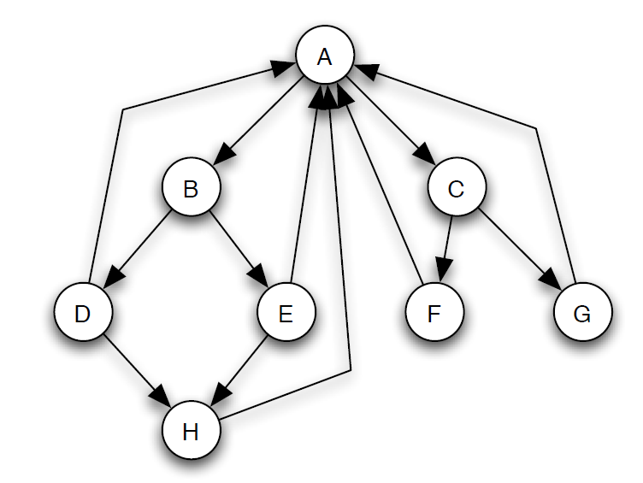
- Explain the “Bow Tie Structure” of the Web with neat diagram.
Unit-4
- Explain the power Laws distribution in detail.
- Describe Rich get Richer Model and its Analysis in detail.
- What is “The Long Tail”? explain with neat graph
- Analyze the Rich get Richer Process?
Unit-5
- Explain the Analysis of decentralized search?
- Describe about Empirical Analysis and Generalized Models?
- Describe about Empirical Analysis and Generalized Models?
- Explain about Structure and randomness in detail?
- Discuss about Decentralized Search?

