SIMATS ENGINEERING
ASSESSMENT TOOL 1
COURSE NAME: Artificial Intelligence COURSE CODE: CSA17

COURSE OUTCOME COVERED
CO1: Apply AI basics such as intelligent agents and uninformed search methods to solve problems effectively. (BL3)
Assessment Tool Weightage: 50%

QUESTIONS: 5 Duration : 1 Hour
Total Marks: 50
Annexure A
Analytical Problem Solving

Code of Conduct:
I _____Aluri poojitha_______________ (Name / Reg No) certify that this submission is my original work and that I have adhered to the guidelines specified for this assessment.
I understand that any violation of academic integrity rules will result in disciplinary action.
Signature of the student:

Annexure A
Analytical Problem Solving
1. Solve the Water Jug problem: you are given 2 jugs, a 4-gallon one and 3-gallon one. Neither has any measuring maker on it. There is a pump that can be used to fill the jugs with water. How can you get exactly 2 gallons of water into 4-gallon jug?
Explicit assumptions: A jug can be filled from the pump, water can be poured out of a jug onto the ground, water can be poured from one jug to another and that there are no other measuring devices available.
2. Find out how Mars Rover, analyse and explore the samples on Mars by answering the following questions.
i. What are the percept's for this agent?
ii. Characterize the operating environment.
iii. What are the actions the agent can take?
iv. How can one evaluate the performance of the agent?
v. What sort of agent architecture do you think is most suitable for this agent? Why?
3. Explore the search space using search strategies and formulate the problem components for the 8-Queens problem using the following information: Place 8 queens on a chessboard such that none of the queen's attack any of the others. A configuration of 8 queens on the board as shown in the figure below, but this does not represent a solution as the queen in the first column is on the same diagonal as the queen in the last column.
4. A customer wants to travel from the one location to another location using OLA Cab booking mobile application. The customer can select any of the cab type as mini, micro, sedan, shared, prime and so on based on his comfort to reach the destination. Identify what type of problem-solving agent can be used and write the pseudocode for the above problem.
5. A logistics company operates a delivery network where packages must be transported between warehouses at minimum cost. Each route between warehouses has an associated travel cost (fuel + time). The company wants to determine the least-cost path from the starting warehouse S to the destination warehouse G using the Uniform Cost Search (UCS) algorithm.
The delivery network is represented as a weighted graph:
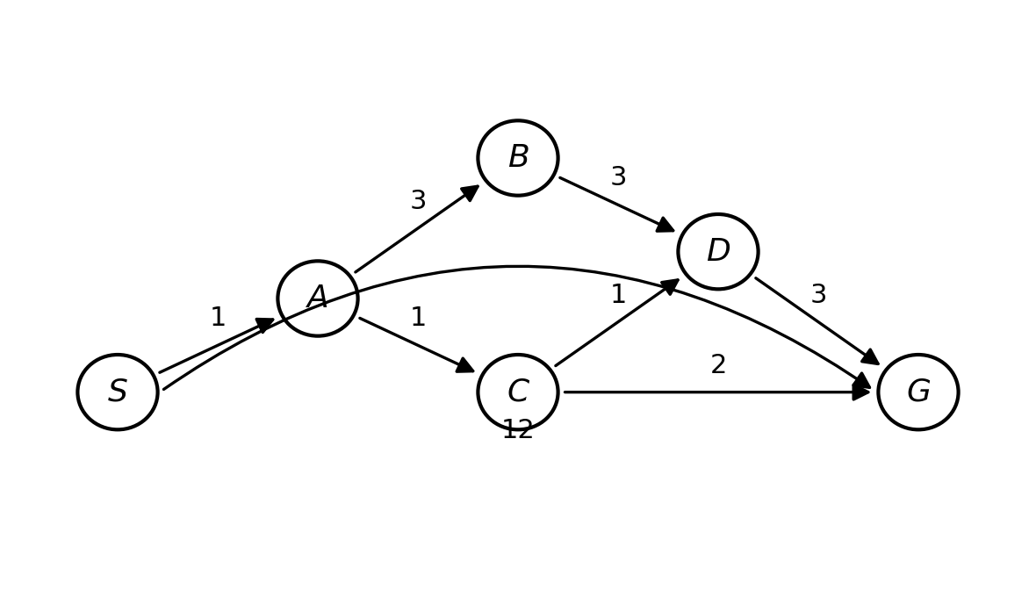

SIMATS ENGINEERING
ASSESSMENT TOOL 1 — ANSWER SCRIPT
Course Name: Artificial Intelligence Course Code: CSA17
Course Outcome: CO1 — Apply AI basics such as intelligent agents and uninformed search methods to solve problems effectively. (BL3)
Annexure A — Analytical Problem Solving

Question 1 — Water Jug Problem
Problem: Given a 4-gallon jug and a 3-gallon jug with no measuring marks, obtain exactly 2 gallons of water in the 4-gallon jug. Allowed operations: fill a jug completely from the pump, empty a jug completely onto the ground, and pour water from one jug into another (until the source is empty or the destination is full).

Step 1: Problem Formulation
State representation: (x, y), where x = amount of water currently in the 4-gallon jug (0–4) and y = amount of water currently in the 3-gallon jug (0–3).
Initial state: (0, 0) — both jugs empty.
Goal state: (2, y) for any y — the 4-gallon jug contains exactly 2 gallons.
Operators (production rules): Fill 4-gallon jug; Fill 3-gallon jug; Empty 4-gallon jug; Empty 3-gallon jug; Pour 3-gallon jug into 4-gallon jug; Pour 4-gallon jug into 3-gallon jug.

Step 2: Step-by-Step Solution Trace
Step | Action Applied | 4-Gallon Jug | 3-Gallon Jug | Reasoning
0 | Initial state | 0 | 0 | Both jugs start empty
1 | Fill 3-gallon jug | 0 | 3 | 3-gallon jug filled completely from pump
2 | Pour 3-gallon jug into 4-gallon jug | 3 | 0 | All 3 gallons transferred; 4-gallon jug has room for 4, so it now holds 3
3 | Fill 3-gallon jug again | 3 | 3 | 3-gallon jug refilled completely
4 | Pour 3-gallon jug into 4-gallon jug | 4 | 2 | 4-gallon jug can only accept 1 more gallon (3→4); 2 gallons remain in the 3-gallon jug
5 | Empty 4-gallon jug | 0 | 2 | 4-gallon jug poured out onto the ground
6 | Pour 3-gallon jug into 4-gallon jug | 2 | 0 | The remaining 2 gallons are transferred into the 4-gallon jug — GOAL REACHED

Goal reached in Step 6: the 4-gallon jug contains exactly 2 gallons of water.
State-space path: (0,0) → (0,3) → (3,0) → (3,3) → (4,2) → (0,2) → (2,0)

Question 2 — Mars Rover as an Intelligent Agent (PEAS Analysis)
The Mars Rover is analysed here as an intelligent agent whose task is to explore the Martian surface, analyse soil/rock samples, and transmit scientific data back to Earth.

i. Percepts
- Images and video from onboard stereo/panoramic and hazard-avoidance cameras
- Spectrometer / chemical-composition readings of rocks and soil
- LIDAR / ultrasonic obstacle-distance readings
- Wheel odometry and IMU (accelerometer/gyroscope) data for position and orientation
- GPS-equivalent positioning relative to landing site (via triangulation with orbiters)
- Battery charge level and solar-panel power input
- Atmospheric data — temperature, dust levels, wind
- Terrain slope and wheel-slippage sensor data
- Incoming commands / data-relay signals from Earth or an orbiter

ii. Environment Characterization
Property | Characterization for the Mars Rover
Observability | Partially observable — only terrain within camera/sensor range is known; the rest of Mars is unknown until explored.
Number of agents | Single-agent (in most missions), though it may coordinate indirectly with an orbiter relay or other rovers.
Determinism | Stochastic — wheel slippage, dust storms, and terrain give uncertain action outcomes.
Episodic vs. Sequential | Sequential — every action (e.g., a drive command) affects future states and future decisions.
Static vs. Dynamic | Dynamic — weather, lighting, and terrain conditions change over time, and long Earth–Mars communication delay means the environment can change before a command arrives.
Discrete vs. Continuous | Continuous — position, speed, and sensor readings are continuous-valued.
Known vs. Unknown | Unknown — the detailed terrain map is not known in advance and must be discovered incrementally.

iii. Actions the Agent Can Take
- Drive forward / backward, turn left / right, adjust wheel speed for terrain
- Extend / retract the robotic arm to reach a rock or soil target
- Drill into rock and collect a sample
- Operate onboard spectrometer / analysis instruments on a sample
- Capture images (panoramic, close-up, hazard-avoidance)
- Transmit collected data to an orbiter or directly to Earth
- Reorient solar panels / enter low-power sleep mode to conserve energy
- Re-plan route to avoid a newly detected obstacle or hazard

iv. Performance Evaluation
The agent's performance can be measured using a performance measure combining:
- Distance covered safely (without collisions, tip-overs, or getting stuck)
- Number and scientific value of samples successfully collected and analysed
- Accuracy and quality of transmitted data
- Energy efficiency — power consumed per unit of useful scientific output
- Mission-time efficiency — objectives achieved within available operational time/sols
- Avoidance of damage to the rover (hazard-avoidance success rate)
- Communication reliability with Earth/orbiter
- Overall operational longevity of the rover

v. Most Suitable Agent Architecture
A model-based, goal-based/utility-based agent architecture is most suitable for the Mars Rover.
Justification:
- Model-based: because the environment is only partially observable, the rover must maintain an internal model (map) of previously explored terrain to make sensible decisions about unobserved areas.
- Goal-based: the rover must plan sequences of actions (e.g., navigate to a specific rock formation) to achieve long-term mission goals, not just react to the current percept.
- Utility-based: with limited power/time and long communication delays preventing real-time human control, the rover must weigh trade-offs — e.g., scientific value of a sample vs. energy cost and risk of the terrain — which requires a utility function rather than a single fixed goal.
A purely simple/reflex agent architecture is insufficient here because it cannot handle partial observability, long-term planning, or trade-off reasoning under uncertainty — all of which are essential for autonomous Mars exploration.

Question 3 — 8-Queens Problem: Search-Space Formulation
Task: Place 8 queens on an 8×8 chessboard so that no two queens attack each other (i.e., no two queens share the same row, column, or diagonal). The example configuration described in the question is not a solution because the queen in the first column and the queen in the last column lie on the same diagonal.

Incremental (Standard) Problem Formulation
Component | Definition for the 8-Queens Problem
Initial State | An empty chessboard — no queens placed.
States | Any arrangement of 0 to 8 queens on the board, with one queen placed per column starting from the leftmost, such that no queen already placed attacks another.
Actions / Successor Function | Add one queen to any empty square in the leftmost column that does not yet contain a queen, choosing a row such that the new queen is not attacked by (does not attack) any queen already on the board.
Goal Test | All 8 queens are placed on the board (one per column) and no two queens attack each other — i.e., no shared row, column, or diagonal.
Path Cost | Not significant to the problem — every step has the same cost (e.g., 1 per placement); only reaching a valid goal state matters, not the length or cost of the path.

Why This Formulation Reduces the Search Space
- Placing one queen per column by construction eliminates all column-conflicts, reducing the raw search space from C(64,8) ≈ 4.4 billion possible placements to 8⁸ ≈ 16.7 million column-wise placements.
- Checking row and diagonal conflicts only against already-placed queens at each step (constraint checking) prunes many branches early, which is exactly the mechanism used by Backtracking Search.
- In the invalid configuration shown in the question, the queen in column 1 and the queen in column 8 lie on the same diagonal (their row and column indices differ by the same amount), so the goal test would correctly reject that state as it violates the diagonal-attack condition.

Search Strategy
Backtracking Search (depth-first search with constraint checking) is the natural strategy: queens are placed column by column; whenever a partial placement violates a row or diagonal constraint, the search backtracks to the previous column and tries the next available row, rather than exploring the entire state space blindly.
Alternative formulation: a complete-state formulation (start with all 8 queens placed, e.g., one per column at random rows, then repeatedly move the queen most in conflict to reduce the number of attacking pairs) is used by local-search methods such as Min-Conflicts / Hill-Climbing, which can be mentioned as an alternative to the incremental backtracking formulation above.

Question 4 — OLA Cab Booking: Problem-Solving Agent
Scenario: A customer uses the OLA app to travel from a pickup location to a destination, choosing among cab types (Mini, Micro, Sedan, Shared, Prime, etc.) based on comfort, cost, and time preferences.

Type of Problem-Solving Agent
This is best modelled as a Utility-Based Problem-Solving Agent (built on top of goal-based search).
Justification:
- Goal-based component: the agent's primary goal is well-defined — transport the customer from the current location to the destination — which is naturally formulated as a shortest/least-cost path search problem (e.g., using Dijkstra's algorithm / A* on the road network).
- Utility-based component: there are multiple ways to achieve that goal (different cab types, different routes), each with a different cost, travel time, and comfort level; the agent must therefore rank options using a utility function that balances these competing factors rather than simply finding any goal-reaching action sequence.

Problem Formulation
Component | Definition
Initial State | Customer's current pickup location
Goal State | Customer successfully delivered to the destination location
States | Possible locations of the vehicle along the road network during the trip
Actions | Move along a road segment; select a cab type; select a route/turn at an intersection
Path Cost | Combination of fare, distance/time, and traffic conditions along the chosen route

Pseudocode
function OLA_CAB_AGENT(pickup_location, destination, user_preferences):
goal ← FORMULATE_GOAL(destination)
problem ← FORMULATE_PROBLEM(pickup_location, goal, road_network)
route ← SEARCH(problem, algorithm = A* / Dijkstra) // least-cost path
available_cabs ← GET_AVAILABLE_CAB_TYPES(pickup_location) // Mini, Micro, Sedan, Shared, Prime, ...
best_cab ← NULL
best_utility ← −∞

for each cab in available_cabs:
fare ← ESTIMATE_FARE(cab, route)
eta ← ESTIMATE_ARRIVAL_TIME(cab, route)
comfort ← COMFORT_RATING(cab)
utility ← UTILITY_FUNCTION(fare, eta, comfort, user_preferences)
if utility > best_utility:
best_utility ← utility
best_cab ← cab

CONFIRM_BOOKING(best_cab, route)

while current_location ≠ destination:
percept ← SENSE_ENVIRONMENT() // GPS, traffic updates, road closures
if percept indicates a better route or disruption:
route ← SEARCH(problem, algorithm = A* / Dijkstra) // re-plan
action ← NEXT_STEP(route)
EXECUTE(action)

return "Trip Completed"

Question 5 — Least-Cost Delivery Route (Uniform Cost Search)
Problem: Find the least-cost path from warehouse S to warehouse G in the weighted delivery network using Uniform Cost Search (UCS).

Step 1: Graph (Edges and Costs) from the Given Network
Edge | Cost
S → A | 1
S → G (direct) | 12
A → B | 3
A → C | 1
B → D | 3
C → D | 1
C → G | 2
D → G | 3

Step 2: UCS Priority-Queue Trace
UCS always expands the node with the lowest cumulative path cost g(n) from the frontier (a priority queue), and keeps only the lowest known cost to each node.
Step | Node Popped (g-cost) | Frontier Before Expansion | Newly Generated / Updated Nodes | Frontier After Expansion
1 | S (0) | S(0) | A(0+1=1), G(0+12=12) | A(1), G(12)
2 | A (1) | A(1), G(12) | B(1+3=4), C(1+1=2) | C(2), B(4), G(12)
3 | C (2) | C(2), B(4), G(12) | D(2+1=3), G(2+2=4) — G updated: 12 → 4 (lower cost found) | D(3), B(4), G(4)
4 | D (3) | D(3), B(4), G(4) | G via D = 3+3=6 — worse than existing G(4), discarded (no update) | B(4), G(4)
5 | B (4) | B(4), G(4) | D via B = 4+3=7 — D already expanded with lower cost 3, discarded | G(4)
6 | G (4) | G(4) | G is the goal node and is now the minimum-cost node in the frontier | GOAL — search terminates

Step 3: Optimal Path Reconstruction
Tracing parent pointers back from G: G ← C ← A ← S
Least-cost path: S → A → C → G
Total cost = 1 (S→A) + 1 (A→C) + 2 (C→G) = 4

Step 4: Comparison with Other Possible Paths
Candidate Path | Cost Calculation | Total Cost
S → A → C → G | 1 + 1 + 2 | 4 (optimal)
S → A → C → D → G | 1 + 1 + 1 + 3 | 6
S → A → B → D → G | 1 + 3 + 3 + 3 | 10
S → G (direct) | 12 | 12

Conclusion: Uniform Cost Search correctly identifies S → A → C → G, with total cost 4, as the least-cost delivery route from warehouse S to warehouse G — significantly cheaper than the seemingly convenient direct S → G route of cost 12.
