# **Name : Poojitha Kavuri**

# **Reg No : 20NN1A1225**

# **College : Vignan’s Nirula Institute of Technology and Science for Women**

# **Ph No : 9866704603**

# **E-mail : poojithakavuri02@gmail.com**

# **FIXED LOD:**

1) In the below visualization we fixed the total sales according to the region by using fixed LOD expressions. 2)We selected the area chart for better appearance .

3)we took the fixed LOD and sales into the columns and by using dual axis we merged both visualizations. 4)by synchronizing the axis we fixed the area chart to show the same LOD value.

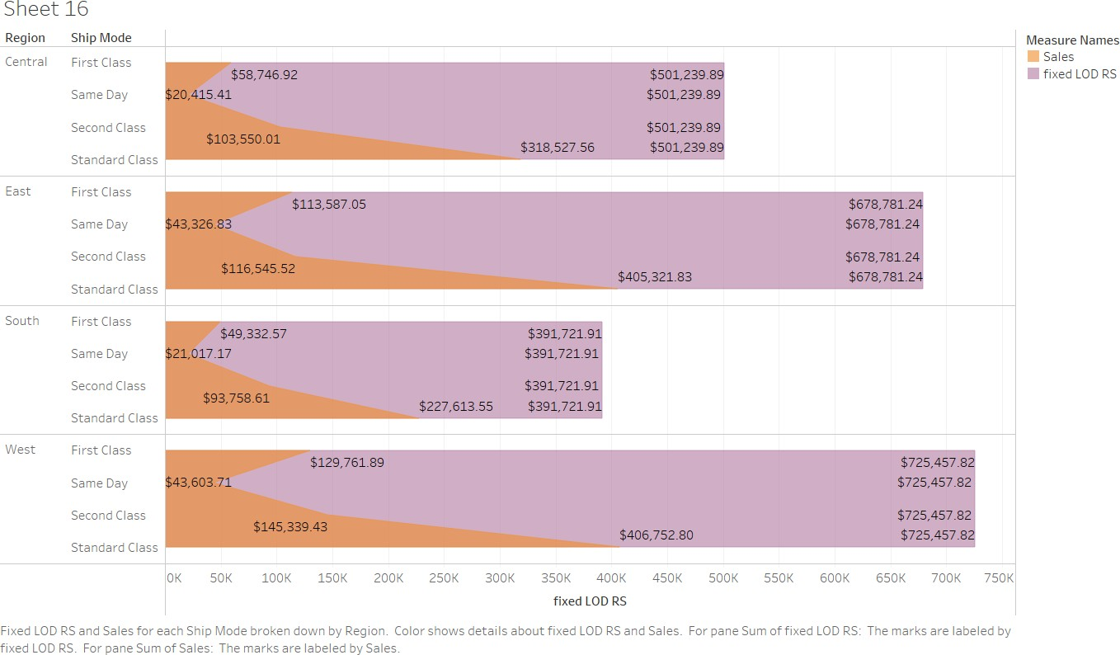

# **Exclude LOD:**

1. In the below visualization we fixed the total sales according to the region by excluding LOD expressions.
2. We selected the area chart for better appearance .
3. We excluded the sales by each shipping mod based on subcategory from category subcategory and by using dual axis we merged both visualizations.
4. by synchronizing the axis we fixed the area chart to show the same LOD value.

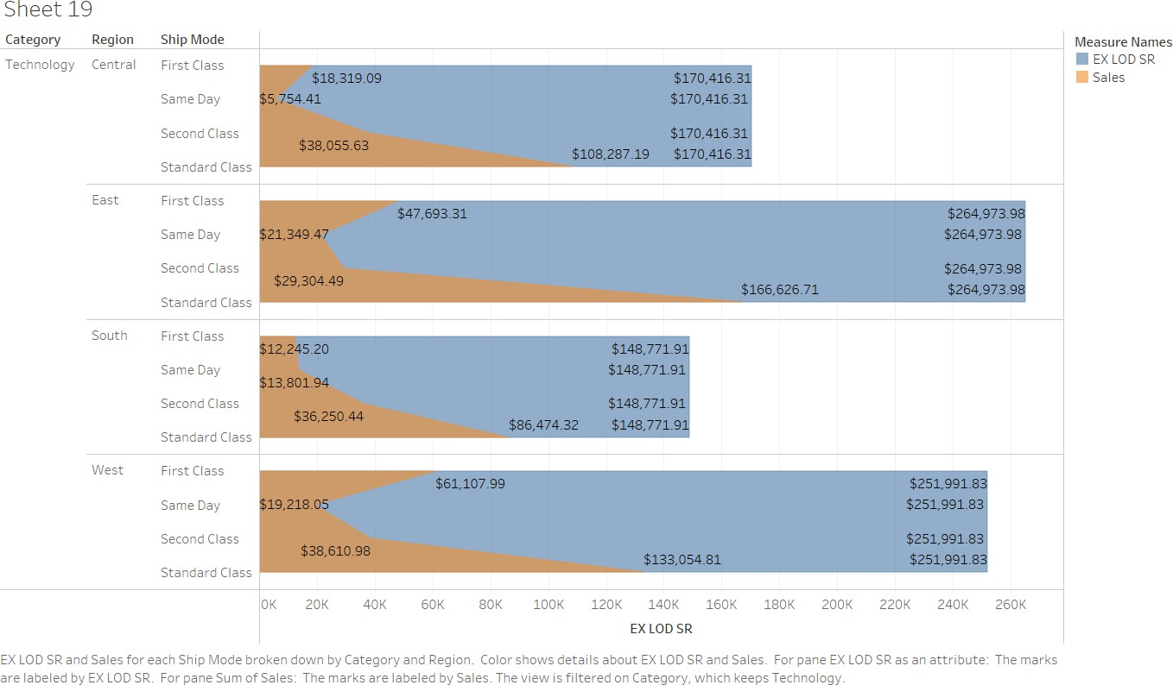

It is a geographical representation of sales in each state on geo map:

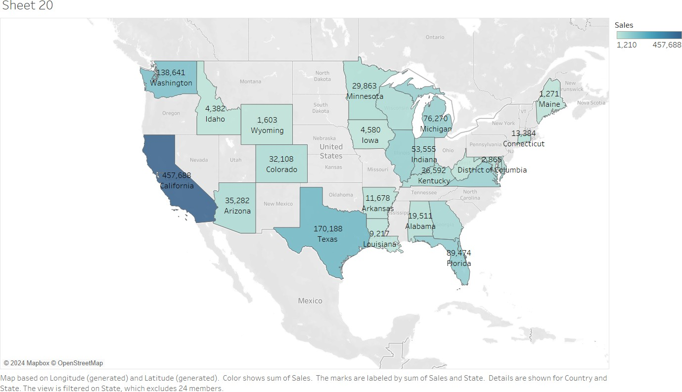

It is a geographical representation of profit in each state on geo map:

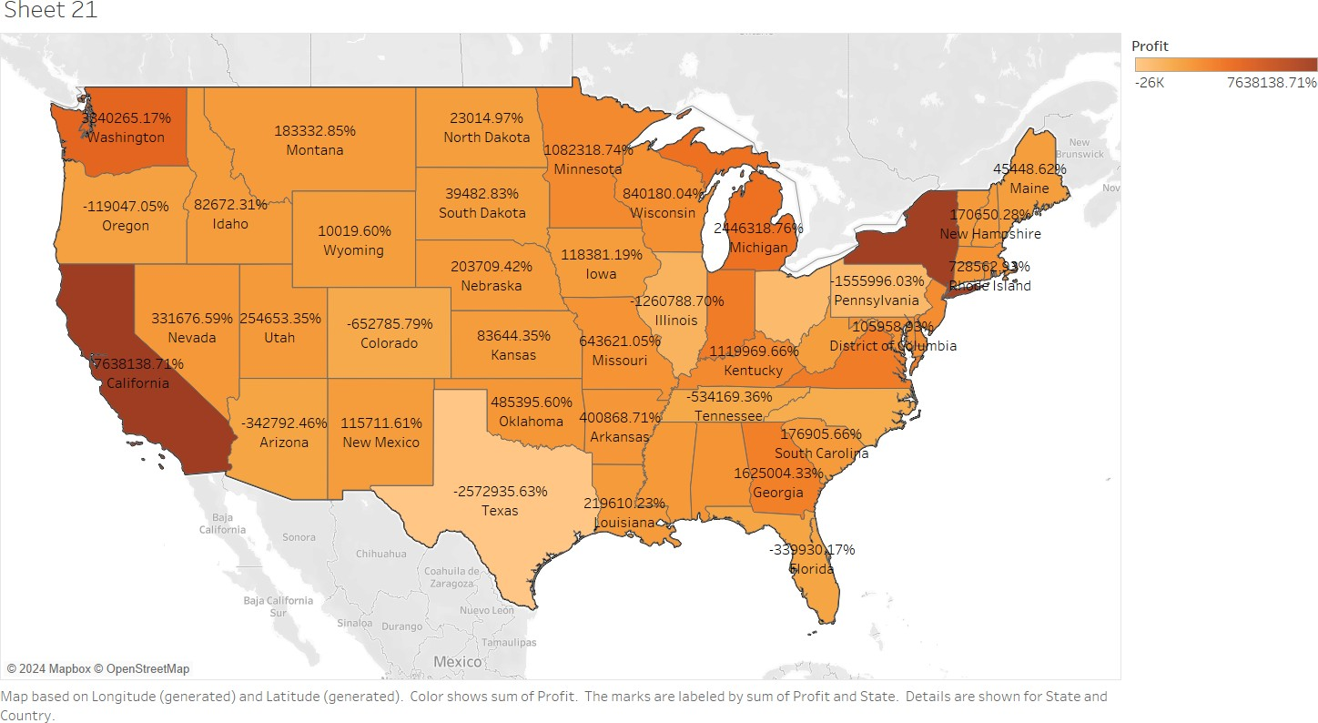

# parameters:

1. In this visualization we created the parameter of top earned cities by clicking the drop-down option beside the search box.
2. We added measure values such as profit ,sales and quantity to parameters. 3)Now we took the city into the solemn and sales into the row.
3. and dragged the city into filters and in top option selected created parameter that is top earned cities.
4. from parameter clicked on show parameter .

