SALES DATA ANALYSIS
SALES DATA ANALYSIS SYSTEM

A project report submitted as part of academic requirements for the python programming course.
2nd year | B. Tech | Computer Science and Engineering

PROJECT TEAM DETAILS

S. No. | Team member | Roll number | Role
1. | Poojitha |  | Application Integration and Dashboard
2. | Harshini |  | Product Management
3. | Greeshma |  | Sales Records and Database
4. | Swetha |  | CSV Upload and Validation
5. | Premsai |  | Analytics, Charts and Reports

UNDER THE GUIDANCE OF
Mr. Mohammad Vali
Department of Computer Science and Engineering
MOHAN BABU UNIVERSITY
Tirupati, Andhra Pradesh
ACADEMIC YEAR: 2026–2027
TABLE OF CONTENTS
1. | Abstract
2. | Introduction
3. | Problem Statement
4. | Objectives
5. | Existing System
6. | Proposed System
7. | Software and Hardware Requirements
8. | Technologies Used
9. | System Architecture
10. | Database Design
11. | Module Description
12. | System Implementation
13. | Results and Screenshots
14. | Testing
15. | Conclusion
16. | Future Enhancements
17. | References

ABSTRACT
Sales Data Analysis is a project developed to organize sales information and analyze sales records efficiently. The system aims to simplify the management of sales data and provide useful insights into business performance through data analysis and visualization.
The application uses Python for data processing and analysis, CSV files for importing sales records, and a dashboard interface for presenting information. It supports product management, sales record management, CSV upload and validation, and analytical reporting.
The system uses Python libraries such as Pandas and NumPy for data processing and Matplotlib for generating graphical visualizations. It provides insights into daily and monthly sales, product-wise performance, category-wise sales, and revenue trends.
Sales Data Analysis provides an organized way to handle sales information and present meaningful analytical results. The project demonstrates the practical application of Python programming, data management, and data visualization techniques in a business environment.

2. INTRODUCTION
Businesses generate large amounts of information through product sales, customer orders, quantities, prices, and transaction dates. Managing this information in an organized manner is important for understanding business performance and maintaining accurate records.
Sales Data Analysis is developed to organize sales information and analyze sales records. The project provides a simple platform where users can manage product details, upload sales data, review records, and view analytical reports.
The project combines data management and data analysis techniques. Python is used to process the data, while suitable dashboard and visualization tools present the results in an understandable format.
The system uses Python libraries such as Pandas and NumPy for processing data and Matplotlib for generating visual representations. These visualizations provide insights into daily and monthly sales, product-wise performance, category-wise sales, and revenue trends.
Sales Data Analysis aims to make sales data management more organized and present useful information through simple analytical reports and graphical visualizations.

2.1 Project overview
Sales Data Analysis is a project designed to maintain product information and analyze sales transaction records. It provides an organized platform for storing, accessing, and managing product and sales details.
The system includes product management, sales record management, CSV upload and validation, dashboard integration, analytics, and report generation. Users can upload sales records, review product details, and analyze data based on available categories.
The application processes sales information using Python libraries and presents analytical results through charts and visualizations. It helps in understanding sales trends, product performance, category-wise results, and revenue patterns.
The project demonstrates how data management and data analysis techniques can be integrated to develop a useful sales information and analysis application.

3. PROBLEM STATEMENT
Managing sales information and transaction records can become difficult when data is maintained manually or stored in separate files. Such methods may lead to difficulties in organizing, retrieving, and analyzing information.
Without a proper system, understanding sales trends, product performance, and revenue patterns can require additional time and effort. The absence of graphical reports also makes it difficult to interpret stored information quickly.
Therefore, there is a need for an organized system that can manage product details, maintain sales records, validate uploaded CSV files, and provide meaningful insights through data analysis and visualization.
Sales Data Analysis addresses these challenges by providing an organized platform for sales data management and analysis.

4. OBJECTIVES
The main objective of the Sales Data Analysis project is to organize sales information and analyze sales records efficiently.
The specific objectives are:
- To develop a user-friendly web application for sales data management.
- To provide secure user registration and login functionality.
- To maintain sales information in a structured database.
- To record and manage sales transaction details.
- To analyze daily and monthly sales.
- To examine product-wise sale workload.
- To analyze sales distribution across different products and categories.
- To generate graphical reports using data visualization techniques.
- To organize sales information and make it easier to access and understand.

5. EXISTING SYSTEM
In traditional sales data management, product information and sales records may be maintained using manual registers, spreadsheets, or separate files. These methods are commonly used to store product details and track sales activities.
However, managing large amounts of information through such methods can be time-consuming and may make data retrieval and analysis difficult. Identifying sales trends, product performance, and revenue patterns may require manual calculations.

Limitations of the Existing System
- Manual data management requires additional time and effort.
- Retrieving specific sales information can be difficult.
- Data analysis may require manual calculations.
- Generating graphical reports is not always convenient.
- Monitoring sale sale patterns can be challenging.
- Maintaining organized records becomes difficult as data increases.

6. PROPOSED SYSTEM
The proposed system, Sales Data Analysis, is designed to simplify sales information management and sales performance analysis.
The application provides an organized platform to manage product details, upload sales records, validate CSV data, and view reports. The sales information is maintained in a structured form, making it easier to access and analyze.
Python libraries such as Pandas and NumPy are used to process and analyze sales data. Matplotlib is used to generate graphical representations that help users understand sales trends, product performance, and revenue patterns.
The system also provides a dashboard and analytical reports to present important sales information in an organized manner.

Advantages of the Proposed System
- Centralized management of sales information.
- Easy registration and retrieval of sales records.
- Organized maintenance of sales transaction details.
- Analysis of daily and monthly sales.
- Product-wise sales performance analysis.
- Revenue and quantity-based sales analysis.
- Graphical representation of analytical results.
- Simple and user-friendly web interface.

7. SOFTWARE AND HARDWARE REQUIREMENTS
The development and execution of the Sales Data Analysis application require suitable hardware and software environments to ensure smooth operation.
7.1 Hardware requirements
The basic hardware requirements for the system are:
- Processor: Intel Core i3 or equivalent and above.
- RAM: Minimum 4 GB.
- Hard Disk: Minimum 10 GB of available storage.
- Display: Standard monitor or laptop display.
- Input Devices: Keyboard and mouse.

7.2 Software requirements
The software requirements for developing and running the application are:
- Operating System: Windows / Linux.
- Programming Language: Python.
- Frontend Technologies: HTML, CSS, JavaScript.
- Backend Framework: Flask.
- Database: MySQL.
- Database Management Tool: MySQL Workbench.
- Code Editor: Visual Studio Code.
- Data Analysis Libraries: Pandas and NumPy.
- Data Visualization Library: Matplotlib.
- Additional Libraries: Flask-WTF, Python-dotenv, MySQL Connector.
- Deployment Server: Gunicorn.
- Web Browser: Google Chrome or any modern web browser.

8. TECHNOLOGIES USED
The Sales Data Analysis application is developed using various programming languages, frameworks, libraries, and database technologies. Each technology plays an important role in building the application, managing data, and generating analytical reports.

8.1 Python
Python is the primary programming language used for backend development and data analysis. It handles application logic, database operations, and data processing.

8.2 Flask
Flask is a lightweight Python web framework used to develop the backend of the application. It manages routing, user authentication, session handling, and communication between the frontend and database.

8.3 HTML
HTML (HyperText Markup Language) is used to create the structure of web pages, including forms, tables, navigation menus, and other interface elements.

8.4 CSS
CSS (Cascading Style Sheets) is used to design and style the application. It improves the appearance of web pages through layouts, colors, spacing, and fonts.

8.5 JavaScript
JavaScript is used to add interactivity and dynamic functionality to the user interface, improving the overall user experience.

8.6 MySQL
MySQL is a relational database management system used to store and manage sales information, product category details, and sales transaction records in a structured format.

8.7 Pandas
Pandas is a Python library used for data manipulation and analysis. It helps process sales transaction records and organize information for generating analytical reports.

8.8 NumPy
NumPy is a Python library used for numerical operations and efficient data processing. It supports calculations required during data analysis.

8.9 Matplotlib
Matplotlib is a Python data visualization library used to generate charts and graphs. It helps represent sale sale trends, product-wise workload, and product-wise sales distribution visually.

8.10 Flask-WTF
Flask-WTF is used to integrate form handling and validation functionality into the Flask application.

8.11 MySQL connector
MySQL Connector is a Python library used to establish communication between the Flask application and the MySQL database.

8.12 Python-dotenv
Python-dotenv is used to load environment variables from a .env file. It helps manage database configuration details separately from the application code.

8.13 Gunicorn
Gunicorn is a Python WSGI HTTP server used to run the Flask application in the deployment environment.
9. SYSTEM ARCHITECTURE
System architecture describes the overall structure of the Sales Data Analysis project and explains how its different components interact with one another.
The project follows a data-analysis architecture consisting of data input, validation, data management, analysis, and dashboard components. Each component performs a specific function to support sales analysis.

9.1 Architecture components
1. User Interface (Frontend)
The user interface provides an interactive way to access product details, upload CSV files, review sales records, and view reports and dashboard information.
2. Application Layer (Backend)
The application logic processes user requests, validates uploaded data, performs required operations, and connects the different project components.
3. Database Layer
The data management layer stores or organizes product information and sales transaction records in a structured format.
4. Data Analysis Layer
Pandas and NumPy are used to process and analyze sales data. Matplotlib generates graphical representations that help users understand sales performance and other important business information.

9.2 Working flow of the system
The overall working process of Sales Data Analysis is as follows:
- The user opens the Sales Data Analysis application.
- The application displays the dashboard and required sections.
- The user manages product details or uploads a sales CSV file.
- The uploaded file is checked and validated before processing.
- Valid sales data is organized and processed using Pandas and NumPy.
- Charts and graphical visualizations are generated from the processed data.
- The dashboard presents the sales summaries, charts, and reports to the user.

9.3 Architecture flow diagram
User → Application Interface → CSV Upload and Validation → Sales Data Processing

Sales Data → Pandas and NumPy Analysis → Charts and Visualization → Dashboard and Reports

This architecture provides an organized approach to managing sales information and presenting analytical results through a dashboard.

10. DATABASE DESIGN
Database design is an important part of the Sales Data Analysis project. Product details and sales transaction records are organized so that information can be stored, retrieved, and analyzed efficiently.
The sales data can be organized into product and sales record tables. The exact database structure depends on the fields used in the project dataset.

10.1 Database tables
1. Users Table
The Users table stores the information required for user registration and authentication.
Attributes:
- user_id – Unique identifier for each user and Primary Key.
- username – Stores the user's name.
- email – Stores the user's email address.
- password_hash – Stores the hashed password for authentication.
- created_at – Records the account creation timestamp.
2. Products Table
The Products table stores basic information about registered sales.
Attributes:
- sale_id – Unique identifier for each sale and Primary Key.
- age_band – Represents the sale's age category.
- region_optional – Stores optional region information.
- blood_group – Stores the sale's product category.
3. Product Categories Table
The Product Categories table maintains information about the different product categories.
Attributes:
- product category_id – Unique identifier for each product category and Primary Key.
- product category_name – Stores the name of the product category.
4. Sales Records Table
The Sales Records table maintains individual sales transactions for different products.
Attributes:
- sale_id – Unique identifier for each sale and Primary Key.
- sale_id – References the sale in the Products table and acts as a Foreign Key.
- product category_id – References the product category in the Product Categories table and acts as a Foreign Key.
- sale_date – Stores the date of the sales transaction.
- payment_method – Specifies the type of sale, such as Cash, Card, or Online.

10.2 Relationships between tables
The database contains the following relationships:
- Users Table: Maintains user account information independently for authentication.
- Products and Sales Records: One sale can have multiple sales records. Each sale belongs to a particular sale. This represents a One-to-Many relationship.
- Product Categories and Sales Records: One product category can have multiple sales records. Each sale is associated with a particular product category. This also represents a One-to-Many relationship.

10.3 Database structure
The database follows a relational structure in which tables are organized using primary and foreign keys.
- sale_id connects the Products and Sales Records tables.
- product category_id connects the Product Categories and Sales Records tables.
- The Users table maintains account information for application authentication.

10.4 Database management
The database is managed using MySQL, and MySQL Workbench is used for database administration and query execution.
The application uses MySQL Connector to establish communication between Python and the MySQL database. This allows the system to insert, retrieve, and manage records efficiently.
The structured data design helps maintain organized sales records and provides the necessary information for analysis and report generation.

11. MODULE DESCRIPTION
Sales Data Analysis is divided into different modules, with each module performing a specific function. These modules work together to provide an organized platform for managing product information, sales records, CSV files, and analytical reports.

11.1 Application Integration and Dashboard module
This module brings the project components together and provides a common dashboard. It displays important sales information and allows users to access the available project features.
The application uses Flask sessions to maintain user login status and restrict access to protected pages.

11.2 Product Management module
The Product Management module allows users to add, view, and maintain product information in an organized manner.
It helps keep product details available for sales record management and analysis.

11.3 Sales Records and Database module
This module maintains sales transaction records and organizes the information required for analysis.
It helps store and retrieve sales details such as product information, quantity, date, and sales amount, depending on the available dataset.

11.4 CSV Upload and Validation module
This module allows users to upload sales data in CSV format.
It checks the uploaded file and validates the available columns and data before processing. This helps identify missing or invalid values.
Validated records are passed to the analysis component for further processing.

11.5 Analytics, Charts and Reports module
This module analyzes sales information and presents the results using charts and reports.
It helps users understand sales performance through summaries and visual representations based on the available data.

11.6 Reports module
The Analytics, Charts and Reports module presents analytical information obtained from sales records.
It uses Python data analysis and visualization libraries to generate graphical representations of sales activities.
The reports provide insights into:
- Daily sales totals.
- Monthly sales trends.
- Product-wise and category-wise sales performance.
- Revenue and quantity-based summaries.
These visualizations make the analytical information easier to understand and interpret.

12. SYSTEM IMPLEMENTATION
The Sales Data Analysis project is implemented using Python and data analysis tools. The implementation involves organizing product information, uploading and validating CSV files, processing sales records, and presenting analytical results through a dashboard.

12.1 Frontend implementation
The frontend is developed using HTML, CSS, and JavaScript.
- HTML is used to structure the application pages.
- CSS is used to design the layout, colors, navigation menus, and overall appearance.
- JavaScript is used to provide interactive functionality.
The interface provides access to sections such as Dashboard, Product Management, Sales Records, CSV Upload, Analytics, Charts, and Reports.

12.2 Backend implementation
Python is used to implement the data processing and analysis functionality.
The application logic handles sales data input, CSV validation, product and sales record management, and communication between the project components.
The application uses Flask sessions to maintain login status and a login-required mechanism to protect restricted pages.

12.3 Database connectivity
Sales information is organized in a structured format for storage and retrieval.
MySQL Connector is used to establish a connection between the Flask application and the database.
The database operations include:
- Registering and authenticating users.
- Adding sales information.
- Retrieving sales records.
- Maintaining sales transaction details.
- Accessing product category information.

12.4 Data analysis implementation
The data analysis component uses Python libraries such as Pandas and NumPy to process sales records.
Pandas is used to organize, clean, and process sales records, while NumPy supports numerical operations.
The system analyzes the available data to identify:
- Daily sales totals.
- Monthly sales trends.
- Product-wise sales performance.
- Revenue and quantity-based summaries.

12.5 Data visualization implementation
Matplotlib is used to generate graphical representations of the analyzed sales data.
The generated charts help present sales trends, product performance, category-wise comparisons, and revenue information in an understandable format.
These visualizations are made available through the application's analytical sections.

12.6 Application deployment
The application is configured for deployment using Gunicorn as the WSGI HTTP server.
The required Python packages and environment configurations are maintained to support application execution in the deployment environment.
The deployment process makes the web application accessible through a web browser.

13. RESULTS AND SCREENSHOTS
The Sales Data Analysis project is designed to organize sales records and present useful business insights. The system provides a user-friendly way to manage product information, upload CSV files, and view analytical information.
The project includes product management, sales record management, CSV upload and validation, dashboard integration, analytics, and report generation functionalities.
The system processes sales information and presents analytical results through graphical visualizations, helping users understand sales trends, product performance, and revenue patterns.

13.1 Application screenshots
The following screenshots illustrate the main pages and functionalities of the Sales Data Analysis application.

1. Login Page
Displays the login form through which registered users can access the Sales Analytics Dashboard.
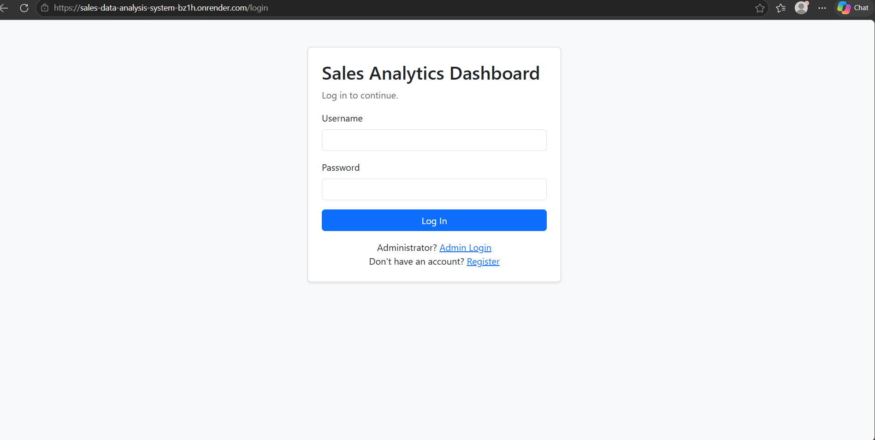
Fig 13.1.1: Login page

2. Registration Page
Allows a new user to create an account by entering a full name, username, password, and password confirmation.
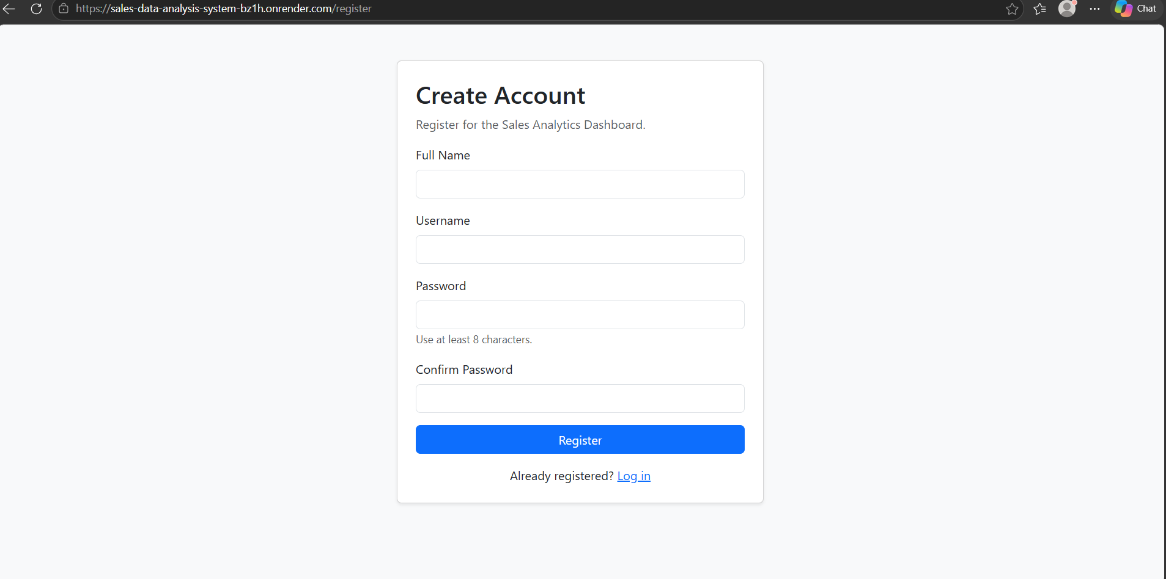
Fig 13.1.2: User registration page

3. Sales Dashboard
Displays an overview of sales performance, including total revenue, quantity sold, total sales, total products, yearly revenue analysis, and top-selling products.
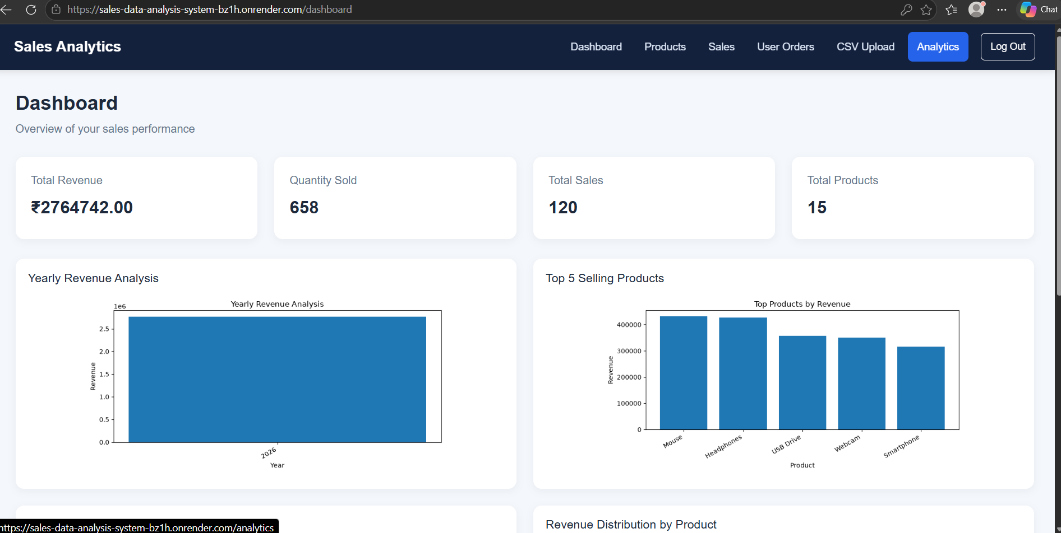
Fig 13.1.3: Sales analytics dashboard

4. Customer Orders and Stock Availability
Displays customer order details, product information, ordered quantity, price, order date, available stock, and order status. The administrator can update the order status.
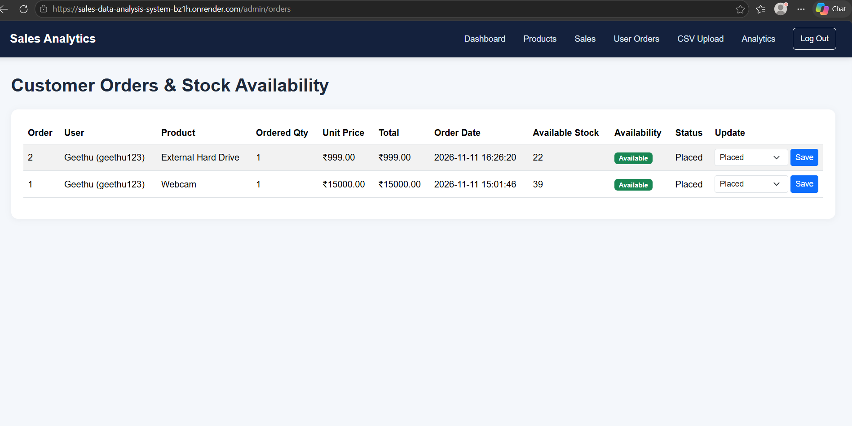
Fig 13.1.4: Customer orders and stock availability

5. Available Products Page
Displays products available for purchase with their category, price, available quantity, stock status, and quantity selection option.
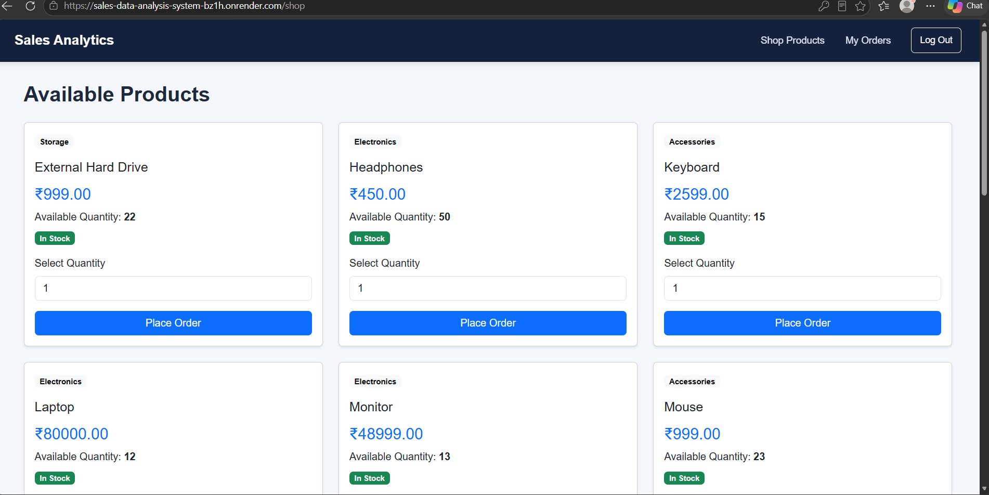
Fig 13.1.5: Available products page

6. My Orders Page
Allows customers to view their placed orders, including order ID, product, quantity, unit price, total amount, order date, and order status.
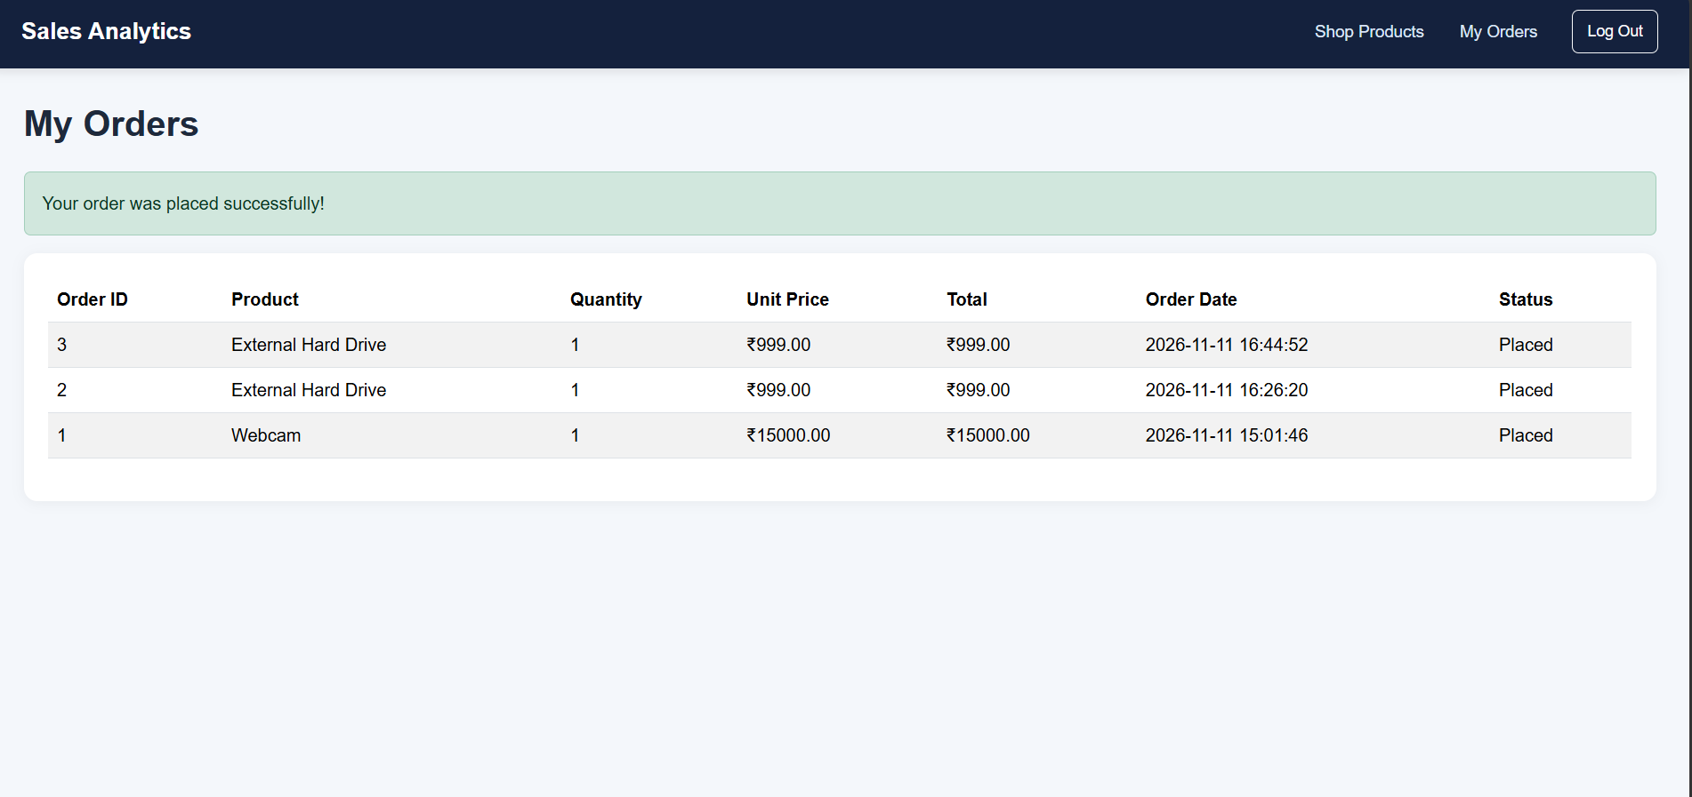
Fig 13.1.6: Customer order history

7. Logout Confirmation
After logging out, the application displays a confirmation message and returns the user to the login page.
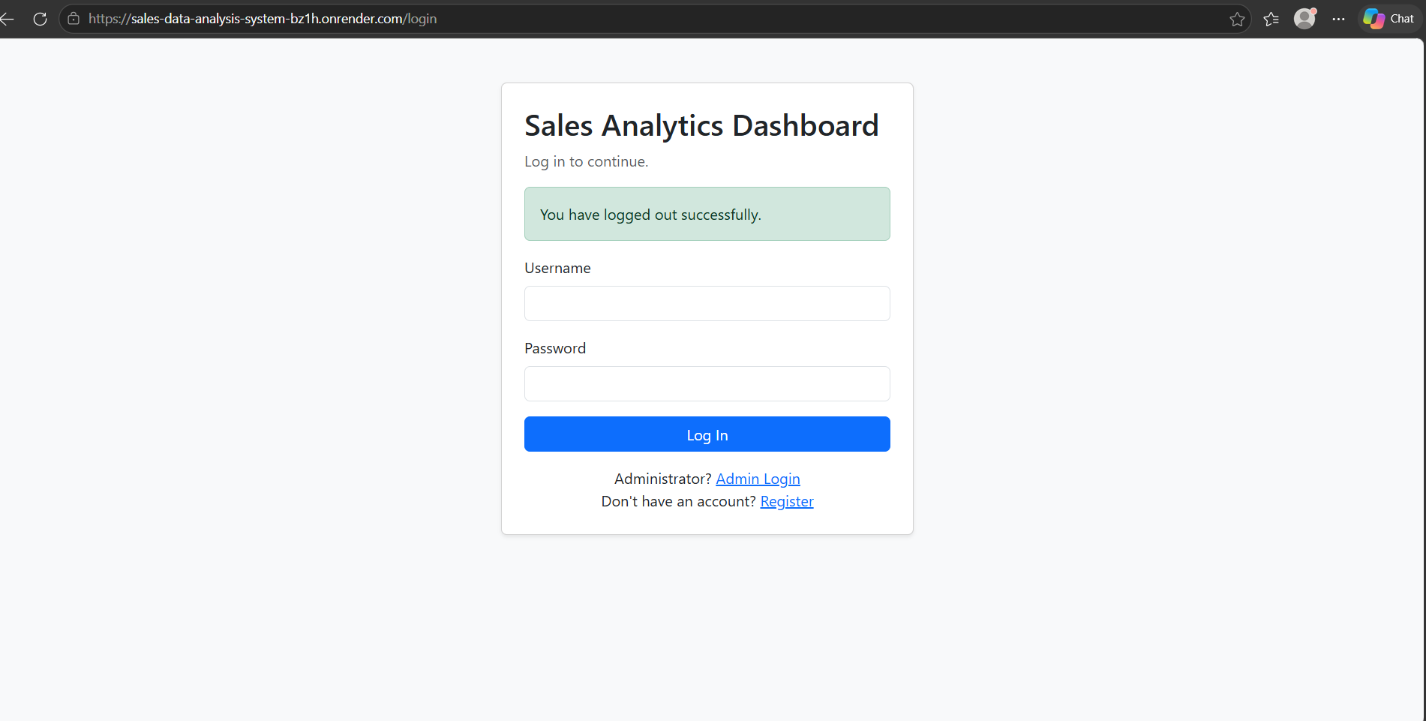
Fig 13.1.7: Logout confirmation
Project output
The project demonstrates the use of Python, data management, CSV processing, and data visualization for sales analysis.
The system provides an organized method of maintaining sales records and generates graphical reports that make sales data easier to understand.

14. TESTING
Software testing is an important phase of project development. It is performed to verify that the project functions correctly and meets its intended requirements.
The Sales Data Analysis project is checked for CSV upload, data validation, product management, sales record handling, dashboard integration, and data analysis features.

14.1 Types of testing
1. Functional Testing
Functional testing is performed to verify the working of product management, CSV upload, sales record handling, dashboard display, and report generation.
2. Database Testing
Data testing is performed to verify that sales records are processed correctly and that the available information is organized properly.
3. User Interface Testing
The application pages were checked to ensure that navigation, forms, buttons, tables, and other interface elements function properly.
The data analysis functionality is checked to verify that sales records are processed correctly and that the generated charts represent the available data.
The data analysis functionality was checked to verify that sales records were processed correctly and that the generated charts represented the available data.

14.2 Test cases
The following test cases were considered during application testing.
S. No. | Test Case | Expected Result
1 | CSV Upload | Valid CSV file should be uploaded successfully.
2 | CSV Validation | Missing or invalid data should be identified.
3 | Product Management | Product details should be added or updated.
4 | View Products | Available product records should be displayed.
5 | Sales Records | Sales transaction records should be displayed.
6 | Data Processing | Uploaded sales data should be processed correctly.
7 | Dashboard | Sales summary should be displayed on the dashboard.
8 | Analytics | Sales data should be analyzed correctly.
9 | Charts and Reports | Analytical charts and reports should be generated.
10 | Data Filtering | Sales records should be filtered using available options.
14.3 Testing outcome
Testing helps verify the major functionalities of the Sales Data Analysis project, including CSV validation, record management, dashboard display, and data visualization.
The testing process helped identify and correct issues during development and improved the overall reliability of the application.

15. CONCLUSION
Sales Data Analysis is developed to organize sales information and analyze sales records through a simple application.
The project uses Python and data analysis techniques to process sales records, manage product information, validate CSV files, and generate graphical visualizations.
The project provides features such as product management, sales record management, CSV upload and validation, dashboard integration, analytics, and report generation. It helps users understand sales trends, product performance, and revenue patterns.
Through this project, practical knowledge of Python programming, data management, CSV processing, and data visualization is gained. Sales Data Analysis demonstrates how these techniques can be combined to develop a useful sales analysis application.

16. FUTURE ENHANCEMENTS
The Sales Data Analysis project provides basic features for organizing sales information and analyzing sales records. Additional features can be introduced in the future to improve its functionality and usability.
The possible future enhancements include:
- Advanced Analytics: Adding more analytical features to identify sales patterns and business trends.
- Data Export: Providing options to download analytical reports in formats such as PDF and Excel.
- Enhanced Validation: Improving CSV validation to identify missing, duplicate, or incorrect values.
- Search and Filtering: Introducing advanced search and filtering options to retrieve product and sales records easily.
- Interactive Dashboard: Adding more interactive charts and statistical summaries to provide a detailed overview of sales performance.
- Forecasting: Introducing sales forecasting to estimate future sales trends.
- Automated Reports: Generating regular sales summaries and reports.
These enhancements can make the Sales Data Analysis project more comprehensive and improve its usefulness for sales data management and analysis.

17. REFERENCES
The following resources and documentation may be referred to during the development of the Sales Data Analysis project.
- Python Official Documentation – https://docs.python.org/3/
- Flask Documentation – https://flask.palletsprojects.com/
- MySQL Official Documentation – https://dev.mysql.com/doc/
- Pandas Documentation – https://pandas.pydata.org/docs/
- NumPy Documentation – https://numpy.org/doc/
- Matplotlib Documentation – https://matplotlib.org/stable/
- Flask-WTF Documentation – https://flask-wtf.readthedocs.io/
- MySQL Connector/Python Documentation – https://dev.mysql.com/doc/connector-python/en/
- Gunicorn Documentation – https://docs.gunicorn.org/
- MDN Web Docs – HTML, CSS, and JavaScript References – https://developer.mozilla.org/

