COMPUTER NETWORKS — PRACTICAL SKILL LAB SUBMISSION
Skill – 1: Encapsulation Builder
Analyzing Protocol Header Overhead & Network Transmission Efficiency Using Wireshark

Student Name: Musunuri Poojitha | Roll Number: 2520030541
Cluster & Section: Cluster 2 – Section 6 | Campus: KLH Bachupally Campus
1. Aim & Objective
Aim: To capture network packets using Wireshark, understand how Ethernet II (Layer 2), IPv4 (Layer 3), and TCP/UDP (Layer 4) headers are added during data transmission, calculate total header overhead, and determine payload transmission efficiency.
2. Packet Capture & Display Filter Exploration
Network traffic was captured on the Wi-Fi interface (en0) while browsing multiple websites, recording 246,870 total packets in the saved trace (wireshark_Wi-Fi46KQY3.pcapng). Each display filter was then applied separately to observe protocol-specific behavior.
2.1 Capturing Network Traffic & Stopping Capture (Unfiltered)
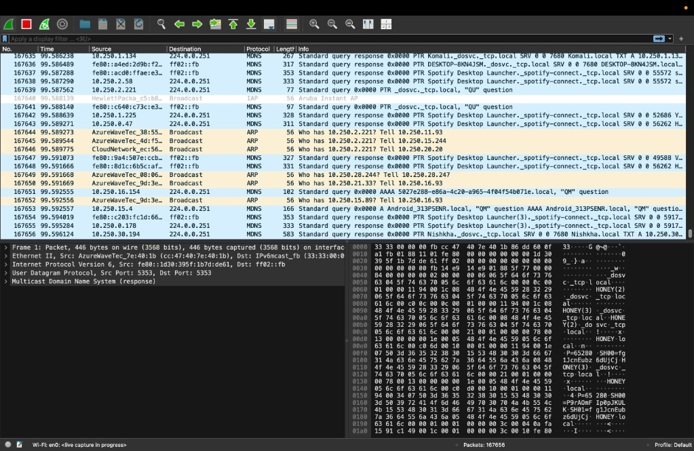
Screenshot 1: Live packet capture on Wi-Fi interface (en0) prior to clicking the red Stop button (167,656 packets captured).
Observation — Packet Capture & Interface Overview:
Active Interface & Capture Status: Packets are captured on the Wi-Fi (en0) interface (status bar shows 'Wi-Fi: en0: <live capture in progress>' with 167,656 packets recorded at the snapshot before stopping the capture at 246,870 packets).
Wireshark Three-Pane Layout: The top Packet List pane displays frame metadata (No., Time, Source, Destination, Protocol, Length, Info); the middle Packet Details pane displays the protocol stack hierarchy; and the bottom Packet Bytes pane displays raw hexadecimal and ASCII data.
Mixed Unfiltered Traffic: Without a filter applied, the capture shows a combination of ARP broadcasts (resolving local IPv4 addresses to MAC addresses), MDNS multicast service discovery packets (224.0.0.251 and ff02::fb), and background TCP/UDP flows.

2.2 Display Filter: tcp
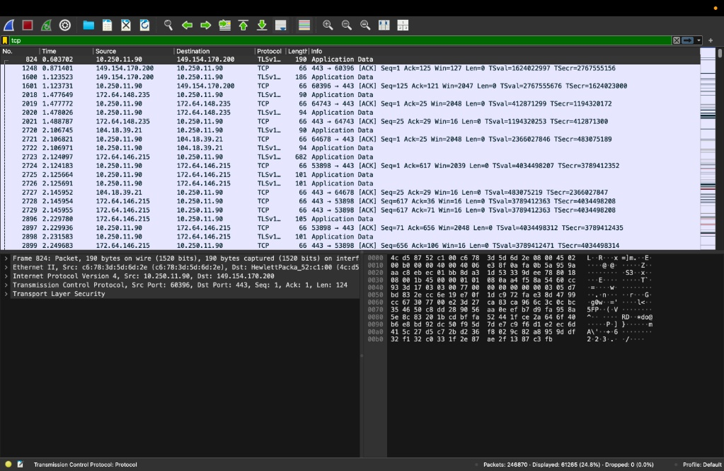
Screenshot 2: Applying display filter 'tcp' — isolating 61,265 TCP/TLS packets (24.8% of total capture).
Observation — tcp Filter:
Filtered Packet Count: Typing 'tcp' in the display filter bar (highlighted in green for valid syntax) filters the trace to 61,265 packets out of 246,870 (24.8% of total traffic).
Connection-Oriented Sessions: Displays TCP segments and upper-layer TLSv1.2/TLSv1.3 encrypted web application traffic between the local client (10.250.11.90) and remote HTTPS servers (port 443).
Control & Data Exchange: Includes zero-length acknowledgment frames ([ACK], Len=0) alongside encrypted Application Data frames, displaying Sequence (Seq), Acknowledgment (Ack), and Window (Win) fields.

2.3 Display Filter: udp
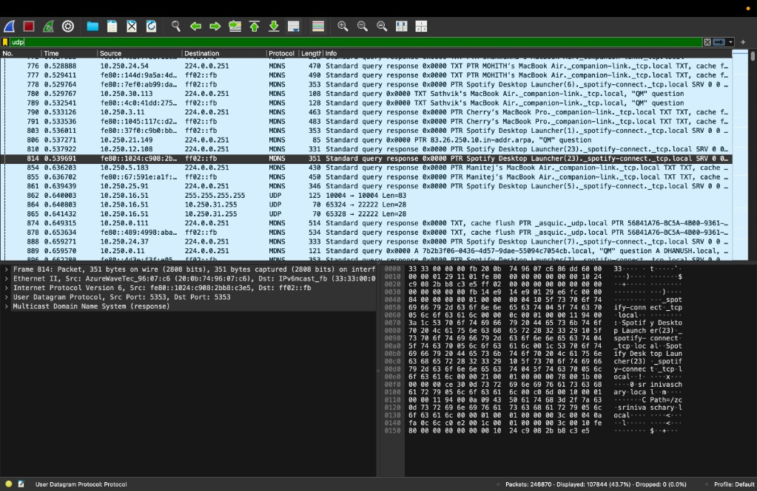
Screenshot 3: Applying display filter 'udp' — isolating 107,844 UDP packets (43.7% of total capture).
Observation — udp Filter:
Filtered Packet Count: Applying 'udp' isolates 107,844 packets out of 246,870 (43.7% of total traffic), representing the largest transport-layer share on the local Wi-Fi network.
Connectionless Multicast & Broadcast Traffic: Displays standard UDP datagrams (such as broadcast packets to 255.255.255.255 and 10.250.31.255) and Multicast DNS (MDNS) queries/responses on port 5353.
Lightweight Transport Header: Packets transfer data directly without connection setup handshakes, sequence tracking, or acknowledgment packets.

2.4 Display Filter: icmp
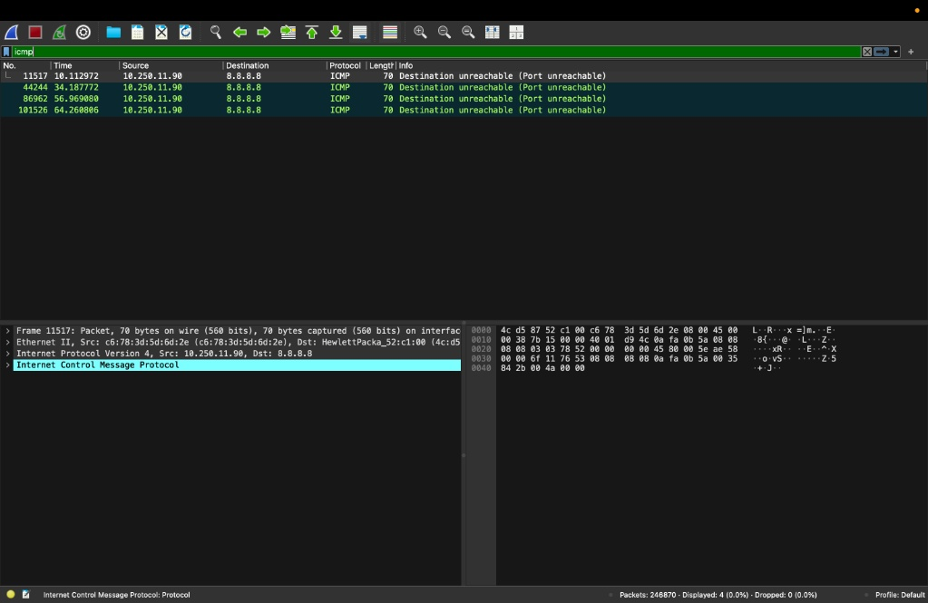
Screenshot 4: Applying display filter 'icmp' — isolating 4 ICMP control packets (0.0% of total capture).
Observation — icmp Filter:
Filtered Packet Count: Applying 'icmp' isolates exactly 4 Internet Control Message Protocol packets out of 246,870 captured frames.
Diagnostic Error Messages: All 4 packets (Frames 11517, 44244, 86962, and 101526) are 70-byte 'Destination unreachable (Port unreachable)' messages sent from 10.250.11.90 to 8.8.8.8.
Network-Layer Control Protocol: ICMP sits directly above IPv4 (Protocol 1) without a Layer 4 TCP/UDP header to report unreachable ports and network diagnostics.

2.5 Display Filter: tcp.len > 0
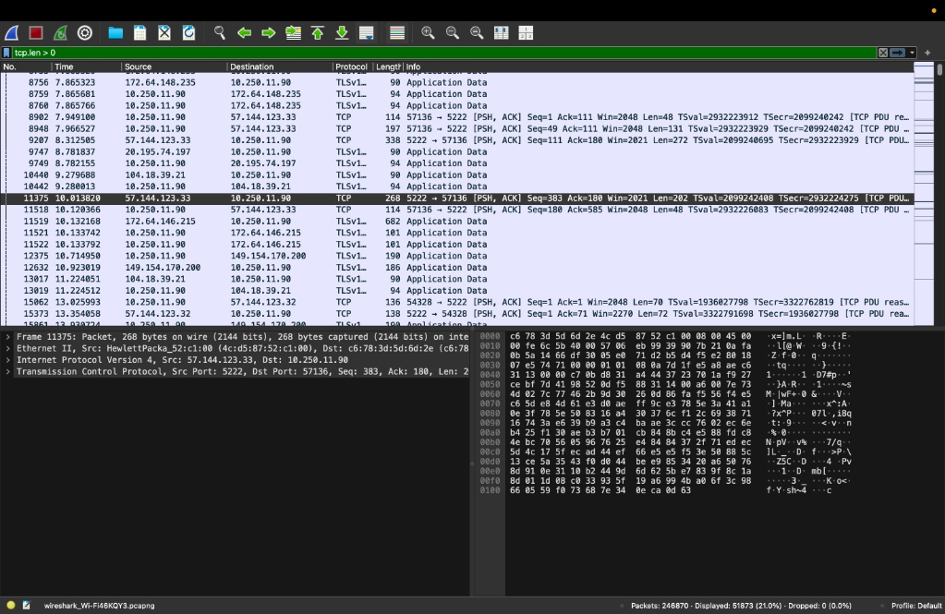
Screenshot 5: Applying display filter 'tcp.len > 0' — isolating 51,873 payload-carrying TCP segments (21.0% of total capture).
Observation — tcp.len > 0 Filter:
Filtered Packet Count: Applying 'tcp.len > 0' filters the 61,265 TCP packets down to 51,873 segments (21.0% of total capture) that carry actual upper-layer payload bytes.
Exclusion of Pure ACKs: All 66-byte pure TCP [ACK] packets with Len=0 are excluded, leaving only data-carrying [PSH, ACK] segments (e.g., Frame 11375 with Len=202) and TLS Application Data frames.
Control Overhead Insight: Comparing 'tcp' (61,265 packets) against 'tcp.len > 0' (51,873 packets) shows that 9,392 TCP frames (15.33% of TCP packets) are zero-payload control/acknowledgment packets.

3. Detailed Packet Header Inspection (TCP & UDP)
To inspect encapsulation across Layers 2, 3, and 4, one TCP packet (Frame 23755 under the 'tcp' filter) and one UDP packet (Frame 23747 under the 'udp' filter) were selected and expanded in the Packet Details pane.
3.1 TCP Packet Header Inspection — Frame 23755 (Filter: tcp)
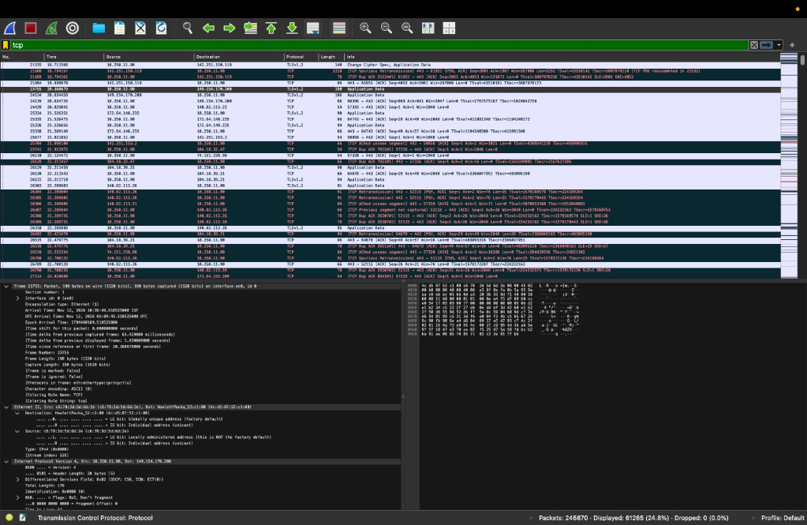
Screenshot 6: TCP filter — Frame 23755 selected with Frame (190 bytes), Ethernet II (14 bytes), and IPv4 (Header: 20 bytes, Total Length: 176 bytes) expanded.
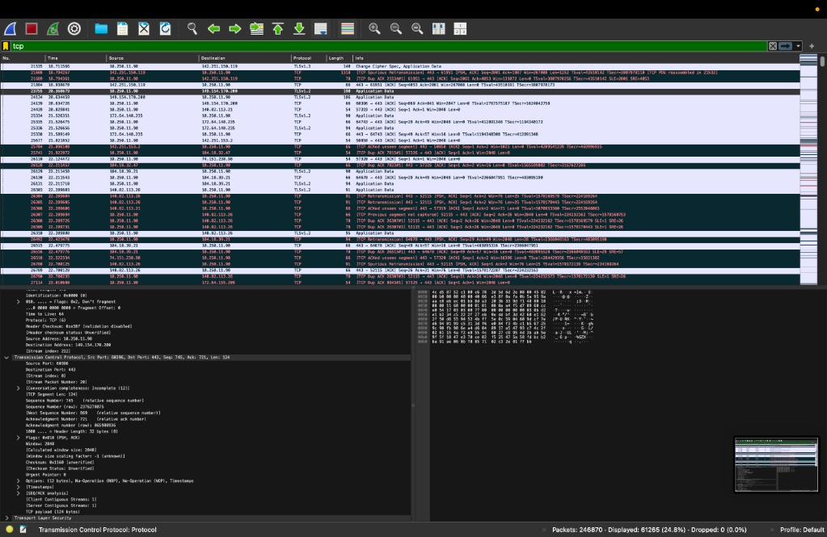
Screenshot 7: TCP filter — Frame 23755 continued, showing IPv4 addresses and expanded Transmission Control Protocol header (Header Length: 32 bytes, TCP Segment Len / Payload: 124 bytes).
Parameter | Where to Find It (Wireshark) | Observed Value (Frame 23755)
Frame Length | Frame | 190 bytes (1520 bits on wire)
Ethernet Header Length | Ethernet II | 14 bytes (6B Dst + 6B Src + 2B Type 0x0800)
Source MAC Address | Ethernet II | c6:78:3d:5d:6d:2e (Locally administered)
Destination MAC Address | Ethernet II | 4c:d5:87:52:c1:00 (HewlettPackard)
IPv4 Header Length | Internet Protocol Version 4 | 20 bytes (IHL = 5 × 4 bytes)
IPv4 Total Length | Internet Protocol Version 4 | 176 bytes
TCP Header Length | Transmission Control Protocol | 32 bytes (Data Offset = 8 × 4 bytes; includes 12B Options)
TCP Segment Length (Payload) | Transmission Control Protocol | 124 bytes (TLS Application Data)

3.2 UDP Packet Header Inspection — Frame 23747 (Filter: udp)
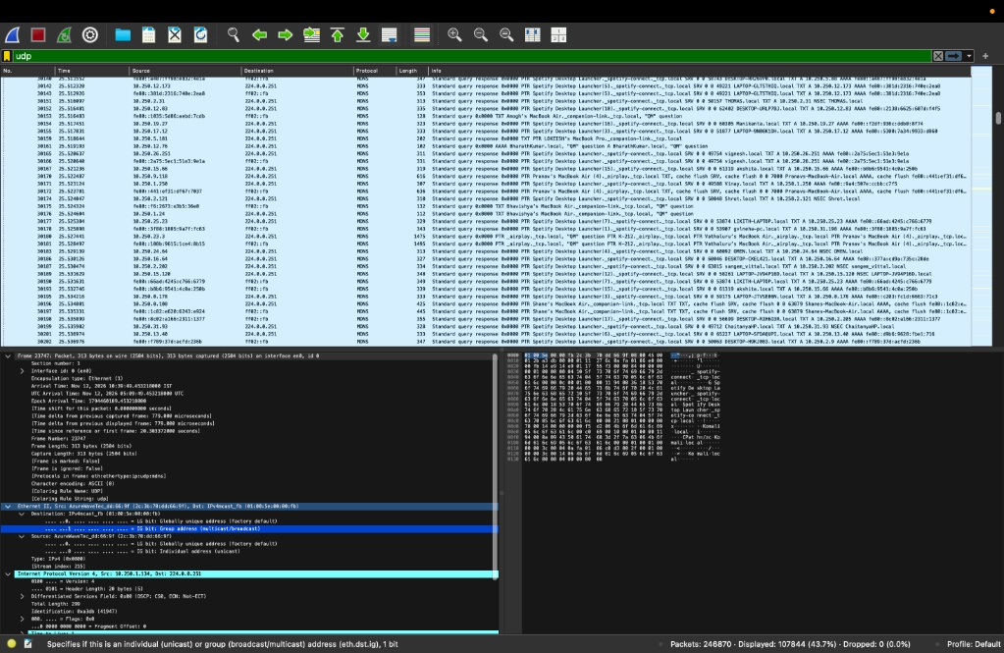
Screenshot 8: UDP filter — Frame 23747 selected with Frame (313 bytes), Ethernet II (14 bytes), and IPv4 (Header: 20 bytes, Total Length: 299 bytes) expanded.
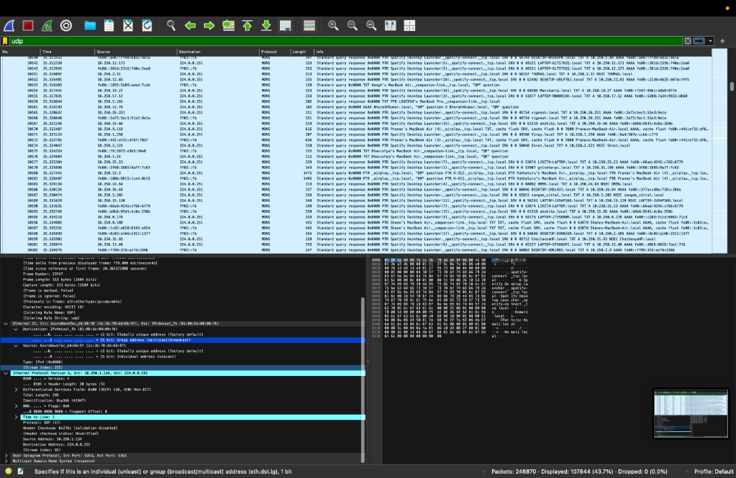
Screenshot 9: UDP filter — Frame 23747 continued, showing IPv4 details (Protocol: UDP 17) and User Datagram Protocol (Src Port: 5353, Dst Port: 5353).
Parameter | Where to Find It (Wireshark) | Observed Value (Frame 23747)
Frame Length | Frame | 313 bytes (2504 bits on wire)
Ethernet Header Length | Ethernet II | 14 bytes (6B Dst + 6B Src + 2B Type 0x0800)
Source MAC Address | Ethernet II | 2c:3b:70:dd:66:9f (AzureWave Technologies)
Destination MAC Address | Ethernet II | 01:00:5e:00:00:fb (IPv4 Multicast)
IPv4 Header Length | Internet Protocol Version 4 | 20 bytes (IHL = 5 × 4 bytes)
IPv4 Total Length | Internet Protocol Version 4 | 299 bytes
UDP Header Length | User Datagram Protocol | 8 bytes (Fixed standard UDP header)
UDP Payload Length | User Datagram Protocol | 271 bytes (IPv4 Total 299 − IPv4 Hdr 20 − UDP Hdr 8)
4. Observation Table & Header Overhead Calculations
Note: Wireshark captures frames without the 4-byte Ethernet Frame Check Sequence (FCS) trailer because the NIC strips the FCS before passing the frame to the operating system. Thus, Frame Length = Ethernet Header + IPv4 Total Length.
4.1 Observation Table (Step 7)
Parameter | TCP Packet (Frame 23755) | UDP Packet (Frame 23747)
Frame Length | 190 bytes | 313 bytes
Ethernet Header Length | 14 bytes | 14 bytes
IP Header Length | 20 bytes | 20 bytes
Transport Header Length | 32 bytes (20B base + 12B options) | 8 bytes (fixed)
IP Total Length | 176 bytes | 299 bytes
Total Header Overhead | 66 bytes | 42 bytes
Payload Length | 124 bytes | 271 bytes

4.2 Step-by-Step Header Overhead & Efficiency Calculations
1. Captured TCP Packet Calculations (Frame 23755 — From Screenshots 6 & 7)
Given Values from Capture: Ethernet II Header = 14 bytes | IPv4 Header = 20 bytes | TCP Header = 32 bytes (20B standard + 12B options) | TCP Payload (Segment Len) = 124 bytes.
Total Frame Size: 14 + 20 + 32 + 124 = 190 bytes (matches Wireshark Frame Length = 190 bytes).
Total Header Overhead: 14 + 20 + 32 = 66 bytes.
Payload Efficiency (%): (Payload Length / Total Frame Length) × 100 = (124 / 190) × 100 = 65.26%.
Header Overhead (%): (Total Overhead / Total Frame Length) × 100 = (66 / 190) × 100 = 34.74%.

2. Captured UDP Packet Calculations (Frame 23747 — From Screenshots 8 & 9)
Given Values from Capture: Ethernet II Header = 14 bytes | IPv4 Header = 20 bytes | IPv4 Total Length = 299 bytes | UDP Header = 8 bytes (fixed).
UDP Length & Payload Derivation: UDP Total Length = IPv4 Total Length − IPv4 Header = 299 − 20 = 279 bytes. | UDP Payload Length = 279 − 8 = 271 bytes.
Total Frame Size: 14 + 20 + 8 + 271 = 313 bytes (matches Wireshark Frame Length = 313 bytes).
Total Header Overhead: 14 + 20 + 8 = 42 bytes.
Payload Efficiency (%): (Payload Length / Total Frame Length) × 100 = (271 / 313) × 100 = 86.58%.
Header Overhead (%): (Total Overhead / Total Frame Length) × 100 = (42 / 313) × 100 = 13.42%.

3. Standard Theoretical MTU Calculation (Step 6 Reference with 4-Byte FCS)
Standard Values: Ethernet Header = 14 bytes | IPv4 Header = 20 bytes | TCP Header (no options) = 20 bytes | Application Data = 1500 bytes | Ethernet FCS = 4 bytes.
Total Frame Size (including FCS): 14 + 20 + 20 + 1500 + 4 = 1558 bytes.
Total Header Overhead: 14 + 20 + 20 + 4 = 58 bytes.
Payload Efficiency (%): (1500 / 1558) × 100 = 96.28% (Overhead = 3.72%).

Packet Type | Frame Size | Header Overhead | Payload Size | Overhead % | Payload Efficiency
Captured TCP (Frame 23755) | 190 B | 66 B | 124 B | 34.74% | 65.26%
Captured UDP (Frame 23747) | 313 B | 42 B | 271 B | 13.42% | 86.58%
Theoretical MTU TCP (+FCS) | 1558 B | 58 B | 1500 B | 3.72% | 96.28%
5. Conceptual Review Questions & Answers
1. What is encapsulation?
Ans: Encapsulation is the process by which data moves down the protocol stack at the sending host, and each layer wraps the data received from the upper layer with its own protocol header (and trailer at Layer 2). Specifically, application data is wrapped in a TCP segment or UDP datagram (Layer 4), encapsulated inside an IP packet (Layer 3), and framed inside an Ethernet II frame (Layer 2) for physical transmission.
2. What is the purpose of the Ethernet header?
Ans: The 14-byte Ethernet II header facilitates node-to-node delivery across the local physical network (LAN/Wi-Fi). It stores the 6-byte Destination MAC address, the 6-byte Source MAC address, and a 2-byte EtherType field (such as 0x0800 for IPv4 or 0x86DD for IPv6) that identifies which Layer 3 protocol is encapsulated inside the frame.
3. What information is stored in the IP header?
Ans: The IPv4 header (minimum 20 bytes) stores logical addressing and routing control fields, including IP Version (4), Internet Header Length (IHL), Differentiated Services (DSCP/ECN), Total Length, Identification, Flags, Fragment Offset, Time to Live (TTL), Upper-Layer Protocol ID (e.g., 6 for TCP, 17 for UDP, 1 for ICMP), Header Checksum, 32-bit Source IP Address, and 32-bit Destination IP Address.
4. What is the difference between TCP and UDP headers?
Ans: A TCP header is 20 to 60 bytes long (32 bytes with options in Frame 23755) and contains fields for reliable, connection-oriented communication: Sequence Number, Acknowledgment Number, Data Offset, Control Flags (SYN, ACK, PSH, FIN, RST), Window Size, Checksum, Urgent Pointer, and TCP Options. In contrast, a UDP header is fixed at 8 bytes and contains only four 2-byte fields—Source Port, Destination Port, Length, and Checksum—providing fast, connectionless delivery without handshakes or retransmissions.
5. Why does each protocol add a header?
Ans: Each protocol layer performs an independent networking responsibility and requires its own control metadata—such as port multiplexing and reliability at Layer 4 (TCP/UDP), end-to-end routing across networks at Layer 3 (IP), and hardware MAC addressing on the local link at Layer 2 (Ethernet). Headers enable peer layers at the receiver to demultiplex, verify, and reassemble data accurately.
6. What is packet overhead?
Ans: Packet overhead is the sum of all non-payload protocol header and trailer bytes (Ethernet, IP, and TCP/UDP headers) added to a frame to support addressing, routing, error detection, and transport control. Mathematically, Total Overhead = Total Frame Length − Payload Length.
7. How does header overhead affect network efficiency?
Ans: Header overhead consumes a fraction of link bandwidth for control information rather than user payload. Payload efficiency is given by (Payload Length / Total Frame Length) × 100%. Small payloads (such as 124 B in TCP Frame 23755) suffer higher relative overhead (34.74%, yielding 65.26% efficiency), whereas larger payloads (271 B in UDP Frame 23747 at 86.58% efficiency, or 1500 B MTU frames at 96.28% efficiency) amortize fixed header costs and maximize network throughput.

