NAME : Gnana Poojitha Nadendla

EMAIL : [poojithanadendla01@gmail.com](mailto:poojithanadendla01@gmail.com)

PHONE : 9010114345

ROLL NO : 20NN1A1280

|  |
| --- |
|  |

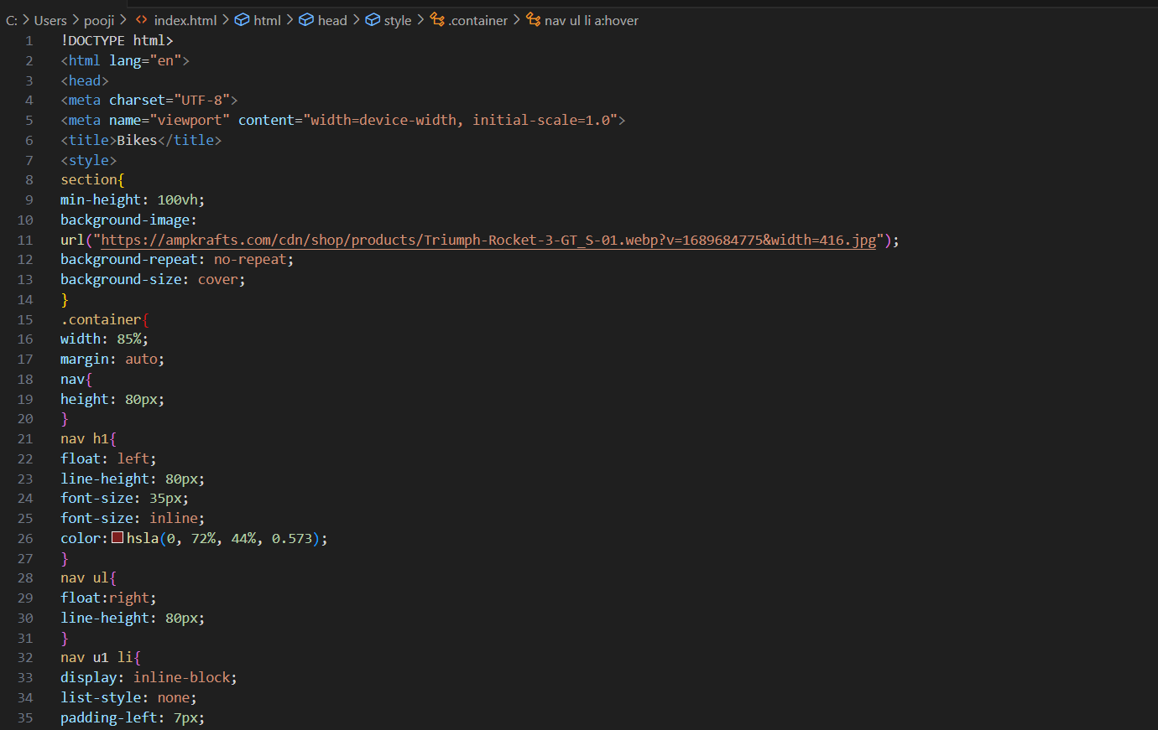

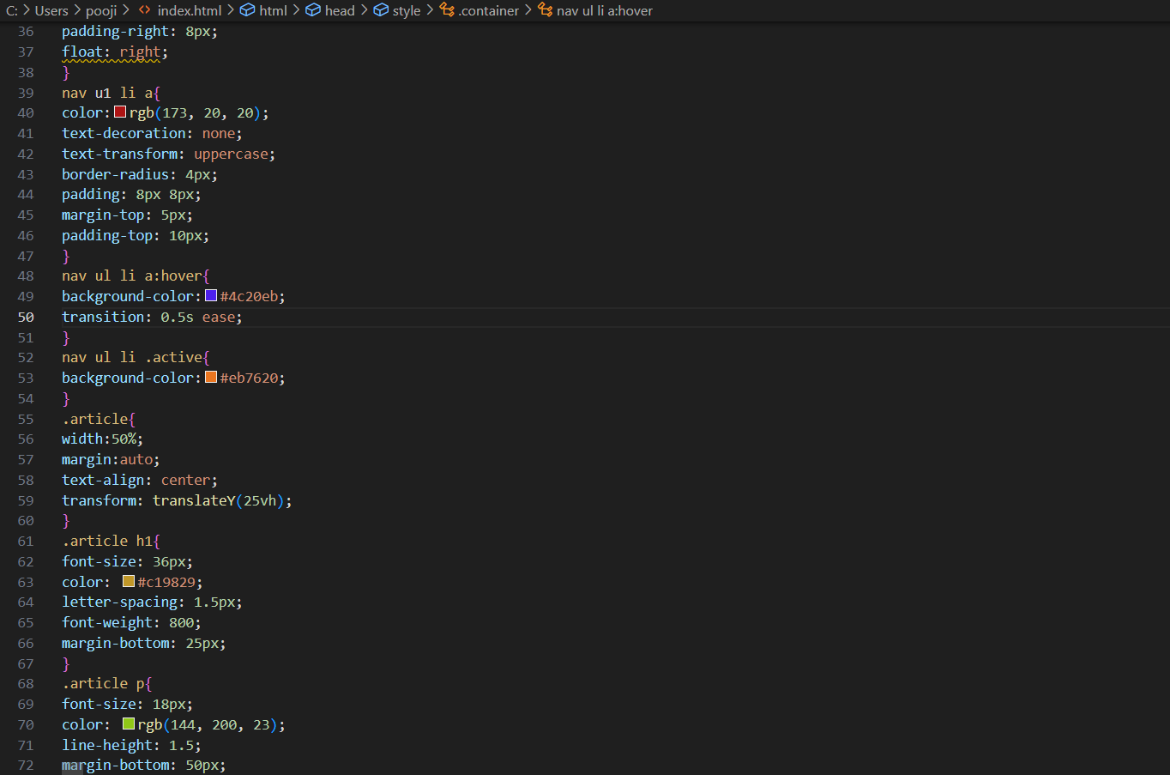

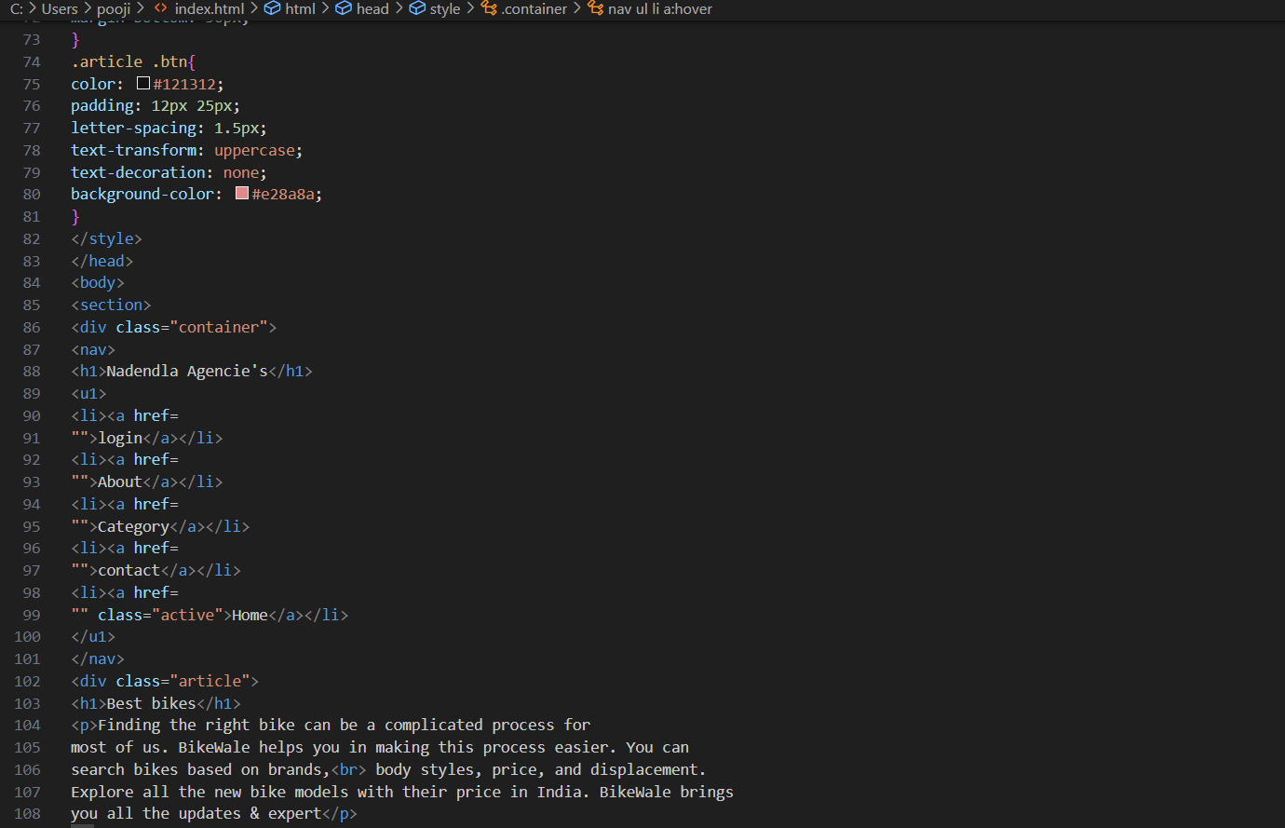

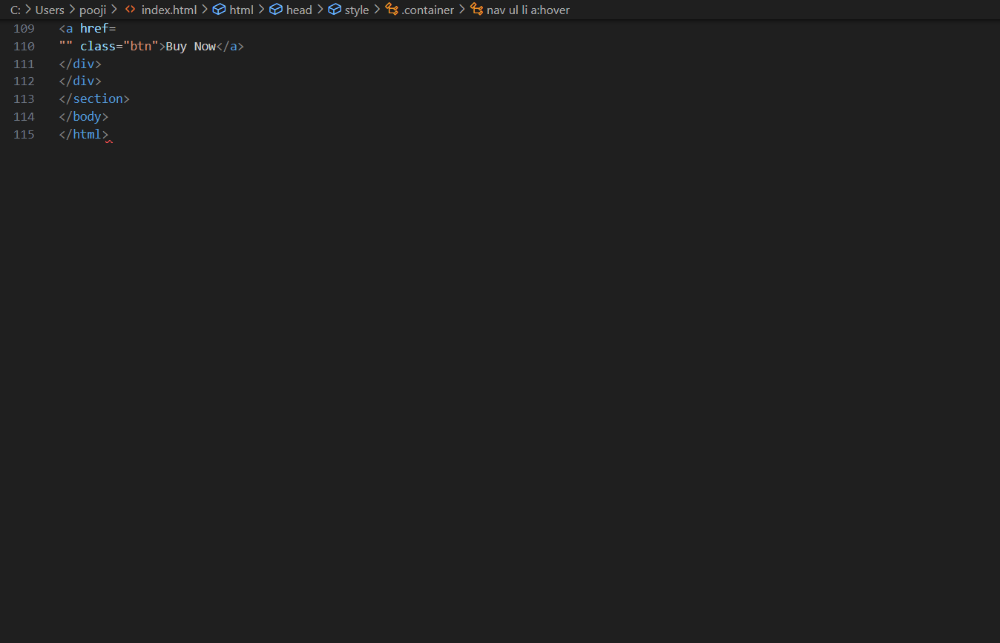

OUTPUT :

