# ASSIGNMENT 3 - A simple RESTFUL API using React.js, Database Creation, and Creating Index.

NAME: Gnana Poojitha Nadendla

MOBILE NO: 9010114345

ROLL NO: 20NN1A1280

COLLEGE: Vignan’s Nirula Institute of Technology and Science for Women

# Restful API code

**Rest Output on Thunder Client**

**This is the output when we create an API using REST.**

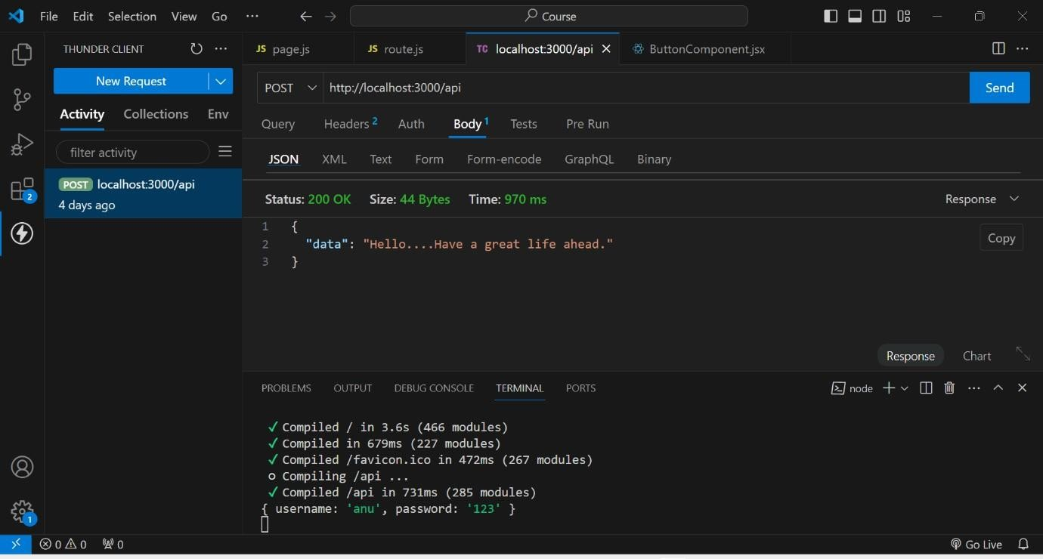

# DataBase Creation

1st we created a database named test

In that test we created a collection named Students

And finally by using ADD DATA , we added data of the students like rno, name, age.

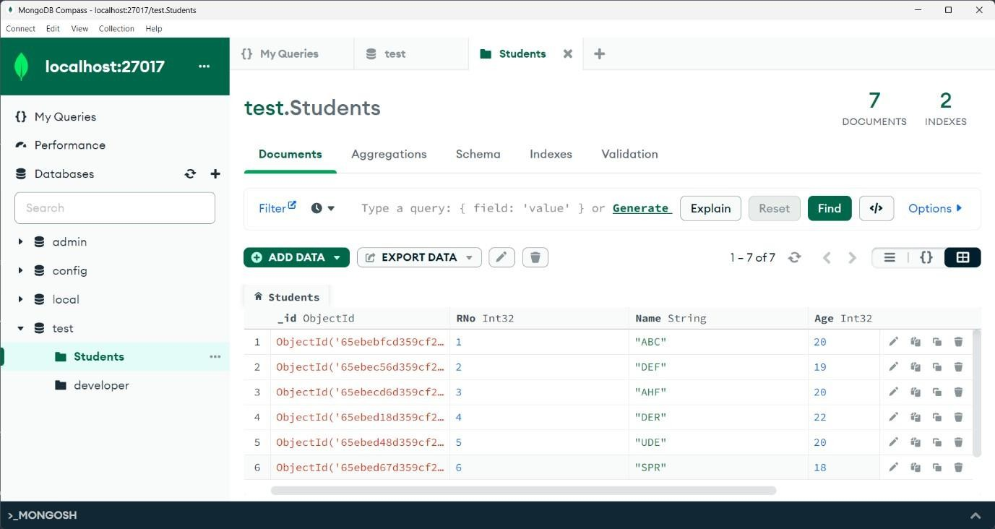

# Indexing Creation

As rno is the unique attribute through which we identify a student uniquely. So, here I created an index based on Rno. And assigned unique key to it.

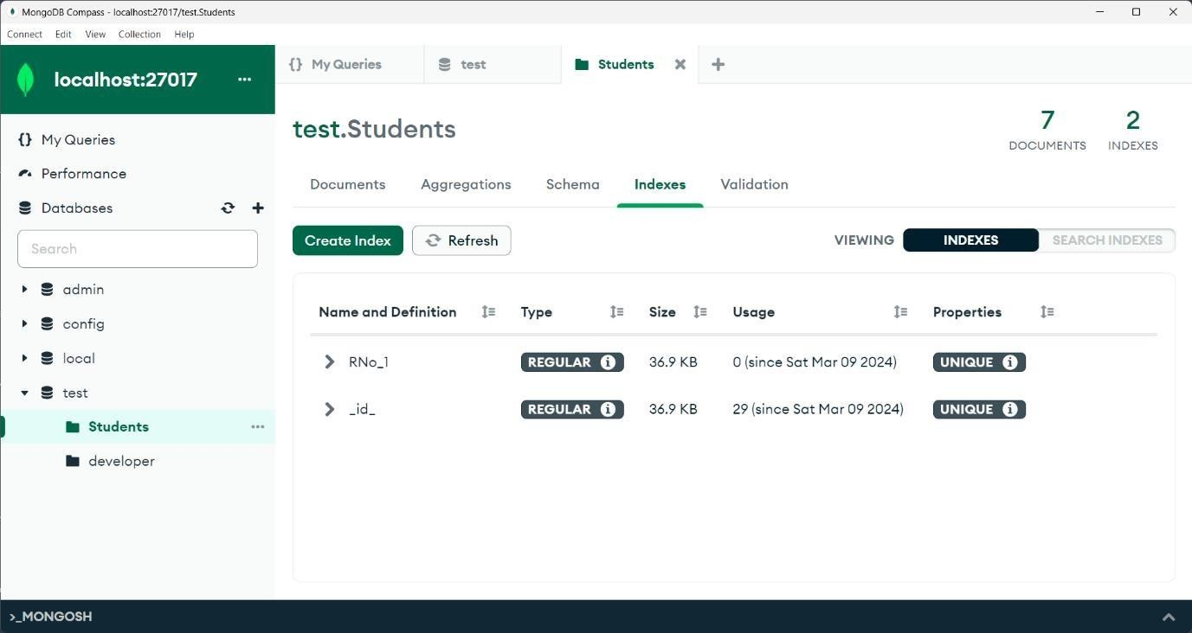

# Indexing usage

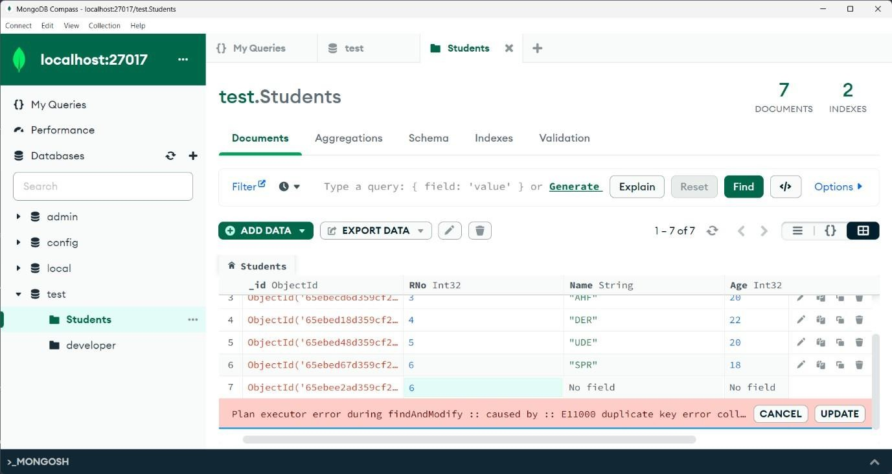As we gave Rno as unique, if we try to insert a duplicate document that is existed it shows an error like. Duplicate collection.