

Company Name : Charani Infotech Pvt Ltd

Project Name : HRM Portal

Prepared by: HRM Team

1. Introduction

1.1 Purpose of the Document
This document provides a complete professional overview of the HRM Portal, including business problems, solutions, system roles, workflows, features, implementation strategies, and real-world usability.
The goal is to design an enterprise-ready HRM system that supports organizational growth, employee experience, and HR operational efficiency.

2. Problem Statement – Why We Need HRM Portal
In traditional organizations, HR processes are often handled manually or across disconnected tools such as emails, spreadsheets, and messaging apps.
This causes:
- Lack of transparency in employee activities
- Delays in approvals and communication
- Payroll errors and compliance risks
- Difficulty tracking performance and attendance
- Data security concerns
- No centralized system for employee lifecycle
As organizations scale, manual processes become inefficient and create operational risks.

3. Proposed Solution – HRM Portal
The HRM Portal provides a centralized digital platform that manages:
- Employee lifecycle
- Attendance and leave
- Performance management
- Payroll and compliance
- Daily work tracking
- Reporting and analytics
It improves collaboration between Admin, HR, Managers, and Employees while ensuring data accuracy and scalability.

4. Objectives of the System
- Digitize HR operations
- Improve employee experience
- Reduce manual errors
- Provide real-time dashboards
- Enable data-driven decisions
- Maintain security and compliance

5. System Users & Access Roles
The HRM Portal supports four primary roles:
- Admin / CEO
- HR
- Manager / Team Lead
- Employee
Each role has specific responsibilities, access levels, and workflows.
User Roles
• Admin – Full access • HR – HR operations • Manager – Approvals & reviews • Employee – Self-service

6. Role-Based System Design

👑 6.1 Admin / CEO Model

Perspective: Thinking as CEO/Admin
Admin focuses on strategic control, compliance, and organizational insights.

Requirements
- View company performance dashboards
- Manage roles and permissions
- Approve payroll and policy changes
- Monitor audit logs

Key Features
- Organization setup
- Role & access management
- Payroll approval
- Analytics dashboard
- System configuration

Access Level
- Full system access
- View all employee data
- Approve critical actions

Advantages
- Real-time company overview
- Faster executive decisions
- Strong governance

Limitations
- Cannot edit daily employee tasks
- Not involved in operational HR activities

Implementation Approach
- Role-based access middleware
- Dashboard analytics APIs
- Secure audit logging

🧑‍💼 6.2 HR Model

Perspective: Thinking as HR Professional
HR manages the entire employee lifecycle.

Requirements
- Recruit and onboard employees
- Manage attendance and leave
- Process payroll
- Maintain compliance documents

Key Features
- Employee onboarding & offboarding
- Attendance and shift management
- Training and development
- Document management
- Expense and reimbursement

Access Level
- Manage employee records
- Configure policies
- Generate payroll

Advantages
- Centralized HR operations
- Automation of repetitive tasks
- Compliance tracking

Limitations
- Cannot override Admin decisions
- Limited financial approvals

Implementation Approach
- Employee database modules
- Automated notification system
- Workflow-based approvals

👨‍💼 6.3 Manager / Team Lead Model

Perspective: Thinking as Manager/TL
Managers focus on team productivity and performance.

Requirements
- Track team attendance
- Approve leaves and expenses
- Conduct performance reviews
- Monitor daily status updates

Key Features
- Team dashboard
- Performance review system
- Approval workflows
- Productivity reports

Access Level
- View only team data
- Approve requests
- Provide feedback

Advantages
- Clear visibility of team work
- Faster approvals
- Improved performance tracking

Limitations
- No payroll editing
- No system configuration rights

Implementation Approach
- Team-based data filtering
- Approval status tracking
- Role-based dashboards

👩‍💻 6.4 Employee Model

Perspective: Thinking as Employee
Employees use the portal for self-service actions.

Requirements
- Apply leave
- Update daily status
- View payslips
- Update personal profile

Key Features
- Daily work status form
- Attendance check-in/out
- Leave application
- Expense claims
- Training enrollment

Access Level
- Personal data only
- Submit requests
- View approvals

Advantages
- Transparency
- Self-service convenience
- Reduced dependency on HR

Limitations
- Cannot access other employees’ data
- Cannot approve requests

Implementation Approach
- Secure login
- Employee-specific dashboards
- Form-based workflows

7. Daily Employee Status Update (Real-World Feature)
Purpose:
Employees submit daily updates to track progress and blockers.
Fields:
- Date
- Task Title
- Work Description
- Status (In Progress / Completed / Blocked)
- Hours Worked
- Blockers
- Tomorrow Plan
Workflow:
Employee submits → Manager views → Used in performance evaluation.

8. Key Modules of HRM Portal
- Employee Management
- Attendance & Leave
- Payroll
- Performance Management
- Training & Development
- Document Management
- Expense Management
- Asset Management
- Reports & Analytics

9. System Workflow Overview :
Employee Action → Manager Approval → HR Processing → Admin Oversight → Reports

10. Benefits of HRM Portal
- Increased operational efficiency
- Better employee engagement
- Reduced manual errors
- Improved data security
- Scalable HR infrastructure

11. Limitations & Risks
- Requires user training
- Initial implementation effort
- Dependency on internet connectivity

12. Security & Compliance
- Role-based access control
- Data encryption
- Audit logging
- Secure authentication

13. Future Enhancements
- AI-based performance analytics
- Mobile application
- Biometric attendance integration
- Predictive workforce analytics

14.MODEL-BASED FLOW CHARTS
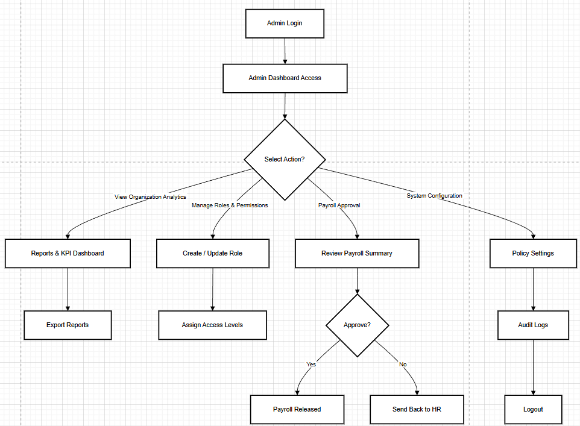
Fig 1 :Admin login

👑 ADMIN / CEO WORKFLOW — STEP BY STEP PROCESS
This process describes how an Admin interacts with the HRM Portal from start to finish.

🟢 STEP 1 — Admin Login

Process
- Admin opens HRM Portal login page.
- Enters email and password.
- System validates credentials.

System Actions
- Role check (Admin access).
- Session created.
- JWT token generated.
- Login activity stored in Audit Logs.
👉 Outcome:
Admin is authenticated successfully.

🟢 STEP 2 — Admin Dashboard Access
After login, Admin lands on Dashboard.

Dashboard Displays:
- Organization analytics
- Total employees
- Attendance insights
- Payroll status
- Pending approvals
- Alerts & notifications
👉 Purpose:
Provides high-level organizational overview.

🔶 STEP 3 — Select Action (Main Decision Point)
Admin chooses what to do next.
Available Actions:
1️⃣ View Organization Analytics
2️⃣ Manage Roles & Permissions
3️⃣ Payroll Approval
4️⃣ System Configuration
Each action leads to a different workflow path.

📊 STEP 4 — View Organization Analytics

Process
- Admin opens Reports & KPI Dashboard.

Admin Can:
- View employee trends
- Analyze department performance
- Monitor company KPIs

Next Step:
➡️ Export Reports
Admin downloads PDF/Excel reports.
👉 Use Case:
CEO reviewing monthly performance.

🧩 STEP 5 — Manage Roles & Permissions

Process
- Admin creates or edits roles.
Examples:
- HR Role
- Manager Role
- Employee Role

Next Step:
➡️ Assign Access Levels
Admin defines:
- Module access
- Data visibility
- Approval permissions
System Updates:
- Role database updated.
- Audit log recorded.

💰 STEP 6 — Payroll Approval Workflow

Process
- Admin opens Payroll Summary.
Admin Reviews:
- Total salary cost
- Deductions & taxes
- Bonuses
- Compliance status

🔶 STEP 7 — Approval Decision
Admin decides whether payroll is correct.

✔ If Admin Approves (YES)
System Actions:
- Payroll Released
- Payslips generated
- Employees notified
- Finance workflow triggered
👉 Final State:
Payroll completed successfully.

❌ If Admin Rejects (NO)
System Actions:
- Payroll sent back to HR
- Status = “Rework Required”
- HR receives notification
👉 Purpose:
Prevent payroll errors.

⚙️ STEP 8 — System Configuration
Admin enters Policy Settings.
Admin Configures:
- Leave policies
- Attendance rules
- Work schedules
- Approval hierarchy
System Saves:
- Configuration stored.
- Version control updated.

🔎 STEP 9 — Audit Logs Review
Admin checks activity history.
Shows:
- Login records
- Role changes
- Payroll approvals
- Policy updates
👉 Important for:
Security and compliance.

🔚 STEP 10 — Logout
Admin ends session.
System Actions:
- Token invalidated
- Session closed
- Logout recorded in audit logs
👉 End of workflow.
COMPLETE FLOW SUMMARY (ONE LINE) :
Login → Dashboard → Select Action → Perform Strategic Task → Decision → System Update → Logout

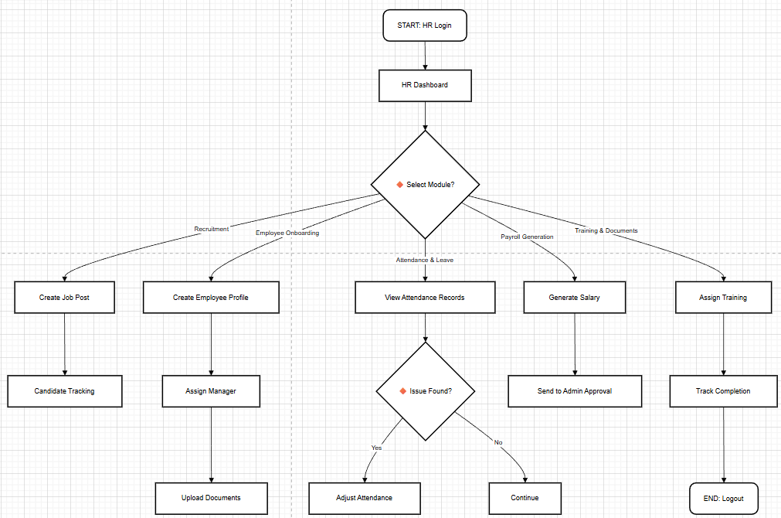

🧑‍💼 HR WORKFLOW — STEP BY STEP PROCESS
This workflow represents how the HR role operates inside the HRM Portal to manage recruitment, onboarding, attendance, payroll, and training activities.

🟢 STEP 1 — HR Login (Start)

Process
- HR user logs into the portal using credentials.
- System verifies role-based access.

System Actions
- HR session created.
- Dashboard permissions loaded.
- Login recorded in audit logs.
👉 Outcome:
HR successfully enters the system.

🟢 STEP 2 — HR Dashboard Access
After login, HR lands on the dashboard.

Dashboard Shows:
- Recruitment status
- Employee onboarding progress
- Attendance alerts
- Payroll tasks
- Training updates
👉 Purpose:
Provides a centralized operational view.

🔶 STEP 3 — Select Module (Main Decision Point)
HR chooses which module to work on.
Available Modules:
1️⃣ Recruitment
2️⃣ Employee Onboarding
3️⃣ Attendance & Leave
4️⃣ Payroll Generation
5️⃣ Training & Documents
Each option leads to a different workflow branch.

📋 STEP 4 — Recruitment Workflow

Process
HR selects Recruitment.

Actions
- Create Job Post
- Define role, department, and requirements.
Next Step:
➡️ Candidate Tracking
HR tracks:
- Applications
- Interview stages
- Hiring status
👉 Business Goal:
Manage hiring pipeline efficiently.

👤 STEP 5 — Employee Onboarding Workflow

Process
HR creates employee profile.

Actions
- Enter employee details
- Assign reporting manager
Next Steps:
➡️ Upload Documents
Examples:
- ID proof
- Offer letter
- Certificates
👉 Outcome:
Employee becomes active in the system.

🕒 STEP 6 — Attendance & Leave Management

Process
HR views attendance records.
System Displays:
- Daily attendance
- Leave balance
- Absence alerts

🔶 STEP 7 — Issue Found? (Decision)
HR checks if attendance issues exist.

✔ If YES:
➡️ Adjust Attendance
HR corrects:
- Missing check-ins
- Leave errors
- Shift changes

❌ If NO:
➡️ Continue
No changes required.

💰 STEP 8 — Payroll Generation Workflow

Process
HR selects Payroll module.
Actions:
- Generate Salary
- System calculates earnings and deductions.
Next Step:
➡️ Send to Admin Approval
Admin reviews before release.
👉 HR Role:
Prepare payroll, not approve it.

🎓 STEP 9 — Training & Document Management

Process
HR assigns training programs.
Actions:
- Select employees
- Assign courses
Next Step:
➡️ Track Completion
HR monitors:
- Training progress
- Certification uploads

🔚 STEP 10 — Logout (End)
HR ends session.
System Actions:
- Session terminated
- Logout recorded in audit logs
👉 Workflow completed.
COMPLETE FLOW SUMMARY (PROFESSIONAL LINE) :
HR Login → Dashboard → Select Module → Perform Operational Tasks → Send Approvals → Track Results → Logout

👩‍💻 EMPLOYEE WORKFLOW — STEP BY STEP PROCESS
This workflow represents how an employee interacts with the HRM Portal to perform self-service activities like daily updates, attendance, leave requests, expense claims, and profile management.

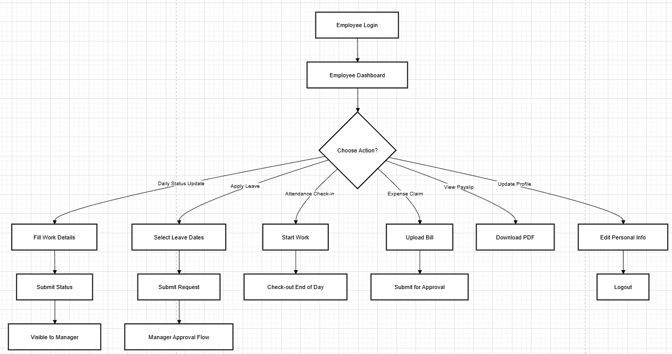
Figure No: 3

🟢 STEP 1 — Employee Login

Process
- Employee enters credentials.
- System verifies identity and role.

System Actions
- Session created.
- Employee dashboard loaded.
- Login activity recorded.
👉 Purpose:
Secure access to personal HR services.

🟢 STEP 2 — Employee Dashboard Access
After login, employee reaches the dashboard.

Dashboard Shows:
- Attendance summary
- Leave balance
- Daily status reminder
- Payroll notifications
- Pending approvals
👉 This is the main entry point for all actions.

🔶 STEP 3 — Choose Action (Decision Point)
Employee chooses what task to perform.
Available Actions:
1️⃣ Daily Status Update
2️⃣ Apply Leave
3️⃣ Attendance Check-in
4️⃣ Expense Claim
5️⃣ View Payslip
6️⃣ Update Profile
Each option opens a different workflow.

📋 STEP 4 — Daily Status Update Workflow

Process
Employee selects Daily Status Update.
Actions:
- Fill Work Details
- Add tasks, hours worked, blockers.
Next Steps:
➡️ Submit Status
System Result:
- Status saved in database.
- Visible to Manager dashboard.
👉 Business Purpose:
Track daily productivity without meetings.

🌴 STEP 5 — Apply Leave Workflow

Process
Employee selects leave option.
Actions:
- Select Leave Dates
- Choose leave type.
Next Step:
➡️ Submit Request
System Flow:
- Request enters Manager Approval Flow.
👉 Employee waits for approval notification.

🕒 STEP 6 — Attendance Check-in Workflow

Process
Employee starts workday.
Actions:
- Click Start Work (Check-in)
End of Day:
➡️ Check-out
System Records:
- Work hours
- Attendance status
👉 Used for payroll calculation.

💰 STEP 7 — Expense Claim Workflow

Process
Employee submits expense.
Actions:
- Upload Bill
- Add expense details.
Next Step:
➡️ Submit for Approval
System Flow:
- Manager reviews claim
- HR processes reimbursement

📄 STEP 8 — View Payslip Workflow

Process
Employee opens payroll section.
Action:
- Download PDF payslip.
System Provides:
- Salary breakdown
- Tax deductions
- Net pay details
👉 Employee cannot modify payroll data.

🧑 STEP 9 — Update Profile Workflow

Process
Employee edits personal information.
Actions:
- Update address
- Emergency contact
- Bank details (if allowed)
System Saves:
- Updated profile securely.

🔚 STEP 10 — Logout (End)
Employee ends session.
System Actions:
- Token invalidated.
- Logout activity recorded.

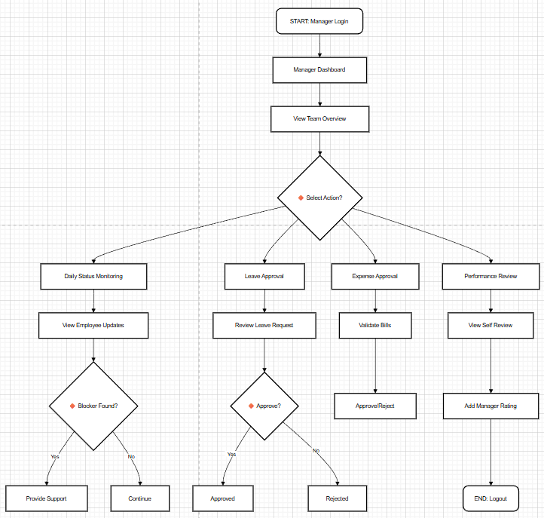

MASTER ORGANIZATION FLOW :

15.ORGANIZATION HIERARCHY FLOWCHART
