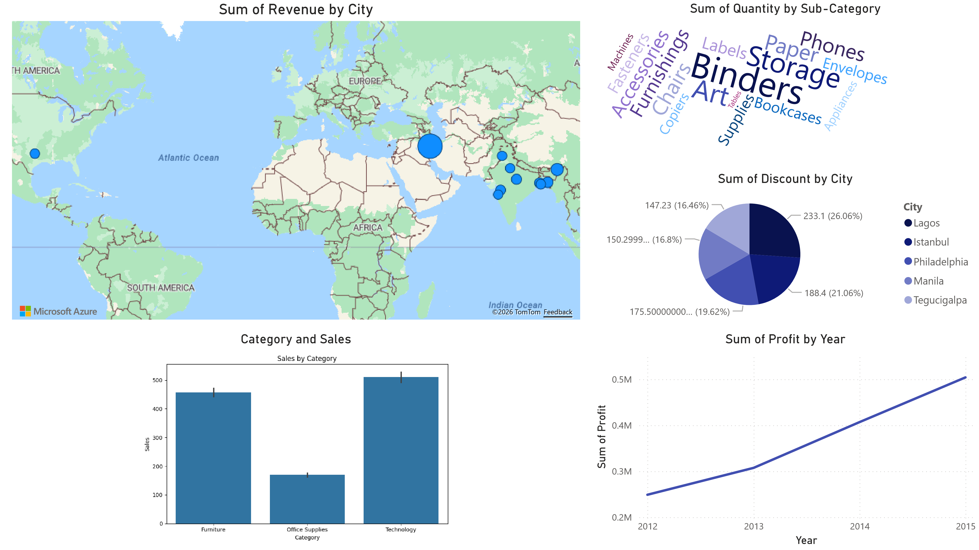
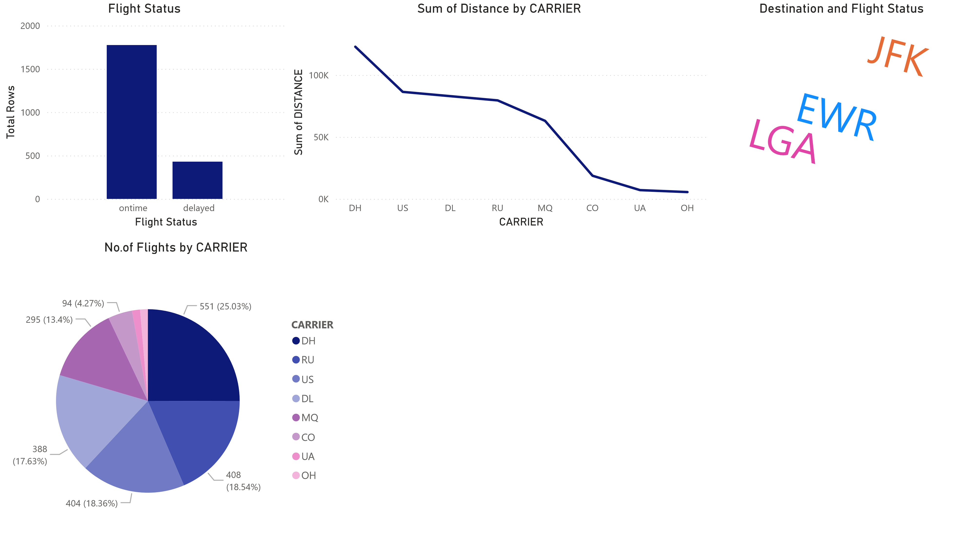

Flight Status DEST^{Power BI Desktop}Sum of FL_NUM
delayed | EWR | 559209
delayed | JFK | 473467
delayed LGA 810877
ontime EWR 1739881
ontime JFK 1944118
ontime | LGA | 2869453
Total 8397005

