**EXERCISE-4**

**BO:**

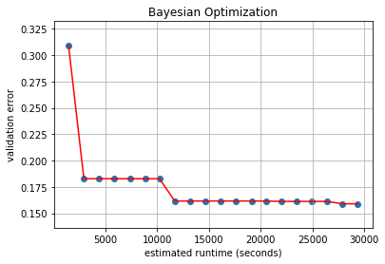

**HYPERBAND:**

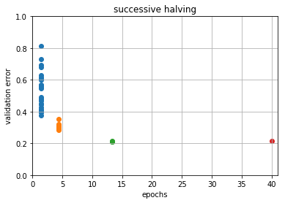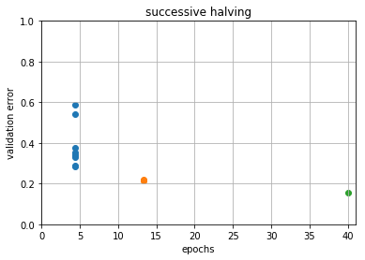

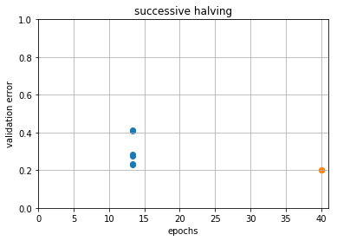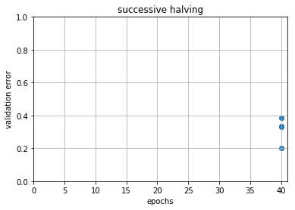

**BOHB:**

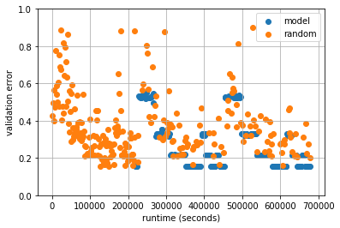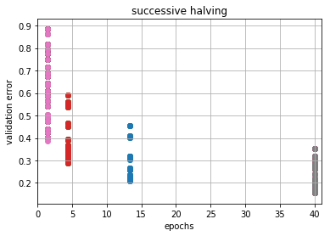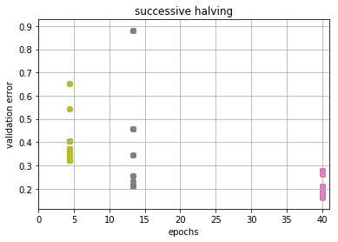

……………………………….

……………………………………

Final run

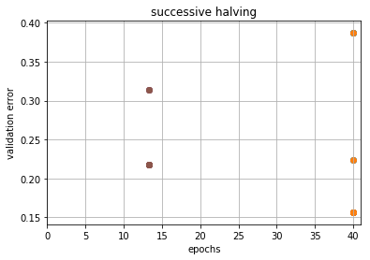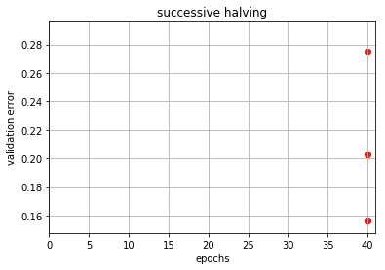

1. BOHB gives the least validation error.
2. We can also see that as the iteration proceeds, the quality of points sampled increases compared to hyperband, as we are sampling from the distribution of ‘good points’.
3. Exploration of the points are also done- this can be seen in the first iteration of every budget