# CHAPTER 1

# INTRODUCTION

**1.1 COURSE OBJECTIVE**

The main objective of the mini project is to develop the application that will have the following functions like: -

* Basically the mini project helps us explore and strengthen the understanding of fundamentals through practical applications of theoretical concepts.
* It also helps us to boost your skills and widen your visual of thinking.
* It helps the beginners to do larger projects in their career for their future.
* It is helpful to design algorithm.
* Better learning of the coding language.
* To implement the concepts and learn to implement them properly.

**1.2 PROBLEM DEFINITION**

Medicines are one of the important factors that are necessary to cure a persons disease. “PREVENTION IS BETER THEN CURE” is one of the famous proverbs. Taking precautionary measures before getting suffered from the dreadful diseases is very important. The medicines are required when you do not follow this famous saying. Due to the delay of medicines, there are chances that the person might even loses life. To solve all these problems, the medical shop management system plays a major role.

The medical shop management system helps to maintain and keep the medicines in the medical store in a proper place. When you need a particular medicine, you can get to know the exact location of the particular medicine that you are searching for.

**1.3 METHODOLOGY TO BE FOLLOWED**

* When we execute the program, it shows the main menu which contains,

1. MEDICINE MENU
2. CUSTOMER MENU
3. SUPPLIER MENU
4. REPORT MENU
5. INVOIVING
6. EXIT THE PROGRAM

* We need to enter the numbers 1-6 to choose to go to any menu of the above.
* After entering the number, we can go to the respective menu allotted for that number.
* After entering the menu, there will be other options. We have enter numbers to choose the respective options.

## 1.4 EXPECTED OUTCOMES

When user executes the program, following are the expected outcomes.

* MEDICINE MENU

If a user enters 1, then they can go to medicine menu. In which, there are some options like

1. add medicine
2. search medicine
3. update medicine info
4. medicine to be purchased list
5. go to main menu.

When we choose to add a medicine, then it asks to enter the medicine name, id, its sale price, cost price, quantity, minimum quantity to maintain, company name and supplier id.

* CUSTOMER MENU

If a user enters 2, then they can go to customer menu. In which, there are options

1. search customer
2. add customer
3. update customer info
4. go to main menu.

* SUPPLIER MENU

If a user enters 3, then they can go to supplier menu. In which, there are options like

1. search supplier
2. add supplier
3. update supplier info
4. go to main menu.

**CHAPTER 2**

**REQUIREMENT SPECIFICATION**

## HARDWARE REQUIREMENTS

* + - Processor : intel core i3
    - RAM : at least 1Gb
    - Hard Disk : 10 GB
    - Input device : Standard Keyboard and Mouse
    - Output device : High Resolution Monitor

## SOFTWARE REQUIREMENTS

* + - Operating system : Windows XP
    - Front End : ASP.Net 2.0
    - IDE : Visual Studio 2008
    - Data Base : SQL Server Management Studio 2005 Required..
    - Server : Internet Information Services
    - Platform : Python IDE or Jupiter Notebook
    - Database Software : SQLite3

# CHAPTER 3

**FUNDAMENTALS**

## DATABASE FUNDAMENTALS

A database is an organized collection of structured information, or data, typically stored electronically in an exceedingly automatic data processing system. A database is sometimes controlled by a direction system (DBMS).It introduces database concepts, relational database, tables and data types, manipulation and data selection, views, stored procedures, backup and restore, normalization, constraints, indexes, security, and functions.

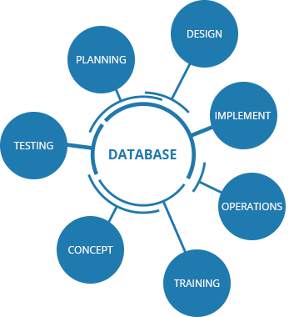

#### Fig 3.1 Data base

**->Tables:** It is most basic building of a database. It’s the place where we will put our idea, and define their data type, and also their relationship with the other tables. It consists of rows and columns.

* + - Columns consists of three types: - Simple, Composite, Multi-valued

**->SQL:** SQL stands for Structured Query Language. It’s a standard computer language for managing the relational database and manipulation of data. It is used to do all the operation in database like creation of schema, table, inserting, updating, deleting and

retrieving rows. SQL is used by various database management systems like: MySQL, Oracle, vertical, Sybase, etc.

**->Select:** The select statement retrieves zero or more rows from one or more database tables.

1. SQL join combines the records from two or more tables in a relational database.
2. CROSS join will produce the row which is the combination of each row from the first table with each row from the second table.
3. AN INTERSECTION gives the results of two queries and only returns rows that appear in both result sets.
4. A UNION enables to combine the results of two SQL queries into a single table of all matching row.

**->Manipulate data:**

1. Insert data: - The statement INSERT adds one or more records for any single table in a relational database.
2. Update data: - The statement UPDATE changes the data of one or more records in a table.
3. Delete data: - DELETE statements removes one or more records from the table. Views:

Create views: It is the results of set data of stored query on data, where database system users can get only query just as they always collect the database object.

Stored Procedures: It is a subroutine which is available to all applications that access a relational database management system.

### ->Functions:

A user defined functions are provided by user and aggregate function is a function where the multiple values of rows are grouped together as an input on an certain criteria to form single value of more significant meaning.

### ->Normalization:

It is the process of organizing the columns and tables of a relational database to reduce into small size or minimize data redundancy.

The types are First normal form (1NF), Second normal form (2NF), Third normal form (3NF), Fourth normal form (4NF).

### ->Constraints:

We have to choose appropriate primary keys, select appropriate data type, select appropriate fields for composite keys, understand the relationship between foreign and primary key.

### ->Indexes:

They are basically used to quickly to locate data without having to search each and every row in database table every time a database table is accessed.

### ->Security:

Database security is the use of a board range of information security controls to store functions, protect databases, data servers, database systems, against compromises of their confidentiality, integrity, and availability.

### ->Backup and restore:

The process of backup are refers to the copying data of system or a computer and hiding the computer data so it may be used to restore the original data after the data loss event.

## Entity and Attributes:

Entity type is a collection of entities which consists of various attributes which may be of various data types and can have various constraints. While selecting an entity we must always care of two things, does that selected entity have enough members and also enough attributes. If the entity satisfies both the conditions then such entities are called good entity but if the entity fails to satisfy one of these conditions then such entities are considered to be bad entities. Attributes for each entity should have a proper data type assigned to it and may or may not have constraints. All the entities of Interactive

multimedia are good entities because all of them has enough members and enough attributes. The entities used in this project and corresponding attributes are listed below:

* + - 1. USER (Uid, Fname, Lname, DOB, Address, Email, Password, Phone no, College)
      2. GROUP (Gid, Gname, Tot_mem, Date_of_creation)
      3. EVENT (Eid, Ename, Edate, Etime, Place, Interested_ppl)
      4. POST (Pid, Ptype, No_likes, No_comments, No_shares)

## Keys:

Key is a constraint used while defining attributes in a table. The key is useful to identify a row in a table.

It plays an important role in finding the relation between two tables. It helps you uniquely identify a row in a table by combination of one or more columns in that table. There are various keys which has various properties, one of them which is widely used is Primary key. Primary key is a unique identification of a table that is used while combining tables and it can never be NULL. In one table more than one column can be primary key. When this primary key column is used in other tables then that becomes Foreign key and its values can be NULL. Both primary and foreign key plays an important role in determining relation between two tables. Unique key is also one of them which ensures that the particular column has unique values.

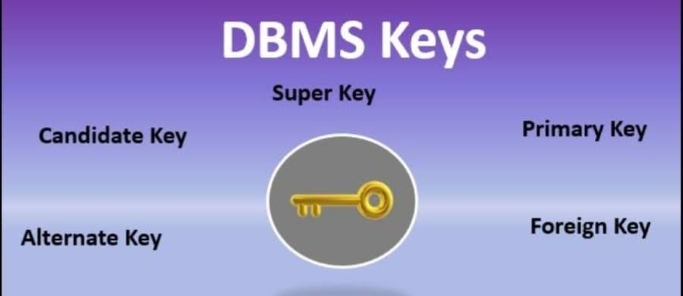

#### Fig 3.2 Keys

Interactive multimedia makes use of two keys which are listed below:

1. Primary key:
   * Uid
   * Gid
   * Eid
   * Pid
   * Mid
   * Uid,Frnd_id
   * Uid,Gid
   * Uid,Eid
2. Foreign key:
   * Uid
   * Gid
   * Eid
   * User_id

## Relationship and Participation:

If one table has a foreign key that references the primary key of another table then there exists a relation between two relational databases. This means one or the other way an entity is related to the other like user entity type is related with group entity with the relation “joins”. Participation may be 1: 1, 1: N or M: N. One entity can relate with another table and can have partial or full participation. Here partial participation means the members of one entity may or may not be associated with the other entity whereas the full participation means that at least one member of an entity is associated or combined with the other one.

Interactive multimedia associates all relation with full participation which is reflected by the ER diagram above i.e. It means one or the other way at least one of the members of each entity is associated with other which are in relation. A sample snippet for relationship and participation from this project in chapter 4.

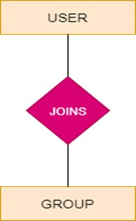

#### Fig 3.3 User-Group relation and participation

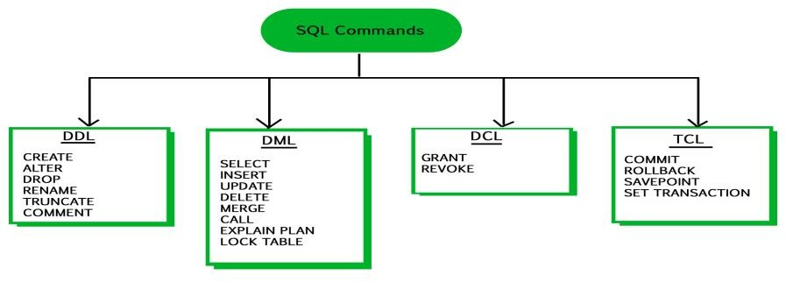

**Fig 3.4 SQL Commands**

1. **DDL Command:** DDL stands for Data Definition Language. These are the commands used for schema or the table definition manipulation but not for data. There are various DDL commands which are listed below:

CREATE **-**it is used to create the database

DROP-used to delete the objects

ALTER-used to alter structure of database

TRUNCATE- it is used to remove all records from a table which includes all the spaces allocated for records.

COMMENT-used to add comments to the data dictionary.

RENAME- used to rename the object which is already there in the database

1. **DML Command:** DML stands for Data Manipulation Language and is used to manipulate the rows in the table. The rows in the table can be selected , updated, deleted and inserted, etc.

SELECT-selects records from a table INSERT-used to enter data in database UPDATE-update existing record with table

DELETE-removes unwanted records from a table

1. **DCL Command:** DQL stands for Data Query Language for performing database queries.

GRANT- permits user to access the database REVOKE-withdraws the permission given by GRANT

1. **TCL Command:**

TCL stands for Transaction Control Language which deals with the transaction within the database.

COMMIT: This command is used to commit the transaction so that the previous transaction will be successfully saved into the database. Once commit is done. it is not possible to rollback. Syntax: COMMIT;

ROLLBACK: This command is used to rollback/ undo the transaction if any error occurs. Syntax: ROLLBACK;

## PYTHON FUNDAMENTALS

Python is a high-level language programming and it is very easy to construct a program using python, it uses in large applications like GUI (graphical user interface) and web applications. Python program easy to construct code and simple to execute rather than other programming languages like c++, c and java …

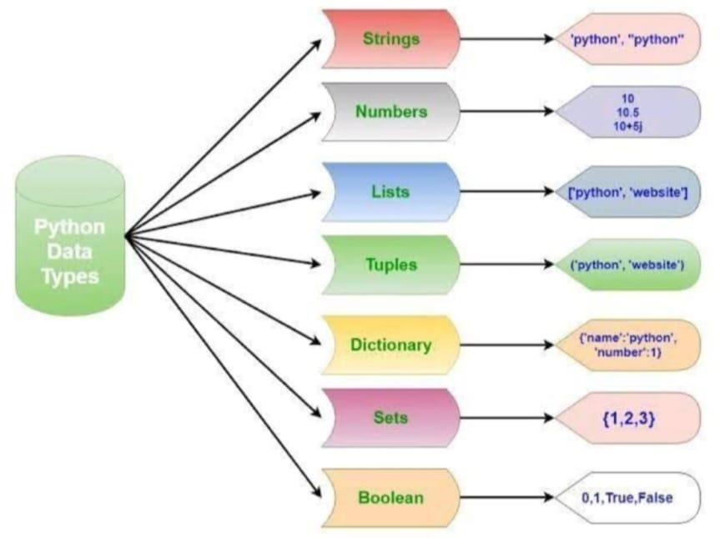

#### Fig 3.5 Python data types

To construct a good program of python you must know the basics concepts of python It is major classified into

* + - Conditional Statements
    - variables
    - Loop
    - strings

To use the python programming, we need to access an editor to execute the programming. Lot of us use NumPy, visual studio code and Anaconda and Jupiter and etc.

Programming is the background part of the web applications many applications uses different type of programming but everyone is more interested in python programming because it is very simple and easy to execute the code.

Now lets us discuss about the prerequisites of python programming.

1. **Conditional statements**

In order to write programs very easier, we always need the ability to check the statements and make it program as simple and easy to execute

Let us see about some control statements

* + IF STATEMENT
  + IF ELSE STATEMENT
  + NESTED STATEMENTS

#### IF STATEMENT

It is the simplest form Ex: x=8

>>> if x < 10:

Print (‘NEW HORZION ‘)

…

Output:

NEW HORIZON

The Boolean expression after if statement is called as conditional, we always end the if statement with a colon (:)

To stop an if statement we use break statement.

#### IF ELSE STATEMENT

This statement allows us to check for multiple expressions.

Ex: a=12

b=12

if y>x:

print (‘b is greater than a ‘)

elif x==y:

print (‘x and y are equal’)

Output:

x and y are equal

In if statements there are two possibilities If the given statement is true it executes statement 1 or else it runs and execute the second statements.

#### NESTED STATEMENT

Nested statements are three branch statements like one conditional statement are connected to other nested statements

Ex: if x == y:

Print (‘x and y are equal')

Else:

if x < y:

Print (‘x is less than y')

Else:

Print ('x is greater than y')

Nested statements always allow one inside another.

### VARIABLES

* + A variable is named place in the memory where a programmer can store

data…

* + A programmer gets to choose the names of the variable.
  + Variable is always important for any language of programming because

without a variable we can’t print many outputs in programming language.

* + Python variables Name rules
  + Must start with a letter or underscore
  + Must consists of letters, numbers and underscores
  + It is a case sensitive

Ex: New horizon Sreeja 23

Let’s see an example of program with containing variables in it ..

Ex: a=11.0

b=12.24

c = a * b print (c)

Here a, b, c are the variables of the given program it prints the output through c by

calculating a * b…

### LOOPS

Loops are (repeated steps) it have iteration variables that change each and every time through a loop, often their iteration variables go through a sequence of numbers.

When we are executing big applications were, we should print many values at that time loops are very helpful to us, by using loops we can reduce the code and easily can print the output.

Let us see discuss about different types of loops

1. While loops
2. For loops

First let us discuss about Infinite loops

#### While loop

While loops are used in python it is used to repeatedly execute a certain statement as long as the condition provided in while loop is true.

Let us see a program on while loop Ex: n=5

While n > 0:

Print (n) n = n-1

print (‘new horizon !!‘)

print(n) Desired output:

5

4

3

2

1

new horizon!! 0

#### a. Infinite loops in while loop

Infinite loops in while loop the given statement while never become false, the program enters the loop and keep on repeating the same steps over and over again

Ex: n=5

while n >0:

print(‘friends’)

print (‘new horizon’) print(‘family’)

It is not good to have an infinite loop

#### For loop

Most of the programming languages uses the for loop because it helps in coding easily the program it always has single line code.

Definite loop (for loop) have explicit iteration variables that change each time through a loop.

Syntax for loop in python For a in sequence:

Body of for

Let us take an example for loop Ex: for I in [5,4,3,2,1]:

Print [i]

* In loops we use the statements break, continue, count.

### Strings

* + A string is a sequence of characters (alphabets or letters)
  + It always uses either single or double quote
  + In strings + is used for Adding two words it is called as “concatenate”.
  + We can always convert a string number into a number by using int () because int is used for numbers

Let’s us see example of sequence of characters

>>>fruit = ‘apple’

>>>letter= fruit [1]

>>>print (letter) Output: a

This example shows the index position of the 1 from the fruit Variable and assigns it to the letter variable.

#### Len function

A function is stored code that we use. This Lena function always takes some input and produces us a desired output

It is used to find the length. The built-in function is LEN. EX: >>>car = ’polo’

>>>print ( len (fruit)) Desired output:

4

#### String concatenation

* 1. When + operator is applied to string it means “concatenation “

Ex: >>>a= ‘hello’

>>> b= a + ‘world’

Print (b) Desired output:

hello world

* 1. When the space required b/w two name

>>> c= a + ‘+’

>>>print (c) Desired output:

hello world

* + - strings are used in many ways such as:
      * slicing strings
      * using as logical operator
      * string library
      * searching, replacing
      * prefix and postfix etc.…...

### Binary Trees: bytes, byte array, memory view

1. **Bytes:** The bytes () are method which returns a immutable bytes object initialized with the given size and data of it.

#### Syntax:

Bytes ([source [, encoding [, error]]])

#### Example:

size = 5

arr=byte(size) print(arr)

#### Output:

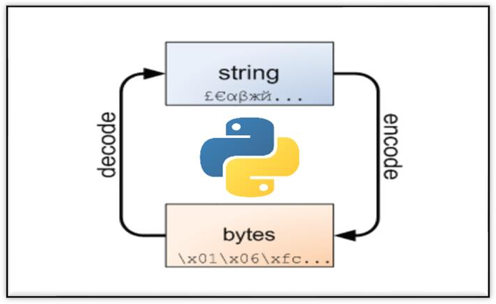B’\X00\X00\X00\X00\X00’

#### Fig 3.6 Bytes

1. **Byte array:** this method returns a byte array object which is an array of given bytes. It gives an mutable sequence of integers in the range of (zero) 0 <= x < 256.

**Syntax:** byte array (source, encoding, error)

#### Example:

String = “Python is very interesting.” arr = byte array (string, ‘utf-8’) print(arr)

#### Output:

Byte array (b’ Python is very interesting.’)

1. **Memory view:** memory view objects allow Python code to access the interior data of an object that supports the buffer protocol without copying.

The memory view () function allows direct read and write access to an object’s byte- oriented data with no need to repeat it first.

Which will yield large performance gains when operating on large objects since it

doesn’t create a replica when slicing.

**Syntax:** memory view (obj)

Parameters:

Return value:

#### Example:

random_byte_array = byte array (‘ABC’, ‘utf-8) mv = memory view(random_byte_array) print(mv[0])

## Tkinter Widgets

### Frame:

A frame is a container which associated with other type of widgets. It is mainly used for grouping and organizing widgets. A bunch of labels, entry, buttons, etc. can be added into the frame and moving frame alone moves other widgets too. The examples are: bg, bd, cursor, relief, width, etc. can be used to configure frame.

**Syntax:** Frame (window_name, options)

Gaffer has made use of multiple frames with the help of which other contents can be raised above the previous contents using the same window without creating an extra window creating an illusion of user interface like in real world applications.

### Label:

A label is an widget which is used to display an non-editable text. Label in fact is also used to display images using Photo Image module. The most commonly used label is with ‘text’ configuration option and can change this at any time. In label we can have a many option like: fg, bg, font, width, height, etc.

#### Syntax:

Label (window_name, options) We can add an image into label as below:

project_img=PhotoImage (file="path with file name") project_img_label=ttk.Label(captainDashboard, image=project_img)

### Entry:

An entry is a single line text field user can use to type anything. It’s mostly used in

‘log_in’ form for retrieving username and password. It has a special property to hide/ encrypt the texttyped by a user by using “show=’*’” option which replaces each and every letter with the specified symbol/letter (in this case every letter typed by a user is encrypted with ‘*’).

**Syntax:** Entry (window name, options)

### Button:

Button -> It is one of the widely used widget among all in Graphical user interface (GUI) with Tkinter. It is a functional widget that is clickable and on click it performs some action defined in the command option. It is used for linking two functions. They can display text or images same as labels, but also have a whole range of new options used to control their behavior.

**Syntax:** Button(window name, options)

Interactive multimedia has multiple buttons with various functions like raising a frame over other, linking two functions, etc.

### List box:

List box displays a list of contents which a user interacts with and user can accept any number of times. It looks like a column of a table that displays values in various rows. It provides option to browse, select multiple, select single through select mode option. It also offers other variety of options like: bg, fg, font, height, width, highlight color, etc. **Syntax:** List box(window name, options)

### Scrolled Text:

This widget provides the feature of multiple line input field with scrollbar wherein user can type multiple lines of text. This very much useful for typing paragraphs, letters, essays, etc. In this it can also supports different options like: height, width, etc. **Syntax:** scrolled text. Scrolled Text (window name, options)

## Python Features

Python has huge collection of defined library which makes very easy to code in python. It’s library is portable and compatible with all platforms like Macintosh, UNIX, and Windows. You do not have to write your own code for each and every thing as it provides rich sets of modules and functions. It has various libraries for web browsing, regular expressions, etc.

## Interpreted Language

Python is one of the Interpreted Language as its code is executed line by line at a time. It is not required to compile our code like in other languages like java, c++, etc. which makes it easier to debug our code. The python source code is converted into an immediate form where this form is called byte code.

## Support for GUI Programming

Python provides various modules like PyQt, Tkinter, wxPython through which can user created through Graphical User Interface (GUI) for all mobile applications. The most popular for creating graphical apps using python is PyQt5. Tkinter also provides all of the required options to create a beautiful user interface even Interactive multimedia is made importing Tkinter module. This user interface can be connected to the backend using any one of the DBMS also supported by python, makes it more beautiful.

## Object Oriented Programming Language

Python is an object-oriented programming language which include the concept of class and object. It supports all OOPs concepts like inheritance, data abstraction, polymorphism, encapsulation etc.

## Scalable and Extendable

Python provides a structure and it supports a large program better than a shell scripting. It can also add a low-level module to the Python programmer. These modules are enable for programming to add or customize their tools which are more efficient.

**CHAPTER 4**

**DATABASE / ALGORITHIM DESIGN**

#### Fig 4.1 ER Diagram

**CHAPTER 5**

**IMPLEMENTION**

## IMPLEMENTATION OF FUNCTION

* A function is a block of code which only runs when it is called.
* We can pass a data, known as the parameters, into a function.
* "def" is the keyword used to define a function.
* A function can return a value

### SYNTAX FOR CREATING A FUNCTION

Def my_function: //for creating a function print ("Hello, I am the block of function code") //block of code my_function() //for calling function.

## IMPLEMENTATION OF TKINTER

* Tkinter is the standard GUI library for Python. fast and easy way to create GUI applications.
* It is a powerful object-oriented interface to the Tk GUI toolkit. • Import the Tkinter module.

### SYNTAX FOR CREATING A TKINTER

import Tkinter

top = Tkinter.Tk()

# Code to add widgets will go here...

top.mainloop()

## IMPLEMENTATION OF FRAMEWORK WIDGET

* Label – it Displayes text on the screen
* Button - It Contain text and can perform an action when clicked
* Entry - It Allows only a single line of text
* Text - It Allows a multiline text entry
* Frame - rectangular region is used to group related widgets or provide padding between the widgets

## IMPLEMENTATION OF MYSQL

**MySQL** is an open source in relational **database** management system that can be easily **implemented** and managed either on-premise or via the cloud through the hosting provider. It supports a lots of simultaneous writes and scales via replication.

# CHAPTER 6

# RESULTS

**RESULT STEP 1:**

## INITIAL LOOK OF THE OUTPUT

When the user executes the program the output screen will be displayed.

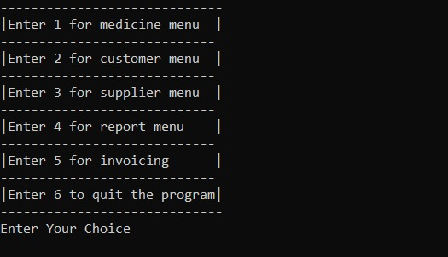

# RESULT 2:

# 

# RESULT 3:

# 

# RESULT 4:

# 

# RESULT 5:

# 

# RESULT 6:

# 

# CONCLUSION

From this Miniproject, we can conclude that, the Miniproject is successfully complied with zero errors. We can create an account by entering user id and password. We can login to that account by again entering that user id and that password. We can go to that sections like, customer info, supplier info, medicines.

By choosing customer info, we can add info, update info, search info and display info. By choosing supplier info, we can add supplier info, update info, search the info and display the info. We can see all the available medicines and also the cost of that medicines. Hence, the Miniproject of EASY MEDICS is totally complete and it error free.

# REFERENCE

**REFERENCE BOOK:**

* The Python Language Reference Manual – 1. Guido van Rossum and Fred L. Drake, Jr.

2. Network Theory Ltd- 120 pages (rev November 2006)

* Python Pocket Reference, 5th Edition

1.Mark Lutz

2.O'Reilly Media, February 2014- 264 pages

**REFERENCE LINK:**

* StackOverflow[:www.stackoverflow.com](http://www.stackoverflow.com/)
* [www.tutorailspoint.com](http://www.tutorailspoint.com/)
* https://[www.geeksforgeeks.org/python-gui-tkinter/](http://www.geeksforgeeks.org/python-gui-tkinter/)
* https://docs.python.org/2/library/tkinter.html
* [www.youtube.com](http://www.youtube.com/)
* Python GUI Programming Cookbook
* [www.wikipedia.org](http://www.wikipedia.org/)
* [www.dev.mysql.com/doc/](http://www.dev.mysql.com/doc/)