Assignment – 6
Ht.no: 2303A54011
Batch: 48

Lab 6: AI-Based Code Completion – Classes, Loops, and Conditionals
Task Description #1: Classes (Student Class)
Scenario
You are developing a simple student information management module.
Task
• Use an AI tool (GitHub Copilot / Cursor AI / Gemini) to complete a Student class.
• The class should include attributes such as name, roll number, and branch.
• Add a method display_details() to print student information.
• Execute the code and verify the output.
• Analyze the code generated by the AI tool for correctness and clarity.
Prompt:
Write a Python program to create a Student class with attributes for name, roll number, and branch. The class should include a method to display the student details. Accept input from the user, create an object of the class, and display the entered information.

Output :
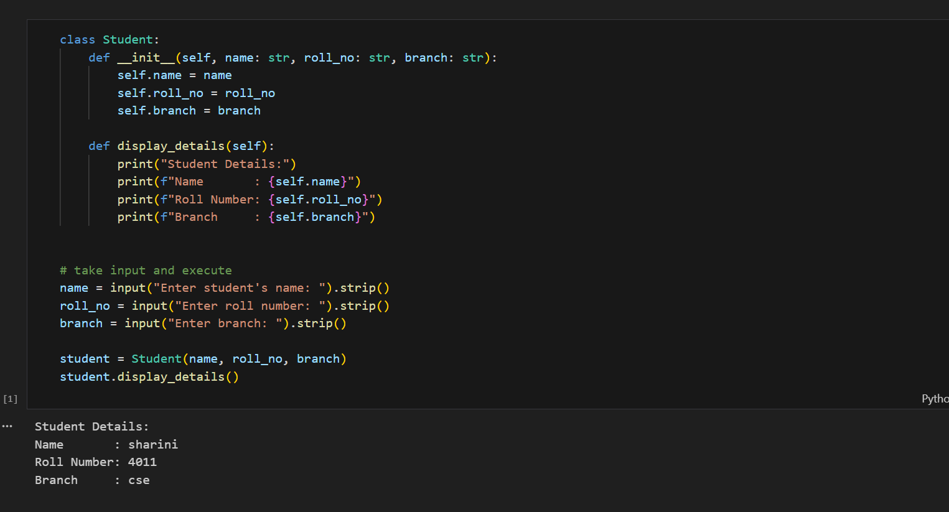
Explanation:
The Student details program uses a class to store and display information about a student. It takes the student’s name, roll number, and branch as input from the user and assigns these values to instance variables using the constructor (__init__). The display_details() method then prints the stored information in a structured format. When the object is created with the given inputs and the display method is called, the program outputs the student details exactly as entered. For example, if the name is sharini, the roll number is 4011, and the branch is cse, the program displays these details under the “Student Details” heading.

Task Description : Loops (Multiples of a Number)
Scenario
You are writing a utility function to display multiples of a given number.
Task
• Prompt the AI tool to generate a function that prints the first 10 multiples of a given number
using a loop.
• Analyze the generated loop logic.
• Ask the AI to generate the same functionality using another controlled looping structure (e.g.,
while instead of for).
Prompt:
Write a Python program to generate and print the first 10 multiples of a given number using a function and a for loop.Then, implement the same functionality using another controlled looping structure, such as a while loop.The program should take user input and display the multiples clearly.

Output:
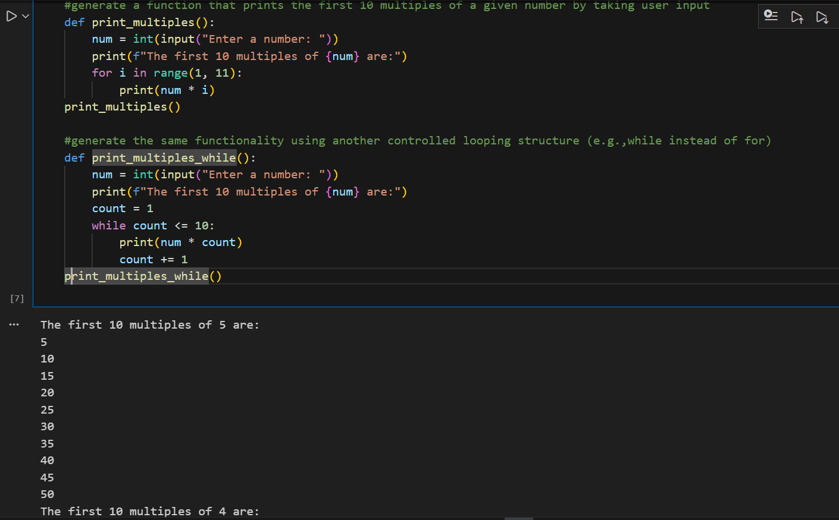
Explanation:
The program defines two separate functions to print the first ten multiples of a given number using different looping structures. In the first function, the user enters a number (for example, 5), and a for loop is used to multiply the number by values from 1 to 10, printing each multiple in sequence. In the second function, the same task is performed using a while loop. The user enters another number (for example, 4), and the loop continues to print multiples until the count reaches ten. Both approaches produce the same result but demonstrate how different controlled looping structures can be used to achieve the same functionality in Python.

Task Description #3: Conditional Statements (Age Classification)
Scenario
You are building a basic classification system based on age.
Task
• Ask the AI tool to generate nested if-elif-else conditional statements to classify age groups
(e.g., child, teenager, adult, senior).
• Analyze the generated conditions and logic.
• Ask the AI to generate the same classification using alternative conditional structures (e.g.,
simplified conditions or dictionary-based logic).
Prompt:
Write a Python program to classify a person into age groups such as Child, Teenager, Adult, or Senior using nested if-elif-else statements.Then, analyze the logic and implement the same classification using an alternative conditional structure, such as a simplified or dictionary-based approach
Output:
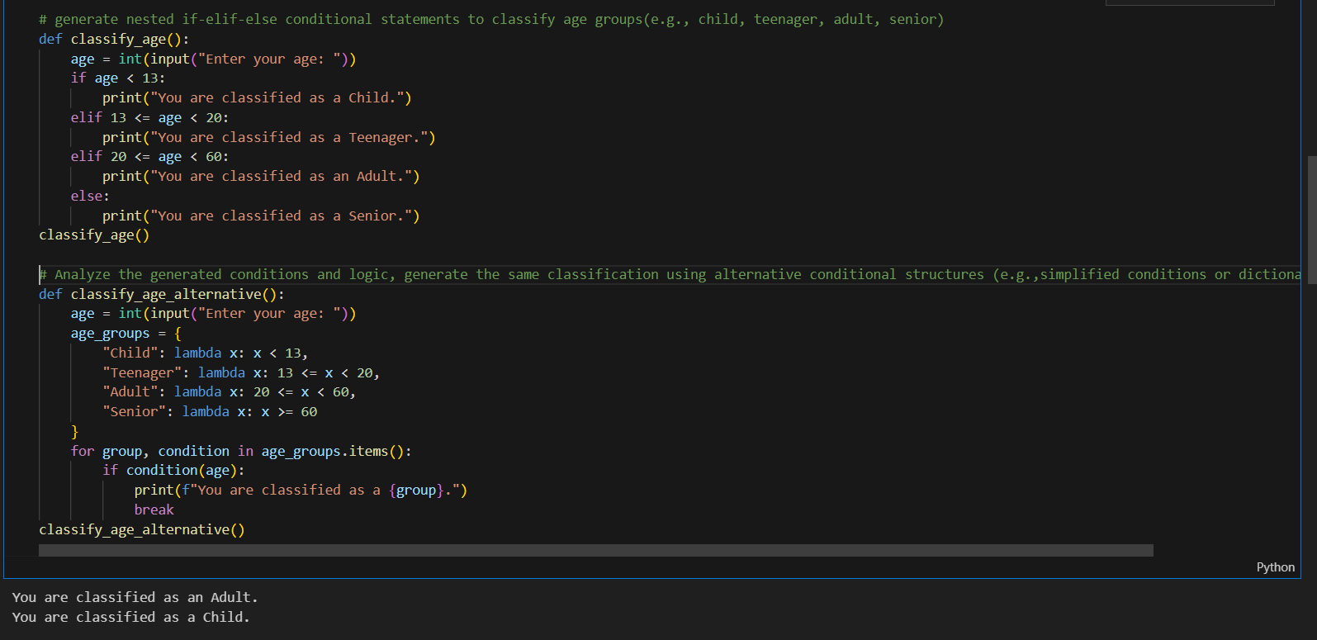
Explanation:
This program classifies a person into different age groups based on the age entered by the user. In the first part, a nested if-elif-else conditional structure is used to check the age against predefined ranges. If the age is less than 13, the person is classified as a Child; ages between 13 and 19 are classified as a Teenager; ages between 20 and 59 are classified as an Adult; and ages 60 and above are classified as a Senior. In the second part, the same classification logic is implemented using an alternative approach with a dictionary and lambda functions. Each age group is mapped to a condition, and the program iterates through these conditions to determine and print the correct classification. Both methods produce the same result but demonstrate different ways of handling conditional logic in Python

Task Description #4: For and While Loops (Sum of First n Numbers)
Scenario
You need to calculate the sum of the first n natural numbers.
Task
• Use AI assistance to generate a sum_to_n() function using a for loop.
• Analyze the generated code.
• Ask the AI to suggest an alternative implementation using a while loop or a mathematical
formula.

Prompt:
Write a Python program to calculate the sum of the first n natural numbers using a for loop. Analyse the logic and implement alternative solutions using a while loop and a mathematical formula.The program should accept user input and display the computed sum
Output:
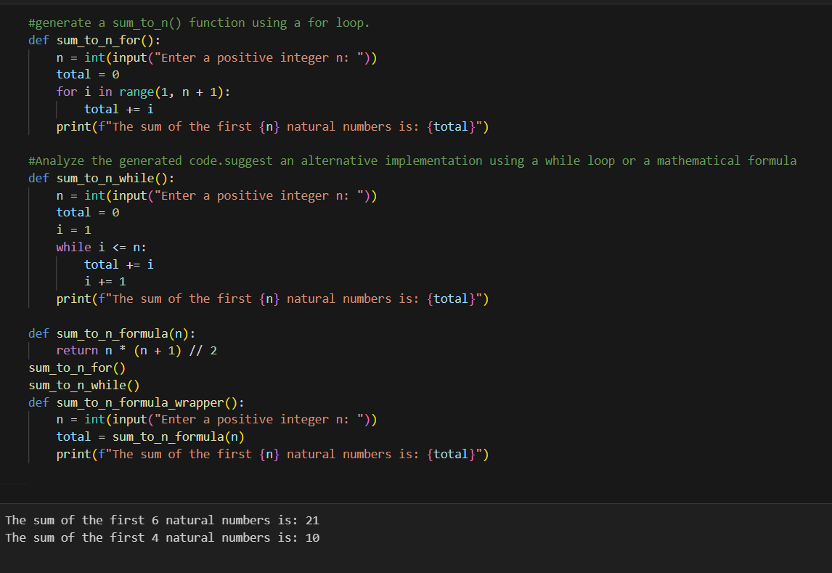
Explanation:
This program calculates the sum of the first n natural numbers using different approaches to demonstrate alternative looping and logical techniques in Python. In the first function, a for loop is used where the user enters a positive integer n, and the loop iterates from 1 to n, adding each value to a running total. In the second function, the same calculation is performed using a while loop, where a counter variable is incremented until it reaches n. Finally, an optimized approach is shown using a mathematical formula, where the sum is calculated directly using n(n+1)/2n(n+1)/2n(n+1)/2 without looping. All three methods produce the same result, but they highlight different ways to solve the same problem, with the formula-based approach being the most efficient.

Task Description #5: Classes (Bank Account Class)
Scenario
You are designing a basic banking application.
Task
• Use AI tools to generate a Bank Account class with methods such as deposit(), withdraw(),
and check_balance().
• Analyze the AI-generated class structure and logic.
• Add meaningful comments and explain the working of the code.
Prompt:
Write a Python program to create a BankAccount class with methods such as deposit(), withdraw(), and check_balance().
Analyse the class structure and logic, add meaningful comments, and explain how each part of the program works

Output:
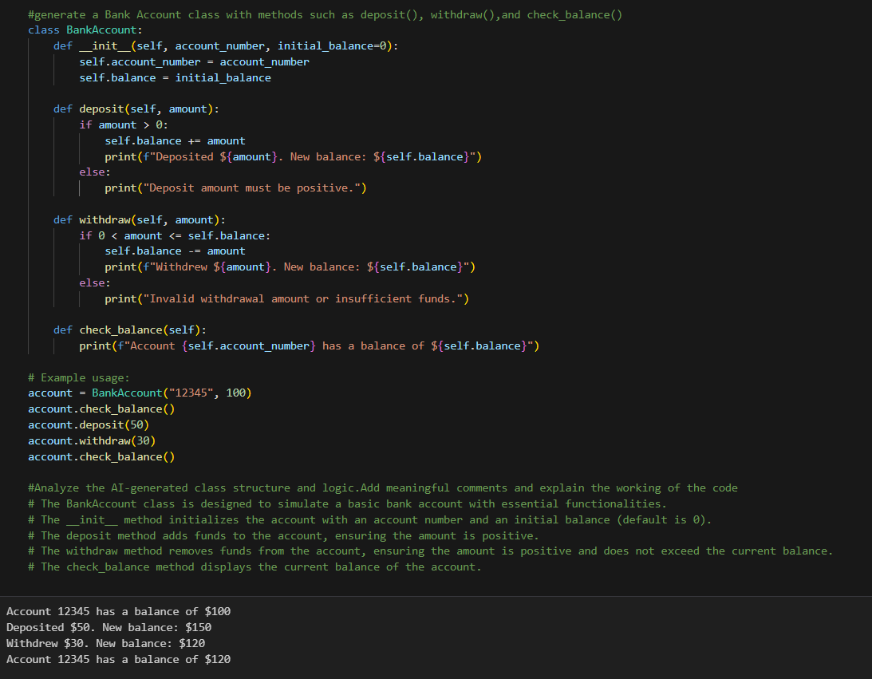
Explanation:
This program simulates a basic bank account system using a class in Python. The BankAccount class stores the account number and balance of a user and provides methods to perform common banking operations. The deposit() method allows money to be added to the account only if the entered amount is positive, while the withdraw() method deducts money only if sufficient balance is available. The check_balance() method displays the current account balance. By creatingn creating an object of the class and calling these methods, the program demonstrates how object-oriented programming can be used to model real-world banking operations in a structured and secure manner

