SE LAB 2
Name: Poojitha T
SRN: PES1UG24AM192

Jira screenshots and epic/stories table

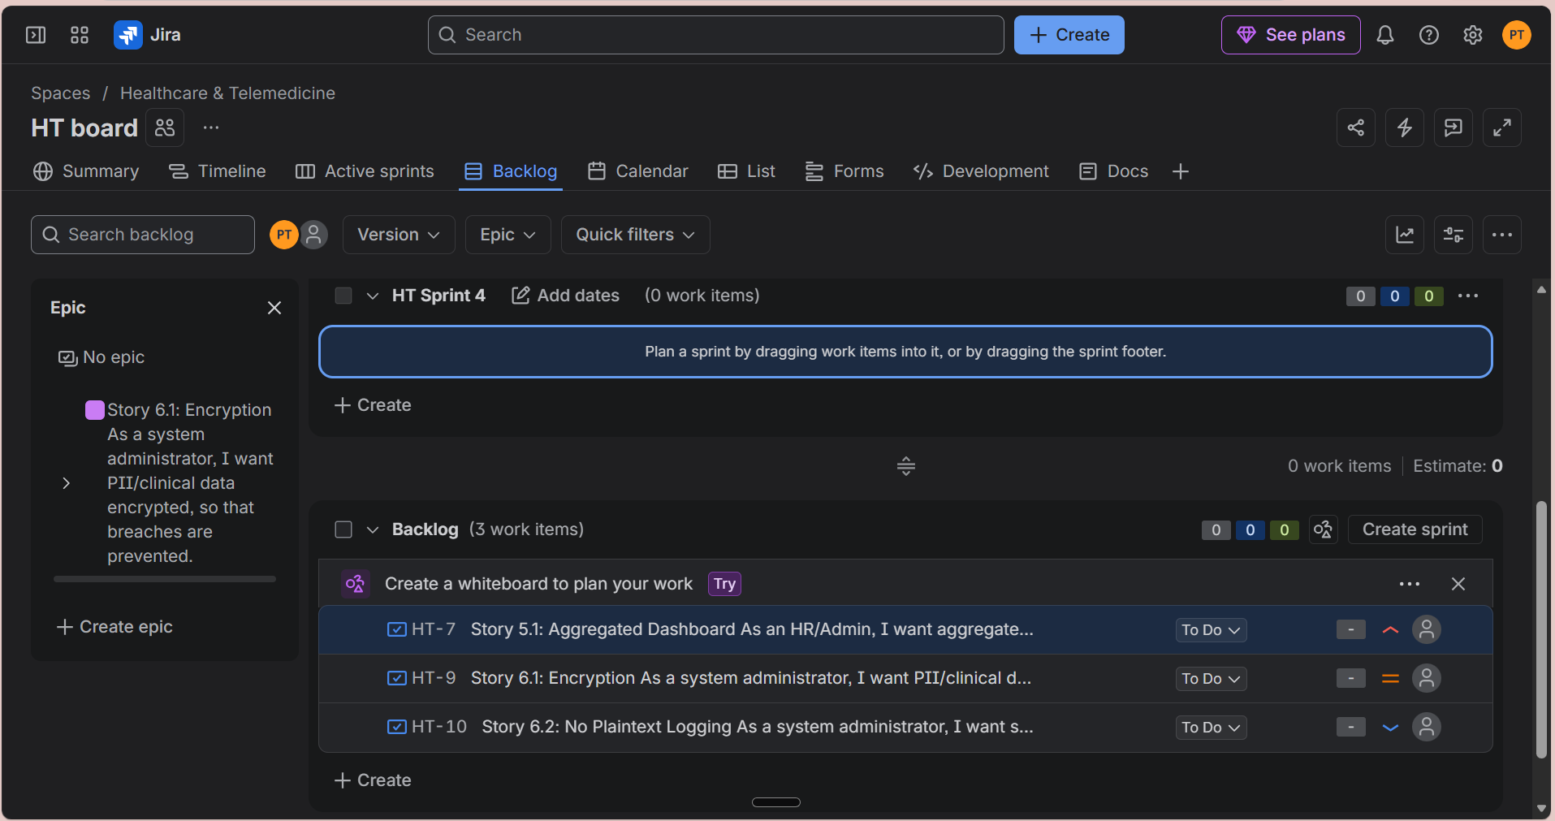

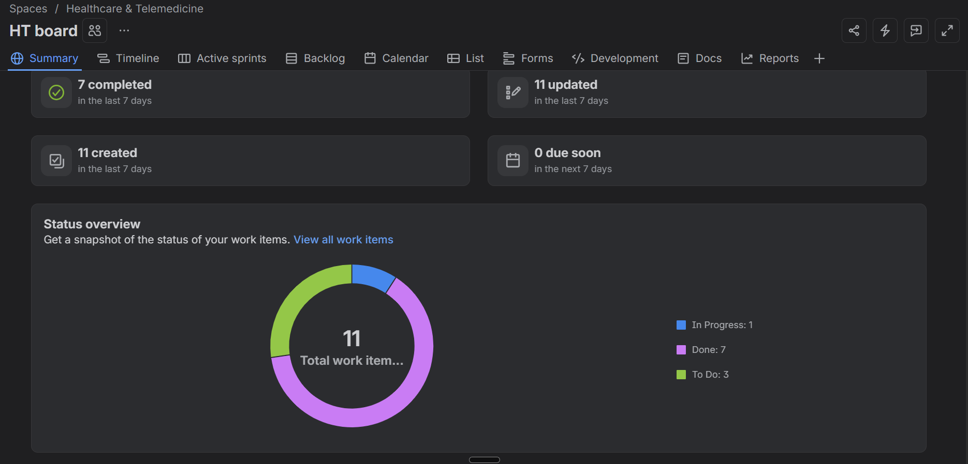
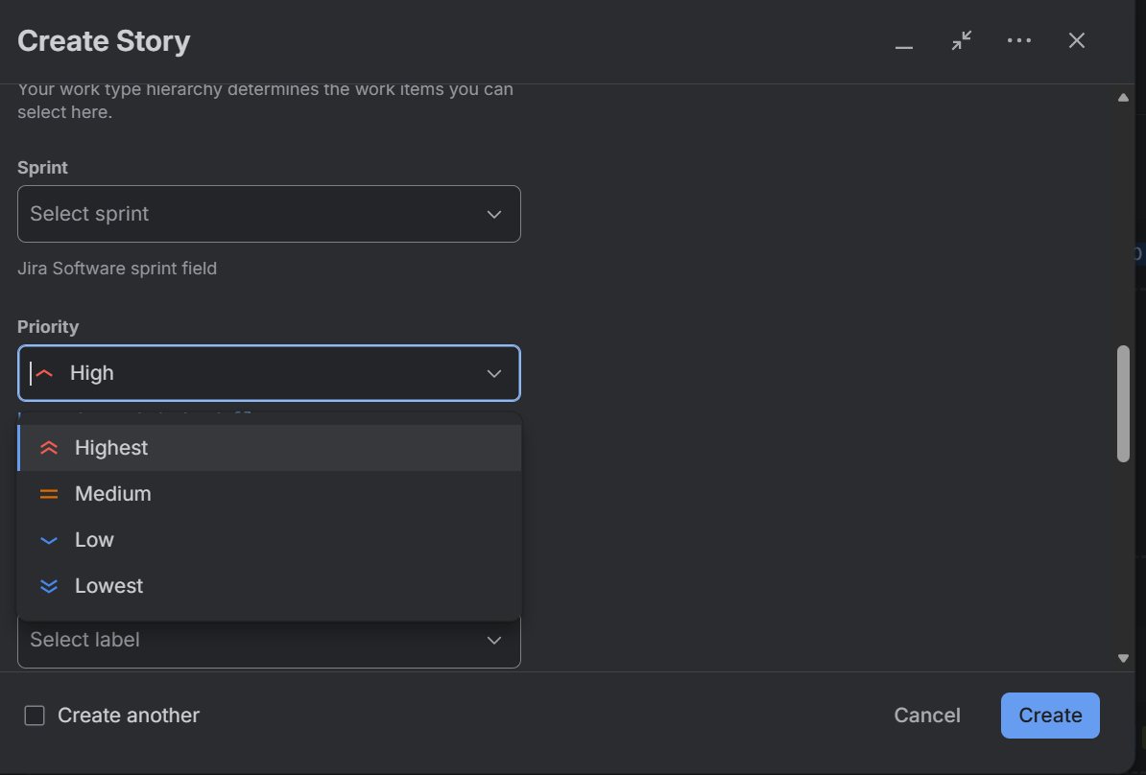
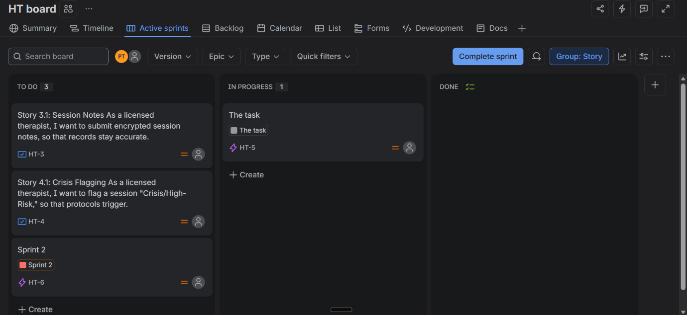
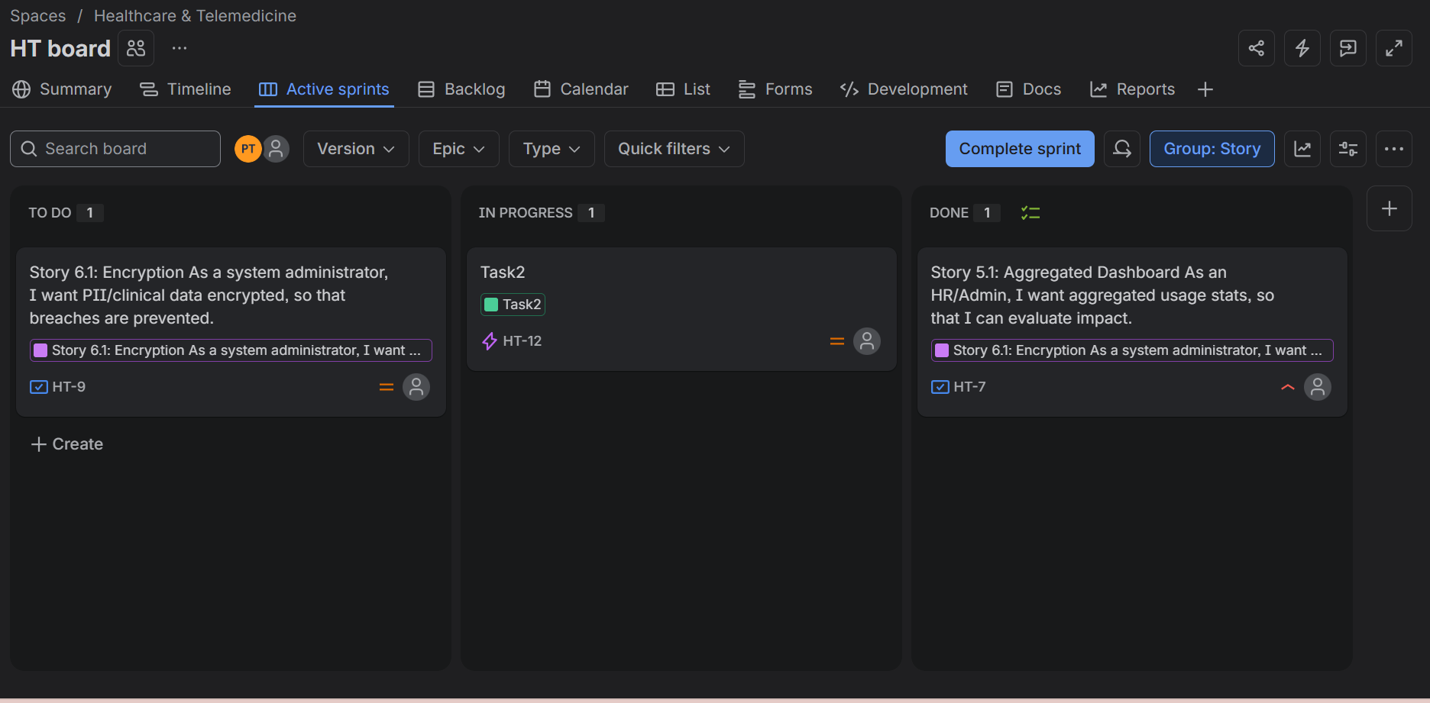
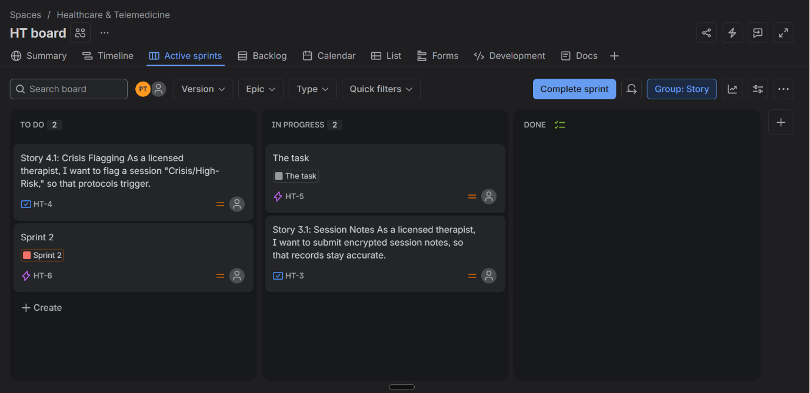

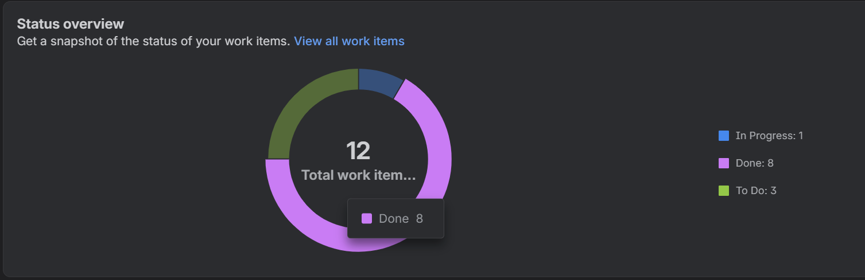
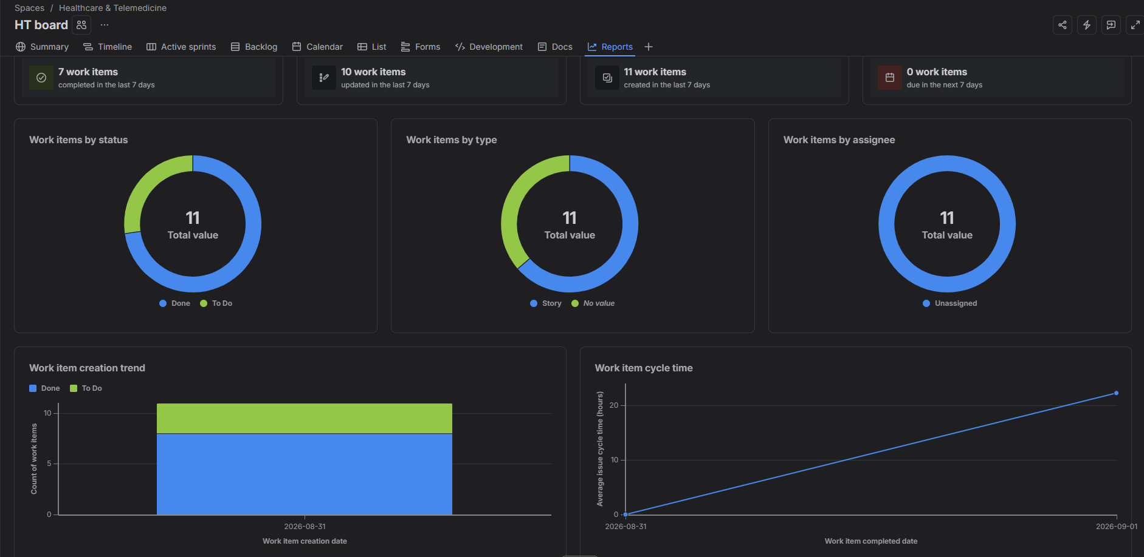
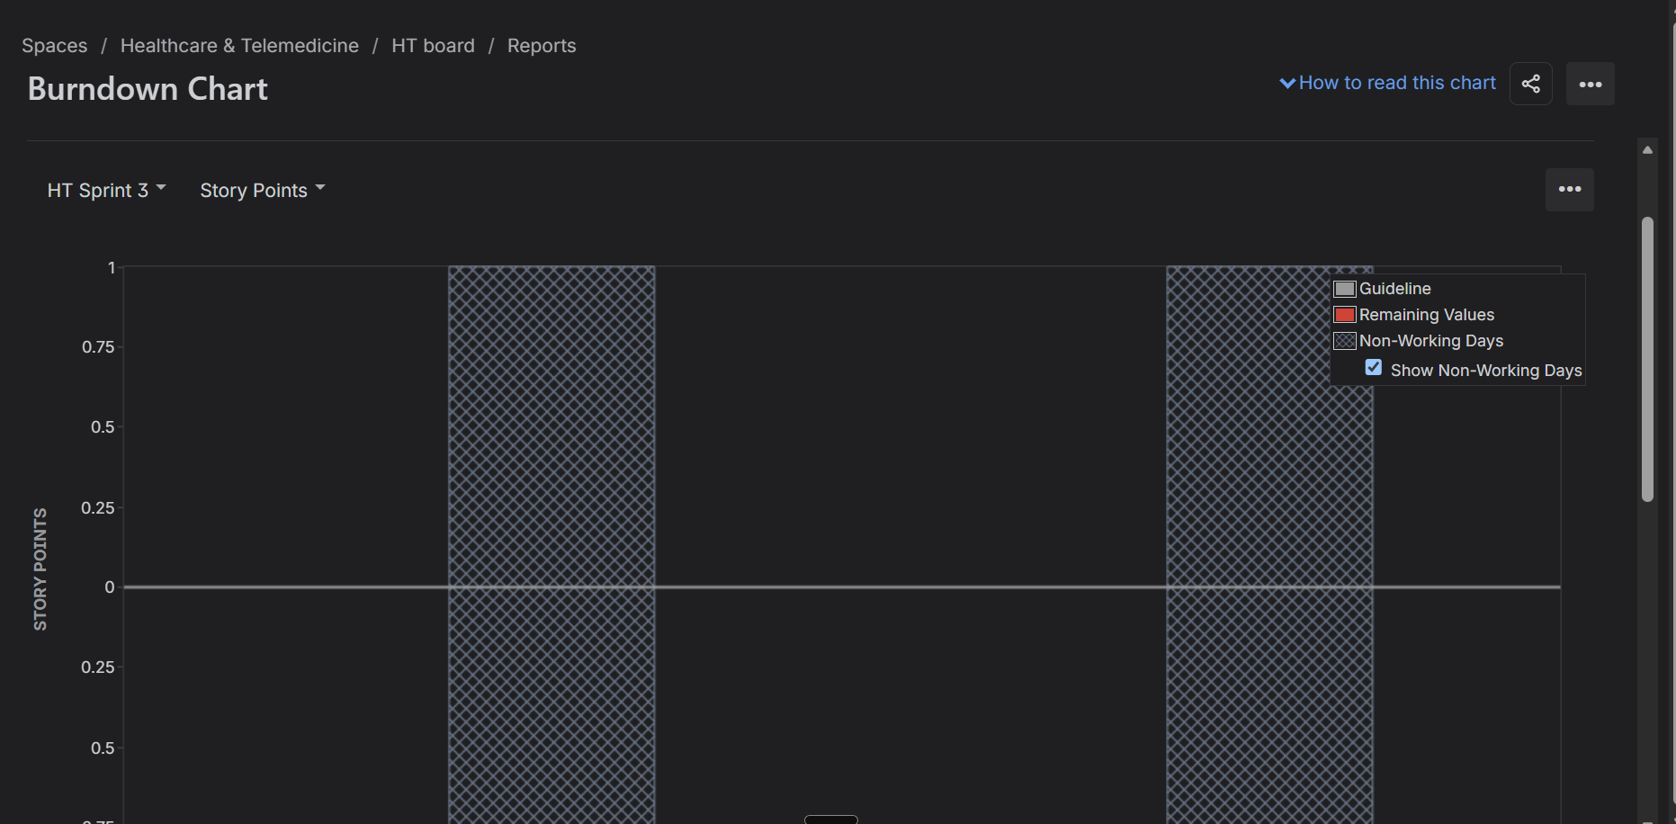
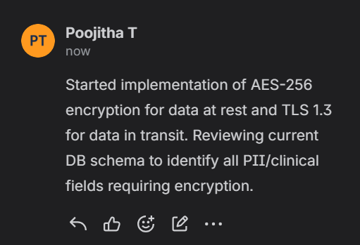

Corporate Mental Wellness & Counseling Platform — Epics & User Stories
Epic 1: Session Booking & Eligibility
Description: Lets employees search therapists and book confidential sessions after an eligibility check.
User Stories: | As a | I want to | So that
Story 1.1: Therapist Search | corporate employee | search therapists by specialization and availability | I find the right fit
Story 1.2: Session Booking | corporate employee | book a confidential session (video, audio, chat) | I use my preferred format
Story 1.3: Eligibility Verification | corporate employee | my quota checked before booking | I know if I must self-pay
Story 1.4: Double-Booking Prevention | corporate employee | only "Available" slots bookable | my session isn't double-booked
Epic 2: Counseling Session Delivery
Description: Provides a reliable platform for live sessions with fast connections and high uptime.
User Stories: | As a | I want to | So that
Story 2.1: Live Session Connection | corporate employee | sessions to connect within 5 seconds | care isn't delayed
Story 2.2: Platform Reliability | corporate employee | 99.9% uptime | I can rely on the platform
Epic 3: Clinical Documentation & Privacy
Description: Lets therapists securely document sessions while keeping notes confidential from HR.
User Stories: | As a | I want to | So that
Story 3.1: Session Notes | licensed therapist | submit encrypted session notes | records stay accurate
Story 3.2: Note Confidentiality | licensed therapist | notes visible only to me | confidentiality is protected
Epic 4: Crisis Escalation & Safety
Description: Ensures distressed employees get an immediate, logged safety-net response.
User Stories: | As a | I want to | So that
Story 4.1: Crisis Flagging | licensed therapist | flag a session "Crisis/High-Risk" | protocols trigger
Story 4.2: On-Call Notification | licensed therapist | the on-call contact notified within 2 minutes | help arrives fast
Epic 5: HR Wellness Analytics
Description: Gives HR visibility into usage via anonymized data only.
User Stories: | As a | I want to | So that
Story 5.1: Aggregated Dashboard | HR/Admin | aggregated usage stats | I can evaluate impact
Story 5.2: Anonymity Threshold | HR/Admin | groups under 5 employees suppressed | individuals stay anonymous
Epic 6: Data Security & Compliance
Description: Protects sensitive data through encryption and strict logging rules.
User Stories: | As a | I want to | So that
Story 6.1: Encryption | system administrator | PII/clinical data encrypted | breaches are prevented
Story 6.2: No Plaintext Logging | system administrator | session content never logged in plaintext | data stays secure

Planning Poker Introduction (Reflection):
For this lab, Planning Poker was simulated individually rather than with a live team, but the same estimation logic was applied to each user story before it was added to a sprint. For every story, the following questions were considered before assigning a Fibonacci point value: how many system components does this touch (booking engine, therapist calendar, notification service, encryption layer, etc.), how much uncertainty exists in the implementation, and how it compares in complexity to a story that was already estimated.
For example, "Therapist Search" was estimated at 3 points — a straightforward read/filter UI feature with low uncertainty. In contrast, "Eligibility Verification" was estimated at 5 points, since it requires real-time validation against a benefits/quota record and must correctly branch into a self-pay flow when quota is exhausted. Similarly, "Crisis Flagging" and "On-Call Notification" were rated 8 points each due to the added complexity of guaranteeing a time-bound (2-minute) escalation with no room for silent failure — a much harder reliability problem than a simple CRUD-style story like "Note Confidentiality" (2 points), which mainly involves a visibility/permission restriction.
This comparative, relative-sizing approach — anchoring new estimates against previously-estimated stories rather than guessing in a vacuum — is the core value Planning Poker provides, even outside a live group setting.

Group Reflection
Sprint 1 (7 stories, 27 points) focused on the core employee booking journey: searching for a therapist, verifying eligibility, booking a confidential session, and preventing double-booked slots, along with the initial encryption groundwork needed to support secure sessions. By the end of Sprint 1, 5 of 7 stories were fully Done, with 1 in Progress and 1 in Review — a completion rate of roughly 71%, close to the sprint's planned velocity.
Sprint 2 (6 stories, 21 points) carried forward the two unfinished items from Sprint 1 and added new stories: Crisis Flagging, On-Call Notification, Aggregated Dashboard, and No Plaintext Logging. By the end of Sprint 2, cumulative Done items rose from 5 to 9, with 1 story still In Progress (Platform Reliability) and 1 in Review (On-Call Notification).
What went well: Prioritizing high-priority, safety-critical stories (Eligibility Verification, Crisis Flagging, On-Call Notification) early in the backlog kept the team focused on features that protect both compliance and employee wellbeing before lower-risk items like analytics dashboards.
What could improve: A couple of stories (Platform Reliability, On-Call Notification) spilled across sprint boundaries rather than reaching Done within their original sprint — suggesting either the estimates were slightly optimistic, or these stories should have been broken into smaller sub-tasks (e.g. separating "escalation trigger logic" from "on-call contact notification delivery") to finish cleanly within a single sprint.
Takeaway: The burndown and status-overview data across both sprints show steady, incremental progress consistent with Agile's iterative delivery model — each sprint reduced the backlog while surfacing realistic friction points (spillover, estimation accuracy on time-bound reliability features) that a real team would address in a sprint retrospective.

