Week-4.1
2303A51304
Batch-05

Task-01: Student Attendance Analysis Using Fenwick Tree
Code:
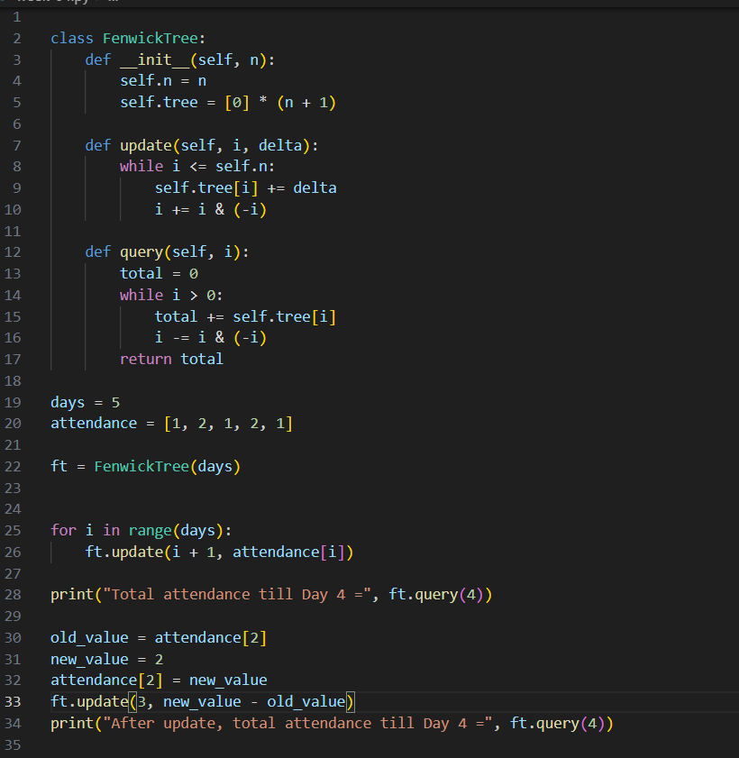

Output:
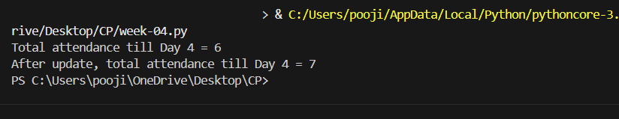

Task-02: Daily Sales Revenue Analysis Using Fenwick Tree
Code:
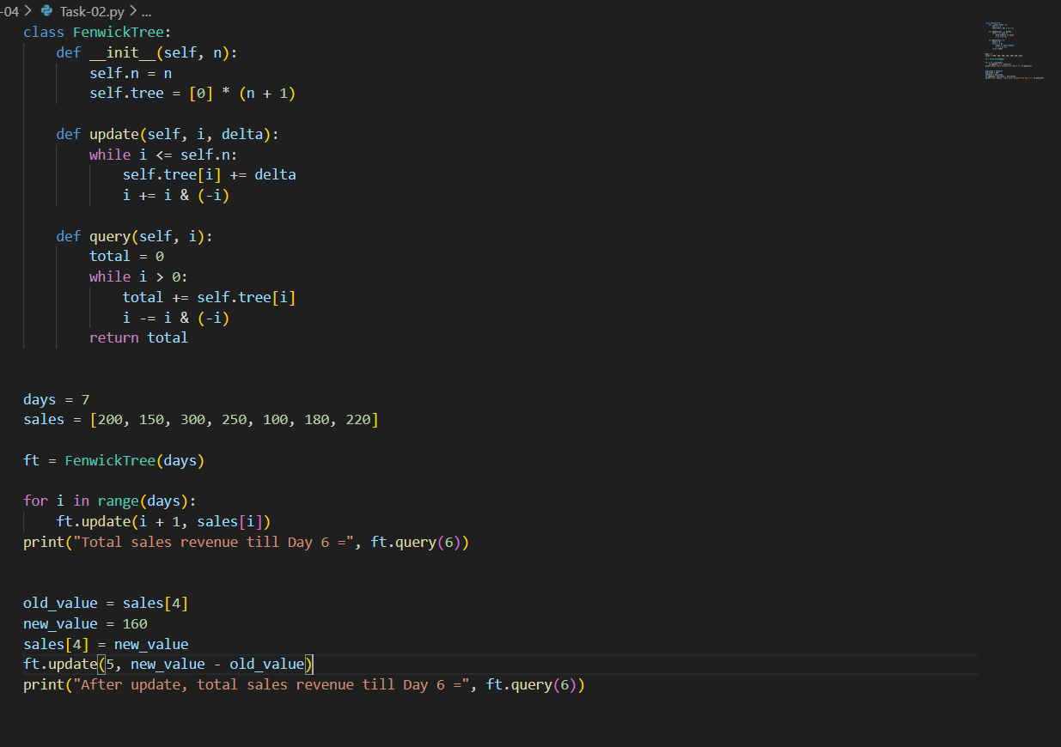

Output:
