Model-5: Hybrid Routing.
- Routing depends on multiple metrics like Distance, congestion, Queue length - - -.
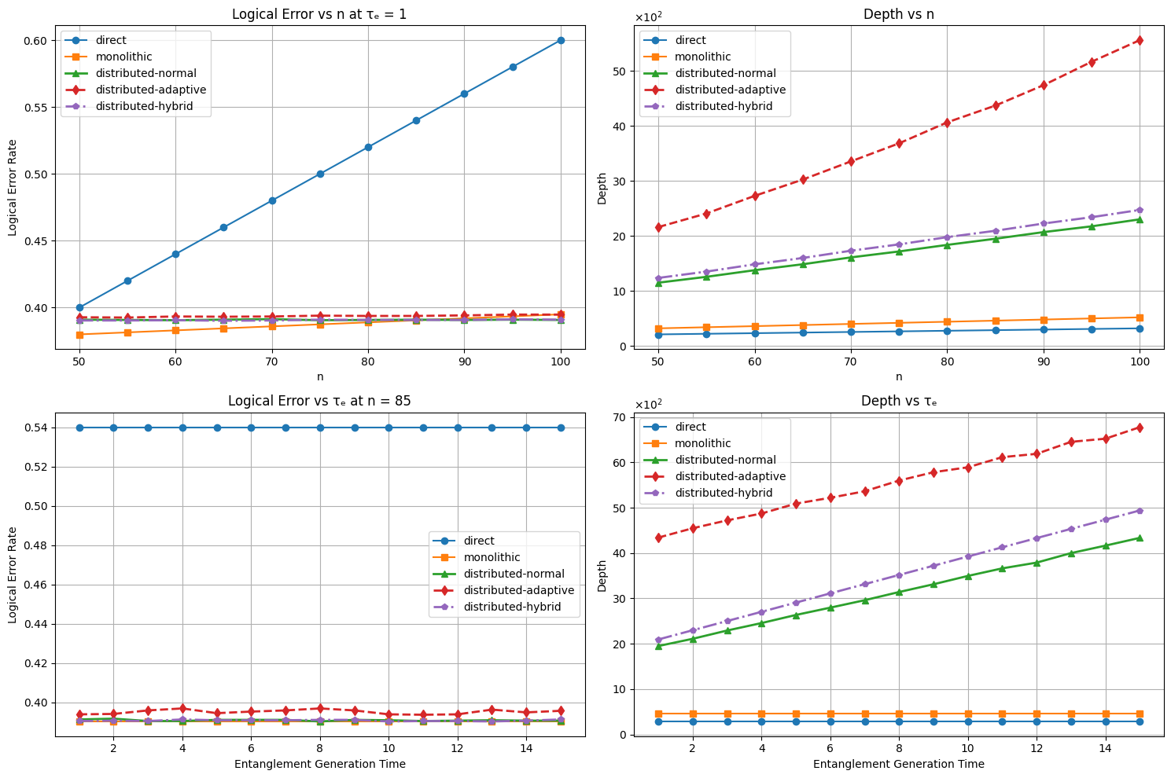
Model-6: TOYTIAO Model [ control layer optimization ].
Scheduling and excecuting communications efficiently using multiplexing.
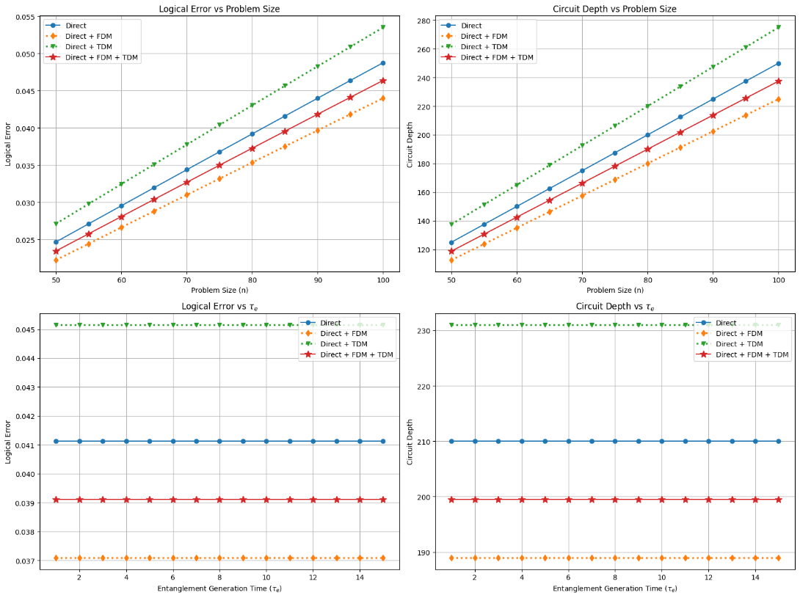
a)FDM vs TDM vs FDM + TDM - Direct

b)FDM vs TDm vs FDM + TDM - Monolithic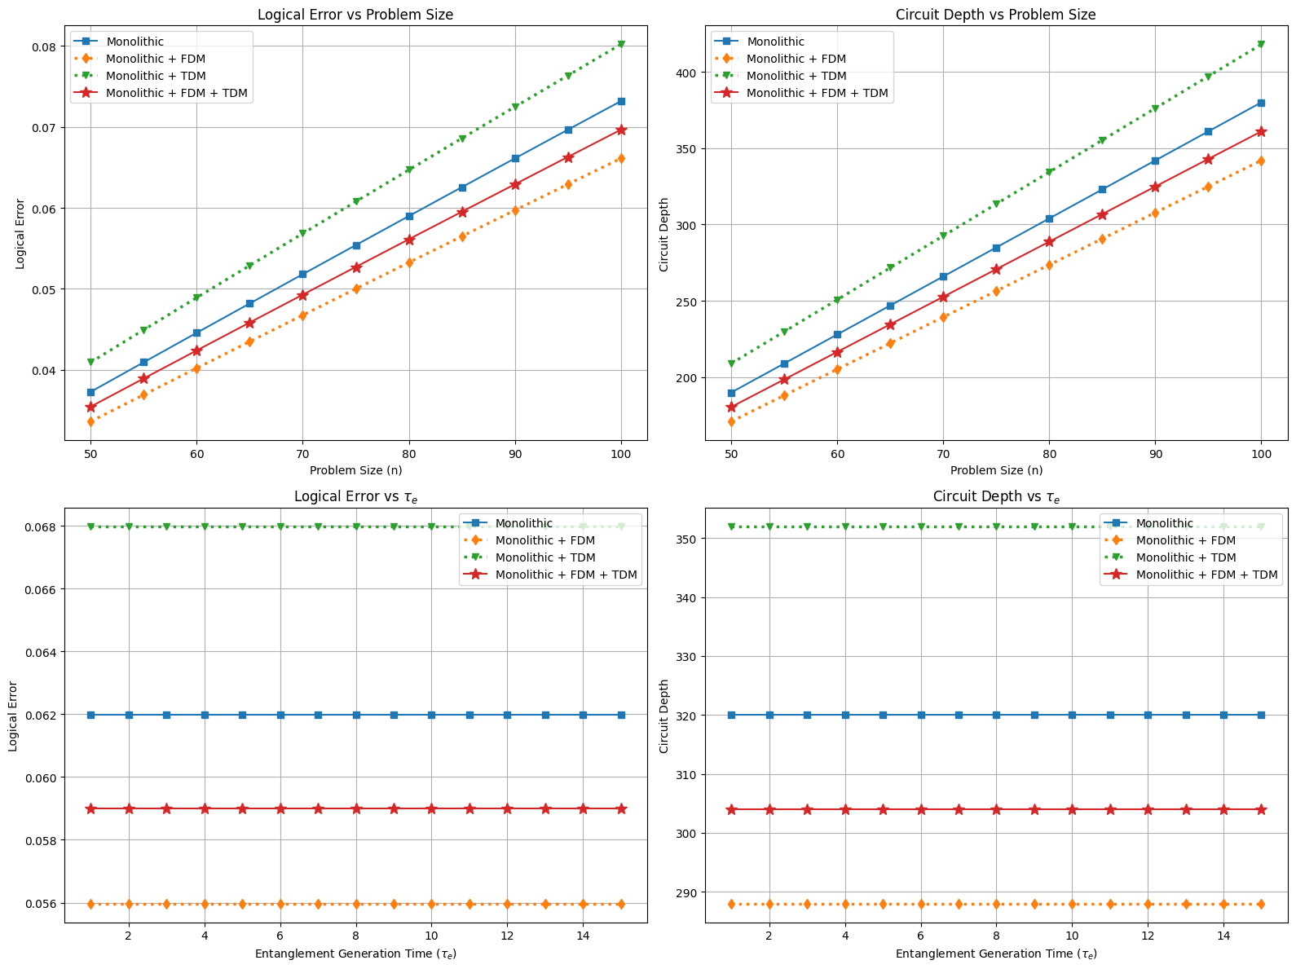
c)FDM vs TDm vs FDM + TDM – Distributed
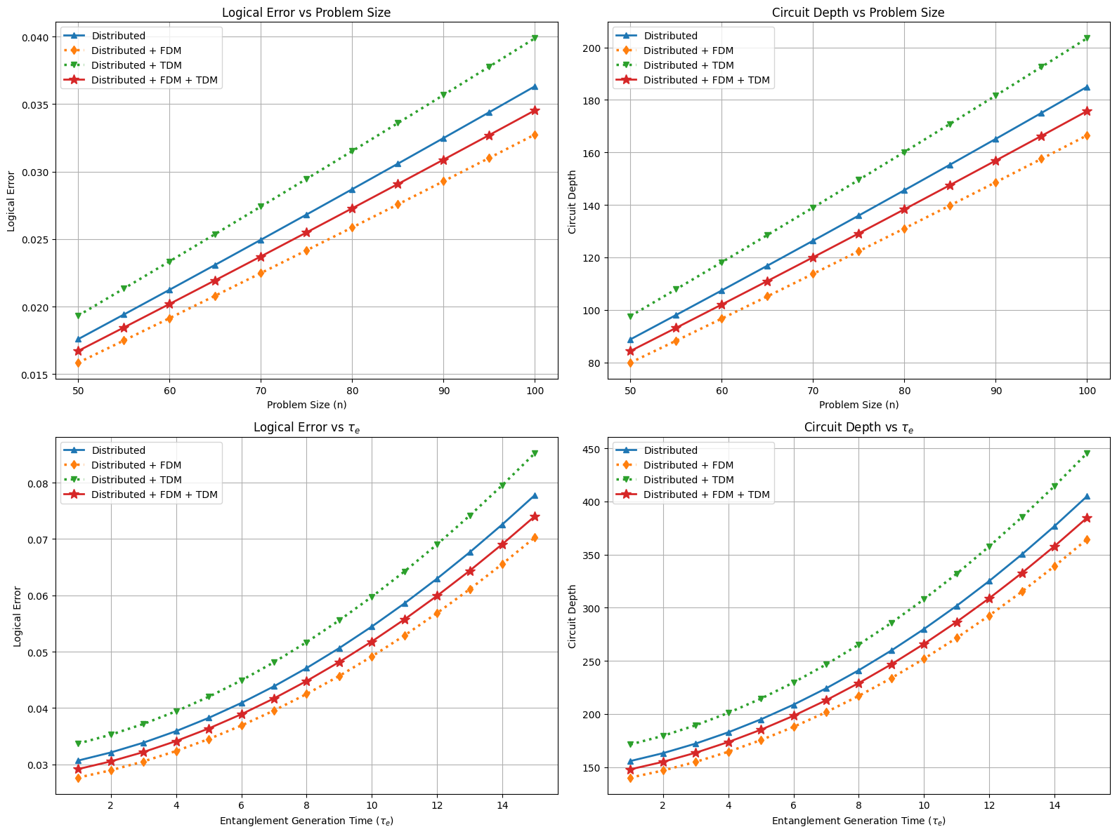
d)direct vs Monolithic vs Distributed
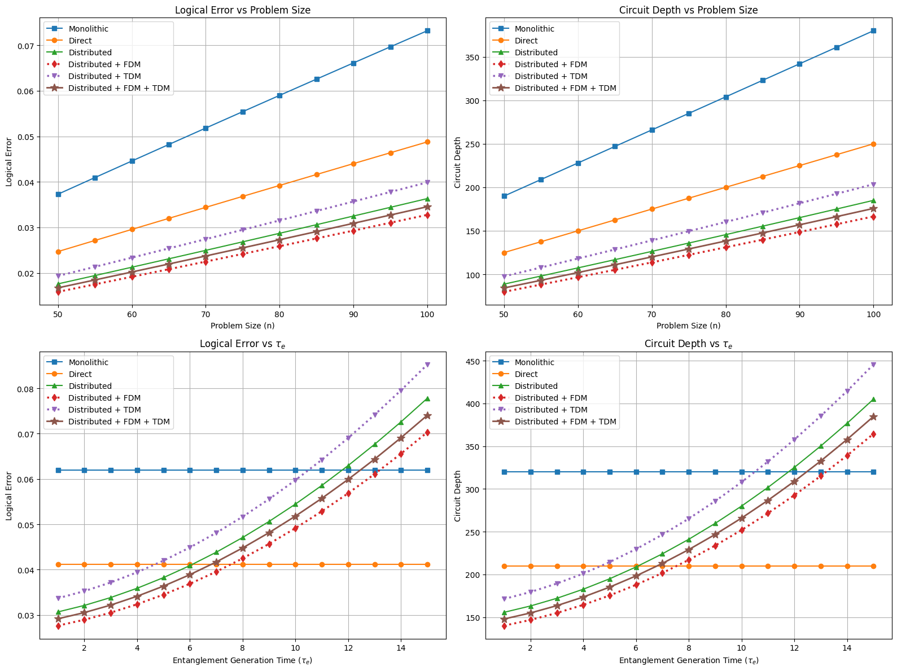
Model – 7: SwitchQnet + Ionq
- Implemented the IonQ distributed Quantum computing with switchQnet inspired routing.
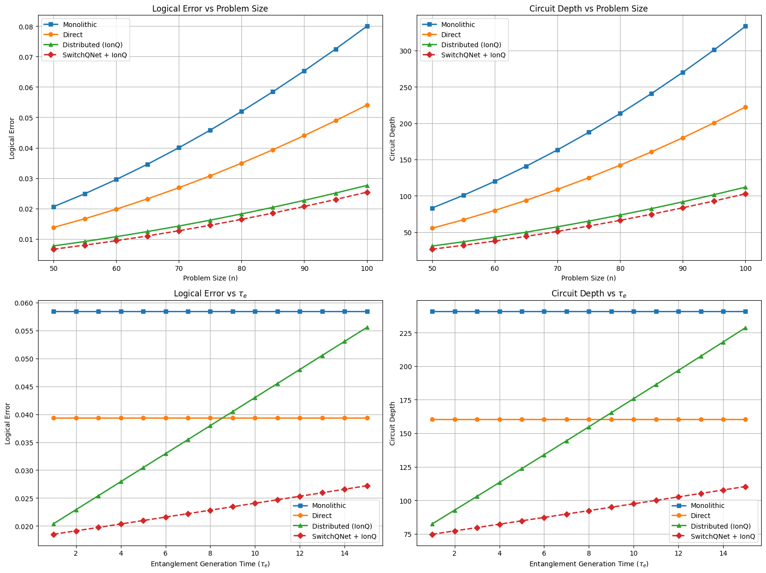

Model -8: Stim + partitioning
- Used stim inspired noise modeling [gate errors, communication errors ]
- Divide into smaller circuit and distributed among QPUs based on communication between Qubits.
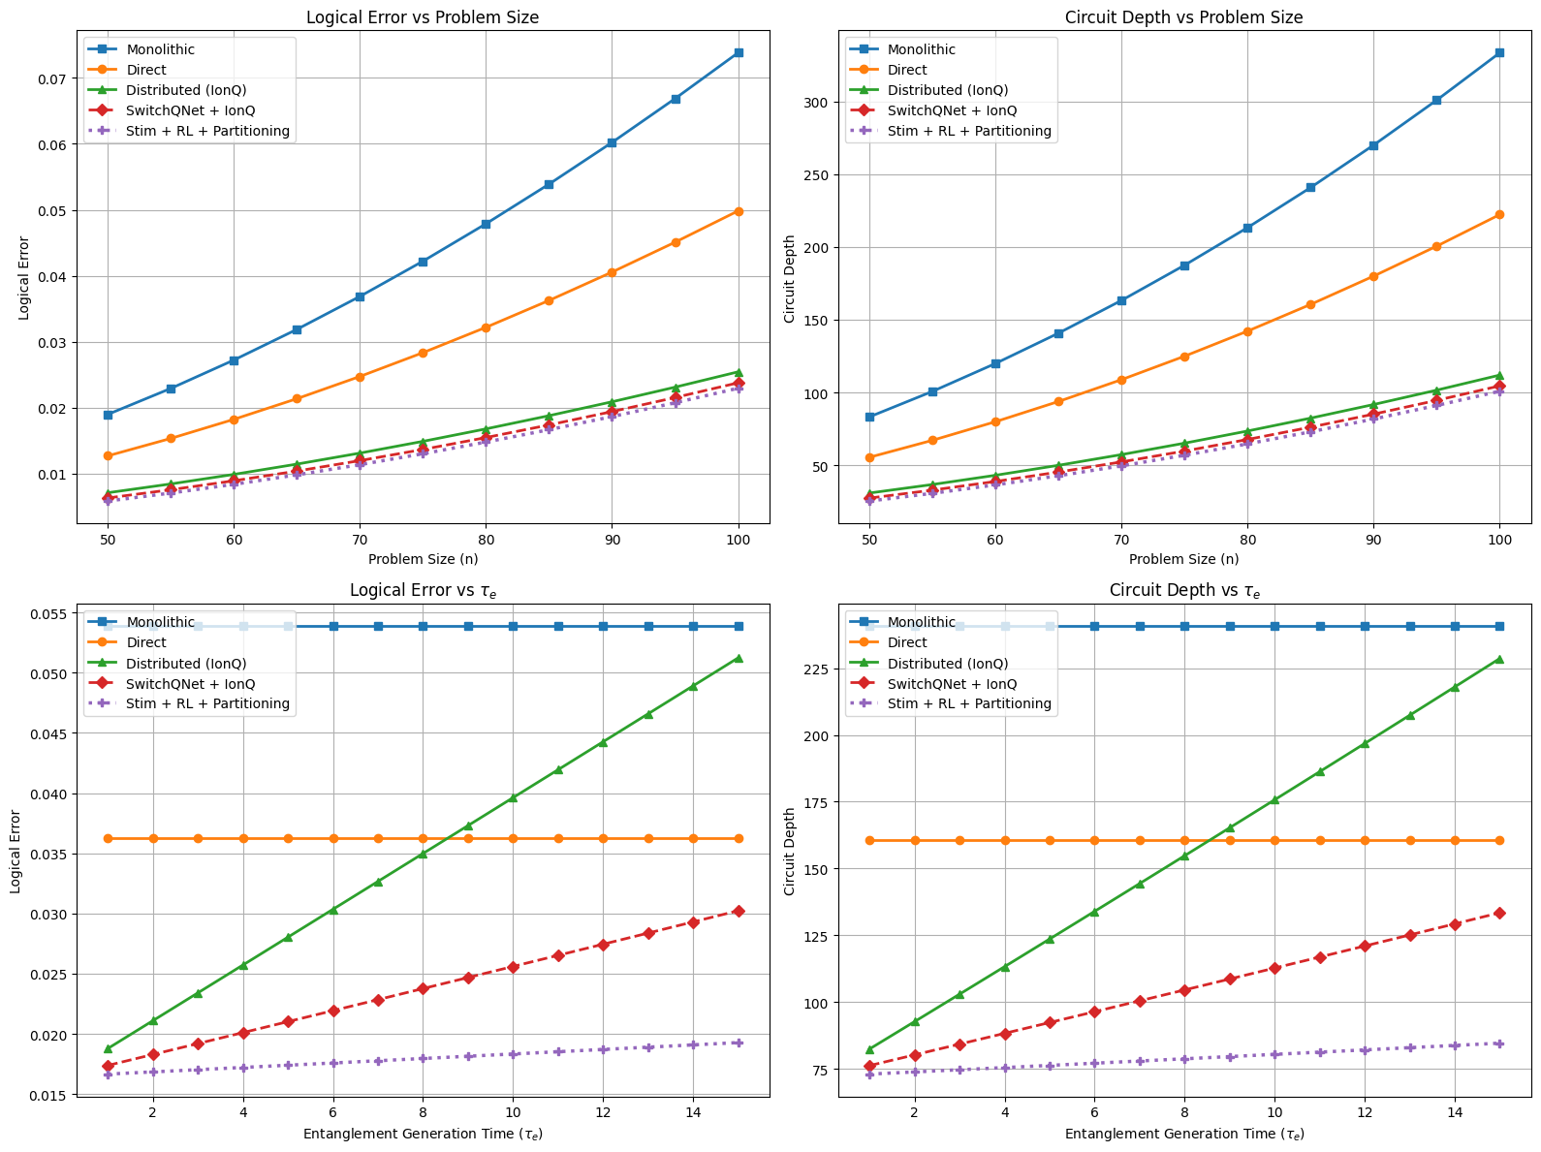

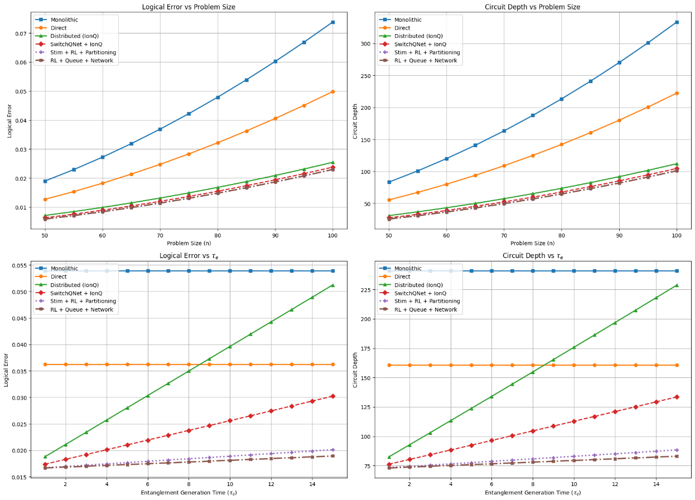
Model – 9: Queueing + congestion modeling

