Implementation of Fast Interconnects:
A)Fast Interconnects by Reducing the EPR Generation Time:
Proposed Idea:
A speed factor $γ$is introduced to model faster quantum interconnects.
The effective entanglement generation time is:
$$τ_{eff}=\frac{τ_{e}}{γ}$$
where:
- $τ_{e}$= original entanglement generation time
- $γ$= interconnect speed factor
- $τ_{eff}$= effective entanglement generation time

B)Bandwidth based Fast-interconnect Model:
Proposed Idea:
Instead of decreasing the Te, we will go for Multiple EPR pair generation at a time.

Difference:
In Model A, we are generating one EPR pair at a time but the speed of generation differs. So, EPR pairs are generated and distributed fast and exhibits the nature of fast interconnects.

In Model B, we are not decreasing the Te but we are generating Multiple EPR pairs at a time. So, Many EPR pairs are available and computation wil be fast which exhibits the nature of fast interconnects
Speed Factor plots:
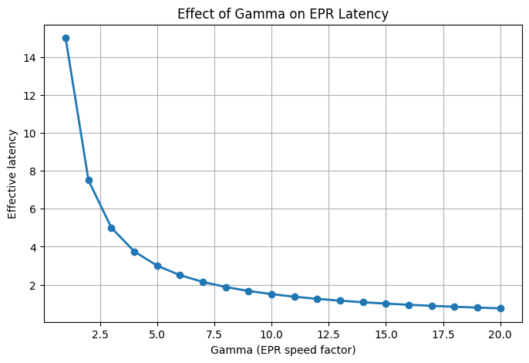

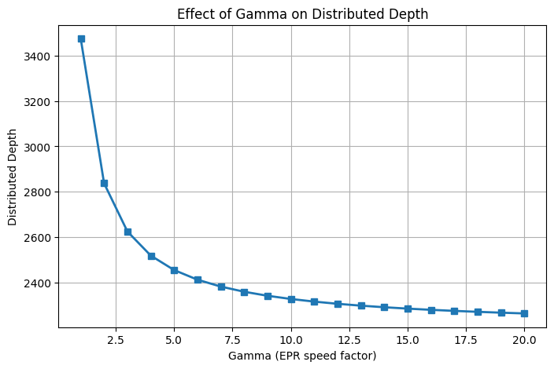
Performance of Fast Interconnects:
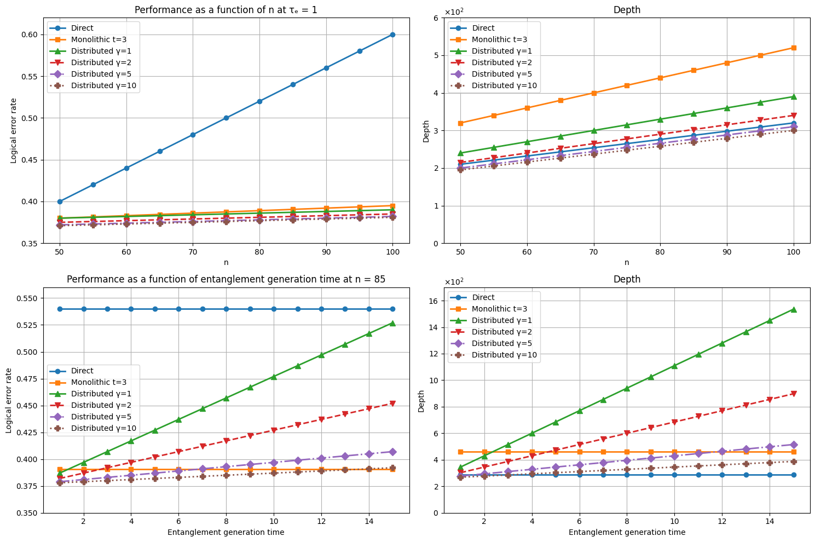

Ionq with Fast Interconnects using Ring topology:

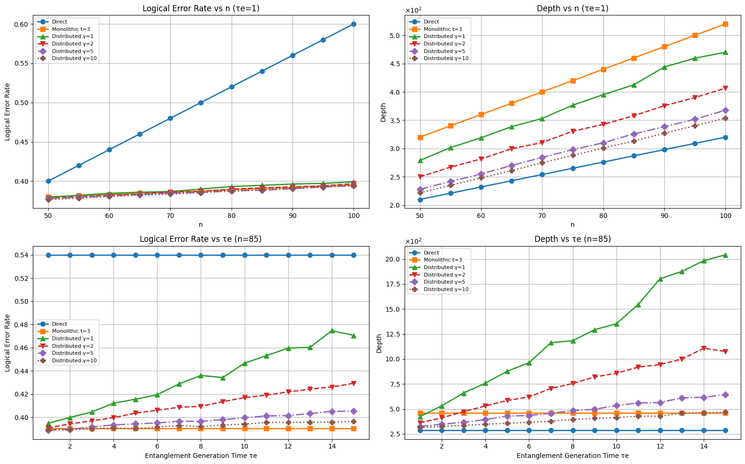

Ionq with fast interconnects using grid topology:
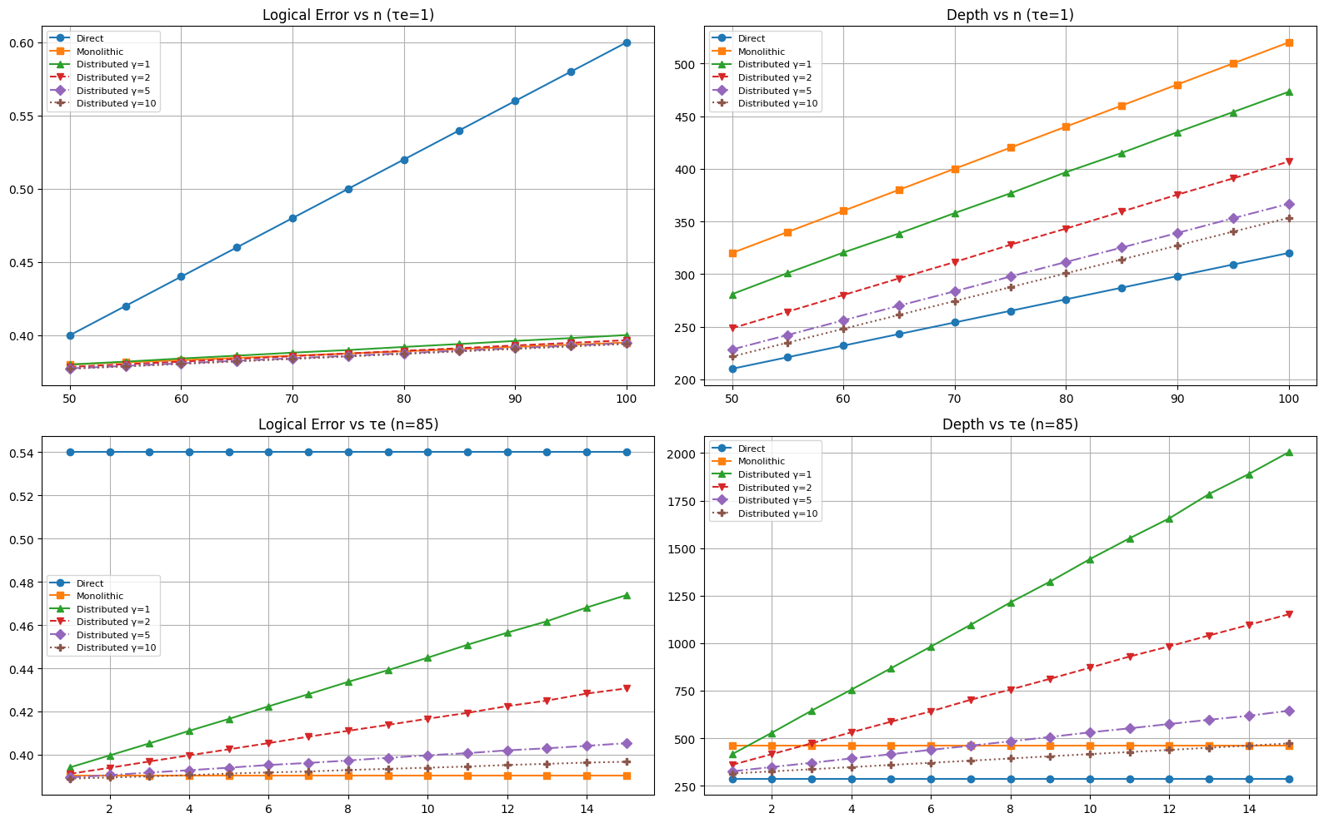

Slow interconnects vs Fast interconnects
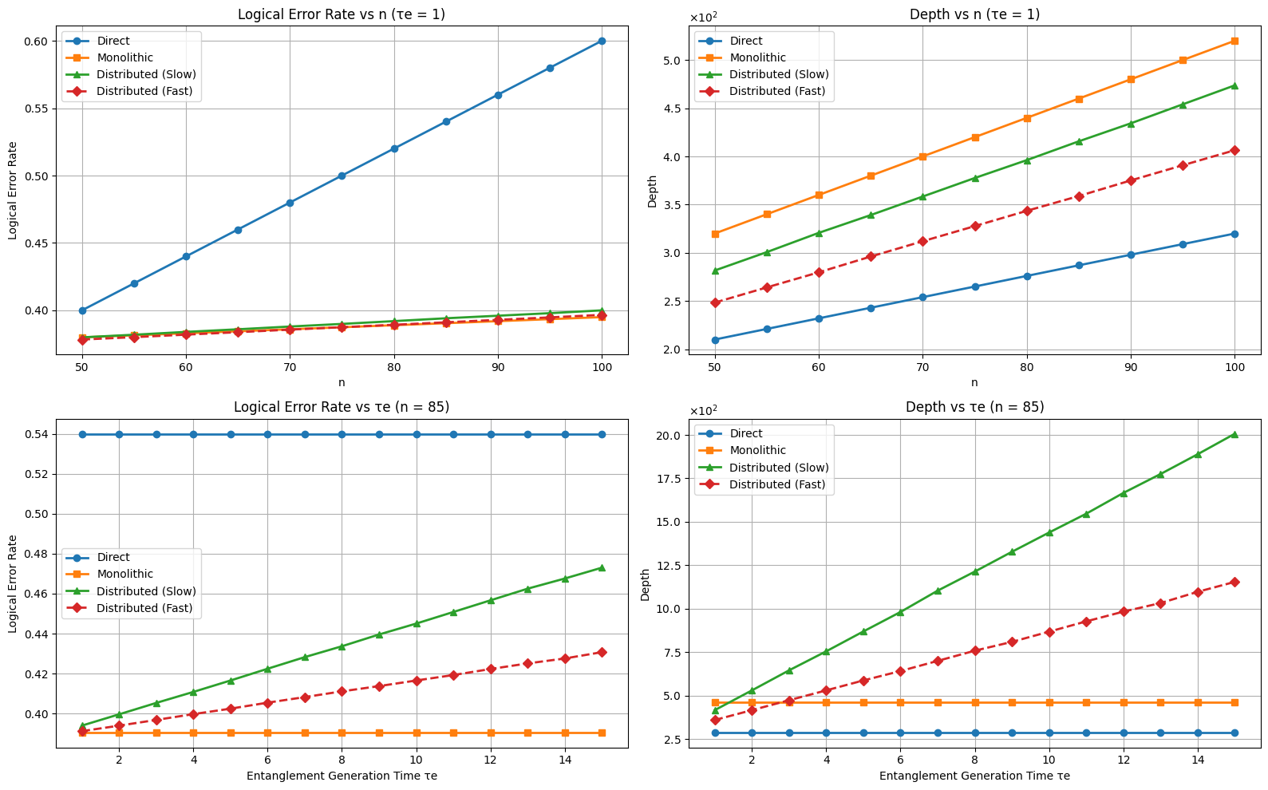

Fast interconnects + SwitchQNet inspired Routing:
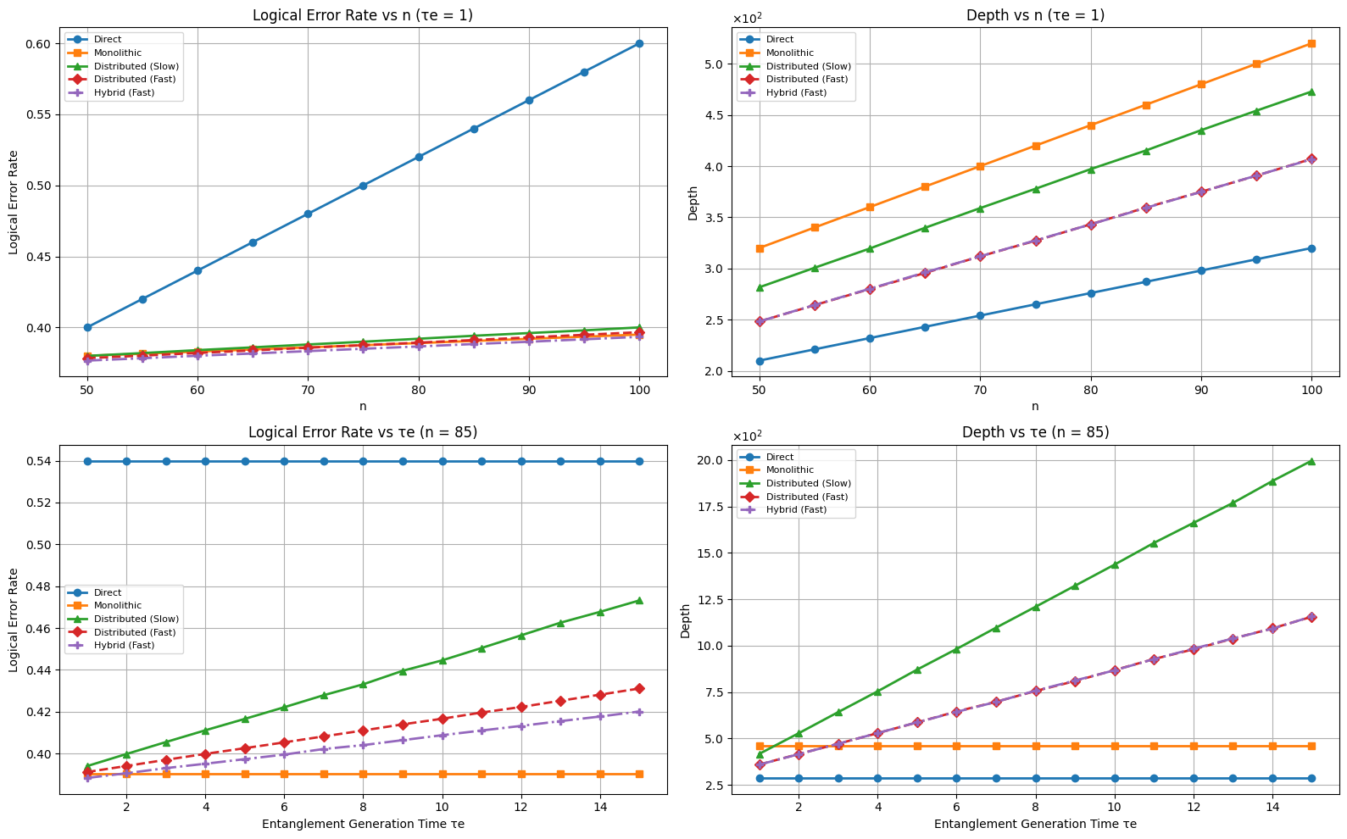

Fast Interconnects with Hybrid Multiplexing
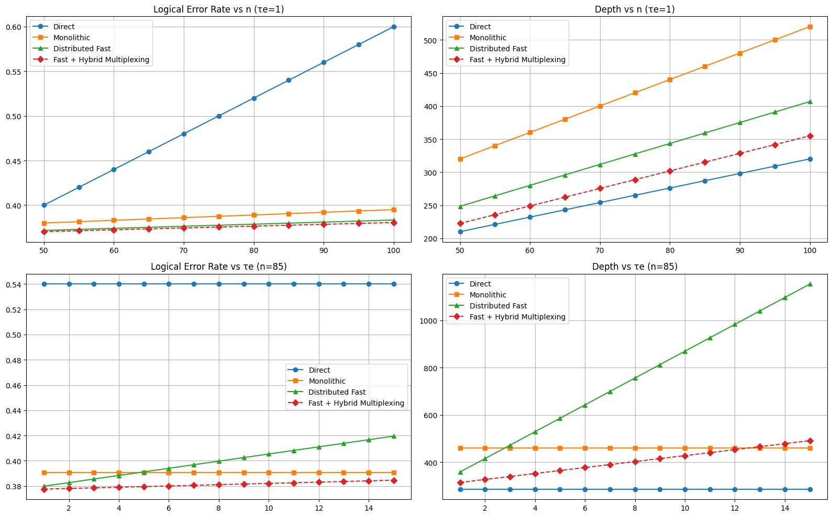

This week:
Model B Bandwidth model.

