Scalable

Distributed Quantum Computers

Using

Slow Interconnects

Introduction
Quantum Computers that are available today are termed as Noisy Intermediate Scale Quantum Computers [ NISQ ] because they typically contain tens to few hundreds of qubits only and are affected by noise, decoherence, errors. Because of these limitations, NISQ devices cannot be useful in executing large and complex quantum algorithms which require very large number of qubits.

Although increasing the number of qubits seems like a straightforward solution, building a single processor incorporated with large number of qubits is extremely challenging due to hardware constraints, increated error rates, maintaining fidelity.

To overcome this problem, Distributed Quantum computing DQC has emerged as a promising approach where, instead of building one large quantum processor, multiple small QPUs are connected through quantum interconnects allowing them to work as a single larfe system.

For computation, local operations are executed within each QPU but Quantum communication is necessary for the interactions between qubits located in different QPUs.

Unlike local quantum gates, inter-QPU communication depends on generating and consuming Bell Pairs [ entangled qubit pairs ]. This bell pair generation is significantly slower than local gate execution and the communication becomes the primary bottleneck in DQC.

Therefore, improving the efficiency of inter-QPU communication is essential for achieving scalable distributed quantum computing. To optimize the communication, we developed a nine-model communication framework.

Results
Model-1: IonQ inspired baseline model
- Fixed Ring topology with 4 QPUs
- No routing optimization
- Slow interconnect communication model
- Architechtural comparision
- Hop-based communication delay

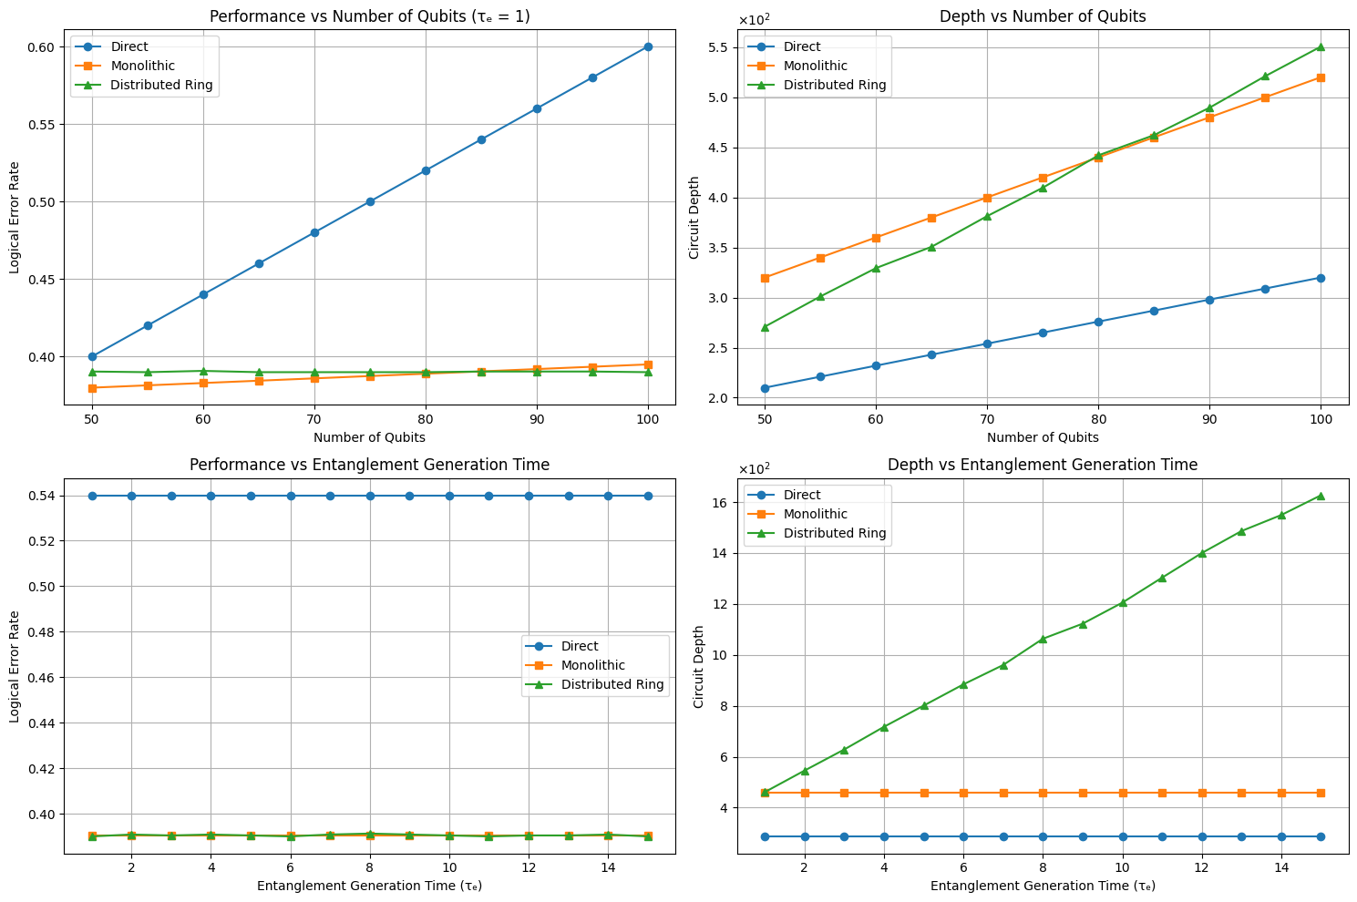
Analysis:
Plot-1 : n vs logical error rate
- Logical error rate increases with n in direct implementation
- Monolithic implementation achieves lowest logical error.
- Distributed Ring performs close to monolithic and performs better than monolithic as n increases.

Plot-2 : n vs circuit depth
- Depth increases with increase in n [circuit size] in all implementations.
- Direct shows lowest circuit depth due to absence of communication overhead.
- Monolithic has highest depth because of additional processing overhead within single large QPU
- Distributed ring has lower depth than monolithic but increases with circuit size and rate of increase is more compared to monolithic.
- As number of qubits increases, more remote communication required. Hence communication overhead increases and depth also increases.

Plot – 3: Entanglement generation time vs logical error rate
- Direct and monolithic implementations remain unaffected by Entanglement generation time as no EPR pairs are required.
- Monolithic and distributed ring exhibit nearly identical logical error rates and increasing T_{e} shows negligible effect.

Plot – 4: entanglement generation time vs circuit depth
- direct and monolithic implementations maintain constant circuit depth.
- Distributed ring implementation shows a steady increase in circuit depth with increse in T_{e.}
- Higher T_{e} increases the communication delay between QPUs and longer communication delays increase the overall circuit execution time.

Model – 2: Grid Topology
- 2 x 2 grid topology with 4 interconnected QPUs.
- Topology aware communication
- Slow interconnect communication model
- Architectural comparision between direct, monolithic and Distributed grid
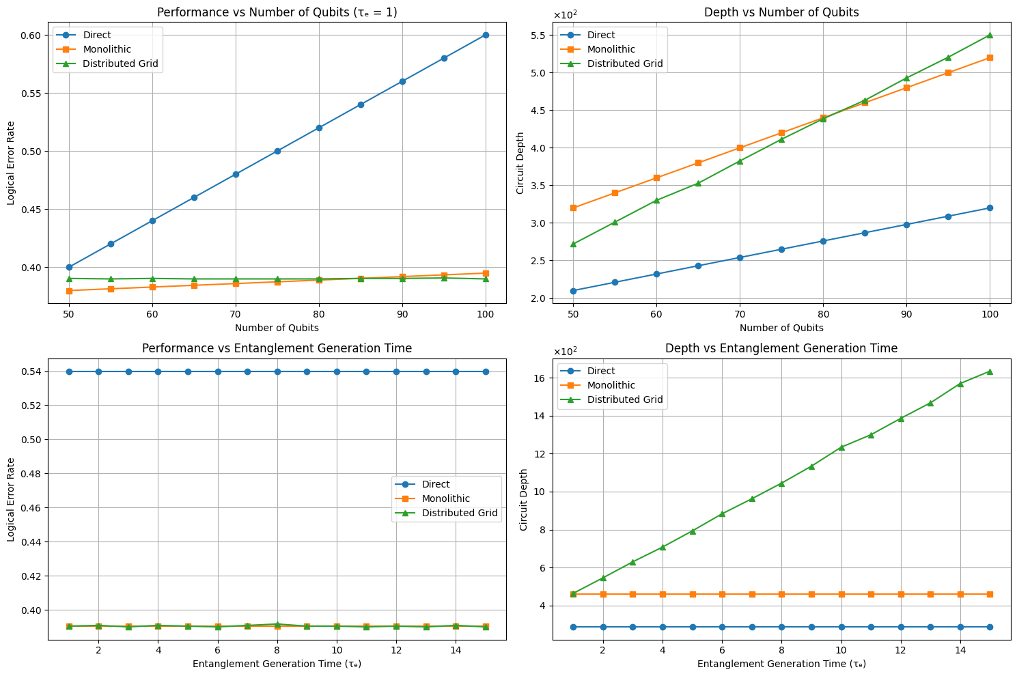
Analysis:
The Grid topology exhibits behavior similar to the Ring topology under the current simulation settings.
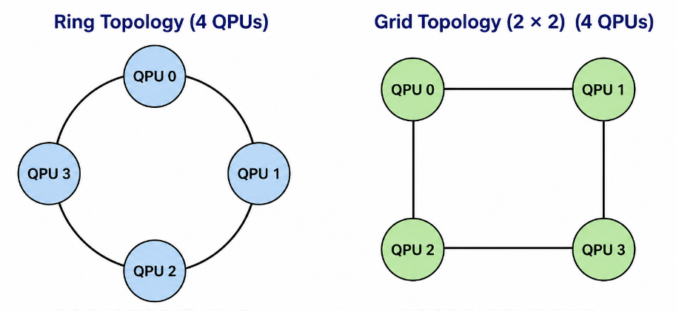

Model – 3: Grid topology + control-line routing
- 2 x 2 grid topology with neighbouring QPUs connected.
- Manhattan distance based communication for inter-QPU communication.
- Control-line communication model
- Hardware-aware communication delay.
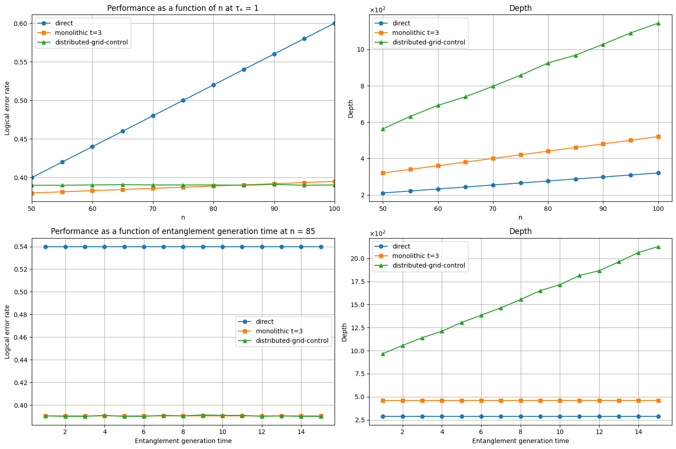

Analysis:
Plot – 2: n vs Depth
- Circuit depth increases with the number of qubits for all implementations.
- The Distributed Grid-Control implementation exhibits the highest circuit depth.
- XY gate, Z tuning, and readout operations add additional hardware control overhead.
- Communication and hardware control delays accumulate as the circuit size increases.
- Hardware control overhead becomes a significant contributor to circuit depth.
Plot – 4: T_{e} vs Depth
- The Direct and Monolithic implementations maintain constant circuit depth.
- The Distributed Grid-Control implementation shows a significant increase in circuit depth with increasing $τ_{e}$.
- Larger entanglement generation times increase the communication delay between QPUs.
- Hardware control operations further increase the total execution time.
- Communication and control overhead dominate the circuit depth in the distributed implementation.

Ring vs Grid for 4 – QPUs
