HOUSEHUNT
Project Documentation
MERN Stack (MongoDB, Express.js, React.js, Node.js)
Team members:
Team Member | Responsibility
Leela Prasad Molleti | MVC Pattern, Backend Development
Bhargavi Sura | Client Setup, Models, Frontend Development
Vandana Kumari | ER Diagram, Roles, Frontend Structure
Shaik Siraj | Technical Architecture, Backend, MongoDB
Jayanth Kumar Rapaka | User Flow, Server Setup, Demo, Features

1. Introduction
HouseHunt is a full-stack web application developed using the MERN (MongoDB, Express.js, React.js, and Node.js) technology stack to simplify and modernize the process of renting residential properties. The application provides a centralized platform where tenants can search for suitable rental houses, landlords can list and manage their properties, and administrators can monitor users and maintain platform integrity. The primary objective of HouseHunt is to eliminate the challenges associated with traditional house rental methods by offering an efficient, transparent, and user-friendly digital solution.
The application enables tenants to browse available properties using advanced search filters such as location, rent range, property type, and amenities. Landlords can securely register, upload property details, edit listings, and manage booking requests. An administrator oversees the platform by verifying owner accounts and ensuring the authenticity of property listings.
The frontend of the application is developed using React.js, providing a responsive and interactive user interface. The backend uses Node.js and Express.js to implement RESTful APIs, while MongoDB serves as the database for storing user accounts, property information, and booking details. JWT-based authentication and role-based authorization ensure secure access to protected resources.
HouseHunt demonstrates the practical application of full-stack web development principles and offers a scalable foundation for future enhancements such as online rent payments, AI-based property recommendations, and real-time communication between tenants and landlords.

2. Project Overview

Purpose
HouseHunt is designed to provide a modern digital platform that connects tenants, landlords, and administrators within a single rental ecosystem. The application simplifies property discovery and management by allowing users to access accurate property information, submit booking requests, and manage rental listings from any location.
The platform aims to reduce the time and effort required to find rental properties while providing a secure and transparent environment for property transactions.

Objectives
- Develop an online house rental platform.
- Enable secure registration and login.
- Allow landlords to publish rental properties.
- Allow tenants to search and request properties.
- Provide booking management.
- Ensure secure authentication using JWT.
- Build a responsive web application using React.
- Store application data using MongoDB.

Key Features
- User Registration & Login
- Property Listings
- Property Search & Filtering
- Property Details
- Booking Requests
- Owner Verification
- Property CRUD Operations
- Responsive User Interface
- Secure Authentication
- MongoDB Integration

3. Architecture:
The HouseHunt application follows a three-tier client-server architecture developed using the MERN (MongoDB, Express.js, React.js, and Node.js) stack. The architecture separates the application into three major layers: the Presentation Layer (Frontend), Business Logic Layer (Backend), and Data Layer (Database). This modular approach improves maintainability, scalability, and security while allowing independent development of each layer.
The frontend, developed with React.js, provides an interactive user interface where users can browse properties, manage accounts, and perform rental-related operations. The backend, built with Node.js and Express.js, processes client requests, applies business logic, and communicates with the MongoDB database. MongoDB stores all application data, including user information, property details, booking requests, and authentication data.
The frontend and backend communicate using RESTful APIs. Axios is used to send HTTP requests from the client to the server, while JWT (JSON Web Token) provides secure authentication and authorization. The overall architecture enables efficient communication between different components and provides a smooth user experience.

3.2 Frontend Architecture
The frontend of HouseHunt is developed using React.js, which follows a component-based architecture. Each page of the application is divided into reusable components, making the code modular and easier to maintain. React Router is used for navigation between pages, while Axios handles communication with backend APIs.
Bootstrap and Material UI are integrated to provide responsive layouts and attractive user interface components. This ensures that the application works seamlessly across desktops, tablets, and mobile devices.
The frontend contains several functional pages, including:
- Home Page
- Login Page
- Registration Page
- Dashboard
- Property Listing Page
- Property Details Page
- Add Property Page
- Edit Property Page
- User Profile Page
Each component interacts with the backend through REST APIs, receives JSON data, and dynamically updates the interface without refreshing the page.

Advantages of React.js
- Component-based development
- Fast rendering using Virtual DOM
- Reusable UI components
- Easy state management
- Responsive user experience
- Simplified routing and navigation

3.3 Backend Architecture
The backend is developed using Node.js and Express.js, which together provide a scalable and efficient server-side environment. Express.js manages routing, middleware, and REST API endpoints, while Node.js handles asynchronous request processing.
The backend follows the MVC (Model–View–Controller) architecture to separate responsibilities and improve code organization.
The backend is responsible for:
- User authentication
- Property management
- Booking management
- Owner verification
- Image upload handling
- Database operations
- Validation and error handling
Middleware components are used to authenticate users with JWT, authorize access based on user roles, and process uploaded property images.

3.4 Database Architecture
MongoDB is used as the NoSQL database for HouseHunt. Data is stored in collections and managed through Mongoose models.
The primary collections include:

Users Collection
Stores user-related information such as:
- User ID
- Name
- Email
- Phone Number
- Password (Encrypted)
- User Role (Tenant, Owner, Admin)

Properties Collection
Stores property information:
- Property ID
- Title
- Description
- Address
- Rent Amount

Bookings Collection
Stores booking requests:
- Booking ID
- Tenant ID
- Property ID

Booking History Collection
Maintains a record of previous booking transactions for future reference.
The database design ensures efficient retrieval and management of information while maintaining data integrity.

4. Setup Instructions:
The HouseHunt application is developed using the MERN (MongoDB, Express.js, React.js, and Node.js) technology stack. Before running the application, all required software dependencies must be installed and configured correctly. The project follows a client-server architecture, where the frontend and backend run independently and communicate through RESTful APIs.
4.1 Prerequisites
Ensure that the following software is installed on your system before setting up the project:
Software | Version | Purpose
Node.js | Latest LTS | JavaScript Runtime Environment
npm | Latest | Package Manager
MongoDB Community Server / MongoDB Atlas | Latest | Database
Visual Studio Code | Latest | Source Code Editor
Git | Latest | Version Control
Google Chrome | Latest | Browser for Testing

5. Folder Structure:
The HouseHunt application is organized into separate Client and Server directories, ensuring modularity and maintainability.
5.1 Client Folder Structure:
Client │
├── public
├── src
│ ├── components
│ ├── pages
│ ├── assets
│ ├── services
│ ├── App.jsx
│ ├── main.jsx
│ └── index.css
│
└── package.json
Description
- components – Reusable UI components such as Navbar and Footer.
- pages – Application pages including Home, Login, Register, Dashboard, Add Property, Property Details, and Profile.
- assets – Images, icons, and static resources.
- services – API communication using Axios.
- App.jsx – Main application component.
- main.jsx – Entry point of the React application.

6. Running the Application:
After completing the installation and configuration process, the frontend and backend servers can be started independently.

Step 1: Start MongoDB
If using the local MongoDB server, ensure that the MongoDB service is running.
If using MongoDB Atlas, verify that the connection string in the .env file is correct.

Step 2: Start the Backend Server
Navigate to the Server directory.
cd Server

7. API Documentation:
The HouseHunt application follows the REST (Representational State Transfer) architectural style to facilitate communication between the frontend and backend. The backend is developed using Express.js, and all data is exchanged in JSON format. Axios is used on the frontend to send HTTP requests and receive responses from the backend APIs.
Each API endpoint is designed to perform a specific operation such as user authentication, property management, and booking management. Authentication-protected APIs require a valid JSON Web Token (JWT), ensuring that only authorized users can access restricted resources.

Booking APIs allow tenants to submit booking requests and owners to manage booking status.
Method | Endpoint | Description
POST | /api/bookings | Create booking request
GET | /api/bookings | Retrieve booking history
PUT | /api/bookings/:id | Update booking status
Booking Workflow
- Tenant selects a property.
- Booking request is submitted.
- Booking status is stored as Pending.
- Owner reviews the request.
- Owner approves or rejects the booking.
- Booking status is updated and reflected in the tenant dashboard.

8. Authentication:
The HouseHunt application implements JWT (JSON Web Token) based authentication to SecuThe HouseHunt application implements JWT (JSON Web Token) based authentication to secure user accounts and protected resources. Passwords are encrypted using bcrypt before being stored in MongoDB, ensuring that sensitive user credentials remain protected.
When a user logs in successfully, the backend verifies the provided credentials. If authentication succeeds, a signed JWT token is generated and returned to the client. The frontend stores this token securely and includes it in the Authorization header of future API requests that require authentication.

Authentication Workflow
- User registers using email and password.
- Password is encrypted using bcrypt.
- User logs in with valid credentials.
- Backend generates a JWT token.
- Token is returned to the frontend.
- Protected API requests include the JWT token.
- Middleware verifies the token before granting access.

Role-Based Authorization
HouseHunt supports multiple user roles:
- Tenant – Can search properties, view details, and submit booking requests.
- Owner – Can manage property listings and booking requests after administrator approval.
- Administrator – Can verify owners, manage users, and monitor platform activities.
Role-based access control ensures that each user can only perform actions permitted for their assigned role.

Security Features
- Password encryption using bcrypt.
- JWT token-based authentication.
- Protected routes using authentication middleware.
- Role-based authorization.
- Secure communication between frontend and backend through REST APIs.

9. User Interface
The HouseHunt application provides a modern, responsive, and intuitive user interface developed using React.js, Bootstrap, and Material UI. The interface is designed to provide a seamless user experience for tenants, property owners, and administrators. Every page follows a consistent design, making navigation simple and improving usability across desktop and mobile devices.
9.1 Home Page
The Home Page serves as the entry point of the application. It provides users with an overview of available rental properties and allows them to search for houses using different filters.

Key Features:
- Responsive navigation bar
- Property search functionality
- Featured property listings
- Property statistics
- Footer with contact information
Purpose:
The Home Page allows users to quickly discover available rental properties and navigate to other sections of the application.
9.2 Login Page
The Login Page enables registered users to securely access their accounts.
Features
- Email validation
- Password authentication
- Secure login
- Error handling for invalid credentials
After successful authentication, users are redirected to their respective dashboards based on their roles.

9.3 Registration Page
The Registration Page allows new users to create an account by entering their personal information.
Information Collected
- Full Name
- Email Address
- Phone Number
- Password
- Confirm Password
After successful registration, users can log in and access the application's services.

9.4 Dashboard
The Dashboard provides users with a summary of the application's activities.
The dashboard displays:
- Total Available Properties
- Average Property Price
- Cities Covered
- Recently Added Properties
For property owners, the dashboard provides access to property management features, while administrators can monitor user activities and platform statistics.

10. Testing:
The application was tested using the following approaches:
- Functional Testing
- Manual Testing
- API Testing
- Integration Testing
- User Interface Testing
10.1 Tools Used for Testing
- Google Chrome
- Postman
- MongoDB Compass
- Visual Studio Code
Testing confirmed that all implemented features operate correctly and the application responds appropriately to valid and invalid user inputs.

11. Screenshots or Demo

4.1 Home Page:
The Home page welcomes users with the heading "Find Your Dream Home" and a short tagline: "Buy, Sell & Rent Properties Easily". It includes a search bar to look up properties by Title, Location, or Price, and a dropdown to filter by price range.
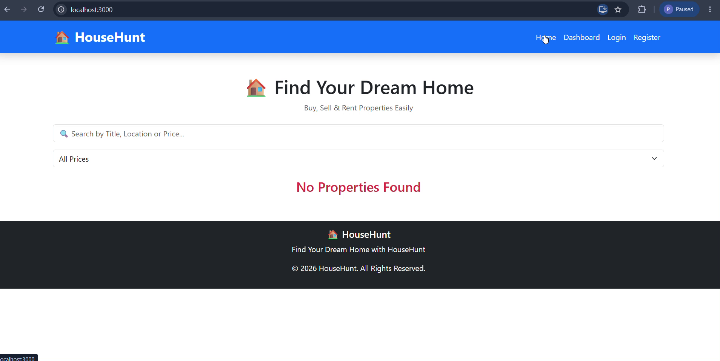
Figure 1: Home page with search bar and price filter

At the time of recording, no properties had been added to the system yet, so the page displays a "No Properties Found" message. Once listings are added on the backend, they will appear here.
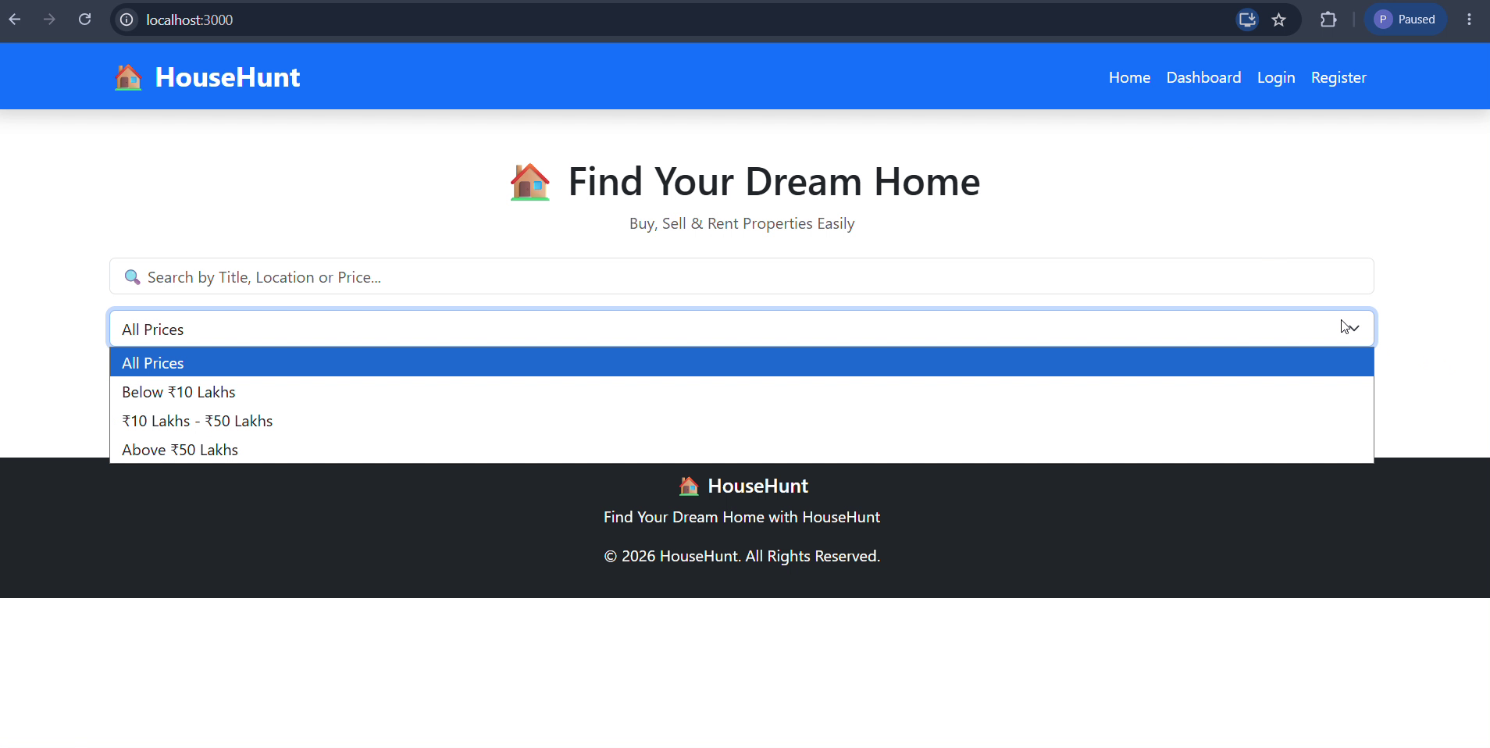
Figure 2: Price filter dropdown with four range options

4.2 Dashboard Page:
The Dashboard page gives a quick summary view of the platform's data using three stat cards:
- Total Properties — count of all listed properties
- Average Price — average price across all listings (shown in ₹)
- Cities Available — number of distinct cities with listings
All three values show 0 in the walkthrough since no property data exists yet.
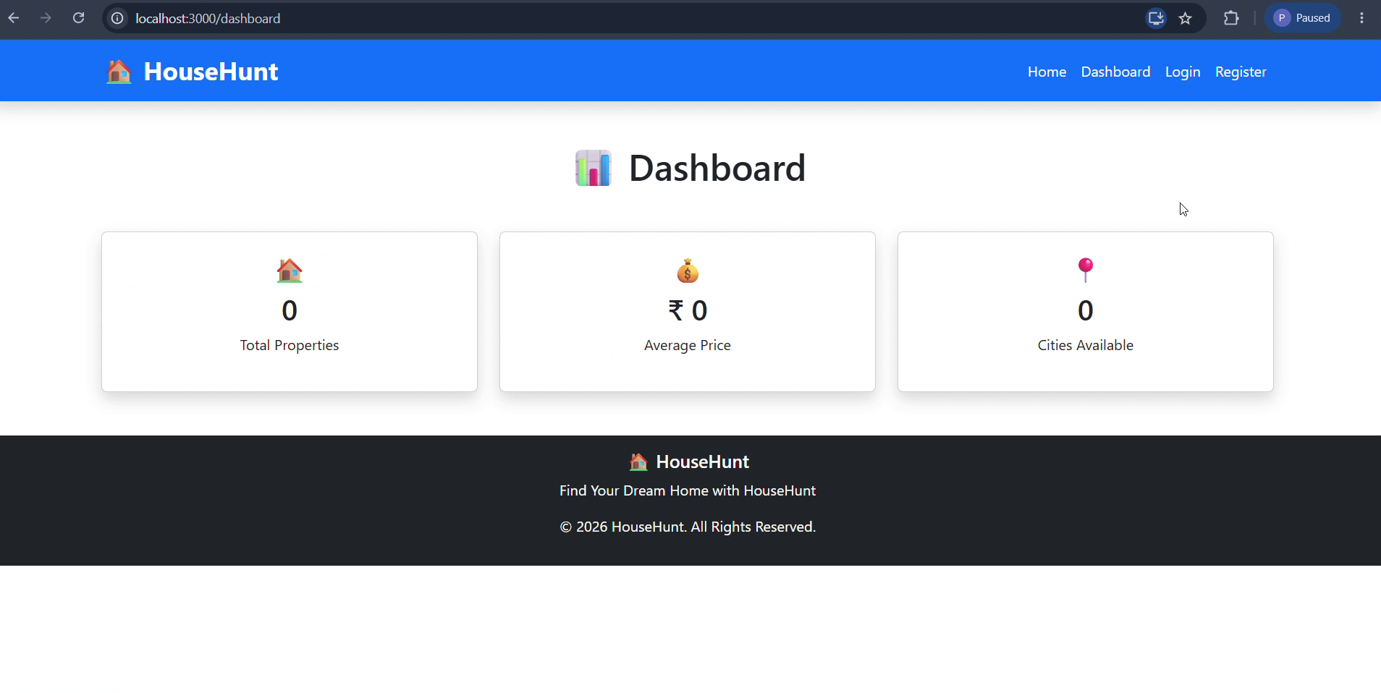
Figure 3: Dashboard with summary statistic cards

4.3 Login Page:
Existing users can log in using their Email and Password. Submitting the form would typically authenticate the user against the backend and start a session.
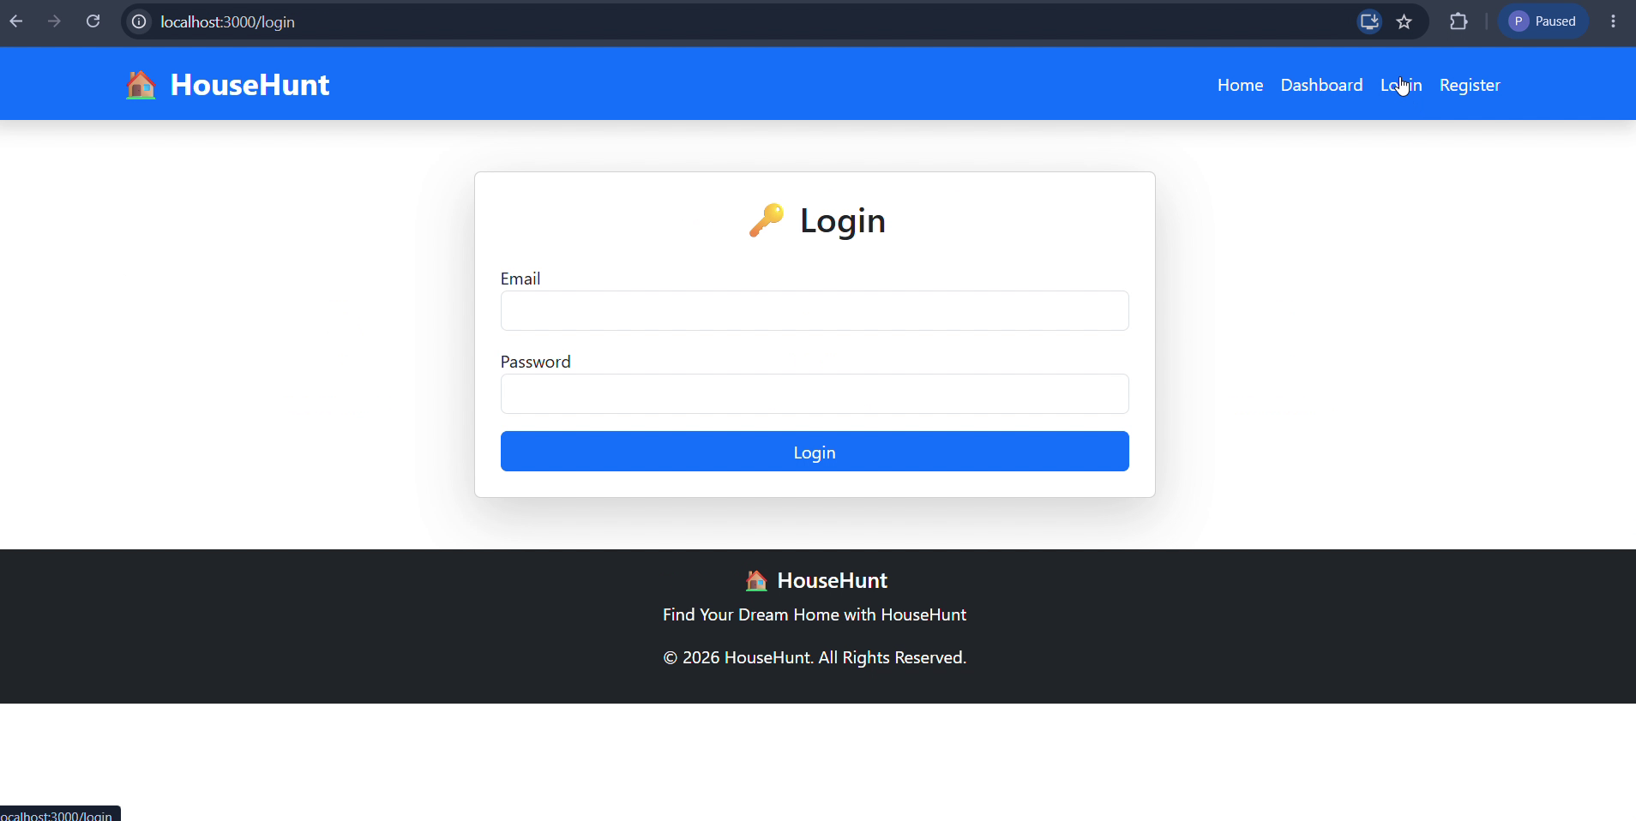
Figure 4: Login page

4.4 Register Page:
New users can create an account by entering their Full Name, Email, and Password, then clicking Register. This would typically create a new user record in the database.
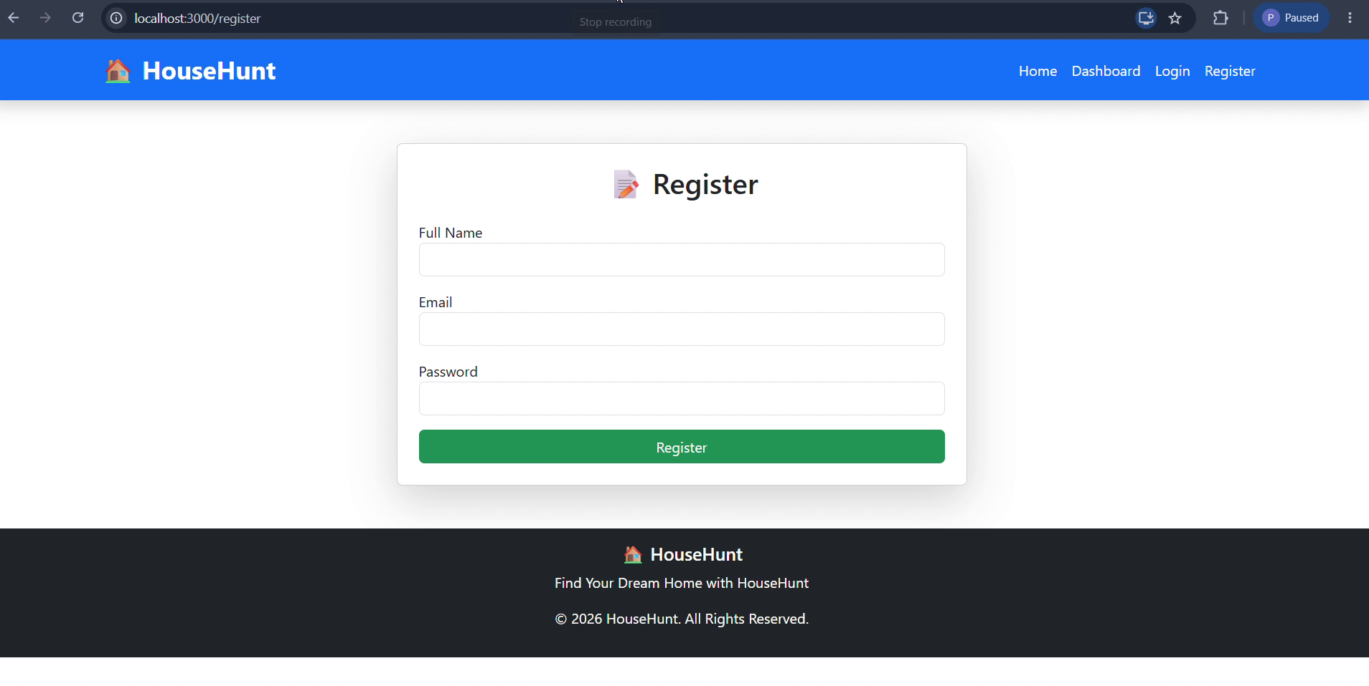
Figure 5: Register page

12. Known Issues:
Although HouseHunt provides a stable and functional platform, a few limitations remain in the current version.

Current Limitations
- Online payment gateway is not integrated.
- Booking agreements are managed outside the application.
- Push notifications are not implemented.
- Real-time chat between tenants and owners is unavailable.
- Property recommendation is not personalized.
- Email verification is not currently implemented.
These limitations provide opportunities for future enhancements.

13. Future Enhancements:
HouseHunt has been designed with scalability in mind. Future versions of the application can include advanced features that further improve the user experience.
Proposed Enhancements
- Integration of online payment gateways (Razorpay, Stripe, etc.)
- Google Maps integration for precise property locations
- AI-based property recommendation system
- Real-time messaging between tenants and owners
- Email and SMS notifications
- Virtual property tours
- Property rating and review system
- Advanced analytics dashboard for administrators
- Mobile application for Android and iOS
- Multi-language support
- Wishlist/Favorite Properties feature
- Improved search using AI-powered recommendations
These enhancements will make HouseHunt a more comprehensive and intelligent property rental platform.
Conclusion:
HouseHunt demonstrates the successful implementation of a modern MERN Stack application for managing rental properties. By integrating React.js, Node.js, Express.js, and MongoDB, the system provides a secure, responsive, and scalable platform for tenants, landlords, and administrators. The application simplifies property discovery, property management, and booking while maintaining transparency and role-based access control.
The modular architecture, RESTful API design, and secure authentication mechanisms make HouseHunt easy to maintain and extend. Future enhancements such as AI recommendations, online payments, and real-time communication can further improve the platform's capabilities.

