**MAVLink**

MAVLink is a very lightweight messaging protocol for communicating with drones. It is also the preferred protol for communication between drone components. MAVLink uses a modern version of MQTT protocol that is publish-subscribe and point to point design pattern. All data are sent or published, received or subscribed to topics.

The MAVLink toolchain uses the XML message definitions to generate MAVLink libraries for each of the supported programming languages. Drones, ground control stations, and other MAVLink systems use the generated libraries to communicate. In our project we use MAVLink protocol for communicating with the drones.

Our complete project is based on ROS and it provides mavros ROS package which enables MAVLink extendable communication between computers running ROS, MAVLink enabled autopilots, and MAVLink enabled GCS.

The protocol defines a large set of messages which can be found in common.xml. MAVLink messages can be sent over almost any serial connection and are technology independent (wifi, 900mhz radio, etc). The messages are not guaranteed to be delivered which means ground stations or companion computers must often check the state of the vehicle to determine if a command has been executed

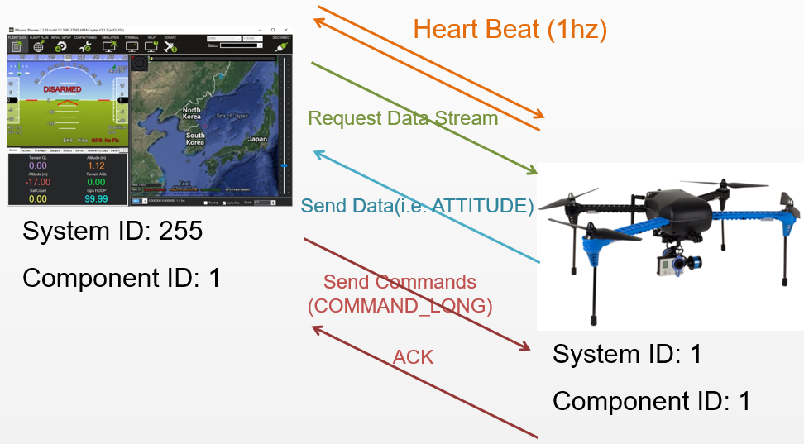

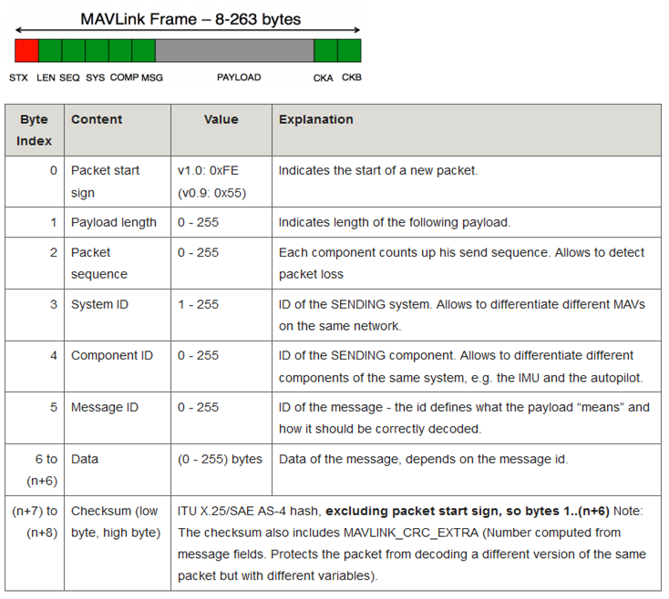

MAVLink supports a lot of commands. These descriptions are defined inside common.xml file. These commands are sent by ground control station or in our case using MAVROS.The common MAV_CMDs used in our project are

MAV_CMD_NAV_TAKEOFF – It is always the first command in nearly all the copter missions. It commands the copter to takeoff to specified location.

|  |  |  |
| --- | --- | --- |
| Command Field | Mission Planner Field | Description |
| **param1** | Grade % | Pitch/climb angle (Plane only). |
| param2 |  | Empty |
| param3 |  | Empty |
| **param4** |  | Yaw angle (ignored if compass not present). |
| **param5** | Lat | Latitude |
| **param6** | Lon | Longitude |
| **param7** | Alt | Altitude |

### **MAV_CMD_NAV_WAYPOINT** – It command the copter to navigate to the specified latitude. Longitude and altitude.It then waits at that point for the specified amount of time

|  |  |  |
| --- | --- | --- |
| Command Field | Mission Planner Field | Description |
| **param1** | Delay | Hold time at mission waypoint in decimal seconds - MAX 65535 seconds. (Copter/Rover only) |
| **param2** |  | Acceptance radius in meters (when plain inside the sphere of this radius, the waypoint is considered reached) (Plane only). |
| param3 |  | 0 to pass through the WP, if > 0 radius in meters to pass by WP. Positive value for clockwise orbit, negative value for counter-clockwise orbit. Allows trajectory control. |
| param4 |  | Desired yaw angle at waypoint target.(rotary wing) |
| **param5** | Lat | Target latitude. If zero, the Copter will hold at the current latitude. |
| **param6** | Lon | Target longitude. If zero, the Copter will hold at the current longitude. |
| **param7** | Alt | Target altitude. If zero, the Copter will hold at the current altitude. |

MAV_CMD_NAV_RETURN_TO_LAUNCH – It is the RTL command. It is always the last command in a mission. Once a copter recieves this commands it abandons all other activities and starts navigating towards the launch location. All the parameters are NULL for this command.