**Object detection using drone swarms**

Drones can be used for a variety of applications. In our project we have demonstrated an application where in a swarm of drones are used locate lost objects in open space. For example, when a flight goes down or when a ship gets lost in a storm it becomes difficult to fiind debries. It is difficult to search large geographical area manually. In those situations it becomes easy to deploy drones.

In our project given a geographical area, we divide the entire area into smaller sub areas. Each sub area is covered by indivisual drones. In our case the rectangular area is covered by three drones. Hence the area is divided into three regions. Each region is triangular covering 1/3 rd of the area.

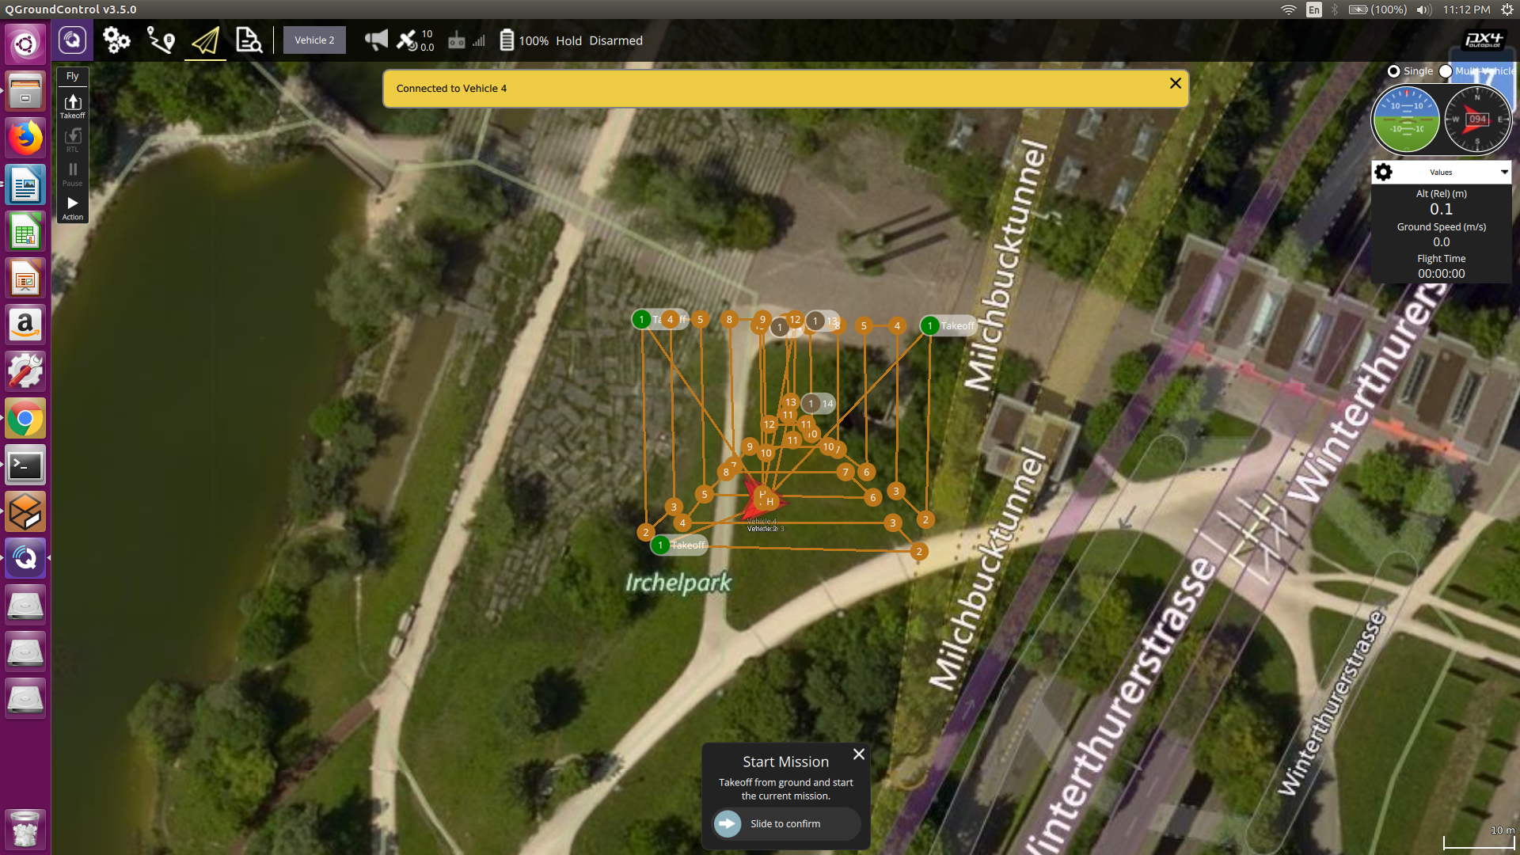

Continuing with multi-drone simulation, We attached cameras to each and every drones. This enabled vision to our drones. Drones are controlled using MAVROS. All the control signals and responses are carries out through ROS topics. For example, to send a takeoff command to a particular drone, It is simply enough to publish the control information on a proper channel. In the same way drones publish camera data and other sensor data. To work on camera feed we subscribed to the camera topic of all the drones.

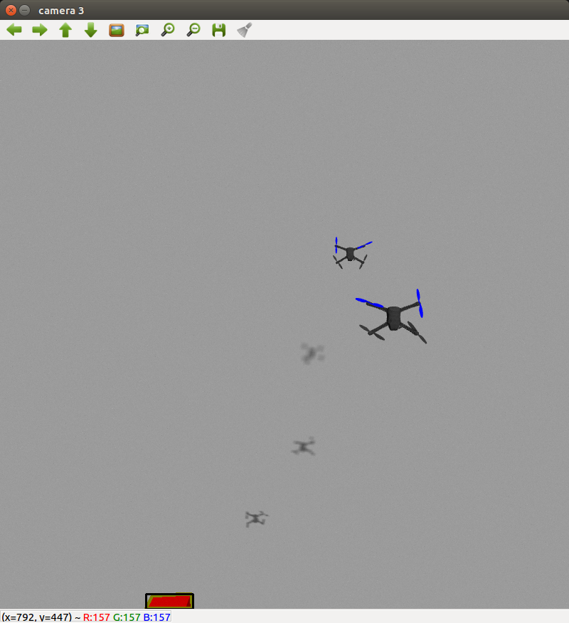

OpenCV (Open Source Computer Vision Library) is an open source computer vision and machine learning software library. ROS is a toolkit/offboard API for automating vehicle control. Adding to the advantage of ROS, It has libraries to work along with OpenCV. Using CvBridge we can convert ROS image messages to OpenCV messages. Further image processing tools of OpenCV can be used to detect objects.

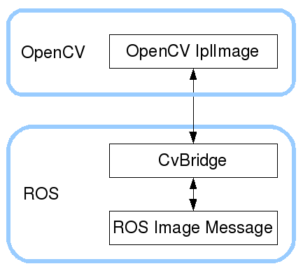

To demonstrate a use case, we place red colored boxes ( whose location we tend to determine ) along with other boxes at random places in Gazebo. Object detection is done by passing image through red color filter after random noise. The largest contour is identified and if its area is greater than certain threshold then its identified as box. All the camera feeds are processed continously for identifing.

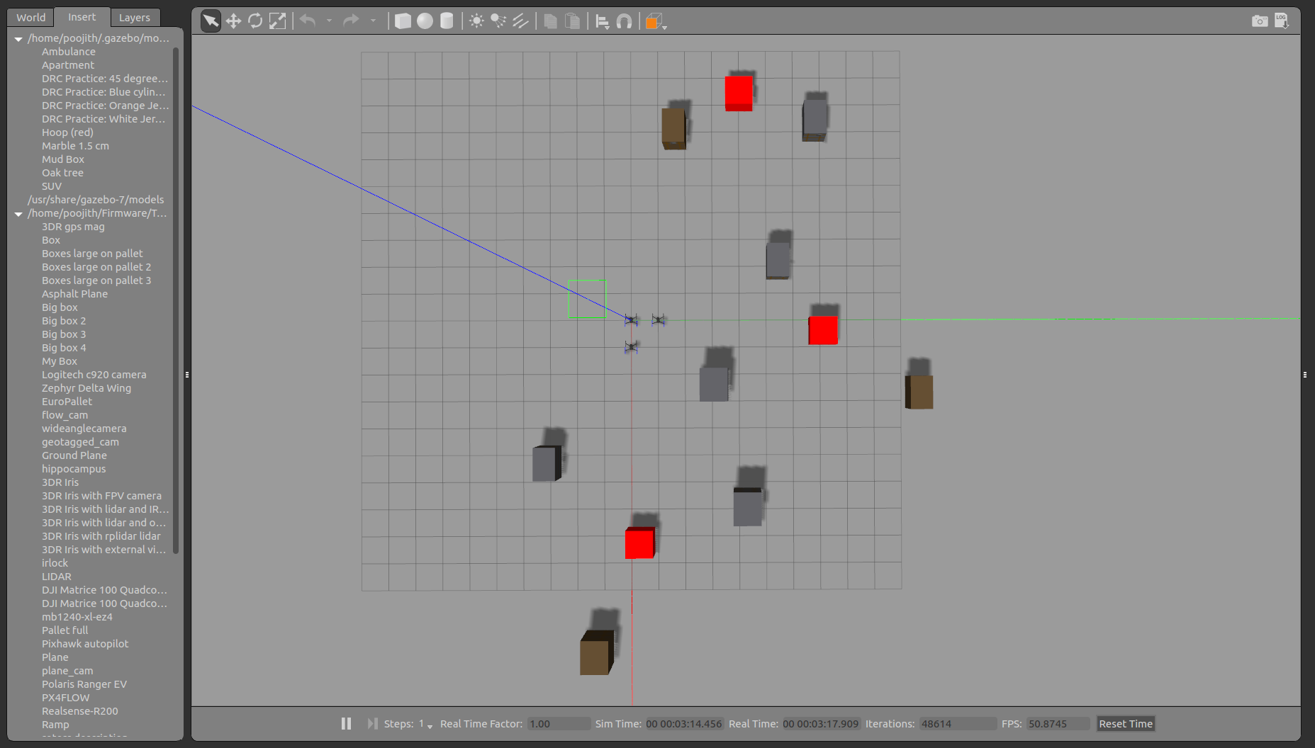

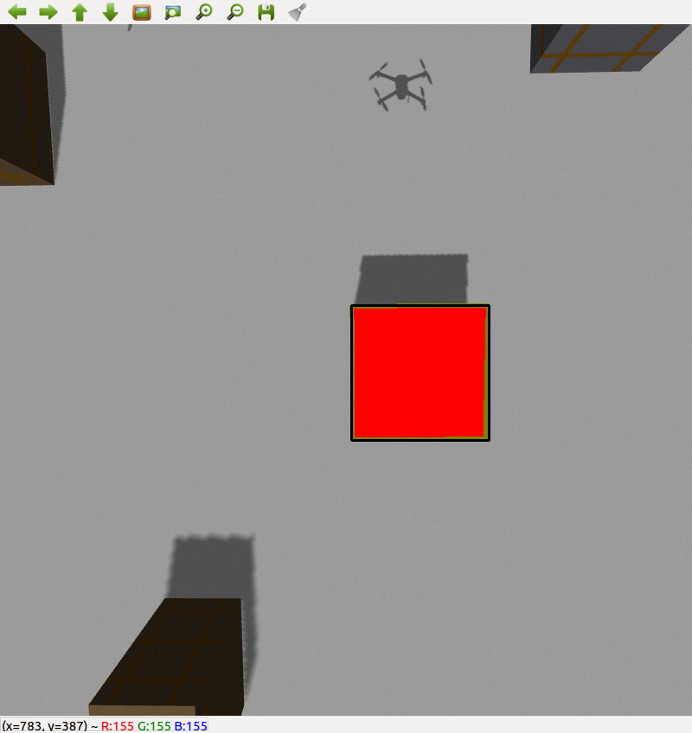

The simulation starts with each drone receiving a mission. They then start following the trajectory looking for red colored boxes. Once a box is found its location is remembered. This is used to decide if the box was previously detected by other drones. All successful detections made at locations very close to each other are considered as single boxes and the same is logged on the terminal.

