**SIMULATION**

**OVERVIEW**

According to Wikipedia, a simulation is an approximate imitation of the operation of a process or system, the act of simulating first requires a model is developed. Drones are very expensive instruments and our project which is on swarm of drones makes it even more difficult to implement the same on hardware. Simulators allow PX4 flight code to control a computer modeled vehicle in a simulated "world". You can interact with this vehicle just as you might with a real vehicle, using QGroundControl, an offboard API, or a radio controller/gamepad.

Simulation is the safest way to test each and every confguration on a vehicle before attempting tofly in the real world. PX4 support two types of simulations.

* **Software In the Loop (SITL)** runs the complete system on the host machine and simulates the autopilot. It connects via local network to the simulator. The setup looks like this:

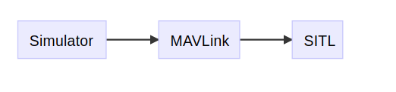

* **Hardware In the Loop (HITL)** simulation using a simulation firmware on a real flight controller board.

PX4 supports 4 simulators. For SITL simulation the supported simulators are Gazebo, jMAVSim and Airsim and for HITL simulation it supports Xplane simulator. During the course of our project we have explored two of them jMAVSim and Gazebo.

All simulators communicate with PX4 using the Simulator MAVLink API.This API defines a set of MAVLink messages that supply sensor data from the simulated world to PX4 and return motor and actuator values from the flight code that will be applied to the simulated vehicle.

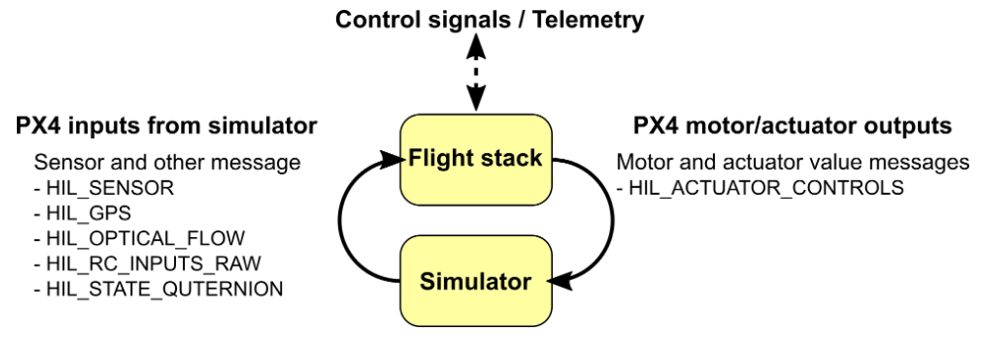

All the interactions between the simulator,PX4 and offboard API’s happen through UDP connections. All these nodes can be either on the same computer or on the same network.Offboard API’s listen for connections on port no 14540 and ground control stations on 14550. Simulators initiate connection by broadcasting data on port 14560.

Simulators exchange information using Simulator MAVLink API.PX4 on SITL and simulator can run either on same or different computers. PX4 uses normal MAVLink module to connect to GroundStations. Gamepad communicate using serial connection.

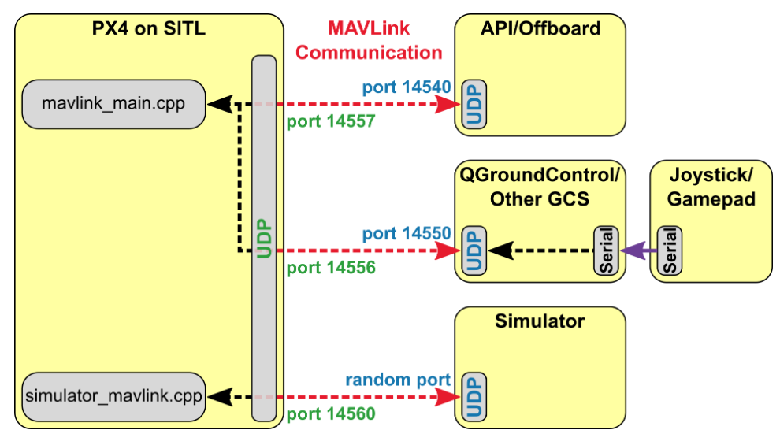

**JMAVSim**

jMAVSim is a simple simulator that allows simulations of fly copter vehicles running PX4 in a simulated world.It allows the user to control the vehicles.It supports operations such as takeoff,landoff and check how the vehicle responds to various fail conditions such as GPS failure etc.

We have used jMAVSim for SITL simulation, but it also supports HITL simulation. jMAVSim supports only one vehicle Quad. This simulator is suitable for single drone simulations. Eventhough it supports multi-drone simulation, it is not possible to view all the drones in a single window. Each drone is simulated in a new window. Thus it does not provide a way for effective visualization of multi-drones.

JMAVSim simulator can be launched using the command *make posix_sitl_default jmavsim.* The flight can be controlled using PX4 commands such as *commander takeoff, commander land* etc.

Missions can be *QgroundControl.*

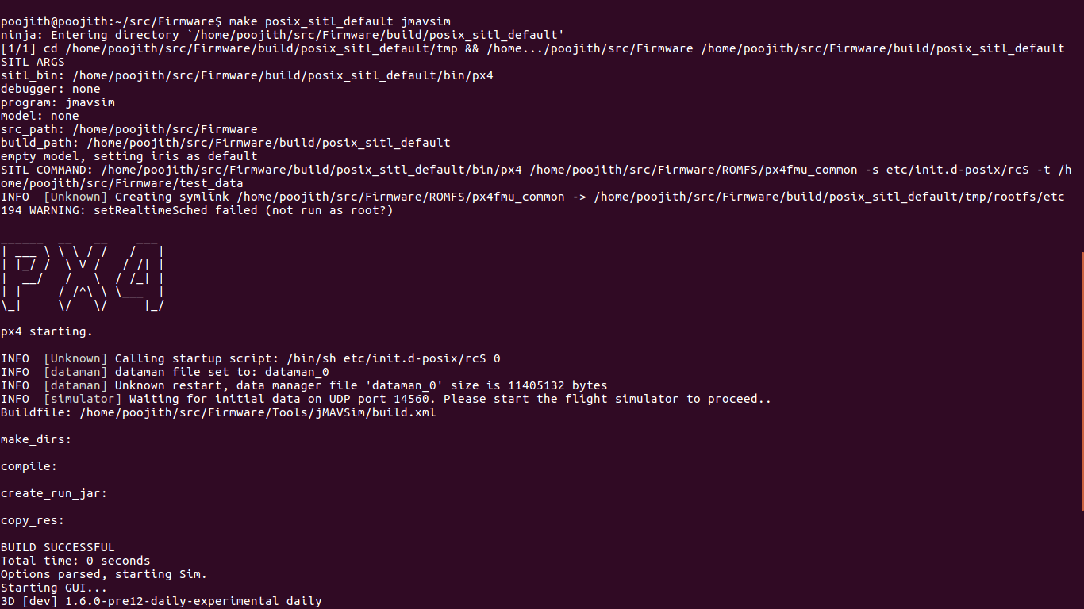

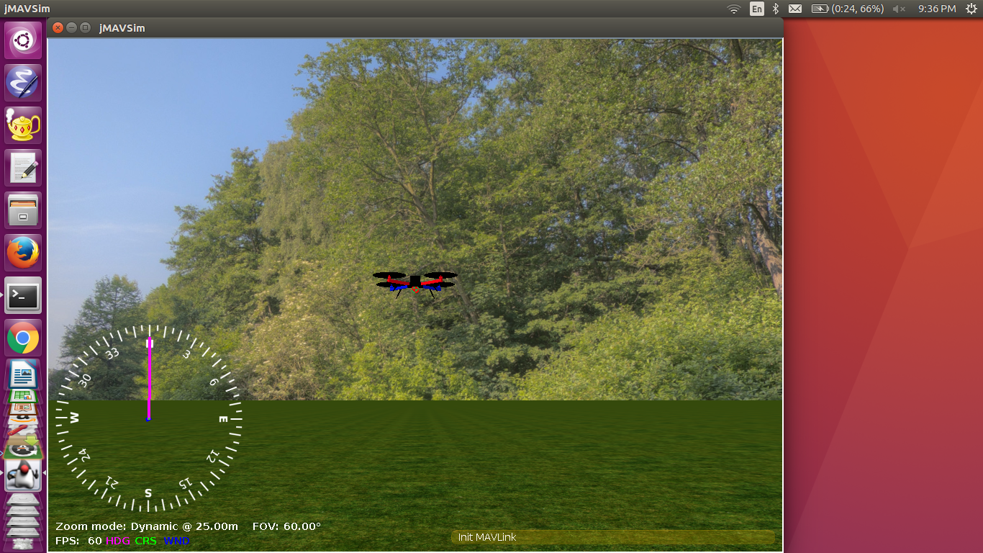

JMAVSim is a very light weight simulator and doesnot have much functionalities. It does not have options like inserting real world objects into the world,interfacing with ROS, different orientational views etc.. As our project mainly focuses on detecting of objects in the world and visualization of multiple drones in a very effective manner we had to shift to a different simulator.

**Gazebo**

Gazebo is a powerful 3D simulation environment for autonomous robots that is particularly suitable for testing object-avoidance and computer vision.It is the most preferred simulator for multi-vehicle simulation. Its seamless integration with ROS, a collection of tools for automating vehicle control, makes Gazebo a very powerful. It supports a lot of vehicles like Quad (Iris and Solo, Hex (Typhoon H480), Generic quad delta VTOL, Tailsitter, Plane, Rover, Submarine etc.

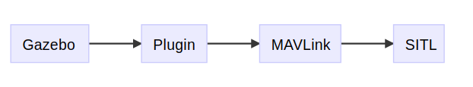

Gazebo supports both SITL and HITL simulations. In our project we use gazebo for SITL simulation.Gazebo simulation can be started by using the command *make posix_sitl_default gazebo*

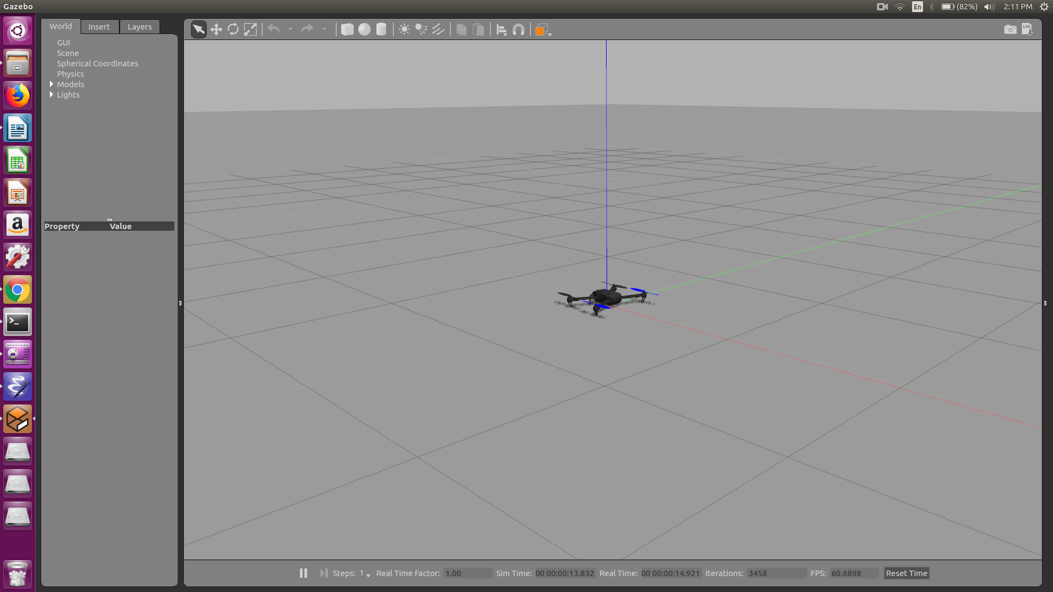

Multi-drone simulation in Gazebo is done together with ROS. Each vehicle is generated from a *xacro* file and is assigned a TCP_port. This is the gazebo model of a drone.Parallely a SITL PX4 app is started, which is the PX4 node. This node connects to the vehicles on the TCP_port.In the earlier verision of the Firmware all connections were on UDP. Multi-drone simulation is started with the command *roslaunch px4 multi_uav_mavros_sitl.launch*

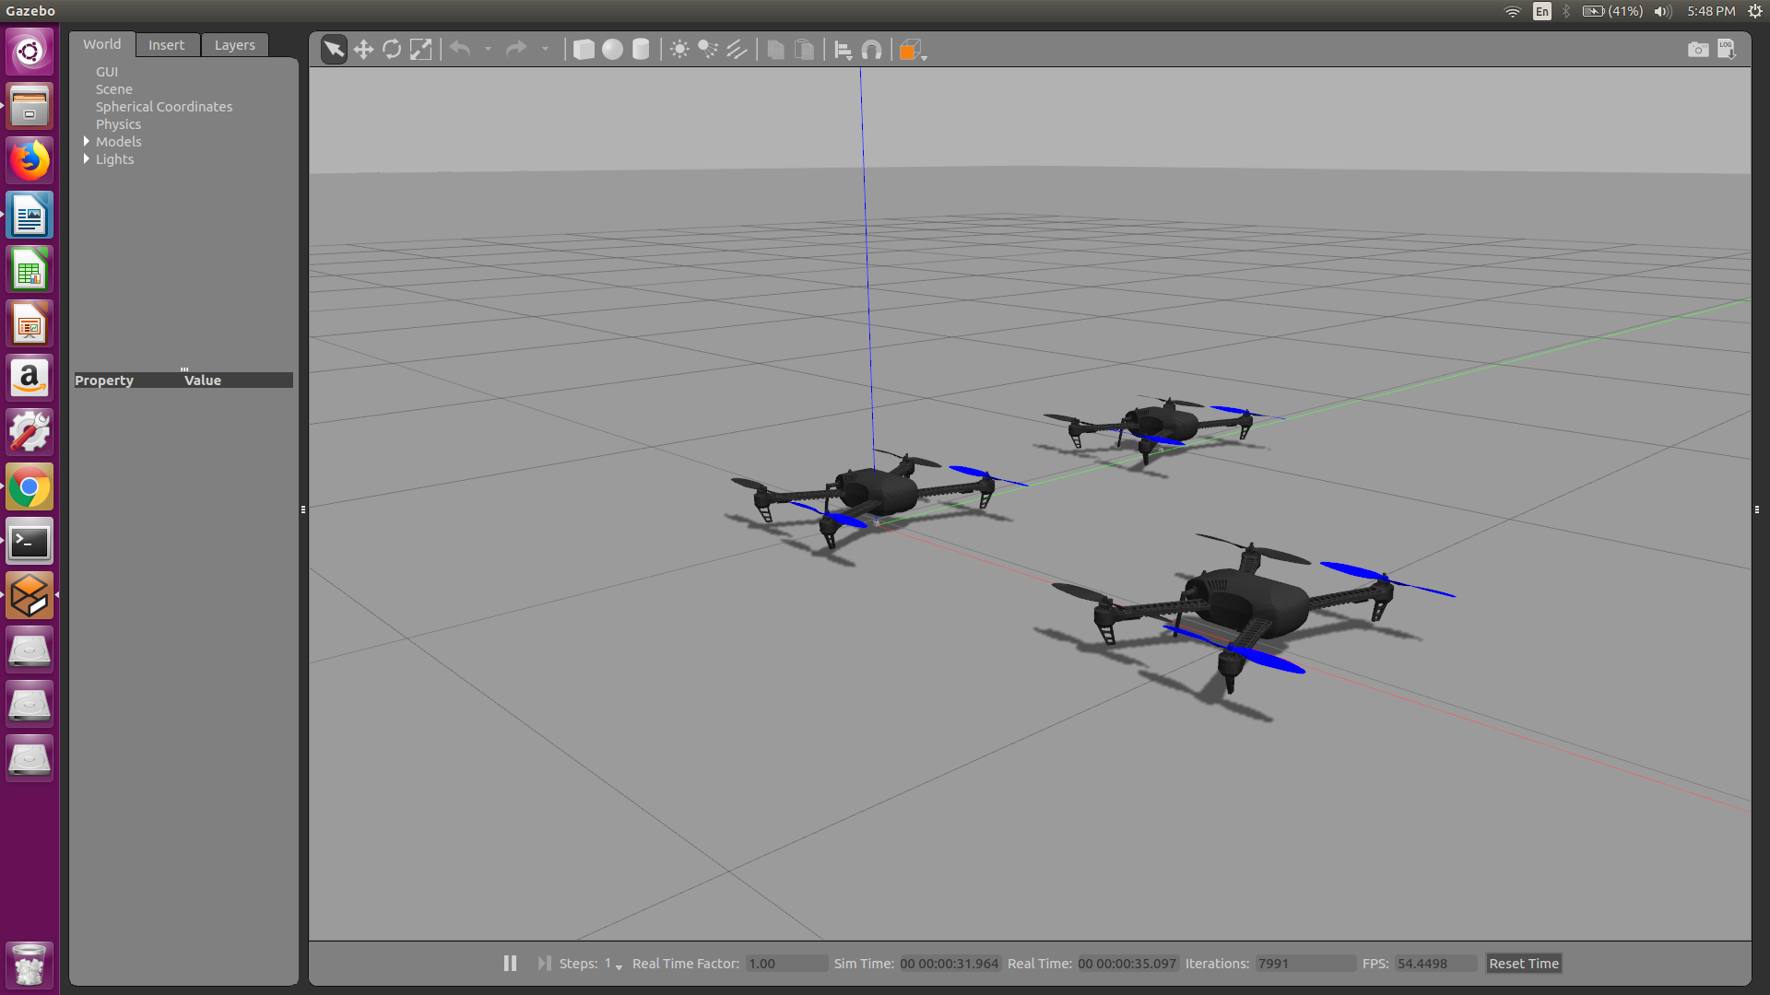

Vehicles can be controlled with QGroundControl or MAVROS in a similar way to a single vehicle is managed. QGroundControl will have a drop-down to select the vehicle that is "in focus"

MAVROS requires that you include the proper namespace before the topic/service path (e.g. for <group ns="uav1"> use /uav1/mavros/mission/push).