### Screenshots for building a gradle project in Jenkins Pipeline.

**1. Install Jenkins on EC2 Instance**

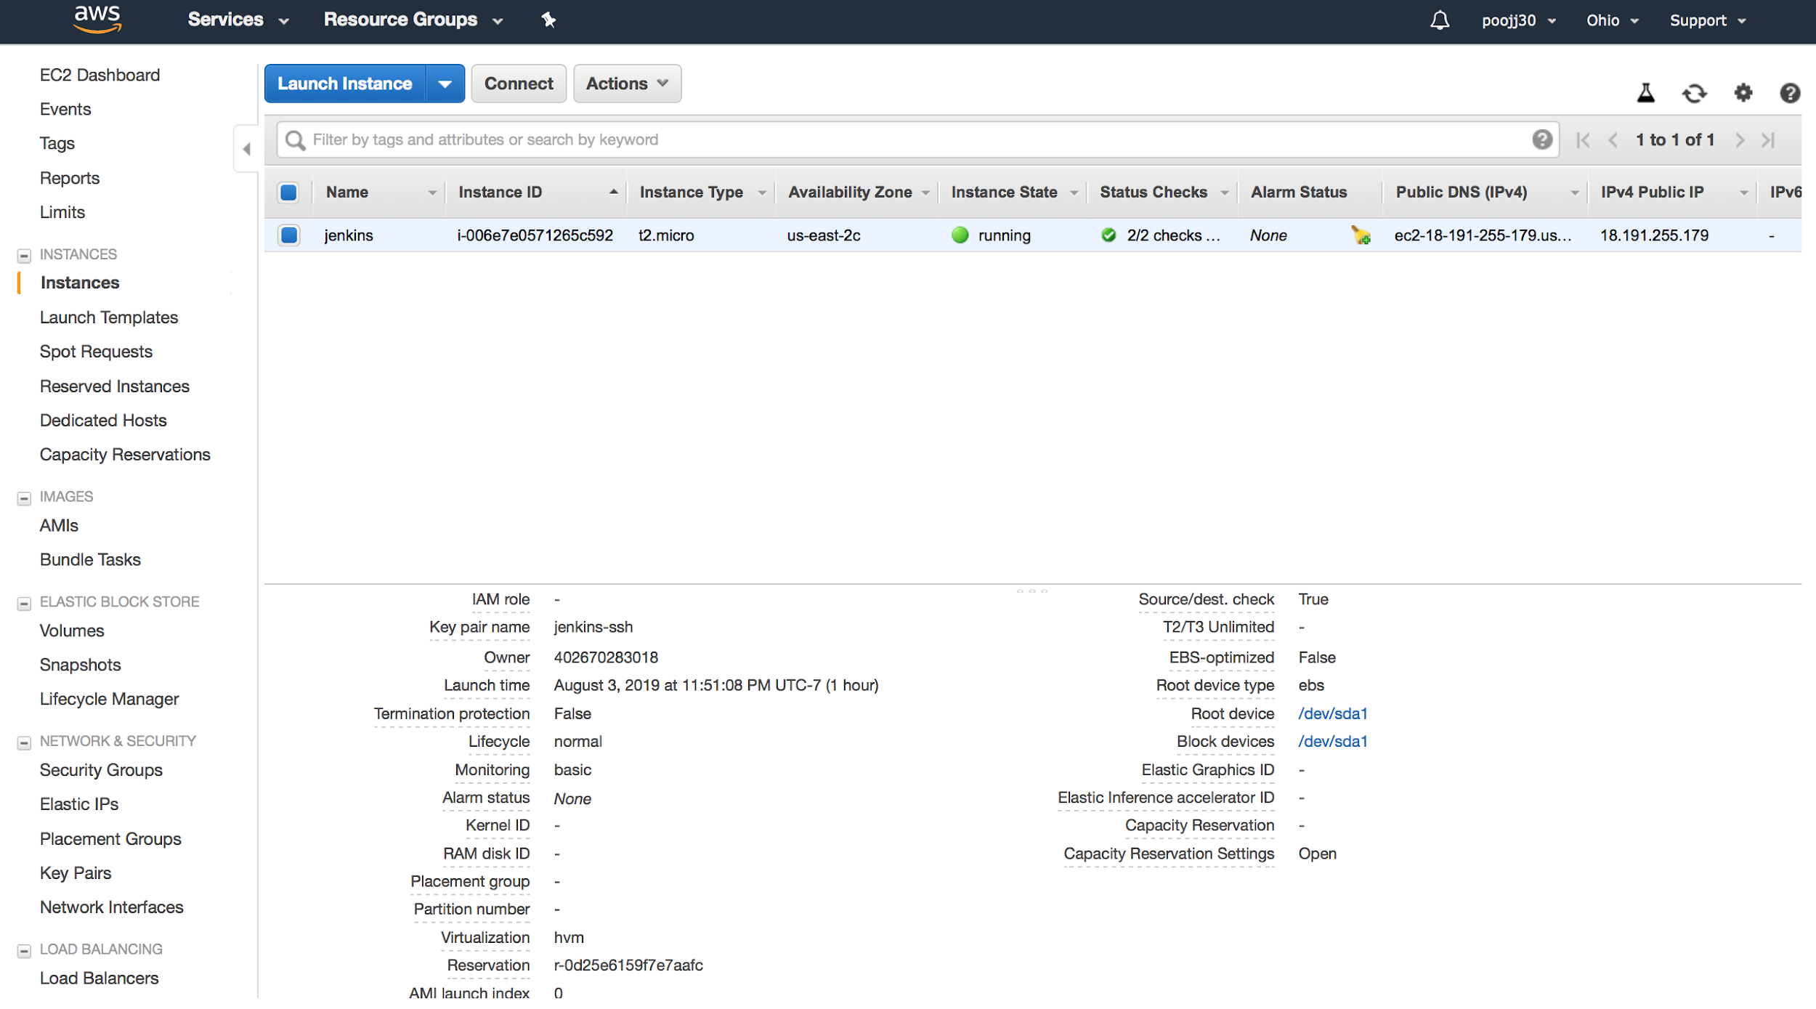

**2. Create a Jenkins Job after setting up Jenkins on AWS EC2**

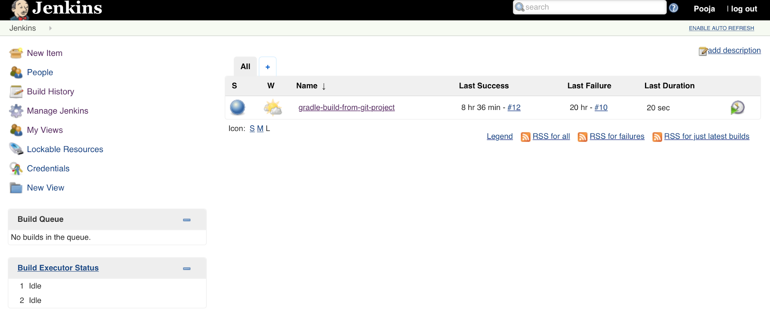

**3. Configure Jenkins Pipeline**

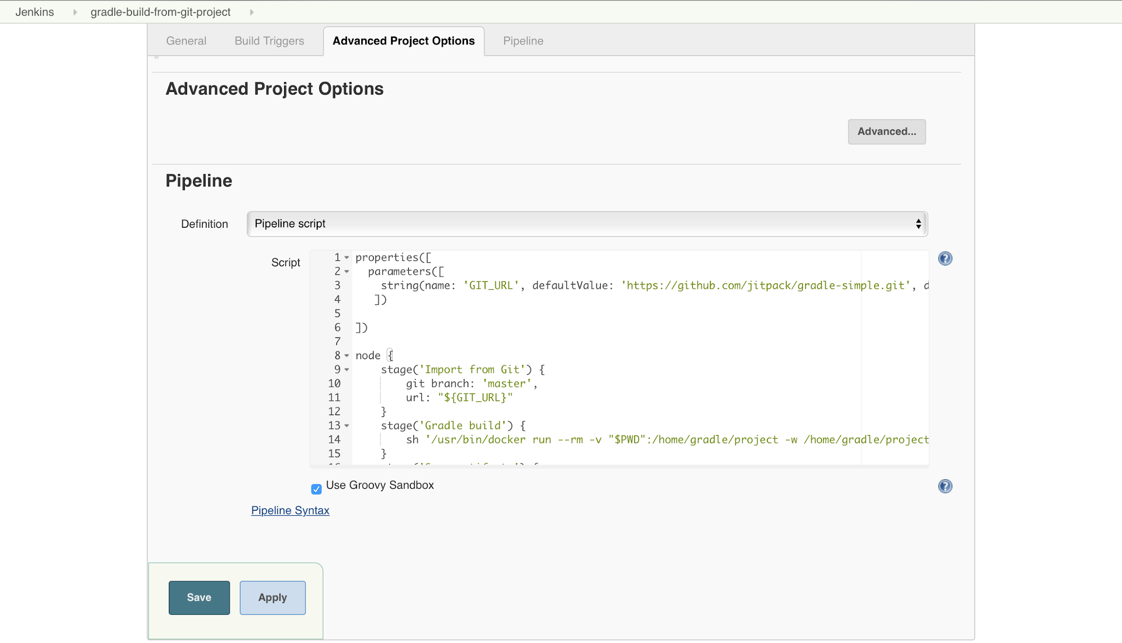

**4. Parameterize Jenkins Pipeline**

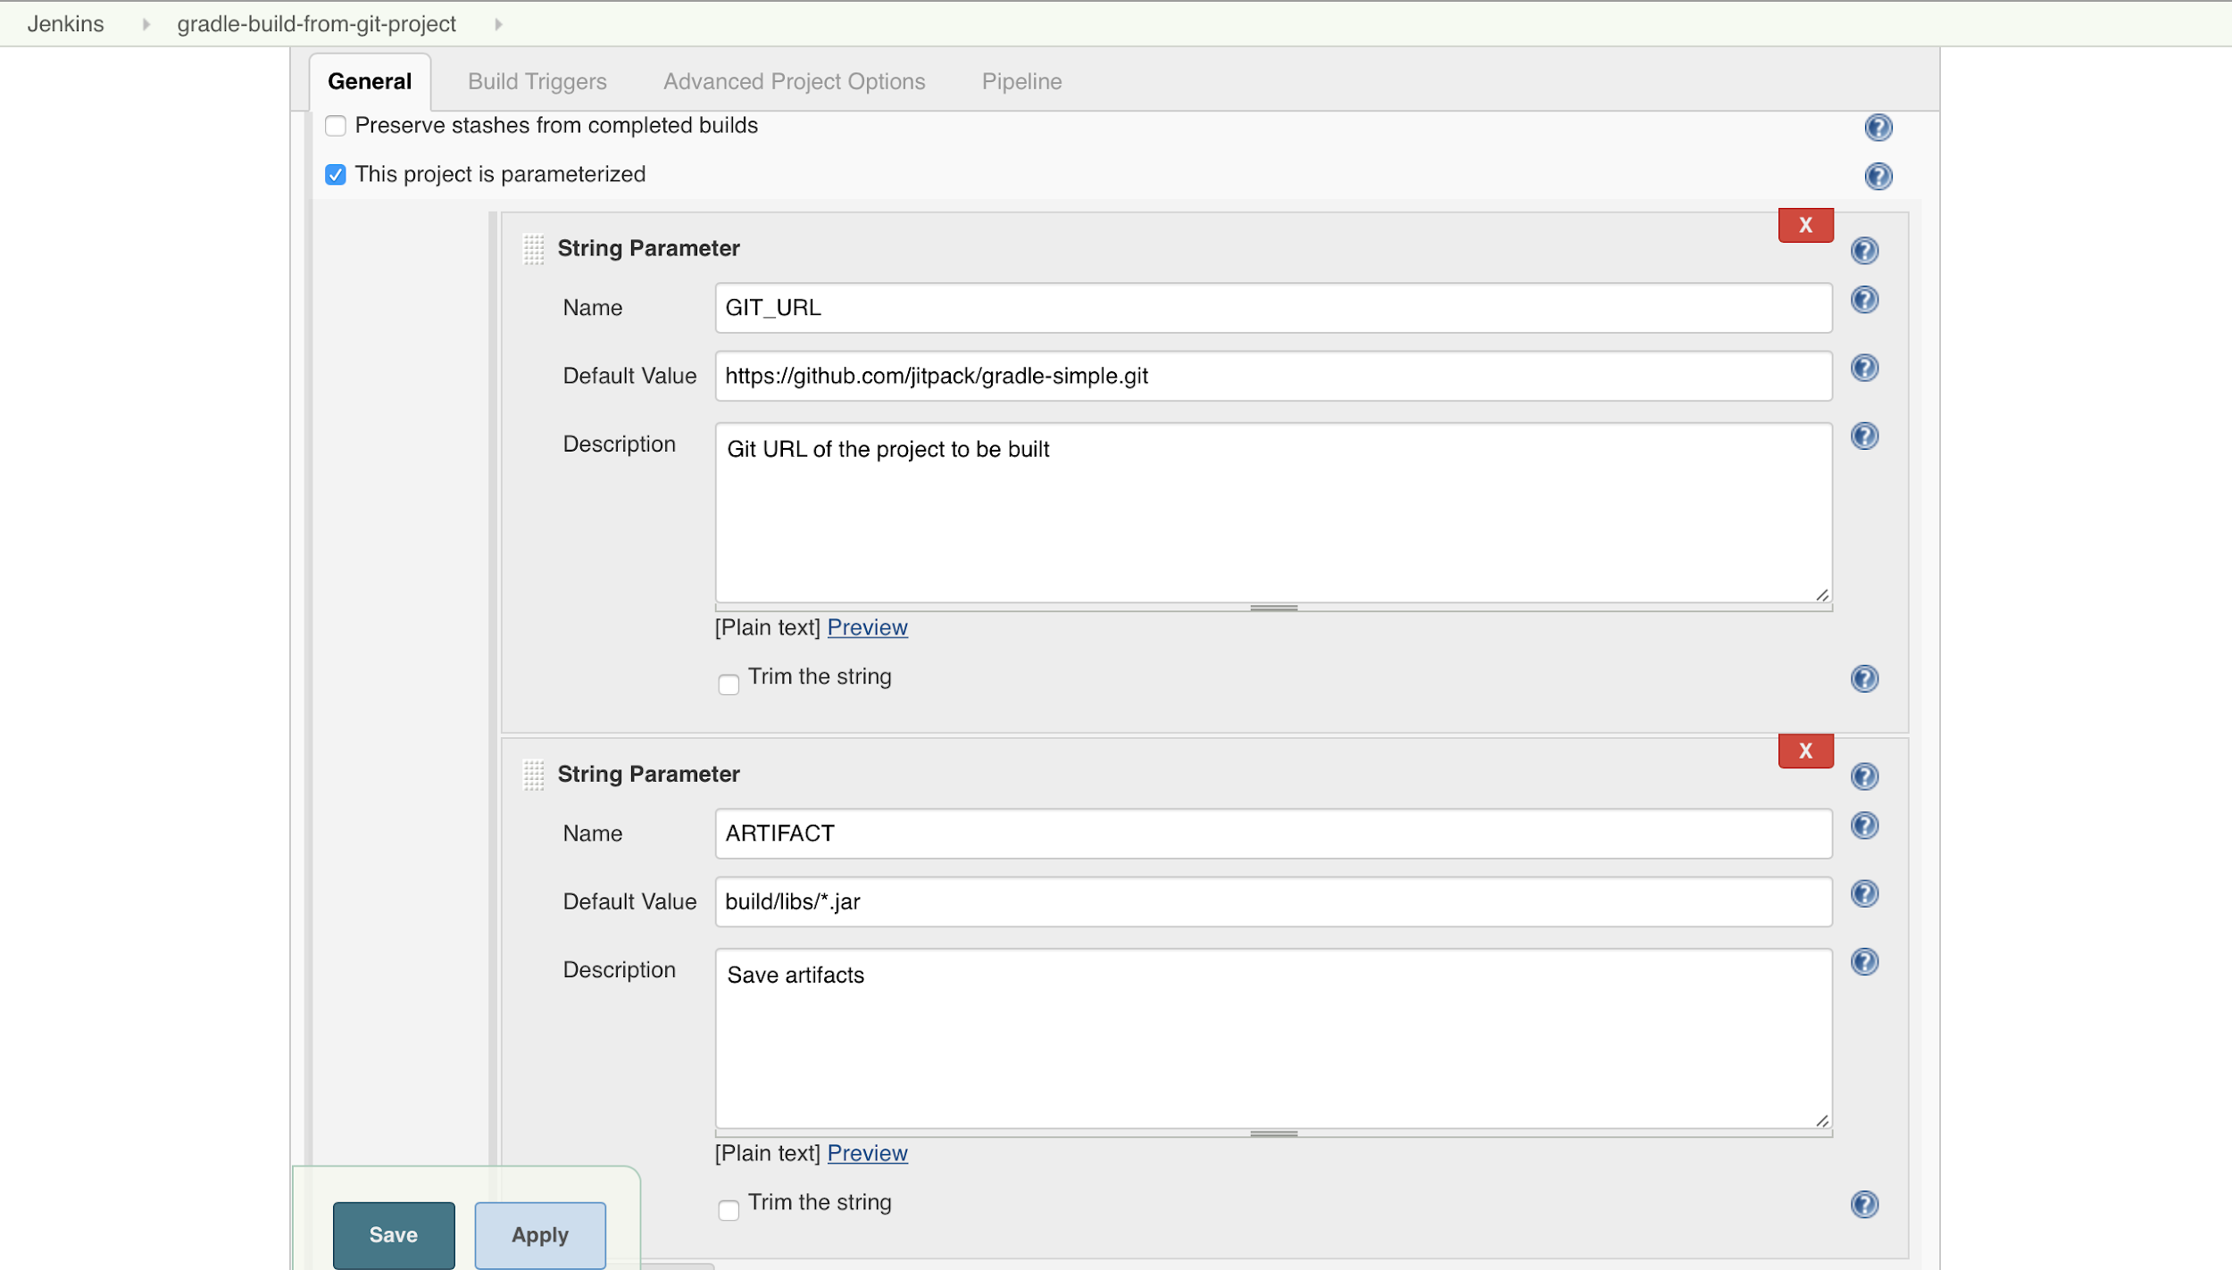

**5. Build Jenkins Job**

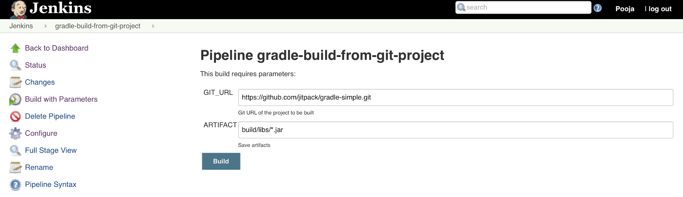

**6. The Jenkins Job is currently building - Build 13**

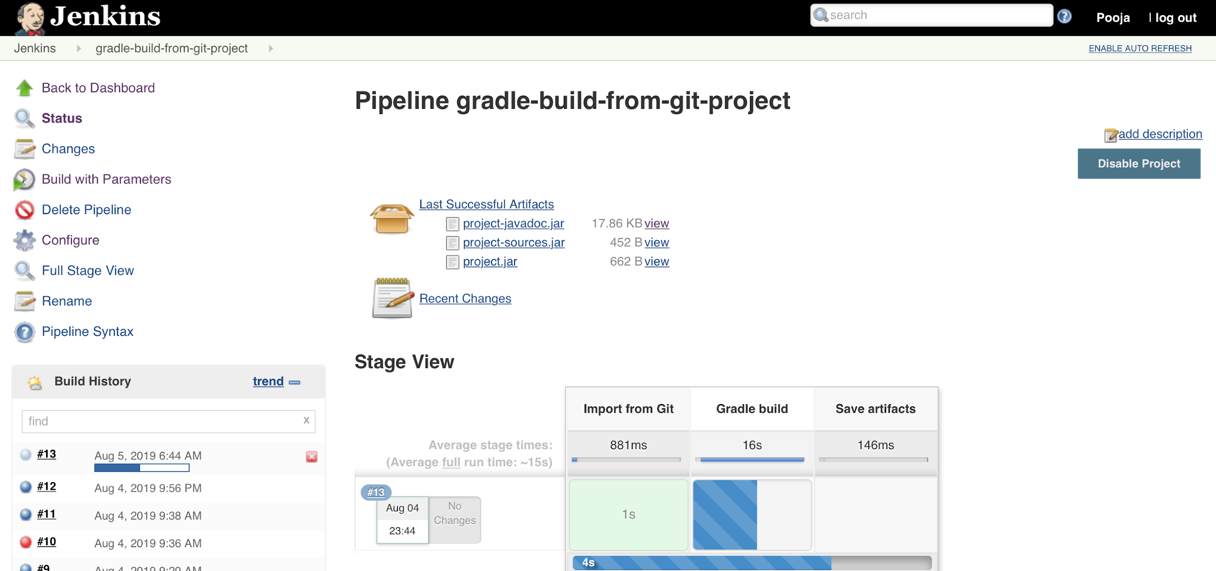

**7. Build Output - Build 13 Completed Successfully**

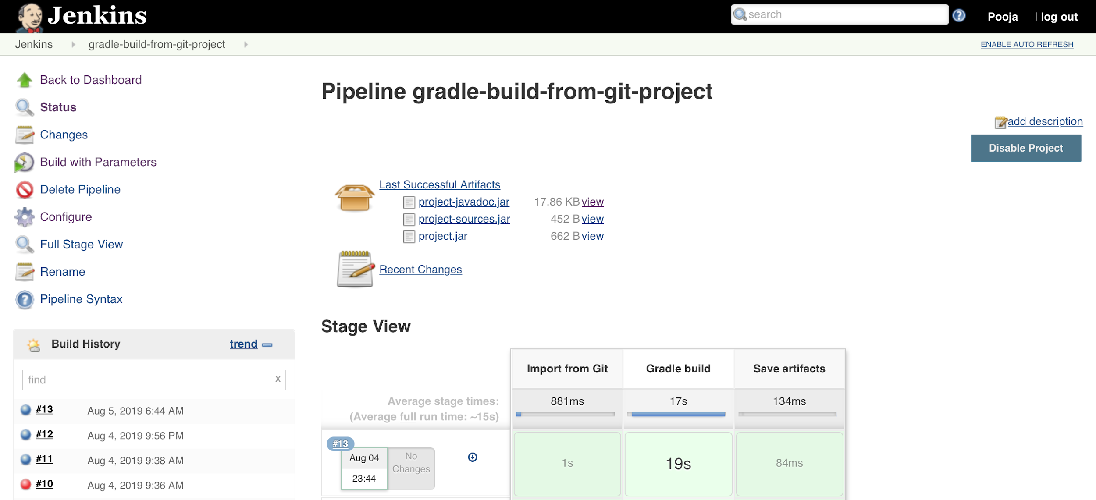

**8. Console Output**

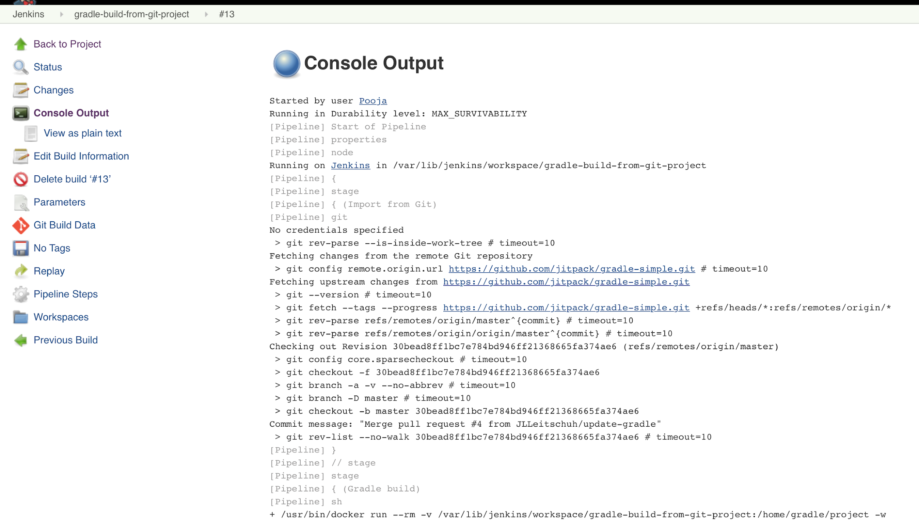

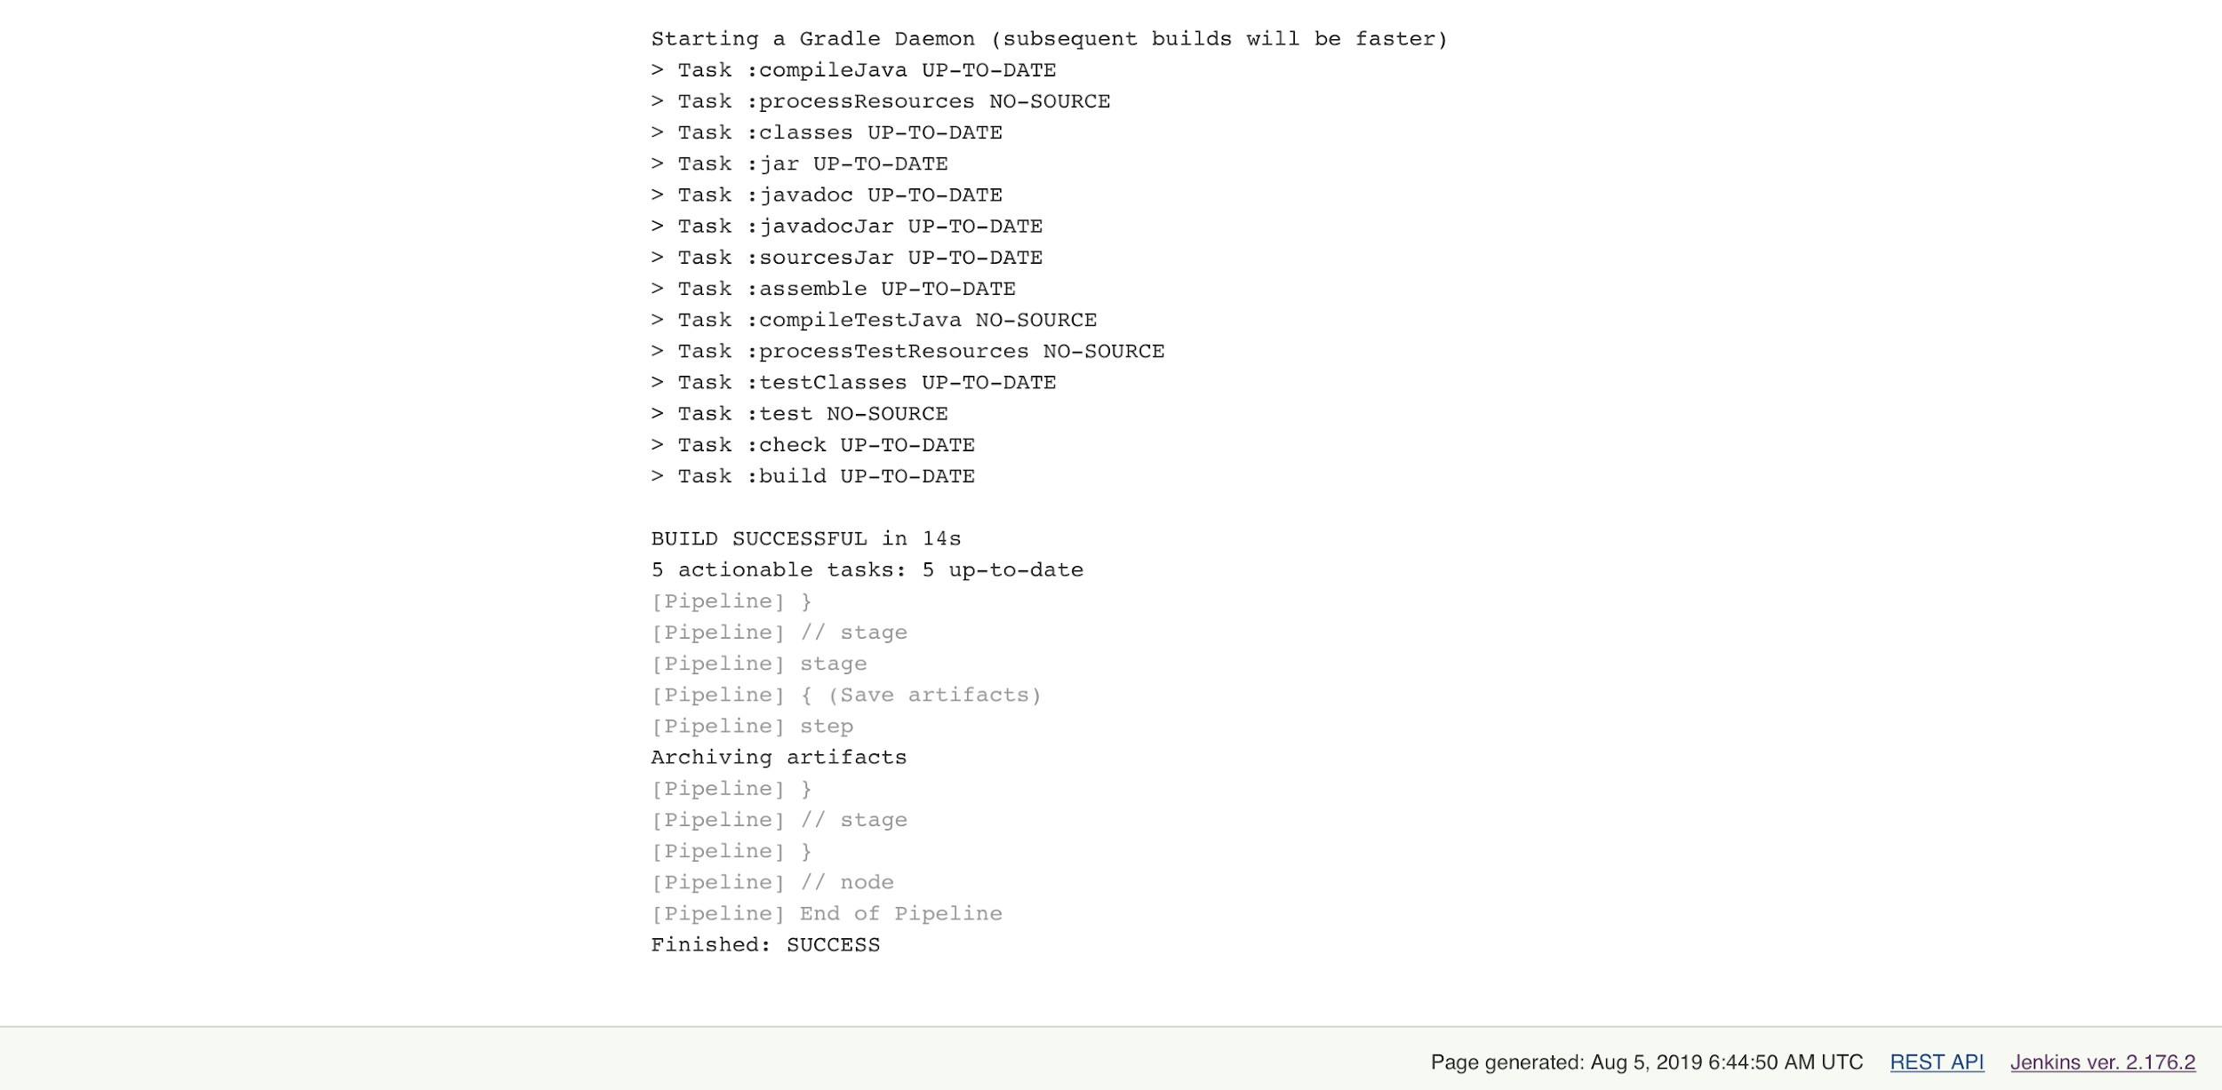

**9. Jars stored in Artifact- Build 13**