**INDEX**

**1.INTRODUCTION:**

**1.1 OVERVIEW:**

Youtube project means the impact in daily life’s activities. Exploring world’s top YouTube channel is our project

Title.

In this project, we can able to understand about the YouTube and the channels and also about the users and their mindset about YouTube channels.

**1.2 PURPOSE:**

The purpose of the project, “World’s top YouTube channels”, is to understand about YouTube channels, advantages and disadvantages about the YouTube channels and also the impact of the YouTube in people’s life.

**2. PROBLEM DEFINITION &**

**DESIGN THINKING.**

**2.1 EMPATHY MAP:**

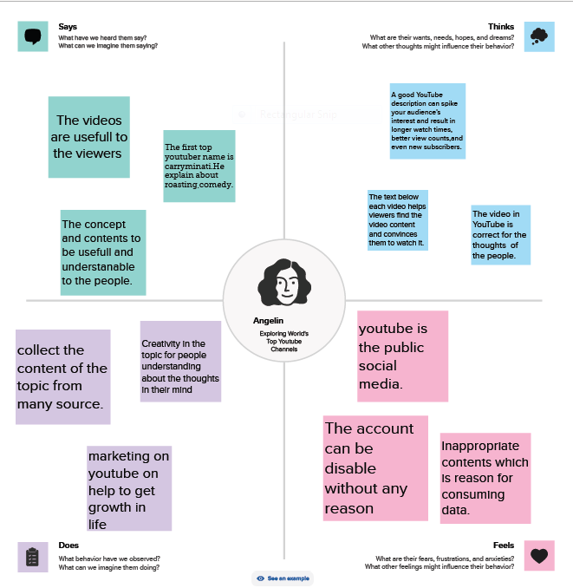

**2.2 IDEATION & BRAINSTORMING MAP:**



**3. RESULT**



**4. ADVANTAGES AND DISADVANTAGES.**

**ADVANTAGES:**

* YouTube is right behind Google in the world’s most visited website.
* There are a total of 122 million daily active users on YouTube.
* While other platforms may have certain parameters for the audience, YouTube is extremely varied with users from all different ages, backgrounds, education level, etc.
* YouTube is perfect for gaining traffic that is qualified.
* YouTube will increase the brand’s online presence in a number of ways.

**DISADVANTAGES:**

* Ads- a drawback of YouTube for the audience.
* A lot of distractions in YouTube.
* Obscentity – one of the biggest drawbacks the YouTube has.
* Deformation in bullying.
* Making money it’s not that easily.

**5. APPLICATIONS**

* With the help of our project, we can analysis all about the “YouTube”.

So we are clearly explained about the importance, advantages, and disadvantages about the YouTube.

* Most of the top YouTube channels are impressed the audience.

That kind of channels is in the high position. So, in our project we analyses about it and include the impact about the YouTube channels in the world.

**6. FUTURE SCOPE**

There are many future scopes in YouTube and their channels. Because, it is a growing market.

It will become an all encompassing entertainment service, where we can watch videos, listen to music, and watching the shows.