JHU_COVID-19_MD

Jonah Pool

5/26/2020

Constants

yd <- today() - ddays(1)  
td <- today()  
  
  
day <- yd  
MichiganRiots<- seq(ymd("2020-05-26"), ymd("2020-06-1"), by = 1)  
exclude = c("")  
# date for daily data release  
a <- as.character(ymd(day))  
b <- str_split(a, "-")  
c1 <- as.character(b[[1]][2])  
c2 <- as.character(b[[1]][3])   
c3 <- as.character(b[[1]][1])  
d_lookup_str <- str_c(c1, c2, c3, sep = "-")  
  
sinceMarch16 <- seq(date("2020-03-16"), day, by=1)  
  
last30 <- seq(td-30, td, by=1)  
last21 <- seq(td-21, td, by=1)  
last14 <- seq(td-14, td, by=1)  
last7 <- seq(td-7, td, by=1)  
  
  
  
bold.14.text <- element_text(face = "bold", size = 12)  
  
red.fill.5 <- c("#bf080e","#bf080e","#bf080e","#bf080e","#bf080e")  
blue.fill.5 <- c("#0016bd","#0016bd","#0016bd","#0016bd","#0016bd")  
  
red.fill.10 <- c("#bf080e","#bf080e","#bf080e","#bf080e","#bf080e","#bf080e","#bf080e","#bf080e","#bf080e","#bf080e")  
blue.fill.10 <- c("#0016bd","#0016bd","#0016bd","#0016bd","#0016bd","#0016bd","#0016bd","#0016bd","#0016bd","#0016bd")  
  
x.limit.march15 <- seq(ymd("2020-03-15"), day, by=1)  
  
#annotation.moving.average <- annotate(geom = "text", x = xrange[1], y = yrange[2], label = paste(strwrap("Note: 5 Day Moving Average", 40), collapse = "\n"), hjust = 0, vjust = 1, size = 4)  
  
pq <- theme(text = bold.14.text) +  
 #theme(axis.ticks = element_blank()) +  
 theme(panel.border = element_rect(colour = "black", fill=NA, size=2))  
jhu_caption <- labs(caption="Data Source: Johns Hopkins University CSSE")

Functions

ma <- function(arr, n=5){  
 res = arr  
 for(i in n:length(arr)){  
 res[i] = mean(arr[(i-n+1):i])  
 }  
 res  
}  
  
movingAverage <- function(x, n=7, centered=FALSE) {  
   
 if (centered) {  
 before <- floor ((n-1)/2)  
 after <- ceiling((n-1)/2)  
 } else {  
 before <- n-1  
 after <- 0  
 }  
  
 # Track the sum and count of number of non-NA items  
 s <- rep(0, length(x))  
 count <- rep(0, length(x))  
   
 # Add the centered data   
 new <- x  
 # Add to count list wherever there isn't a   
 count <- count + !is.na(new)  
 # Now replace NA_s with 0_s and add to total  
 new[is.na(new)] <- 0  
 s <- s + new  
   
 # Add the data from before  
 i <- 1  
 while (i <= before) {  
 # This is the vector with offset values to add  
 new <- c(rep(NA, i), x[1:(length(x)-i)])  
  
 count <- count + !is.na(new)  
 new[is.na(new)] <- 0  
 s <- s + new  
   
 i <- i+1  
 }  
  
 # Add the data from after  
 i <- 1  
 while (i <= after) {  
 # This is the vector with offset values to add  
 new <- c(x[(i+1):length(x)], rep(NA, i))  
   
 count <- count + !is.na(new)  
 new[is.na(new)] <- 0  
 s <- s + new  
   
 i <- i+1  
 }  
   
 # return sum divided by count  
 s/count  
}  
  
bar_chart_ts <- function(df, y, custom.fill = blue.fill.10, lab.title, y.lim = max(y)) {  
 plot <- ggplot(df, aes(x = date, y = y, fill = "")) +   
 geom_col() +  
 scale_fill_manual(values = custom.fill) +  
 labs(y = "", title = lab.title, x = "Date") +  
 theme(legend.position = "none") +  
 ylim(0,y.lim) +  
 pq  
 plot  
}  
  
line_chart_ts <- function(df, y, custom.fill = blue.fill.10, lab.title, y.lim = max(y)) {  
 plot <- ggplot(df, aes(x = date, y = y, color = "", fill = "")) +   
 geom_line(size = 1.2) +  
 scale_fill_manual(values = custom.fill) +  
 scale_color_manual(values = custom.fill)+  
 labs(y = "", title = lab.title, x = "Date") +  
 theme(legend.position = "none") +  
 ylim(0,y.lim) +  
 pq  
 plot  
}  
  
line_chart_ma_ts <- function(df, y, custom.fill = blue.fill.10, lab.title, y.lim = max(y)) {  
 plot <- ggplot(df, aes(x = date, y = y, color = "", fill = "")) +   
 geom_smooth(size = 1.2) +  
 scale_fill_manual(values = custom.fill) +  
 scale_color_manual(values = custom.fill)+  
 labs(y = "", title = lab.title, x = "Date") +  
 theme(legend.position = "none") +  
 ylim(0,y.lim) +  
 pq  
 plot  
}

Load Johns Hopkins Univ. CSSE Data

ts_date_count <- today() - ymd(20200122)  
  
daily_fname <- str_c("../COVID-19/csse_covid_19_data/csse_covid_19_daily_reports_us/", d_lookup_str, ".csv")  
csse_today <- read_csv(daily_fname, col_types = "ccTddddddddddddcdd")  
csse_confirmed_us_ts <- read_csv("../COVID-19/csse_covid_19_data/csse_covid_19_time_series/time_series_covid19_confirmed_US.csv",  
 col_types=str_c('cccddcccddc',   
 str_c(rep("i", times=ts_date_count), collapse=""))  
 )  
  
csse_deaths_us_ts <- read_csv("../COVID-19/csse_covid_19_data/csse_covid_19_time_series/time_series_covid19_deaths_US.csv",   
 col_types=str_c('cccddcccddc',   
 str_c(rep("i", times=ts_date_count+1), collapse=""))  
 )  
uid <- read_csv("../COVID-19/csse_covid_19_data/UID_ISO_FIPS_LookUp_Table.csv", col_types = "cccddcccddci")  
daily_updates_ts <- read_csv("daily_updates_ts_us.csv", col_types="ccDdTdcdddddddddddddd")

Filter US ID Values

us_uid <- uid %>%   
 filter(code3 %in% c(16, 316, 580, 850, 630, 840)) %>%  
 select(UID, Province_State, Combined_Key, Population) %>%   
 arrange(UID)  
states <- c(us_uid$Province_State[1:4], us_uid$Province_State[6:57])  
states_uid <-seq(84000001, 84000056, by = 1)  
uid_states <- us_uid %>%   
 filter(UID %in% c(16, 316, 580, 850, 630, seq(84000001, 84000056, by = 1)))

Maryland Data

md_cases_ts <- csse_confirmed_us_ts %>%  
 select(-Lat, -Long_, -FIPS) %>%  
 filter(Province_State %in% us_uid$Province_State) %>%   
 filter(!(is.na(Admin2))) %>%   
 filter(Province_State %in% c("Maryland")) %>%  
 group_by(UID) %>%  
 pivot_longer(`1/22/20`:last_col(), names_to = "date", values_to = "cases") %>%   
 ungroup()  
  
  
  
md_cases_ts %<>%  
 select(-iso2, -iso3, -code3, -Province_State) %>%   
 inner_join(us_uid, by = c("UID", "Combined_Key")) %>%  
 mutate(date = mdy(date)) %>%  
 arrange(Admin2) %>%  
 group_by(Admin2) %>%   
 mutate(cases_per_hundred_thousand = round((cases / Population * 100000), 1), cases_delta=cases-lag(cases), cases_relative = cases_delta / lag(cases)) %>%   
 ungroup()  
  
md_cases_ts %<>%  
 mutate(cases_delta = case_when(  
 is.na(cases_delta) ~ as.double(cases),  
 TRUE ~ as.double(cases) - as.double(lag(cases))  
 ), cases_delta_per_hundred_thousand = round((100000 * cases_delta / Population), 2), cases_delta_ma = movingAverage(cases_delta), cases_delta_ma_per_hundred_thousand = movingAverage(cases_delta_per_hundred_thousand),  
 cases_relative = case_when(  
 is.na(cases_relative) ~ 0,  
 cases_relative == Inf ~ 1,  
 TRUE ~ cases_delta / lag(cases)), cases_perc = round((100 * cases_relative), 3), cases_perc_ma = movingAverage(cases_perc)) %>%  
 ungroup() %>%   
 filter(!(date %in% exclude)) %>%   
 rename(state = Province_State) %>%   
 rename(County = Admin2) %>%   
 filter(date %in% sinceMarch16)  
  
top5counties <- md_cases_ts %>%   
 filter(date == day) %>%   
 top_n(5, cases)  
  
md_deaths_ts <- csse_deaths_us_ts %>%  
 select(-Lat, -Long_, -FIPS) %>%  
 filter(Province_State %in% us_uid$Province_State) %>%   
 #filter(!(is.na(Admin2))) %>%   
 filter(Province_State %in% c("Maryland")) %>%  
 group_by(UID) %>%  
 pivot_longer(`1/22/20`:last_col(), names_to = "date", values_to = "deaths") %>%   
 ungroup()  
   
  
md_deaths_ts %<>%   
 select(-iso2, -iso3, -code3, -Province_State) %>%   
 group_by(date) %>%   
 inner_join(us_uid, by = c("UID", "Combined_Key", "Population")) %>%  
 ungroup() %>%   
 mutate(date = mdy(date)) %>%  
 arrange(Admin2) %>%  
 group_by(Admin2) %>%   
 mutate(deaths_per_hundred_thousand = round((100000 * deaths / Population), 2), deaths_delta = deaths - lag(deaths), deaths_relative = deaths_delta / lag(deaths)) %>%   
 ungroup()  
  
md_deaths_ts %<>%  
 mutate(deaths_delta = case_when(  
 is.na(deaths_delta) ~ as.double(deaths),  
 #deaths_delta < 0 ~ 0,  
 TRUE ~ as.double(deaths) - as.double(lag(deaths))  
 ), deaths_delta_per_hundred_thousand = round((100000 * deaths_delta / Population), 2), deaths_delta_ma = movingAverage(deaths_delta), deaths_delta_ma_per_hundred_thousand = movingAverage(deaths_delta_per_hundred_thousand),  
 deaths_relative = case_when(  
 is.na(deaths_relative) ~ 0,  
 deaths_relative == Inf ~ 1,  
 TRUE ~ deaths_delta / lag(deaths)), deaths_perc = round((100 * deaths_relative), 3), deaths_perc_ma = movingAverage(deaths_perc)) %>%   
 ungroup() %>%   
 filter(!(date %in% exclude)) %>%   
 rename(state = Province_State) %>%   
 rename(County = Admin2) %>%   
 filter(date %in% sinceMarch16)  
   
md_combined_ts <- md_cases_ts %>%   
 full_join(md_deaths_ts) %>%   
 filter(date %in% sinceMarch16)

## Joining, by = c("UID", "County", "Country_Region", "Combined_Key", "date", "state", "Population")

md_combined_ts[is.na(md_combined_ts)] <- as.double(0)  
md_combined_ts[md_combined_ts == Inf]<- as.double(100)

two_week_sum <- md_combined_ts %>%   
 group_by(County) %>%  
 arrange(date) %>%   
 mutate(week_num = week(date)) %>%   
 ungroup() %>%   
 group_by(week_num, County) %>%   
 filter(date == max(date)) %>%   
 ungroup() %>%   
 group_by(week_num) %>%   
 summarize(date=date, week_num=week_num, County = County, Combined_Key = Combined_Key, cases = cases, deaths = deaths) %>%   
 #select(date, week_num, County, Combined_Key, cases, deaths) %>%   
 ungroup() %>%   
 filter((week_num %% 2) == (max(week_num) %% 2)) %>%   
 group_by(County) %>%   
 mutate(cases_delta_tw = cases - lag(cases),   
 deaths_delta_tw = deaths - lag(deaths),   
 cases_relative_tw = 100 * (cases - lag(cases)) / lag(cases),   
 deaths_relative_tw = 100 * (deaths - lag(deaths)) / lag(deaths),  
 cases_spiking = cases_relative_tw > lag(cases_relative_tw),  
 deaths_spiking = deaths_relative_tw > lag(deaths_relative_tw)) %>%   
 #mutate(deaths_dir = (cases)) %>%   
 ungroup() %>%   
 filter(County == "Montgomery") %>%   
 select(-week_num)

## `summarise()` regrouping output by 'week_num' (override with `.groups` argument)

two_week_sum

## # A tibble: 19 x 11  
## date County Combined_Key cases deaths cases_delta_tw deaths_delta_tw  
## <date> <chr> <chr> <int> <int> <int> <int>  
## 1 2020-03-17 Montg… Montgomery,… 24 0 NA NA  
## 2 2020-03-31 Montg… Montgomery,… 388 1 364 1  
## 3 2020-04-14 Montg… Montgomery,… 1883 54 1495 53  
## 4 2020-04-28 Montg… Montgomery,… 4003 221 2120 167  
## 5 2020-05-12 Montg… Montgomery,… 7130 407 3127 186  
## 6 2020-05-26 Montg… Montgomery,… 10291 567 3161 160  
## 7 2020-06-09 Montg… Montgomery,… 12968 667 2677 100  
## 8 2020-06-23 Montg… Montgomery,… 14204 725 1236 58  
## 9 2020-07-07 Montg… Montgomery,… 15332 752 1128 27  
## 10 2020-07-21 Montg… Montgomery,… 16520 774 1188 22  
## 11 2020-08-04 Montg… Montgomery,… 17910 794 1390 20  
## 12 2020-08-18 Montg… Montgomery,… 19127 812 1217 18  
## 13 2020-09-01 Montg… Montgomery,… 20103 821 976 9  
## 14 2020-09-15 Montg… Montgomery,… 21375 835 1272 14  
## 15 2020-09-29 Montg… Montgomery,… 22512 848 1137 13  
## 16 2020-10-13 Montg… Montgomery,… 23817 856 1305 8  
## 17 2020-10-27 Montg… Montgomery,… 25438 869 1621 13  
## 18 2020-11-10 Montg… Montgomery,… 27731 896 2293 27  
## 19 2020-11-18 Montg… Montgomery,… 29833 916 2102 20  
## # … with 4 more variables: cases_relative_tw <dbl>, deaths_relative_tw <dbl>,  
## # cases_spiking <lgl>, deaths_spiking <lgl>

priority_counties <- c("Montgomery", "Frederick", "Prince George's", "Anne Arundel")  
  
md_priority_ts <- md_combined_ts %>%   
 filter(County %in% priority_counties) %>%   
 group_by(County) %>%   
 arrange(date) %>%  
 ungroup()

xrange <-range(md_priority_ts$date)  
yrange <- range(md_priority_ts$cases_delta_ma_per_hundred_thousand)  
  
p11 <- ggplot(md_priority_ts, aes(x = date, y = cases_per_hundred_thousand, color = County)) +  
 #geom_col(position = "stack", aes(group=County), size = 1.2) +  
 geom_line(aes(group=County), size = 1.2) +   
 labs(y = "", title = "Daily New Cases in Maryland by County", x = "Date") +   
 theme(legend.position = "bottom") +   
 annotate(geom = "text", x = xrange[1], y = yrange[2], label = paste(strwrap("Note: 7 Day Moving Average", 40), collapse = "\n"), hjust = 0, vjust = 0, size = 4)+   
 #facet_wrap("County") +  
 pq+jhu_caption  
p11

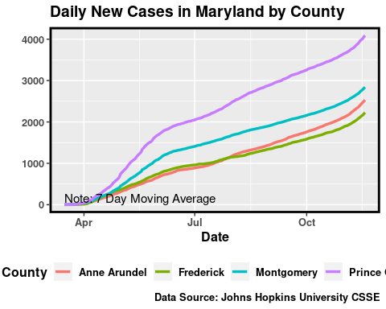

sum_deaths <- md_priority_ts %>% ungroup() %>% group_by(date) %>% select(date, deaths_delta_ma_per_hundred_thousand) %>% mutate(deaths_delta = sum(deaths_delta_ma_per_hundred_thousand))  
max_deaths <- max(sum_deaths$deaths_delta_ma_per_hundred_thousand)  
  
xrange <-range(md_priority_ts$date)  
yrange <- range(0, max_deaths)  
  
p12 <- md_priority_ts %>% ggplot(aes(group = County, x = date, y = deaths_delta_ma_per_hundred_thousand, color = County)) +  
 #geom_col(position = "stack", aes(group=County), size = 1.2) +  
 geom_line(aes(group=County), size = 0.8) +   
 labs(y = "", title = "Daily Deaths in Maryland by County", x = "Date") +   
 theme(legend.position = "bottom") +   
 #xlim(date("2020-03-01"),date("2020-07-15"))+  
 annotate(geom = "text", x = xrange[2], y = yrange[2], label = paste(strwrap("Note: 7 Day Moving Average", 40), collapse = "\n"), hjust = 1, vjust = 1, size = 4) +   
 pq+jhu_caption+  
 facet_wrap("County")  
p12

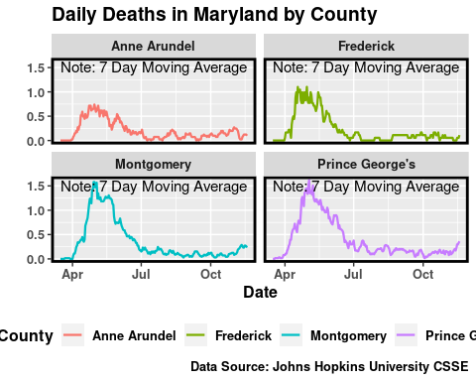

md_sum_ts <- md_combined_ts %>%   
 arrange(date) %>%   
 group_by(date) %>%   
 summarise(population = uid_states$Population[26], cases = sum(cases), cases_it = cases / 1000, cases_delta = sum(cases_delta), cases_per_hundred_thousand = 100000 * cases / population, cases_perc = 100 * cases_delta / lag(cases), deaths = sum(deaths), deaths_delta = sum(deaths_delta), deaths_perc = as.double(100 * deaths_delta / lag(deaths)), deaths_per_hundred_thousand = 100000 * deaths / population)

## `summarise()` ungrouping output (override with `.groups` argument)

md_sum_ts %<>%   
 mutate(lag_cases = as.double(lag(cases)), relative = cases_delta / lag_cases, cases_delta_ma = movingAverage(cases_delta),  
 cases_perc = case_when(  
 cases_perc == Inf ~ 100,  
 TRUE ~ (100 * sum(cases_delta) / lag_cases)), cases_dir = (cases_delta_ma < lag(cases_delta_ma)),  
 cases_perc_ma = movingAverage(cases_perc),  
 lag_deaths = as.double(lag(deaths)), relative = deaths_delta / lag_deaths, deaths_delta_ma = movingAverage(deaths_delta),  
 deaths_perc = case_when(  
 deaths_perc == Inf ~ 100,  
 TRUE ~ (100 * deaths_delta / lag_deaths)), deaths_dir = (deaths_delta_ma <= lag(deaths_delta_ma)),  
 deaths_perc_ma = movingAverage(deaths_perc)) %>%   
 ungroup()  
md_sum_ts[is.na(md_sum_ts)] <- as.double(0)  
md_sum_ts[md_sum_ts == Inf]<- as.double(100)  
md_sum_ts %<>%  
 mutate(cases_dir = factor(md_sum_ts$cases_dir, labels = c("red", "green")))  
md_sum_ts_last30 <- md_sum_ts %>%   
 filter(date %in% sinceMarch16)

md_sum_cases_today <- md_sum_ts_last30 %>%   
 select(date, cases, cases_delta, cases_per_hundred_thousand, cases_delta_ma) %>%   
 tail(1)  
md_sum_cases_today

## # A tibble: 1 x 5  
## date cases cases_delta cases_per_hundred_thousand cases_delta_ma  
## <date> <int> <dbl> <dbl> <dbl>  
## 1 2020-11-18 171823 2018 2493. 1914.

md_sum_deaths_today <- md_sum_ts_last30 %>%   
 select(date, deaths, deaths_delta, deaths_per_hundred_thousand, deaths_delta_ma) %>%   
 tail(1)  
md_sum_deaths_today

## # A tibble: 1 x 5  
## date deaths deaths_delta deaths_per_hundred_thousand deaths_delta_ma  
## <date> <int> <dbl> <dbl> <dbl>  
## 1 2020-11-18 4333 20 62.9 14.9

mortality_rate <- md_sum_deaths_today$deaths / md_sum_cases_today$cases  
mortality_rate * 100

## [1] 2.521781

xrange <-range(md_sum_ts_last30$date)  
yrange <- range(md_sum_ts_last30$cases_delta)  
  
cases_today_md <- round(md_sum_cases_today$cases_delta_ma[1], 0)  
cases_last_week_md <- md_sum_ts$cases_delta_ma[nrow(md_sum_ts)-7]  
  
perc_change_md <- round(((cases_today_md - cases_last_week_md)/cases_last_week_md),3)*100  
perc_change_txt <- function(x){  
 if (x > 0) {  
 out_text <- paste("+", as.character(abs(x)))  
 out_text  
 }  
 else {  
 out_text <- paste("-", as.character(abs(x)))  
 out_text  
 }  
}  
  
cases_text_md <- paste(as.character(today()),"\n","___24 Hours___\nNew Cases: +", as.character(cases_today_md), "\nPercent Change (7 Days): ", perc_change_txt(perc_change_md), "%\nData Source: Johns Hopkins University CSSE")  
  
md_p1 <- md_sum_ts_last30 %>% ggplot() +   
 geom_rect(md_sum_ts_last30, x=md_sum_ts_last30$date, y = md_sum_ts_last30$cases_delta_ma, mapping = aes(xmin = lag(date), xmax = date, fill = cases_dir), ymin = 0, ymax = Inf, alpha = 0.3) +   
 geom_line(aes(x = date, y = cases_delta_ma, color = ""), size = 1.2) +  
 geom_point(aes(x=date, y=cases_delta, color=""), alpha = 0.7)+  
 scale_color_manual(values = "black")+  
 scale_fill_manual(values = c("blue", "yellow"))+  
 labs(y = "", title = "Daily New Cases in Maryland", x = "Date") +  
 theme(legend.position = "none") +  
 pq+  
 ylim(0,max(md_sum_ts_last30$cases_delta_ma))+  
 annotate(geom = "text", x = xrange[1], y = yrange[2], label = paste("Note: 7 Day Moving Average", collapse = "\n"), hjust = 0, vjust = 1, size = 4)+  
 labs(caption=cases_text_md, vjust= 0)  
md_p1

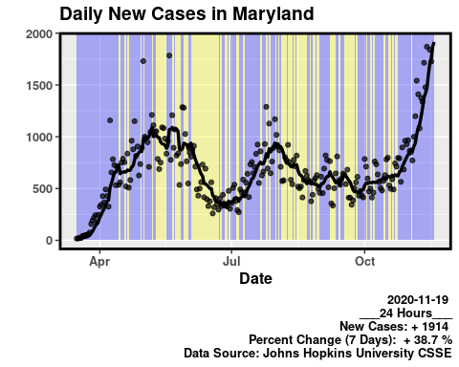

xrange <-range(md_sum_ts_last30$date)  
yrange <- range(md_sum_ts_last30$deaths_delta)  
  
  
deaths_today_md <- round(md_sum_deaths_today$deaths_delta_ma[1],0)  
deaths_last_week_md <- md_sum_ts$deaths_delta_ma[nrow(md_sum_ts)-7]  
  
perc_deaths_md <- round(((deaths_today_md - deaths_last_week_md)/deaths_last_week_md),3)*100  
deaths_text_md <- paste(as.character(today()),"\n","___24 Hours___\nDeaths Today: +", as.character(deaths_today_md), "\nPercent Change (7 Days): ", perc_change_txt(perc_deaths_md), "%\nData Source: Johns Hopkins University CSSE")  
  
md_p2 <- md_sum_ts_last30 %>% ggplot() +   
 geom_rect(md_sum_ts_last30, x=md_sum_ts_last30$date, y = md_sum_ts_last30$deaths_delta, mapping = aes(xmin = lag(date), xmax = date, fill = deaths_dir), ymin = 0, ymax = Inf, alpha = 0.3) +   
 geom_point(aes(x = date, y = deaths_delta, color = ""), alpha = 0.7)+  
 geom_line(aes(x = date, y = deaths_delta_ma), size = 1.2, alpha = 0.9) +  
 scale_fill_manual(values = c("red", "green", "red"))+  
 scale_color_manual(values = c("black", "black", "black"))+  
 labs(y = "", title = "Daily Deaths in Maryland", x = "Date") +  
 theme(legend.position = "none") +  
 pq +   
 ylim(0,max(md_sum_ts_last30$deaths_delta))+  
 annotate(geom = "text", x = xrange[1], y = yrange[2], label = paste("Note: 7 Day Moving Average", collapse = "\n"), hjust = 0, vjust = 1, size = 4)+jhu_caption+  
 labs(caption=deaths_text_md, vjust= 1)  
md_p2

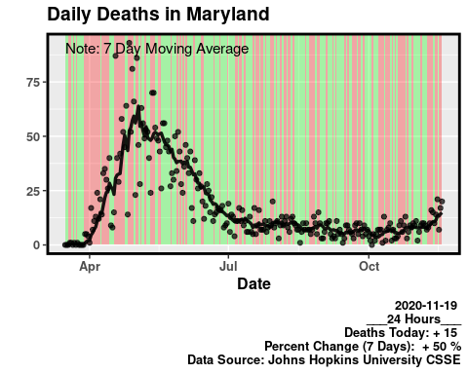

Montgomery County Data

montgomery_ts <- md_combined_ts %>%   
 filter(County == "Montgomery") %>%   
 mutate(cases_dir = (cases_delta_ma <= lag(cases_delta_ma)), deaths_dir = (deaths_delta_ma <= lag(deaths_delta_ma))) %>%   
 filter(date %in% sinceMarch16)

xrange <-range(montgomery_ts$date)  
yrange <- range(montgomery_ts$cases_delta)  
  
cases_today_moco <- round(montgomery_ts$cases_delta_ma[nrow(montgomery_ts)],0)  
cases_last_week_moco <- montgomery_ts$cases_delta_ma[nrow(montgomery_ts)-7]  
  
perc_change_moco <- round(((cases_today_moco - cases_last_week_moco)/cases_last_week_moco),3)*100  
cases_text_moco <- paste(as.character(today()),"\n","___24 Hours___\nNew Cases: +", as.character(cases_today_moco), "\nPercent Change (7 Days): ", perc_change_txt(perc_change_moco), "%\nData Source: Johns Hopkins University CSSE")  
  
mont_p1 <- montgomery_ts %>% ggplot() +   
 geom_rect(montgomery_ts, x=montgomery_ts$date, y = montgomery_ts$cases_delta, mapping = aes(xmin = lag(date), xmax = date, fill = cases_dir), ymin = 0, ymax = Inf, alpha = 0.3) +   
 geom_point(aes(x=date, y=cases_delta, color=""), alpha = 0.7)+   
 geom_line(aes(x = date, y = cases_delta_ma, color = ""), size = 1.2, alpha = 0.9) +  
 scale_color_manual(values = "black", "black")+  
 scale_fill_manual(values = c("blue", "yellow"))+  
 labs(y = "", title = "Daily New Cases in Montgomery County", x = "Date") +  
 theme(legend.position = "none") +  
 pq+  
 ylim(0,max(montgomery_ts$cases_delta))+  
 annotate(geom = "text", x = xrange[1], y = yrange[2], label = paste("Note: 7 Day Moving Average", collapse = "\n"), hjust = 0, vjust = 1, size = 4)+jhu_caption+  
 labs(caption=cases_text_moco, vjust= 1)  
mont_p1

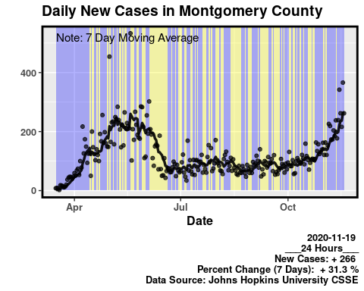

xrange <-range(montgomery_ts$date)  
yrange <- range(montgomery_ts$deaths_delta)  
  
deaths_today_moco <- round(montgomery_ts$deaths_delta_ma[nrow(montgomery_ts)],0)  
deaths_last_week_moco <- montgomery_ts$deaths_delta_ma[nrow(montgomery_ts)-7]  
  
perc_deaths_moco <- round(((deaths_today_moco - deaths_last_week_moco)/deaths_last_week_moco),3)*100  
deaths_text_moco <- paste(as.character(today()),"\n","___24 Hours___\nDeaths Today: +", as.character(deaths_today_moco), "\nPercent Change (7 Days): ", perc_change_txt(perc_deaths_moco), "%\nData Source: Johns Hopkins University CSSE")  
  
mont_p2 <- montgomery_ts %>% ggplot() +   
 geom_rect(montgomery_ts, x=montgomery_ts$date, y = montgomery_ts$deaths_delta_ma, mapping = aes(xmin = lag(date), xmax = date, fill = deaths_dir), ymin = 0, ymax = Inf, alpha = 0.3) +   
 geom_point(aes(x = date, y = deaths_delta, color = ""), alpha = 0.7)+  
 geom_line(aes(x = date, y = deaths_delta_ma, color = ""), size = 1.2, alpha = 0.9) +  
 scale_fill_manual(values = c("red", "green"))+  
 scale_color_manual(values = "black", "black")+  
 labs(y = "", title = "Daily Deaths in Montgomery County", x = "Date") +  
 theme(legend.position = "none") +  
 pq +   
 ylim(0,max(montgomery_ts$deaths_delta))+  
 annotate(geom = "text", x = xrange[1], y = yrange[2], label = paste("Note: 7 Day Moving Average", collapse = "\n"), hjust = 0, vjust = 1, size = 4)+jhu_caption+  
 labs(caption=deaths_text_moco, vjust= 1)  
mont_p2

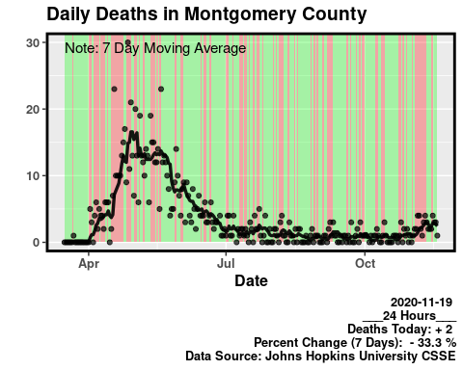

Frederick County Data

frederick_ts <- md_combined_ts %>%   
 filter(County == "Frederick") %>%   
 mutate(cases_dir = (cases_delta_ma <= lag(cases_delta_ma)), deaths_dir = (deaths_delta_ma <= lag(deaths_delta_ma))) %>%   
 filter(date %in% sinceMarch16)

xrange <-range(frederick_ts$date)  
yrange <- range(frederick_ts$cases_delta)  
  
cases_today_fr <- round(frederick_ts$cases_delta_ma[nrow(frederick_ts)])  
cases_last_week_fr <- frederick_ts$cases_delta_ma[nrow(frederick_ts)-7]  
  
perc_change_fr <- round(((cases_today_fr - cases_last_week_fr)/cases_last_week_fr),3)*100  
cases_text_fr <- paste(as.character(today()),"\n","___24 Hours___\nNew Cases: +", as.character(cases_today_fr), "\nPercent Change (7 Days): ", perc_change_txt(perc_change_fr), "%\nData Source: Johns Hopkins University CSSE")  
  
fred_p1 <- frederick_ts %>% ggplot() +   
 geom_rect(frederick_ts, x=frederick_ts$date, y = frederick_ts$cases_delta, mapping = aes(xmin = lag(date), xmax = date, fill = cases_dir), ymin = 0, ymax = Inf, alpha = 0.3) +   
 geom_point(aes(x=date, y=cases_delta, color=""), alpha = 0.7)+   
 geom_line(aes(x = date, y = cases_delta_ma, color = ""), size = 1.2, alpha = 0.9) +  
 scale_color_manual(values ="black", "black")+  
 scale_fill_manual(values = c("blue", "yellow"))+  
 labs(y = "", title = "Daily New Cases in Frederick County", x = "Date") +  
 theme(legend.position = "none") +  
 pq+  
 ylim(0,max(frederick_ts$cases_delta))+  
 annotate(geom = "text", x = xrange[1], y = yrange[2], label = paste("Note: 7 Day Moving Average", collapse = "\n"), hjust = 0, vjust = 1, size = 4)+jhu_caption+  
 labs(caption=cases_text_fr, vjust= 1)  
fred_p1

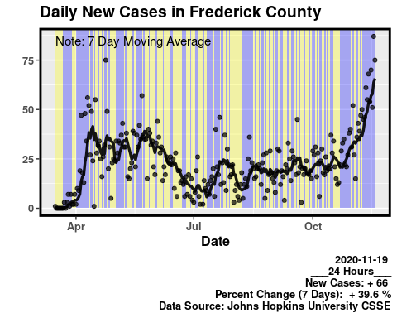

Percent Change in Deaths (5 Day Moving Average)

xrange <-range(frederick_ts$date)  
yrange <- range(frederick_ts$deaths_delta)  
  
deaths_today_fr <- round(frederick_ts$deaths_delta[nrow(frederick_ts)],0)  
deaths_last_week_fr <- frederick_ts$deaths_delta_ma[nrow(frederick_ts)-7]  
  
perc_deaths_fr <- round(((deaths_today_fr - deaths_last_week_fr)/deaths_last_week_fr),3)*100  
deaths_text_fr <- paste(as.character(mdy(as.character(today()))),"\n","___24 Hours___\nDeaths Today: +", as.character(deaths_today_fr), "\nPercent Change (7 Days): ", perc_change_txt(perc_deaths_fr), "%\nData Source: Johns Hopkins University CSSE")  
  
fred_p2 <- frederick_ts %>% ggplot() +   
 geom_rect(frederick_ts, x=frederick_ts$date, y = frederick_ts$deaths_delta_ma, mapping = aes(xmin = lag(date), xmax = date, fill = deaths_dir), ymin = 0, ymax = Inf, alpha = 0.3) +   
 geom_point(aes(x = date, y = deaths_delta), alpha = 0.7)+  
 geom_line(aes(x = date, y = deaths_delta_ma), size = 1.2, alpha = 0.9) +  
 scale_fill_manual(values = c("red", "green"))+  
 #scale_color_manual(values = "black")+  
 labs(y = "", title = "Daily Deaths in Frederick County", x = "Date") +  
 theme(legend.position = "none", plot.tag = element_text(hjust = 0, vjust = 1, size = 12)) +  
 pq +   
 ylim(0,max(frederick_ts$deaths_delta))+  
 annotate(geom = "text", x = xrange[2], y = yrange[2], label = paste("Note: 7 Day Moving Average", collapse = "\n"), hjust = 1, vjust = 1, size = 4)+  
 jhu_caption+  
 labs(caption=deaths_text_fr, vjust= 1)  
  
fred_p2

