
Run Book
[Microsoft Azure GPU Service Location Web Scrap]
[Dec 2017]
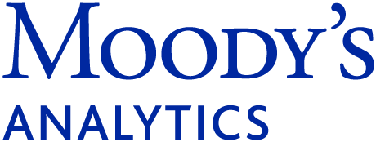 | Moody’s Analytics Knowledge Services

CONFIDENTIAL
The information contained within this document is proprietary to Moody’s Analytics Knowledge Services and it reserves the right to all information provided. The recipient agrees not to distribute, share or use any part of the material without express written permission of Moody’s Analytics Knowledge Services. The recipient would treat this material as Confidential Information.

4. Script Execution
4.1 Prerequisite for execution of script
- Make sure you have updated the project code from the repository.

4.2 Execution guide
The script may be executed by the following command at cmd (windows environment):
python MS_GPU_Locations.py
4.3 Execution guide
The output file will be generated in following path:
***Project_path\data\output\MS_GPU_Locations_<MM_YYYY>.csv
And the log file will be generate in following path:
***Project_path\logs\Log_MS_GPU_Locations.log

4.4 Execution PRODUCTION SCHEDULE
The production version is scheduled to run on the virtual machine via the Microsoft’s task scheduler.
Schedule Time: 6 pm US time on 1st of every month.

